RV College of Engineering®
(Autonomous Institution Affiliated to Visvesvaraya Technological University, Belagavi)
Department of
ARTIFICIAL INTELLIGENCE AND MACHINE LEARNING
WASTEX: Intelligent Multi-Agent Waste Collection Optimization System using Kafka Stream Processing
Project Report
Submitted by
Ibrahim Bagwan 1RV24AI404
Monil Palak Mehta 1RV23AI058
Joseph Rejo Mathew 1RV23AI040

in partial fulfilment for the requirement of 7th Semester
Stream Processing and Analytics (AI372IA)
Under the Guidance of
Dr. S. Anupama Kumar  Associate Professor  Department of AIML  RV College of Engineering  Bengaluru-59 | Dr. Vijayalakshmi M. N.  Associate Professor  Department of AIML  RV College of Engineering  Bengaluru-59

Academic Year
2026 - 2027

RV College of Engineering®
(Autonomous Institution Affiliated to Visvesvaraya Technological University, Belagavi)
Department of ARTIFICIAL INTELLIGENCE AND MACHINE LEARNING
Bengaluru – 560059
CERTIFICATE
This is to certify that the work entitled “WASTEX: Intelligent Multi-Agent Waste Collection Optimization System using Kafka Stream Processing” submitted in partial fulfillment of Stream Processing and Analytics (AI372IA) of VII Semester BE is a result of the bonafide work carried out by Ibrahim Bagwan (1RV24AI404), Monil Palak Mehta (1RV23AI058) and Joseph Rejo Mathew (1RV23AI040) during the Academic year 2026-27.

Faculty In charge | Head of the Department

External Examination
Name of Examiners | Signature with date
1.
2.

ABSTRACT
Municipal solid-waste collection in Bengaluru still follows fixed schedules (07:30–09:00 and 18:00–19:30) even though every bin fills at a different and changing rate. The result is a reactive system: some bins overflow long before the truck arrives while others are emptied half-full, wasting fuel and crew time. BBMP complaint records confirm the pattern; the most frequent grievance is that waste is cleared but comes back.
This project presents WASTEX, an end-to-end event-driven system that turns live smart-bin telemetry into collection decisions in real time. A scenario-driven IoT simulator emits fill level, weight, temperature and battery readings for 140 bins placed on 14 real Bengaluru wards. The readings flow through Apache Kafka (8 topics, 28 partitions, 5 consumer groups) into a stateful stream processor. The processor computes sliding-window fill rates with least squares and EWMA, forecasts the time to overflow, detects sensor spikes, tampering, fire and low battery through a stream–stream join with collection events, and emits 5-minute tumbling-window zone aggregates. A multi-agent decision layer, the JEV Orchestrator, then coordinates three specialised agents. The Waste Intelligence Agent decides WHAT needs collection. The Route Planner Agent decides HOW, using capacity-constrained clustering, batching, nearest-neighbour with 2-opt, and utilisation-aware plant selection. The Fleet Manager Agent decides WHO, by best-fit assignment with dynamic insertion. JEV re-plans adaptively whenever a constraint makes a plan infeasible. A fleet simulator executes the plans and closes the loop by emitting collection events.
On an identical 24-hour simulation, WASTEX reduced overflow bin-minutes by 92.8% and overflow events by 75.8% compared with the current twice-daily BBMP schedule. At a comparable distance to a 4×/day schedule (1,264.1 km vs 1,297.6 km), it cut overflow by 83.4%, needed 41.8% fewer bin lifts, and collected bins at 78.6% average fill instead of 50.5%. On the live Kafka deployment, every consumer group kept up with the stream with zero lag. The JEV orchestrator reached a decision in 2.09 ms on average. An interactive web dashboard, a Route Optimizer that routes operator-selected bins on real Bengaluru roads, live waste-hotspot analytics and a Kafka internals laboratory make every stage of the pipeline observable.
Keywords: Apache Kafka, stream processing, multi-agent systems, smart waste management, IoT, vehicle routing, Bengaluru.

Table of Contents
Chapter 1 Introduction 1
1.1 Project Description 1
1.2 Motivation 2
1.3 Report Organization 2
Chapter 2 Problem Definition 3
2.1 Problem Statement 3
2.2 Background Information (Literature Review) 3
Chapter 3 Objectives 5
3.1 Primary Objectives 5
3.2 Expected Outcomes 5
Chapter 4 Tools and Techniques 6
4.1 Tools 6
4.2 Datasets 6
4.3 Techniques 8
Chapter 5 Implementation 12
5.1 System Architecture 12
5.2 Kafka Topic and Consumer-Group Design 12
5.3 IoT Smart-Bin Simulator 13
5.4 Stream Processor 14
5.5 JEV Multi-Agent Decision Layer 15
5.6 Fleet Simulator 17
5.7 Dashboard and Kafka Laboratory 17
5.8 Route Optimizer and Real-Road Routing 19
5.9 Waste Hotspot Analytics 21
Chapter 6 Results and Discussion 22
6.1 Final Results 22
6.2 Discussion 26
Chapter 7 Conclusion 27
Chapter 8 Future Enhancements 28
Appendix 29
Bibliography 31

List of Tables
Table 1.1: Current fixed BBMP collection schedule (baseline) 1
Table 2.1: Summary of the literature survey 3
Table 4.1: Tools and their purpose 6
Table 4.2: Data sources used by WASTEX 6
Table 4.3: Dry Waste Collection Centres in Bengaluru (four also act as truck depots) 7
Table 4.4: Waste processing plants: capacity and intake 7
Table 5.1: Kafka topics, keys and data flow 12
Table 5.2: Simulated fleet 17
Table 6.1: Measured metrics of the live Kafka deployment 22
Table 6.2: Fixed schedules versus WASTEX on the identical simulated city 22
Table 6.3: Routing algorithms on random bin sets (gap vs exact optimum; live = multi-start 2-opt + Or-opt; saving vs unoptimised order) 25
Table 6.4: Behaviour under the scenario tests 25
Table A.1: Configuration parameters 30

List of Figures
Figure 4.1: Ward-level garbage complaint records used as the history signal 8
Figure 4.2: Capacity versus current intake of Bengaluru's waste processing plants 8
Figure 4.3: Urgency as a function of predicted time to overflow 10
Figure 4.4: Daily waste-generation profile and time-of-day truck speed model 10
Figure 5.1: WASTEX layered architecture (Architecture page of the dashboard) 12
Figure 5.2: Command Center: live Bengaluru bin and fleet map, KPIs and alerts 18
Figure 5.3: JEV Agents page: adaptive workflow and reasoning trace of a decision 18
Figure 5.4: Kafka Pipeline page: topology, partitions and consumer-group lag on the real broker 19
Figure 5.5: Kafka Lab: broker B1 killed, leaders re-elected from the ISR, zero data loss 19
Figure 5.6: Route Optimizer: selected bins routed on real roads, algorithm and plant comparison 21
Figure 6.1: Number of overflowing bins over the simulated day for each policy 23
Figure 6.2: Key metrics of the three policies (scaled for comparison) 23
Figure 6.3: Insights & Results page of the dashboard 24
Figure 6.4: Stream Analytics page: tumbling windows, scenario mix, overflow forecast and alerts 24
Figure 6.5: Runtime of the live heuristic versus the exact Held-Karp solver 25

Chapter 1
Introduction
This chapter introduces the WASTEX project. It describes the operational problem of urban waste collection that motivated it, outlines the solution at a high level, and explains how the rest of the report is organised.

1.1 Project Description
Bengaluru generates several thousand tonnes of municipal solid waste every day. Collection is planned around fixed time windows. On weekdays and weekends alike, trucks visit their beats between 07:30 and 09:00 and again between 18:00 and 19:30 (Table 1.1). Waste generation, however, is highly dynamic. A commercial street in Indiranagar fills far faster than a residential lane in Yelahanka. Festivals, cricket matches and weekend markets cause sudden surges, and the same bin fills at different rates at different hours of the day.
Table 1.1: Current fixed BBMP collection schedule (baseline)
Days | Collection window
Monday - Friday | 07:30 - 09:00
Monday - Friday | 18:00 - 19:30
Saturday - Sunday | 07:30 - 09:00
Saturday - Sunday | 18:00 - 19:30

WASTEX (Intelligent Multi-Agent Waste Collection Optimization System) replaces the fixed schedule with data-driven decisions. Each smart bin streams telemetry to an Apache Kafka cluster. A stream processor turns the raw readings into actionable signals: how full the bin is, how fast it is filling, when it will overflow and whether the sensor is behaving abnormally. A multi-agent decision layer, the JEV Orchestrator with its Waste, Route and Fleet agents, then decides which bins to collect, in what order, and with which truck. The plans are executed by a fleet simulator, and every pickup is fed back into the stream, so the system continuously closes the loop between data and action.
The complete system runs locally on a laptop. It consists of a Dockerised Apache Kafka 3.7 broker in KRaft mode, a Python backend, and a browser dashboard with eight pages. The pages cover a live city map, the live Kafka pipeline, an interactive Kafka internals laboratory, the agents' reasoning traces, stream analytics, the fleet, and the evaluation results.

1.2 Motivation
The motivation is summarised in the SPA Lab presentation: the challenge is not collecting data, it is turning data into timely decisions. Three observations from the exploratory data analysis drive the design.
- Growth rate matters, not level alone. A bin rising from 78% to 84% in ten minutes (0.6%/min) overflows in about 27 minutes, sooner than a slow-filling bin that is already at 92%. Fixed schedules and simple threshold rules both miss this.
- Averages hide bins. Koramangala's average fill was 67.2% while one of its bins was at 91%. Decisions must be made per bin, on the stream, not on daily averages.
- Capacity is unevenly used. Bengaluru's processing plants have 2,900 TPD of mixed-waste capacity but receive only 1,150 TPD (40%). MSGP (83%) and Doddabidarakallu (75%) are near saturation while Kannahalli (8%) is mostly idle, so the choice of disposal site matters.

1.3 Report Organization
Chapter 2 defines the problem and reviews 25 related works. Chapter 3 lists the objectives. Chapter 4 describes the tools, the datasets and the techniques used. Chapter 5 presents the implementation of every component with code snippets. Chapter 6 reports the results of the live system and of the comparative evaluation and discusses them. Chapter 7 concludes, Chapter 8 lists future enhancements, and the Appendix documents how to run the system and the message schemas.

Chapter 2
Problem Definition
This chapter states the problem WASTEX addresses and why it matters. It then surveys the existing literature on smart waste management, streaming architectures and agentic routing to identify the research gap this project fills.

2.1 Problem Statement
Given thousands of geographically distributed smart bins that continuously report their state, and a limited heterogeneous fleet of collection trucks, how do we make the right collection decision in real time? Each decision has four parts: what (which bins need attention before they overflow), when (now, or can it wait for a better batch), where (in which order, and to which processing plant), and how (which truck, given its capacity, current load, location and availability).
The problem is relevant because overflowing bins cause littering, disease vectors, garbage burning and repeated citizen complaints. Collecting half-empty bins on a timetable, meanwhile, wastes diesel, crew hours and road capacity. The data volume (one reading per bin per minute, i.e. hundreds of events per second for a single city zone), the need for sub-second reaction to events such as fires, and the coupling between routing and fleet constraints make this a stream-processing and decision-making problem rather than a batch analytics one.

2.2 Background Information (Literature Review)
Table 2.1 summarises the 25 studies reviewed. They fall into four groups. The first group is IoT monitoring systems and reviews [4, 7, 9, 13, 24]. The second covers forecasting and classification models [5, 6, 12, 18, 19, 22, 23]. The third covers routing and optimisation [8, 10, 14, 21, 25]. The fourth covers LLM or agentic approaches to routing and operations research [1, 2, 3, 15, 16]. Only a few works use a streaming backbone. Miletić et al. [17] built an MQTT-to-Kafka architecture, but for air quality, and Vonitsanos et al. [20] used Spark Streaming for bin levels, but without routing or fleet allocation.
Table 2.1: Summary of the literature survey
# | Author / Year | Main contribution | Gap w.r.t. WASTEX
1 | Zhu et al., 2025 | Edge LLM agent fusing dual-YOLO vision, policy data and bin state | Bin-level only; no city-wide streaming, routing or truck allocation
2 | Li et al., 2025 (ARS) | LLM agents generate constraint-aware VRP heuristics; RoutBench | Generic benchmarks, no live bin data
3 | Zhang & Cao, 2025 | Four cooperating LLM agents for complex VRPs | Offline, not event-driven, no Kafka
4 | Alaoui, Belhiah & Ziti, 2025 | Systematic review of IoT smart-waste approaches | Review only, no implemented pipeline
5 | Ishaque & Florence, 2025 | Deep-learning waste classification + vehicle routing | Model-centric; no stream processing
6 | Reji et al., 2025 | Swin Transformer + ant colony optimisation | Offline; no Kafka ingestion or windowing
7 | Gatti, Barbierato & Pozzi, 2024 | Review of RL/GA/GNN smart-bin routing | Theoretical; no operational system
8 | Ali et al., 2024 | TOPSIS route selection; 14% shorter distance | Static scoring; no streaming or agents
9 | Addas, Khan & Naseer, 2024 | IoT + cloud dynamic routing; 32% better efficiency | No LLM agents or Kafka backbone
10 | Belhiah, El Aboudi & Ziti, 2024 | GIS + contraction hierarchies for unplanned waste | Routing only; no fleet agent
11 | Hussain et al., 2024 | Agent-based simulation: sensor vs periodic collection | Rule-based agents; no real-time pipeline
12 | Kona & Subramoniam, 2024 | DCNN predicts visit period + shortest path | No windowing, explainability or allocation
13 | Sankar & Fathima, 2024 | IoTBinCap scheduling from sensor data | Simulation-level; no distributed streaming
14 | Çil et al., 2024 | K-means container placement (Yalova) | Planning stage only
15 | Huang, Shi & Sukhatme, 2024 | LLMs generate routing programs | General VRP; no live data
16 | Xiao et al., 2024 (Chain-of-Experts) | Multi-agent LLMs for OR problems | Not domain-specific; no streaming
17 | Miletić et al., 2023 | MQTT-to-Kafka architecture for air quality | No waste analytics or agents
18 | Mishra, 2023 | Five time-series models for bin fill (MAE 0.24) | Batch forecasting only
19 | Ahmed et al., 2022 | CNN-LSTM/GRU bin fullness forecast | Forecast only; not linked to routing
20 | Vonitsanos et al., 2022 | Apache Spark framework for waste-level streams | No Kafka topic design, agents or routing
21 | Salehi-Amiri et al., 2022 | Two-stage sustainable IoT waste system | Optimisation model; not real time
22 | Anjum, Shahab & Umar, 2022 | IoT sensing + forecasting models | No event streaming or routing
23 | Al Duhayyim et al., 2022 | DRL recycling object classification | Classification task only
24 | Vishnu et al., 2021 | LoRaWAN/Wi-Fi smart-bin monitoring | Monitoring only
25 | Aktemur, Erensoy & Kocyigit, 2020 | Evolutionary algorithms for collection routes | Offline; no telemetry

Research gap. No reviewed work combines all of the following in one operational loop: (i) a partitioned, replayable event backbone (Kafka) with explicit topic and consumer-group design; (ii) stateful windowed stream operators that forecast overflow and detect sensor faults; (iii) separate, explainable agents for prioritisation, routing and fleet allocation, coordinated adaptively with re-planning; and (iv) feedback of execution events into the stream. WASTEX is designed to fill exactly this gap.

Chapter 3
Objectives
This chapter lists the objectives that guided the design of WASTEX and the measurable outcomes used to judge whether they were met.

3.1 Primary Objectives
The SPA Lab presentation framed the goals as four verbs: Predict, Optimize, Respond and Scale. They translate into the following objectives.
- PREDICT – Identify bins needing collection before they overflow, by estimating each bin's fill rate on the live stream and forecasting its time to overflow, combined with fill level, ward complaint history and anomalies into a priority score.
- OPTIMIZE – Generate efficient collection routes that respect vehicle capacity, batch nearby bins, sequence stops to minimise distance under time-of-day traffic, and choose processing plants with spare capacity.
- RESPOND – React to changing conditions within seconds. This covers demand spikes, event surges, fires, sensor faults and truck breakdowns, with adaptive re-planning when a plan becomes infeasible.
- SCALE – Handle increasing IoT workload through a partitioned Kafka backbone, keyed by bin, so that processing can be parallelised by adding consumers to a group without losing per-bin ordering.
- EXPLAIN – Make every decision transparent through an ordered decision log with each agent's inputs, scores and verdicts, and make the whole pipeline observable on a dashboard.

3.2 Expected Outcomes
- A working local end-to-end system with a real Apache Kafka broker, plus an embedded Kafka-compatible fallback.
- Fewer overflow events and overflow minutes than the fixed BBMP schedule on the same simulated city.
- Higher average bin fill at collection (fewer wasted lifts) at a comparable distance.
- Low-latency processing (zero consumer lag at steady state; decisions in milliseconds).
- An educational Kafka laboratory that demonstrates partitioning, consumer groups, lag, replication and failover.

Chapter 4
Tools and Techniques
This chapter describes the software stack, the datasets (both real and synthetic), and the stream-processing, optimisation and multi-agent techniques used in WASTEX, together with the reasons each was chosen.

4.1 Tools
Table 4.1: Tools and their purpose
Tool | Purpose in WASTEX
Apache Kafka 3.7.1 (KRaft) | Distributed event log; durable, partitioned, replayable transport between all components
Docker Desktop + Compose | Runs the Kafka broker and Kafka UI locally with one command
Kafka UI (provectus 0.7.2) | Independent web view of topics, partitions and consumer groups (port 8080)
Python 3.10 | Implementation language of the simulators, stream processor and agents
kafka-python 3.0 | Kafka client: producers, consumer groups, admin client and offset queries
FastAPI + Uvicorn | REST API, WebSocket push (1 Hz snapshots) and control endpoints
Leaflet 1.9 + Esri basemap | Interactive Bengaluru map with bins, trucks, routes, plants, DWCCs and landfills
Chart.js 4.4 | Dashboard charts (zone windows, trends, scenario mix, alerts, benchmark)
OSRM (OpenStreetMap router) | Real-road route geometry and distances on the Route Optimizer page
HTML5 Canvas | Real-time animation of the Kafka Lab simulator
Matplotlib, python-docx | Report figures and generation of this document
Hardware | Single Windows 11 laptop; no cloud deployment

4.2 Datasets
The data strategy mixes real reference data, used for geographic realism, with synthetic telemetry, used to simulate IoT sensors (Table 4.2). Real coordinates for the Dry Waste Collection Centres (Table 4.3), processing plants with capacities (Table 4.4) and landfills come from BBMP data published on OpenCity. They are embedded in backend/data/bengaluru.py.
Table 4.2: Data sources used by WASTEX
Data | Real / Synthetic | Purpose
Bengaluru bin / ward locations | Real | Geographic realism
Bengaluru road / network data | Real (modelled) | Route optimization
Historical waste generation & complaints | Real where available | EDA + realistic patterns
Live bin fill levels | Synthetic | Simulate IoT sensors
Waste weight | Synthetic | Streaming
Temperature / battery | Synthetic | IoT telemetry
Overflow events | Synthetic / derived | Alerts
Collection events | Synthetic | Kafka events

Table 4.3: Dry Waste Collection Centres in Bengaluru (four also act as truck depots)
Location | Latitude | Longitude
Kempegowda | 13.10928 | 77.576778
Doddabommasandra | 13.06894 | 77.563879
Jakkur | 13.072449 | 77.630249
Hebbal | 13.036574 | 77.597274
Koramangala | 12.934294 | 77.61465
HSR Layout | 12.91263 | 77.649028
JP Nagar | 12.91651 | 77.599874
Kengeri | 12.91477 | 77.481763
Bellandur | 12.912793 | 77.676734
Kadugodi | 12.99371 | 77.759137
K R Puram | 13.018675 | 77.70366
Yelahanka Satellite Town | 13.094001 | 77.578976

Table 4.4: Waste processing plants: capacity and intake
Plant | Area | Mixed TPD | Wet TPD | Intake TPD | Utilisation
Seegehalli SWM Facility | Seegehalli | 200 | 120 | 70 | 35%
Kannahalli | Kannahalli | 500 | 350 | 40 | 8%
Doddabidarakallu | Dodda Bidarakallu | 200 | 150 | 150 | 75%
Subbarayanapalya | Subbarayanapalya | 200 | 150 | 50 | 25%
Lingadeeranahalli | Hemmigepura | 200 | 150 | 90 | 45%
KCDC (Karnataka Compost Development Corp.) | Mangammanapalya | 500 | 350 | 80 | 16%
Chikkanagamangala | Chikkanagamangala | 500 | 300 | 170 | 34%
Mavallipura | Mavallipura | 0 | 0 | 0 | closed
MSGP | – | 600 | – | 500 | 83%

Landfill sites (Outside BBMP, village 15317, and two Jakkur sites in ward 5) are also plotted on the map. The ward complaint EDA (Figure 4.1) shows Bellandur (ward 150, 152 records) and Banaswadi (ward 27, 128 records) as the worst-affected wards. These counts feed the Waste Agent's history term. The plant capacity EDA (Figure 4.2) motivates utilisation-aware plant selection.
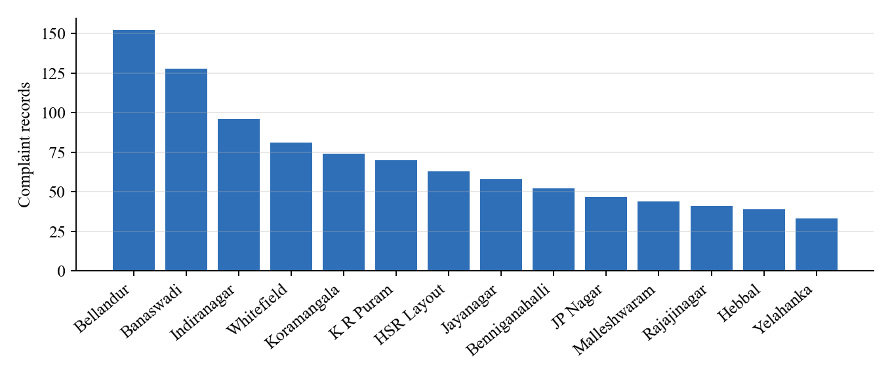
Figure 4.1: Ward-level garbage complaint records used as the history signal
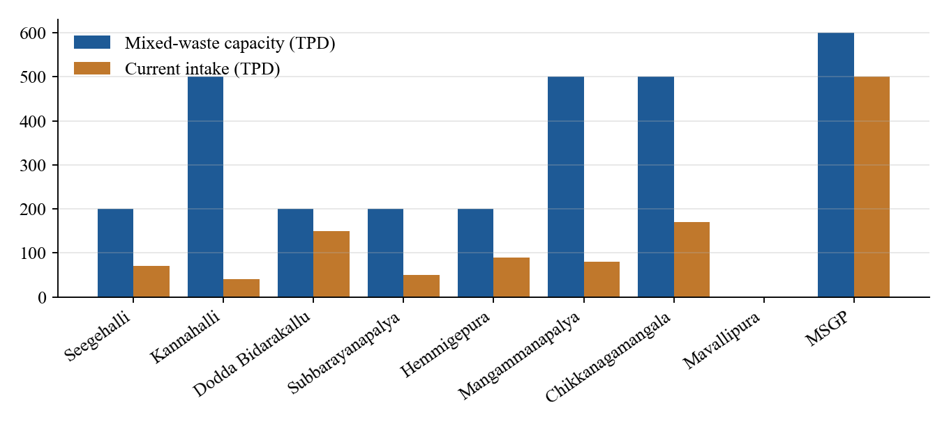
Figure 4.2: Capacity versus current intake of Bengaluru's waste processing plants

4.3 Techniques

4.3.1 Event-driven architecture on Kafka
All components communicate only through Kafka topics, never by direct calls. Producers and consumers are therefore decoupled in time and in scale, and every event is persisted and can be replayed. Records are keyed by bin_id, zone_id or truck_id. Kafka's default partitioner (murmur2(key) mod N) routes all events of one bin to one partition, which guarantees per-bin ordering, the property that fill-rate computation depends on. Consumer groups give each downstream service its own independent position (offset) in the log, and lag (log-end offset minus committed offset) measures whether a service keeps up.

4.3.2 Stateful stream processing
- Sliding count window + least squares: the last 10 validated readings of a bin are fitted with a line. Its slope is the fill rate in %/min, smoothed with an EWMA (α = 0.6).
- Forecasting: time to overflow ETA = (100 − fill) / rate.
- Anomaly detection: jumps above +15% per reading are physically implausible and are quarantined as sensor spikes. Drops below −15% without a matching collection event are flagged as tampering or scavenging. Temperatures ≥ 60 °C are flagged as fire (garbage burning), and battery below 15% raises a maintenance alert.
- Stream–stream join: telemetry is joined with collection-events, so a drop that follows a truck visit resets the window instead of raising a false tamper alarm.
- Tumbling windows: 5-minute, non-overlapping event-time windows per zone produce average and maximum fill, the number of bins above 90%, total kilograms and anomaly counts.
- Alert de-duplication with hysteresis: an alert fires once per bin and type and re-arms only after the condition has clearly cleared (fill < 90%, or ETA > 60 min).

4.3.3 Multi-agent decision making
Decision making is decomposed into three questions, each answered by a specialised agent, and coordinated by the JEV Orchestrator (Figure 5.3).
- Waste Intelligence Agent (WHAT): score = 0.35·fill + 0.35·urgency + 0.15·rate + 0.15·history (+ fire override). Urgency is 1 when the bin will overflow within 60 minutes, the time a truck needs to reach it, and falls linearly to 0 at 240 minutes (Figure 4.3). Scores of 0.65 or more are HIGH (collect), 0.45 or more are MEDIUM (monitor), and the rest are LOW (ignore).
- Route Planner Agent (HOW): capacity-constrained greedy clustering seeded by the most urgent bin. Opportunistic pickup adds MEDIUM bins, and LOW bins that are already at least 55% full, within 3 km. A batching rule dispatches a route only with 4 or more stops or an imminent bin. Stops are sequenced by nearest neighbour and improved with 2-opt. Road distance is modelled as great-circle distance × 1.35 circuity, with a time-of-day traffic speed (Figure 4.4). A truck unloads only when at least 75% full, at the plant with the lowest distance × (1 + 0.6·utilisation), skipping plants that are closed or more than 90% utilised.
- Fleet Manager Agent (WHO): every truck is classed as unavailable, insufficient or feasible. Feasible trucks are ranked by dead-head distance + 6·capacity slack (best fit), with a penalty of 4 for appending to a running route (dynamic insertion).
- JEV Orchestrator: runs on events (overflow, critical fill, predicted overflow, fire, breakdown) and every 5 simulated minutes. If no bin is HIGH it stops early (No Action). If no truck can serve a route it detects the constraint and re-plans by splitting the route geographically, up to 3 attempts, before deferring.
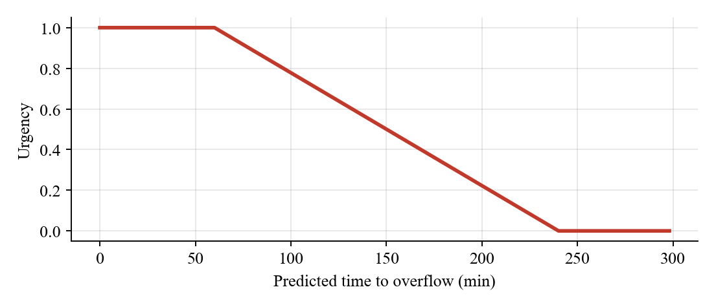
Figure 4.3: Urgency as a function of predicted time to overflow
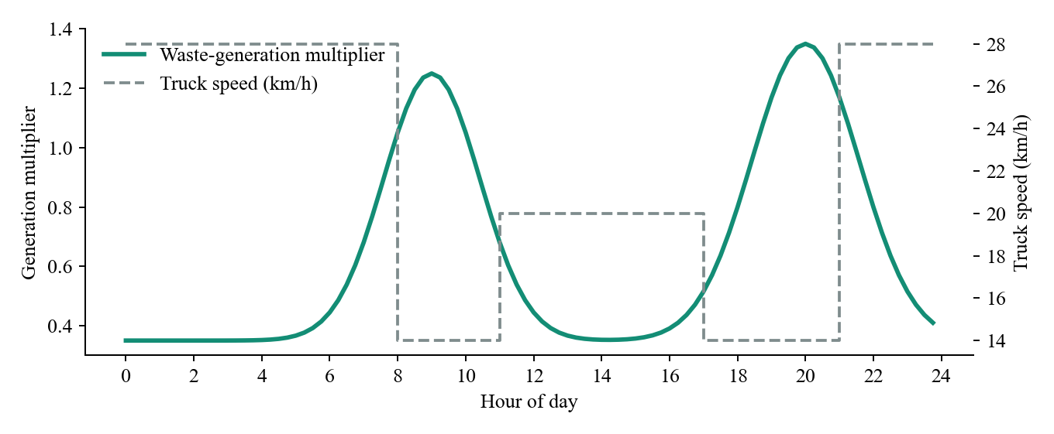
Figure 4.4: Daily waste-generation profile and time-of-day truck speed model

4.3.4 Simulation and evaluation methodology
Because a city-wide sensor network is not available, both the physical world and the fleet are simulated. Every bin has a type (240 L, 1100 L or 3200 L community bin), a ward-specific base rate, a per-bin log-normal factor, Gaussian noise and the daily demand curve in Figure 4.4. Scenarios inject demand spikes (×1.8), event surges (×4 in one ward for 60 minutes) and anomalies. All randomness comes from a fixed seed (42), so experiments are reproducible. The offline benchmark replays the same city for 24 hours under three policies: BBMP 2×/day, 4×/day and WASTEX. The WASTEX run reuses the live agent code.

Chapter 5
Implementation
This chapter explains how WASTEX is built: the overall architecture, the Kafka topic design, each processing component and agent, the dashboard and the Kafka laboratory. Representative code snippets are taken directly from the source.

5.1 System Architecture
Figure 5.1 shows the five layers. The data layer (IoT simulator, real Bengaluru reference data and the scenario engine) publishes to Kafka. The stream-processing layer enriches and aggregates the readings. The JEV multi-agent layer turns them into plans. The action layer (fleet simulator and dashboard) executes and visualises them. collection-events and fleet-status close the feedback loop.
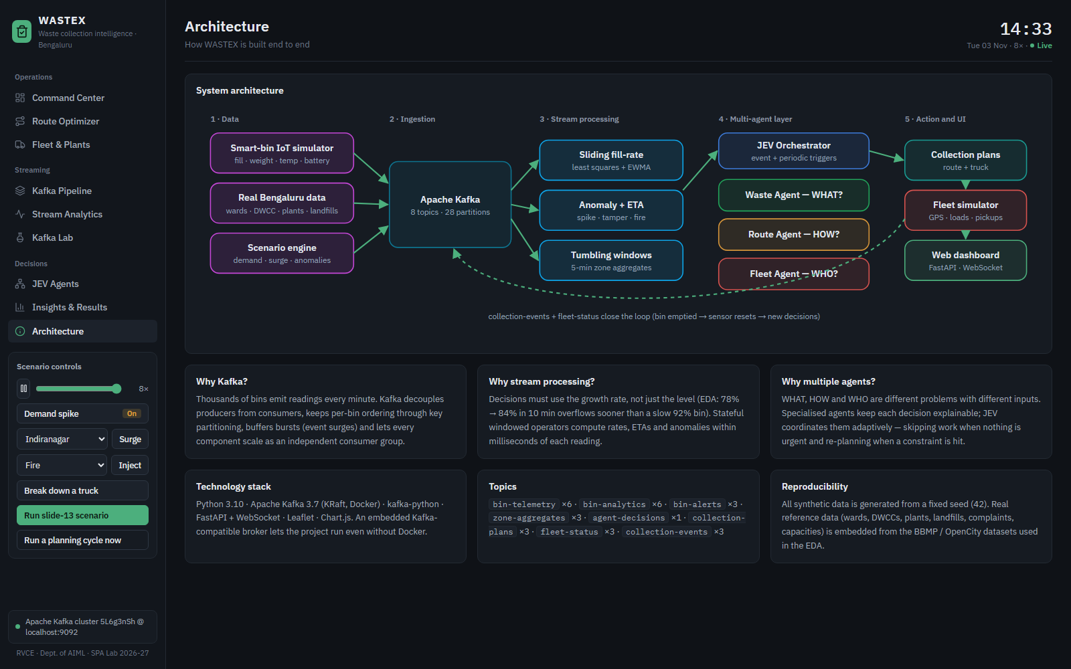
Figure 5.1: WASTEX layered architecture (Architecture page of the dashboard)

5.2 Kafka Topic and Consumer-Group Design
Table 5.1: Kafka topics, keys and data flow
Topic | Partitions | Key | Producer | Consumer(s)
bin-telemetry | 6 | bin_id | IoT simulator | stream processor, dashboard
bin-analytics | 6 | bin_id | stream processor | JEV, dashboard
bin-alerts | 3 | bin_id / truck_id | stream processor, fleet | JEV, dashboard
zone-aggregates | 3 | zone_id | stream processor | dashboard
agent-decisions | 1 | 'jev' (total order) | JEV | dashboard
collection-plans | 3 | truck_id | JEV | fleet simulator, dashboard
fleet-status | 3 | truck_id | fleet simulator | JEV, dashboard
collection-events | 3 | bin_id | fleet simulator | IoT gateway, stream processor, dashboard

Five consumer groups are used: wastex-stream-processor, wastex-jev-orchestrator, wastex-fleet-simulator, wastex-iot-gateway and wastex-dashboard-bridge. At startup, every consumer first joins its group and receives a partition assignment. Only then do the producers start, so no early event is lost. agent-decisions has one partition on purpose, which gives the decision log a total order. The bus abstraction (backend/bus.py) has two implementations. KafkaBus talks to the real broker. EmbeddedBus follows the same semantics: append-only partition logs, the murmur2 partitioner, range-assigned consumer groups, committed offsets, lag and retention. This lets the project run even without Docker.
Snippet 5.1 – Kafka's murmur2 partitioner (backend/bus.py)
def murmur2(data: bytes) -> int:
"""Kafka's murmur2 hash (same as the Java client's DefaultPartitioner)."""
length = len(data)
seed = 0x9747B28C
m = 0x5BD1E995
r = 24
h = (seed ^ length) & 0xFFFFFFFF
for i in range(length // 4):
i4 = i * 4
k = data[i4] | (data[i4 + 1] << 8) | (data[i4 + 2] << 16) | (data[i4 + 3] << 24)
k = (k * m) & 0xFFFFFFFF
k ^= k >> r
k = (k * m) & 0xFFFFFFFF
h = (h * m) & 0xFFFFFFFF
h ^= k
extra = length % 4
base = length & ~3
if extra >= 3:
h ^= data[base + 2] << 16
if extra >= 2:
h ^= data[base + 1] << 8
if extra >= 1:
h ^= data[base]
h = (h * m) & 0xFFFFFFFF
h ^= h >> 13
h = (h * m) & 0xFFFFFFFF
h ^= h >> 15
return h

5.3 IoT Smart-Bin Simulator
The simulator creates 10 bins in each of 14 wards (140 bins), spread around the real ward centroids. Every simulated minute it publishes one record per bin to bin-telemetry. Each record carries the bin id, zone, coordinates, bin type, fill level, weight, temperature, battery, timestamp and scenario label. It also consumes collection-events and empties a bin when a truck visits it. A sample record is listed in Appendix B.

5.4 Stream Processor
The stream processor is the only consumer of raw telemetry. Snippet 5.2 shows the least-squares slope used for the fill rate, and Snippet 5.3 shows the anomaly logic with the collection join.
Snippet 5.2 – Sliding-window fill-rate regression (backend/streaming/processor.py)
def slope(points):
n = len(points)
if n < 3:
return 0.0
mx = sum(p[0] for p in points) / n
my = sum(p[1] for p in points) / n
den = sum((p[0] - mx) ** 2 for p in points)
if den == 0:
return 0.0
return sum((p[0] - mx) * (p[1] - my) for p in points) / den

Snippet 5.3 – Anomaly detection and stream–stream join
def _on_telemetry(self, t):
self.processed += 1
if t["bin_id"] in self.overrides and t["fill_level"] >= 90:
self.overrides.discard(t["bin_id"])
self.state[t["bin_id"]] = BinState()
st = self.state[t["bin_id"]]
now = t["sim_min"]
fill = t["fill_level"]
anomalies = []
# ---- anomaly detection on the raw delta --------------------------------
if st.validated is not None:
delta = fill - st.validated
# a drop to near-empty is how an emptied bin looks even if the event is late
recently_collected = now - st.last_collection <= 5 or fill < 5.0
if delta > SPIKE_JUMP:
anomalies.append("SENSOR_SPIKE")
self._alert(st, t, "SENSOR_SPIKE", "warning",
f"Implausible jump +{delta:.0f}% in one reading - reading quarantined")
fill = st.validated # quarantine the bad reading
elif delta < DROP_JUMP and not recently_collected:
anomalies.append("TAMPER")
self._alert(st, t, "TAMPER", "warning",
f"Fill dropped {delta:.0f}% without a collection event (tamper / scavenging)")
st.window.clear()
elif delta < DROP_JUMP:
st.window.clear() # emptied by a truck - restart the rate window
else:
self._clear(st, "SENSOR_SPIKE")
self._clear(st, "TAMPER")
st.validated = fill
if t["temperature_c"] >= FIRE_TEMP:
anomalies.append("FIRE")

5.5 JEV Multi-Agent Decision Layer
Snippets 5.4 to 5.6 show the core of each agent. The orchestrator in Snippet 5.7 implements the feasibility / re-plan loop of the adaptive workflow. The live trace of a decision is shown in Figure 5.3.
Snippet 5.4 – Waste Intelligence Agent priority score
def score(self, b: dict) -> dict:
fill = b["fill_level"]
rate = b.get("rate_per_min") or 0.0
eta = b.get("eta_min")
if fill >= 100:
eta = 0.0
if eta is None:
urgency = 0.0
elif eta <= URGENT_ETA:
urgency = 1.0
else:
urgency = max(0.0, 1 - (eta - URGENT_ETA) / (HORIZON_ETA - URGENT_ETA))
rate_n = min(rate / 0.5, 1.0)
hist = HISTORY.get(b["zone_id"], 0.3)
score = 0.35 * fill / 100 + 0.35 * urgency + 0.15 * rate_n + 0.15 * hist
reasons = []
anomalies = b.get("anomalies") or []
if "FIRE" in anomalies:
score = max(score + 0.35, 0.85) # garbage burning: always dispatch
reasons.append("fire risk")
if fill >= config.CRITICAL_FILL:
score = max(score, 0.9)
reasons.append(f"critical fill {fill:.0f}%")
score = min(score, 1.0)
if score >= config.HIGH_THRESHOLD:
pri = "HIGH"
elif score >= config.MEDIUM_THRESHOLD:
pri = "MEDIUM"
else:

Snippet 5.5 – Route Planner: nearest neighbour + 2-opt
def optimise_order(self, start, stops, end=None):
"""Nearest neighbour construction + 2-opt / Or-opt local search (see backend/routing.py)."""
return routing.optimise(start, stops, end)

Snippet 5.6 – Fleet Manager: best-fit assignment and constraint detection
def assign(self, route, trucks: dict):
rows = self.evaluate(route, trucks)
feasible = [r for r in rows if r["verdict"] == "feasible"]
nearest_avail = min((r for r in rows if r["verdict"] != "unavailable"), key=lambda r: r["deadhead_km"], default=None)
constraint = None
if nearest_avail and nearest_avail["verdict"] == "insufficient":
constraint = (f"Nearest truck {nearest_avail['truck_id']} can take only {nearest_avail['remaining_kg']} kg "
f"({nearest_avail['remaining_pct']}% free) but the route needs {route['load_kg']:.0f} kg")
if feasible:
return {"feasible": True, "truck_id": feasible[0]["truck_id"], "mode": feasible[0]["mode"],
"candidates": rows, "constraint": constraint}
if any(r["verdict"] == "insufficient" for r in rows):
reason = "capacity"
else:
reason = "no_available_truck"
return {"feasible": False, "reason": reason, "candidates": rows, "constraint": constraint}

Snippet 5.7 – JEV feasibility check and re-plan / retry loop
queue = deque((r, 1) for r in routes)
plans = []
trucks = {k: dict(v) for k, v in self.trucks.items()} # local what-if copy
while queue:
r, attempt = queue.popleft()
res = self.fleet.assign(r, trucks)
brief = self._route_brief(r)
if res["feasible"]:
tid = res["truck_id"]
t = trucks[tid]
start = {"lat": t["lat"], "lon": t["lon"]}
seq = self.route.optimise_order(start, r["stops"])
dispose = self.route.should_dispose(t.get("load_kg", 0) + t.get("planned_kg", 0), r["load_kg"], t["capacity_kg"])
end, km, minutes = self.route.cost(start, seq, hour, dispose)
plan = self._make_plan(t, res["mode"], seq, end, dispose, km, minutes, r, did)
# what a non-optimising dispatcher would drive: most urgent bin first
by_urgency = sorted(seq, key=lambda s: -s.get("score", 0))
plan["naive_km"] = round(routing.tour_km(start, by_urgency, end if dispose else None), 2)
plan["nn_km"] = round(routing.tour_km(start, routing.nearest_neighbour(start, seq), end if dispose else None), 2)
self.stats["naive_km"] = round(self.stats["naive_km"] + plan["naive_km"], 2)
self.stats["optimised_km"] = round(self.stats["optimised_km"] + km, 2)
plans.append(plan)
t["planned_kg"] = t.get("planned_kg", 0) + r["load_kg"]
t["status"] = "en_route" if t["status"] in ("idle", "returning") else t["status"]
t.setdefault("remaining_stops", [])
t["remaining_stops"] = list(t["remaining_stops"]) + [s["bin_id"] for s in seq]
txt = f"{tid} ({t['type']}, {res['candidates'][0]['remaining_pct']}% free) → {len(seq)} stops, " \
f"{r['load_kg']:.0f} kg, {km} km, ~{minutes:.0f} min [{res['mode']}] → " + (f"unload at {end['name']}" if dispose else f"back to {end['name']} (keeps collecting)")
if res.get("constraint"):
steps.append({"agent": "JEV", "node": "constraint", "title": "Constraint detected",
"text": res["constraint"] + f" → {tid} assigned instead"})
steps.append({"agent": "Fleet Agent", "node": "fleet", "title": "Which truck? Feasible ✓",
"text": txt, "data": {"route": brief, "candidates": res["candidates"][:6]}})
else:
steps.append({"agent": "Fleet Agent", "node": "fleet", "title": "Which truck? Not feasible ✗",
"text": f"Route {brief['label']} needs {r['load_kg']:.0f} kg - "
+ ("no truck has enough spare capacity" if res["reason"] == "capacity" else "no truck available"),
"data": {"route": brief, "candidates": res["candidates"][:6]}})
halves = self.route.split(r, hour) if res["reason"] == "capacity" else None
if halves and attempt < config.MAX_REPLAN_ATTEMPTS:
self.stats["replans"] += 1
steps.append({"agent": "JEV", "node": "replan", "title": f"Re-plan / Retry (attempt {attempt + 1})",
"text": f"Splitting route into {len(halves)} smaller routes: "
+ " | ".join(f"{len(h['stops'])} stops/{h['load_kg']:.0f} kg" for h in halves)})
for h in halves:
queue.append((h, attempt + 1))

5.6 Fleet Simulator
Each of the eight trucks (Table 5.2) is a state machine: idle → en_route → collecting → … → to_plant → unloading → returning, plus breakdown. Trucks move along the road model at the time-of-day speed. They emit fleet-status heartbeats every simulated minute and a collection-event at every pickup. A breakdown releases the truck's stops and raises a TRUCK_BREAKDOWN alert, which triggers immediate re-planning.
Table 5.2: Simulated fleet
Truck | Type | Capacity (kg) | Home depot
TRUCK-01 | Compactor | 5000 | Koramangala Depot
TRUCK-02 | Tipper | 2000 | Koramangala Depot
TRUCK-03 | Compactor | 5000 | Hebbal Depot
TRUCK-04 | Tipper | 2000 | Hebbal Depot
TRUCK-05 | Compactor | 5000 | K R Puram Depot
TRUCK-06 | Tipper | 2000 | K R Puram Depot
TRUCK-07 | Compactor | 5000 | JP Nagar Depot
TRUCK-08 | Mini Tipper | 1200 | JP Nagar Depot

5.7 Dashboard and Kafka Laboratory
A dashboard bridge consumer group materialises every topic into views that the FastAPI server pushes over a WebSocket once per second. The Command Center (Figure 5.2) shows the live map of Bengaluru with bins coloured by fill, trucks with their remaining routes, depots, DWCCs, plants and landfills, together with KPIs and the alert feed. The JEV Agents page (Figure 5.3) animates the slide-13 workflow for each decision and lists the full reasoning trace. The Kafka Pipeline page (Figure 5.4) shows the live topology, partition offsets and consumer lag. The Kafka Lab (Figure 5.5) is an interactive simulation of producers, a partitioned topic replicated on three brokers, and a consumer group. It demonstrates key partitioning, rebalancing, lag, leader election from the ISR and acks semantics.
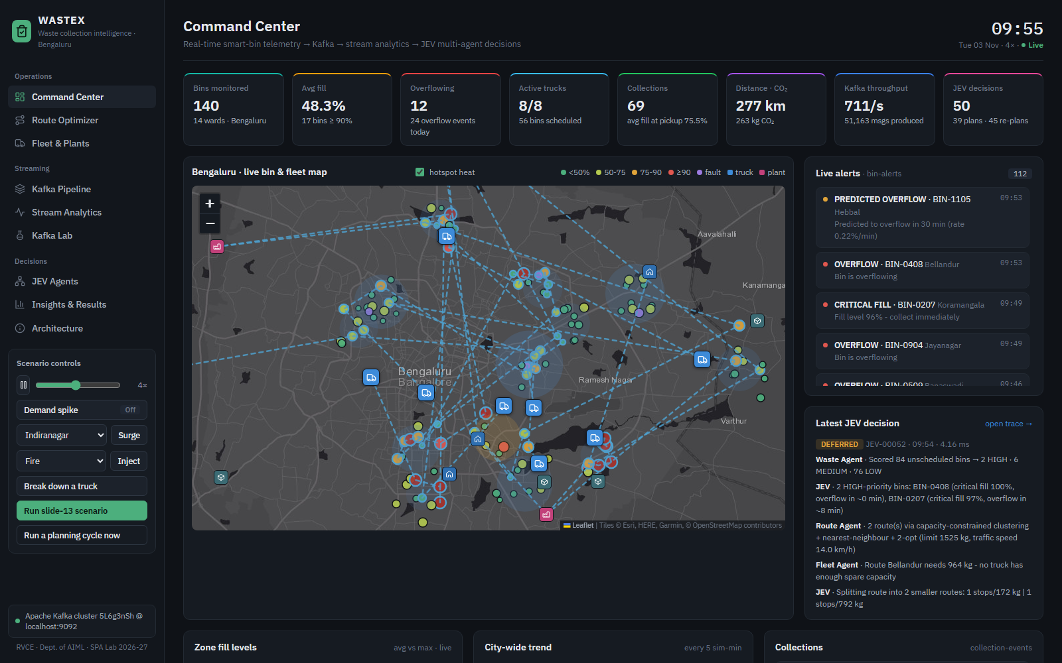
Figure 5.2: Command Center: live Bengaluru bin and fleet map, KPIs and alerts
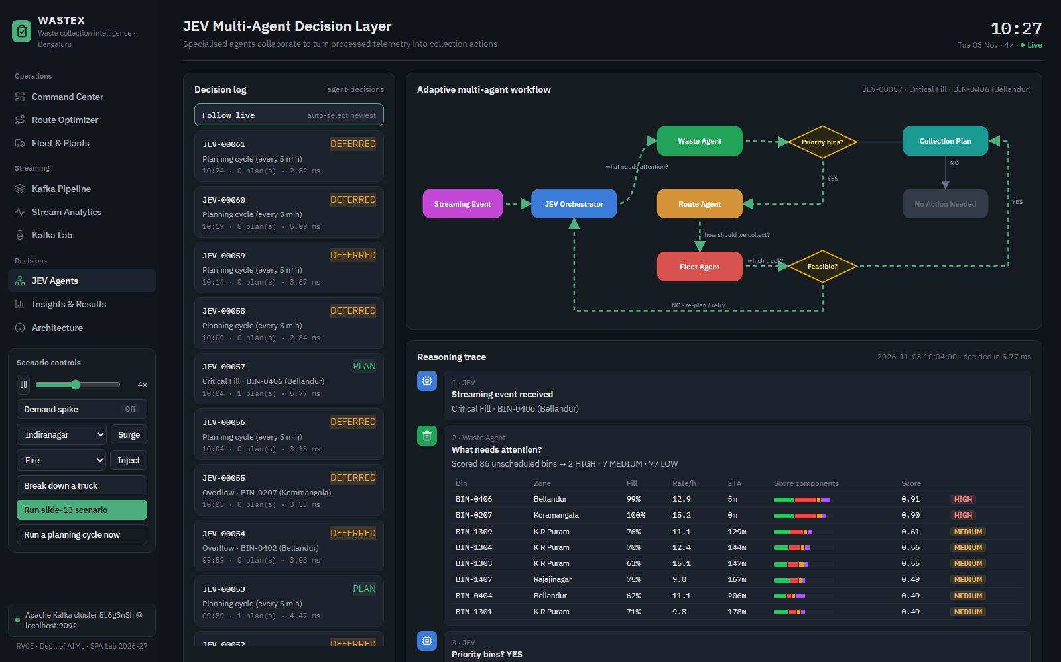
Figure 5.3: JEV Agents page: adaptive workflow and reasoning trace of a decision
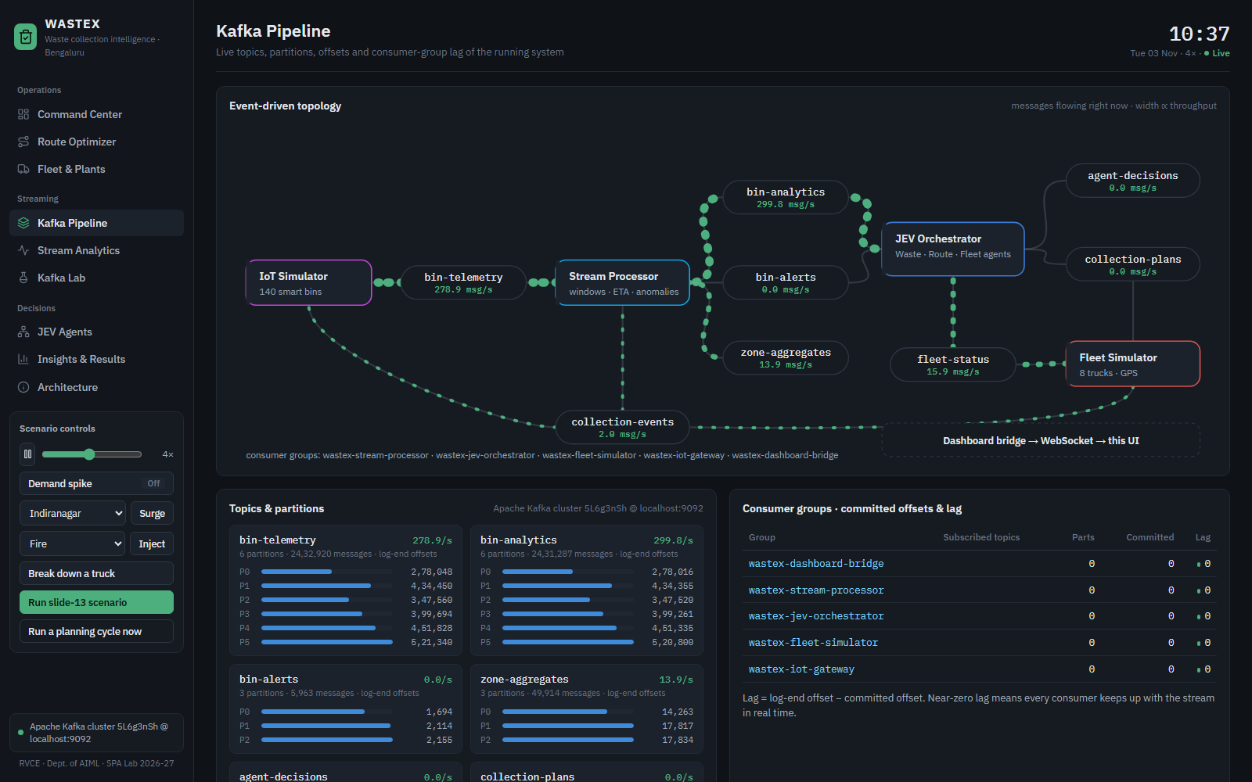
Figure 5.4: Kafka Pipeline page: topology, partitions and consumer-group lag on the real broker
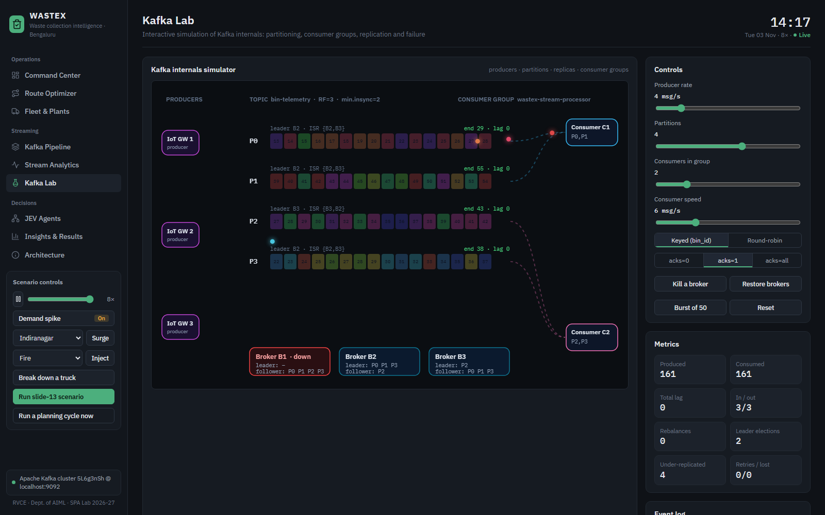
Figure 5.5: Kafka Lab: broker B1 killed, leaders re-elected from the ISR, zero data loss

5.8 Route Optimizer and Real-Road Routing
Inside every route, collection is a travelling-salesman path problem: start (depot or truck) → all selected bins → destination (processing plant or standby). The problem is NP-hard. backend/routing.py therefore implements four strategies: the order the bins were picked (no optimisation), nearest neighbour (greedy, O(n²)), nearest neighbour improved by 2-opt (segment reversal until no improving move remains), and the exact Held-Karp dynamic programme (O(n²·2ⁿ)), which serves as the optimality reference for up to 11 stops (Snippet 5.8). Plain 2-opt can still leave a single stop badly placed, so the live Route Planner Agent adds Or-opt moves (relocating chains of 1–3 stops) and runs this local search from two construction tours, nearest neighbour and cheapest insertion, keeping the shorter (multi-start). A distance cache keeps it fast, at about 100 ms for 15 stops.
Snippet 5.8 – Held-Karp exact solver used as the optimality reference (backend/routing.py)
def held_karp(start, stops, end=None):
"""Exact shortest path start -> all stops -> end (end optional)."""
n = len(stops)
if n == 0:
return []
d0 = [road_km(start, s) for s in stops]
d = [[road_km(a, b) for b in stops] for a in stops]
de = [road_km(s, end) if end else 0.0 for s in stops]
dp = {}
for k in range(n):
dp[(1 << k, k)] = (d0[k], -1)
for mask in range(1, 1 << n):
for last in range(n):
if not mask & (1 << last) or (mask, last) not in dp:
continue
cost = dp[(mask, last)][0]
for nxt in range(n):
if mask & (1 << nxt):
continue
key = (mask | (1 << nxt), nxt)
c = cost + d[last][nxt]
if key not in dp or c < dp[key][0]:
dp[key] = (c, last)
full = (1 << n) - 1
last = min(range(n), key=lambda k: dp[(full, k)][0] + de[k])
order, mask = [], full
while last != -1:
order.append(stops[last])
prev = dp[(mask, last)][1]
mask ^= 1 << last
last = prev
return order[::-1]

The Route Optimizer page (Figure 5.6) lets the operator choose the places. The start can be any depot or truck. Bins can be added by ward with a fill threshold, as the ten most urgent unscheduled bins, or by clicking them on the map. The destination can be the automatically chosen plant, a specific plant, or standby. The page compares all algorithms on the same stops and destination, ranks the processing plants by distance × (1 + 0.6·utilisation), checks every truck's free capacity, and draws both the unoptimised and the optimised route on real roads using the OSRM router (OpenStreetMap data). It also reports the real-road distance next to the modelled distance. With Dispatch, the optimised route is published to the collection-plans topic, so the chosen truck drives it live and the JEV decision log records the operator decision. Bins already scheduled on another truck are refused, to prevent double collection.
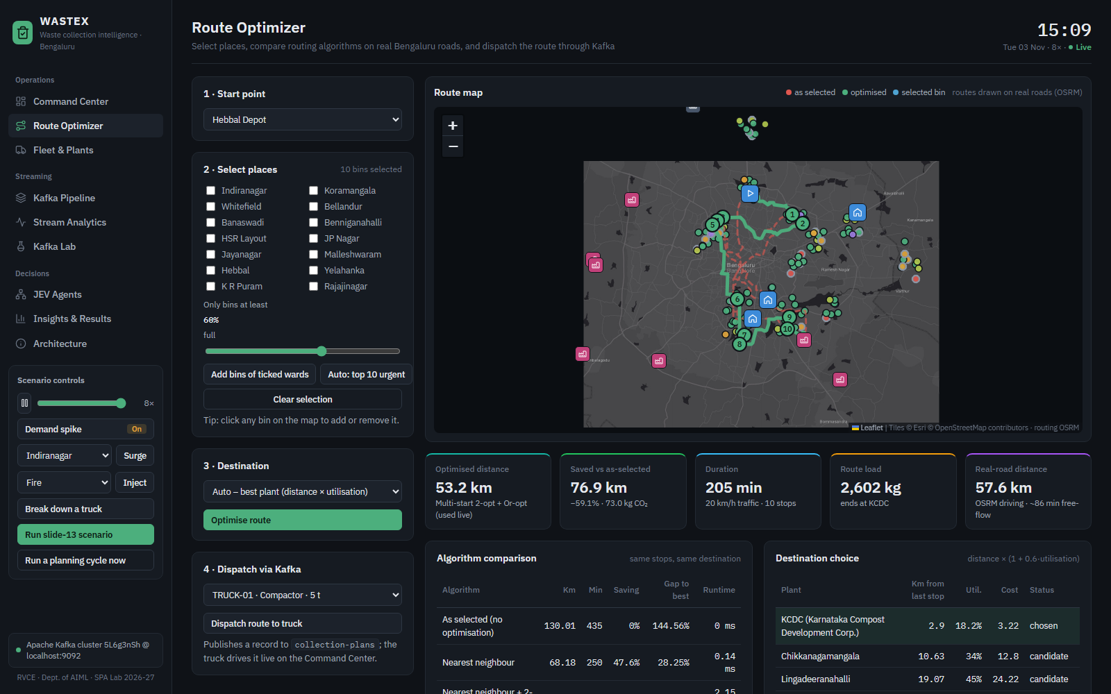
Figure 5.6: Route Optimizer: selected bins routed on real roads, algorithm and plant comparison

5.9 Waste Hotspot Analytics
To show where waste is increasing, each 5-minute zone window carries the zone's waste-generation rate in kg/h, computed as Σ(fill rate × bin capacity). The dashboard bridge compares each zone's live generation rate with its own previous ~45 minutes of windows. It labels zones SURGE (more than +40%), RISING (more than +10%), STABLE or FALLING, and ranks them with a one-hour sparkline. The same signal is drawn as heat circles on the Command Center map. In a test, an event surge in Yelahanka (normally the lowest-rate ward) moved it to rank 1 at +106%, labelled SURGE, within about four simulated minutes. The Waste Agent then started dispatching trucks there.

Chapter 6
Results and Discussion
This chapter presents the measured behaviour of the live Kafka pipeline and the comparative evaluation of WASTEX against the fixed BBMP schedule. It then interprets the results against the objectives, including the unexpected findings and the limitations.

6.1 Final Results

6.1.1 Live pipeline on Apache Kafka
Table 6.1: Measured metrics of the live Kafka deployment
Metric | Value
Broker | Apache Kafka cluster 5L6g3nSh @ localhost:9092
Simulated time covered | 13.4 h (run at 3.0× speed)
Messages produced | 233,643
Telemetry records processed | 112,145
Peak telemetry throughput | 276 msg/s (bin-telemetry) + 413 msg/s (bin-analytics)
Produce → processed latency p50 / p95 | 84.8 ms / 99.7 ms
Consumer lag (all 5 groups) | dashboard-bridge: 0, stream-processor: 0, jev-orchestrator: 0, fleet-simulator: 0, iot-gateway: 0
JEV decisions / plans / re-plans | 171 / 64 / 5
No-action cycles (work skipped) | 126 (74%)
Average JEV decision time | 2.09 ms
Bins collected / waste delivered | 191 / 38.0 t
Average fill at collection | 73.6%

Table 6.1 shows that every consumer group kept up with the stream: committed offsets equalled the log-end offsets, so lag was zero. The JEV orchestrator needed only milliseconds per decision, and most periodic cycles ended early with No Action, which is the adaptive behaviour the design intended. The 85–100 ms produce-to-process latency is dominated by the client batching (linger.ms) and fetch intervals of the Kafka client, not by computation.

6.1.2 Comparative evaluation
Table 6.2: Fixed schedules versus WASTEX on the identical simulated city
Metric (24 h, 140 bins, 8 trucks) | Fixed 2×/day (BBMP) | Fixed 4×/day | WASTEX
Distance driven (km) | 804.6 | 1,264.1 | 1,297.6
CO2 emitted (kg) | 764.4 | 1,200.9 | 1,232.7
Operating cost (Rs.) | 33,794 | 53,093 | 54,498
Bin lifts | 280 | 519 | 302
Average fill at collection (%) | 72.1 | 50.5 | 78.6
Overflow bin-minutes | 6,512 | 2,816 | 467
Overflow events | 62 | 33 | 15
Trips / avg stops per trip | 19 / 14.7 | 23 / 22.6 | 58 / 5.2

Table 6.2 and Figures 6.1 and 6.2 compare the policies. Compared with the current BBMP schedule, WASTEX reduces overflow bin-minutes by 92.8% and overflow events by 75.8%. Simply collecting twice as often (4×/day) costs about as much distance as WASTEX (1,264.1 km vs 1,297.6 km) but still leaves 83.4% more overflow than WASTEX. It also performs 519 lifts against WASTEX's 302 (41.8% fewer for WASTEX), because it empties bins at only 50.5% fill on average versus 78.6%.
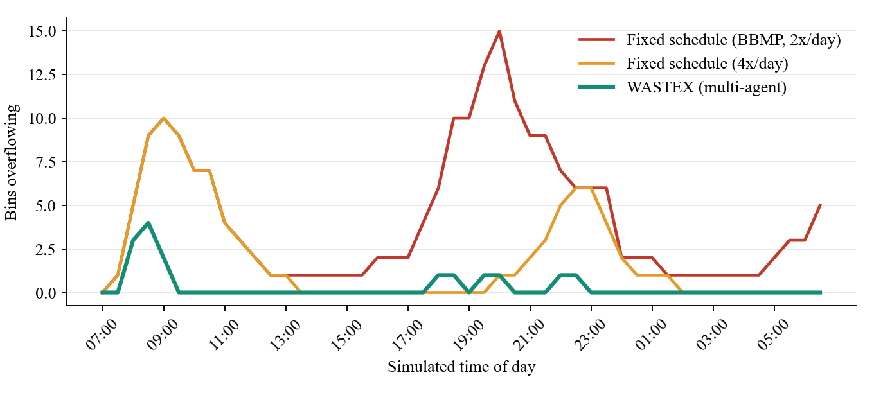
Figure 6.1: Number of overflowing bins over the simulated day for each policy
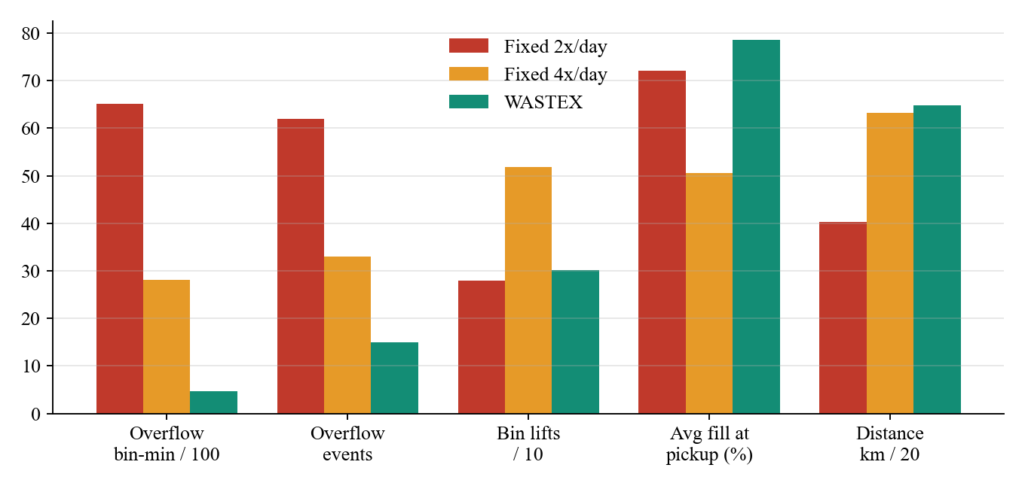
Figure 6.2: Key metrics of the three policies (scaled for comparison)
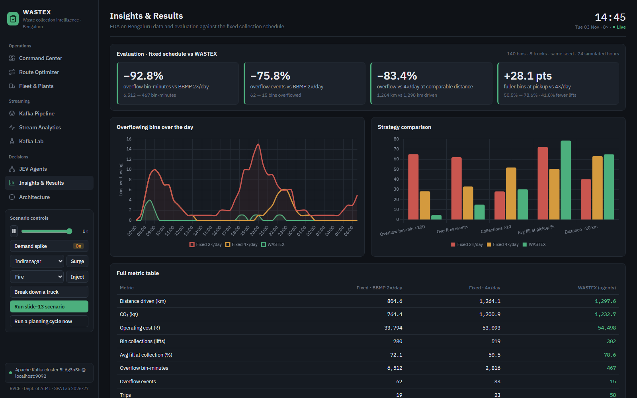
Figure 6.3: Insights & Results page of the dashboard
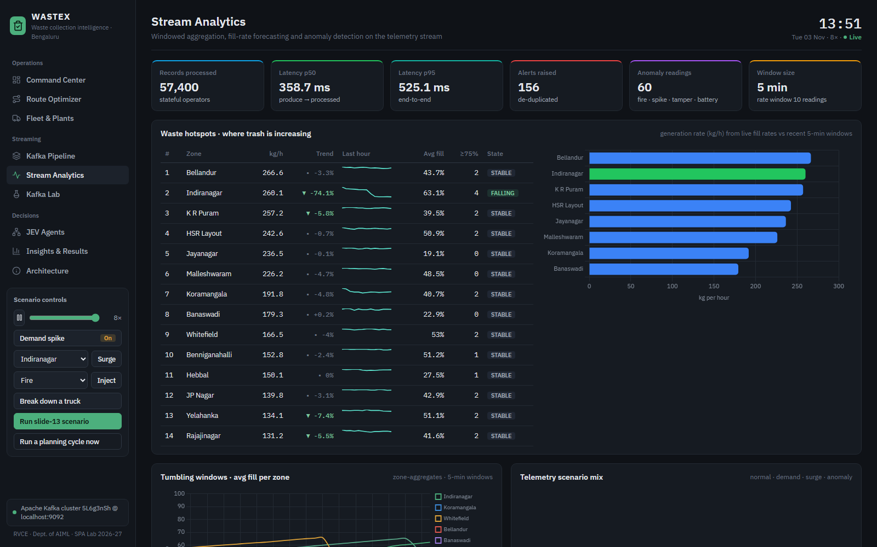
Figure 6.4: Stream Analytics page: tumbling windows, scenario mix, overflow forecast and alerts

6.1.3 Route optimisation study
Each algorithm was run on 20 random bin sets per route size, starting from a random depot (Table 6.3, Figure 6.5). Optimisation saves 35–67% of the distance of an unoptimised visiting order. Plain nearest neighbour is 3–15% longer than the optimum. 2-opt closes most of that gap on average but can be 20% or more off on individual routes. Adding Or-opt with two starting tours (the live algorithm) reaches the exact optimum in almost every case. The exact solver's runtime grows exponentially (about 2.5–3× per extra stop), while the heuristic stays fast even for 20 stops. This is why the live system uses the heuristic and keeps Held-Karp as the reference.
Table 6.3: Routing algorithms on random bin sets (gap vs exact optimum; live = multi-start 2-opt + Or-opt; saving vs unoptimised order)
Stops | NN gap | 2-opt gap | Live saving | Live gap | Live ms | Exact ms
5 | 2.7% | 0.84% | 36.1% | 0.0% | 1.64 | 0.33
6 | 8.98% | 1.65% | 40.0% | 0.23% | 3.35 | 0.78
7 | 8.8% | 2.84% | 44.7% | 0.0% | 5.79 | 1.83
8 | 6.55% | 0.88% | 48.8% | 0.24% | 11.11 | 5.32
9 | 10.04% | 1.69% | 52.5% | 0.16% | 14.58 | 12.92
10 | 14.99% | 2.52% | 49.5% | 0.01% | 21.25 | 29.84
11 | 14.56% | 2.24% | 52.4% | 0.17% | 29.25 | 68.6
12 | – | – | 59.4% | – | 36.18 | –
15 | – | – | 63.6% | – | 82.5 | –
20 | – | – | 67.4% | – | 250.27 | –

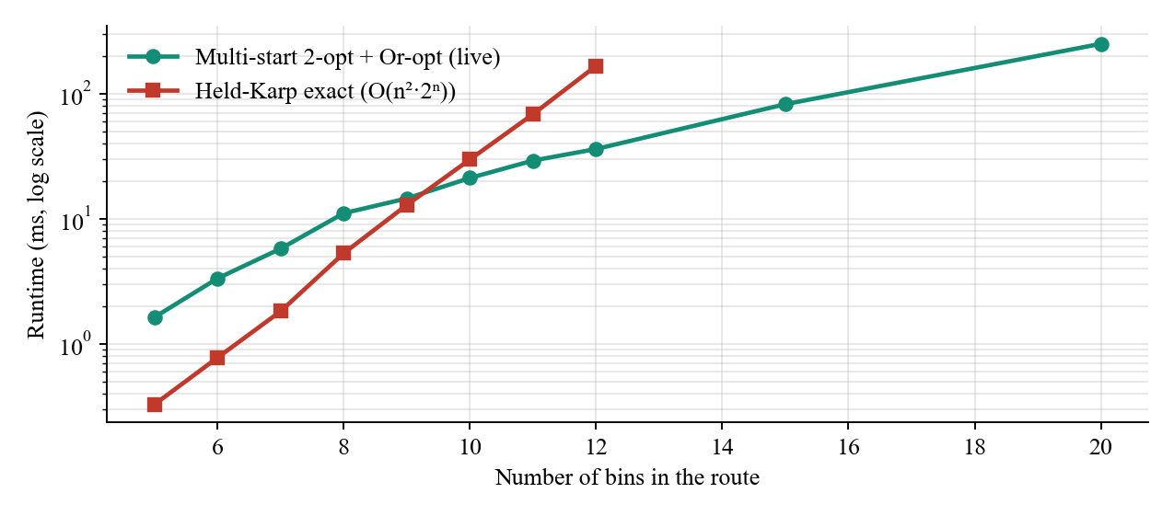
Figure 6.5: Runtime of the live heuristic versus the exact Held-Karp solver

6.1.4 Scenario tests
Table 6.4: Behaviour under the scenario tests
Scenario | Observed system behaviour
Slide-13 example event | Bins forced to 96% and nearest truck at 20% spare capacity. JEV logged “Constraint detected: nearest truck can take only 400 kg but the route needs 935 kg” and assigned another truck.
Fire injection | FIRE alert at 65 °C within one reading; the Waste Agent forces the bin to HIGH and an event-triggered cycle dispatches a truck.
Sensor spike | +37% jump quarantined as SENSOR_SPIKE; the bin is not dispatched on false data.
Tamper | −42% drop with no collection event raised a TAMPER alert; real pickups never raised one, thanks to the stream–stream join.
Truck breakdown | TRUCK_BREAKDOWN alert released 6 stops; the next event-triggered cycle re-assigned them to other trucks.
Demand spike / surge | Telemetry rate unchanged, fill rates ×1.8 / ×4; more HIGH bins, more routes, lag still 0.
Kafka Lab broker kill | Leaders of affected partitions re-elected from the ISR; with acks=all and min.insync=2 no data was lost.
Ward event surge | Yelahanka rose to rank 1 in the hotspot table (+106%, SURGE) and turned red on the heat map; JEV routed trucks there.
Operator route dispatch | 10 urgent bins chosen on the Route Optimizer: the live heuristic matched the exact optimum, about 50% shorter than the selection order; the dispatched plan was driven by the truck.

6.2 Discussion
Were the objectives met? PREDICT is met: bins are prioritised by forecast ETA, and the EDA example of a fast-filling 78% bin outranking a slow 92% bin is reproduced by the score. OPTIMIZE is met: at a comparable distance (within 3%), WASTEX delivers far fewer overflows and lifts. RESPOND is met: alerts trigger decisions within one simulated minute, and breakdowns and capacity constraints are re-planned automatically. SCALE is met: per-bin keyed partitioning lets the stream processor scale out by adding consumers, as demonstrated in the Kafka Lab, and lag stayed at zero during surges. EXPLAIN is met: each decision is an ordered, inspectable trace.
Significance. The results show that the value of streaming comes from acting on rates and forecasts rather than on levels. A fixed schedule must over-collect to avoid overflow, because it cannot know which bins will fill first. A data-driven policy spends the same kilometres where they matter.
Unexpected outcomes. (i) The first tuning sent trucks to the periphery plants after every small route, which made WASTEX drive twice as far as the baseline. Introducing a 75% disposal threshold and a batching rule fixed this. (ii) The anomaly detector initially quarantined the demonstration's own forced 96% readings as sensor spikes. This confirms the detector works, and a controlled operator override was added for the demo. (iii) Alerts sometimes overtook their bin-analytics record because they travel on another topic. JEV now folds the alert's facts into its bin table before deciding. (iv) Utilisation-aware plant choice still concentrated deliveries on KCDC, the plant closest to the eastern wards, which stays well within its capacity.
Limitations. Road distance uses a circuity factor instead of a full OpenStreetMap graph. Telemetry is synthetic, although it is calibrated to the EDA. The fleet does not model crew shifts or fuel. Kafka runs as a single broker in Docker, while replication is demonstrated in the Kafka Lab.

Chapter 7
Conclusion
This chapter summarises what was built and what the evaluation shows.
WASTEX demonstrates a complete, working stream-processing system for smart waste collection in Bengaluru. Synthetic but realistic IoT telemetry, anchored to real ward, DWCC, plant and landfill data, is streamed through Apache Kafka with a deliberate topic, key and consumer-group design. Stateful operators turn the raw readings into fill rates, overflow forecasts, anomaly alerts and windowed zone statistics. A multi-agent layer then answers what to collect, how and with which truck, re-planning adaptively when constraints such as a nearly full truck or a breakdown make a plan infeasible. Collection events feed back into the stream, closing the loop.
Compared with the current fixed schedule on an identical simulated city, WASTEX cut overflow bin-minutes by 92.8% and overflow events by 75.8%. At a comparable distance to doubling the schedule, it still produced 83.4% less overflow with 41.8% fewer bin lifts. On the live Kafka deployment all consumer groups ran with zero lag and decisions took milliseconds. The dashboard and the Kafka Lab make every stage observable and explainable, which turns the project into a practical decision tool as well as a teaching aid for stream processing concepts.

Chapter 8
Future Enhancements
This chapter lists extensions that would take WASTEX from a laboratory system towards a city deployment.
- Road-graph planning: use the OSRM / OpenStreetMap distances (today used for display on the Route Optimizer) inside the planner itself, with live traffic feeds.
- Learned forecasting: LSTM or GRU models trained on historical fill data, served as a stream operator, to forecast beyond linear trends.
- LLM-assisted orchestration: a language model in JEV that explains plans in natural language and negotiates trade-offs, while routing and feasibility stay in the deterministic tools, as recommended by [2, 3, 15, 16].
- Kafka Streams / Flink deployment of the processor with exactly-once semantics and a multi-broker cluster (RF = 3).
- Real sensors over MQTT bridged to Kafka (MQTT source connector), with edge pre-filtering on the bin.
- Crew, shift and fuel constraints, multi-depot VRP with time windows, and electric-vehicle charging.
- Citizen feedback loop: complaints from the BBMP app streamed as events that raise a ward's priority in real time.
- Waste segregation analytics (wet/dry/recyclable) to route loads to the right processing facility.

Appendix
Appendix A – Running the project
- Install Python 3.10+ and (optionally) Docker Desktop.
- Double-click start.bat. It installs dependencies, starts Kafka and Kafka UI in Docker, waits for the broker to be healthy and launches WASTEX at http://127.0.0.1:8000 (Kafka UI at http://localhost:8080).
- Without Docker, run start-embedded.bat; the embedded Kafka-compatible broker is used.
- python -m backend.benchmark reproduces Table 6.2; python docs/build_report.py regenerates this report.
A companion document, docs/VIVA_QUESTIONS.md, answers 45 likely examiner questions on Kafka, stream processing, the agents, route optimisation and the evaluation, each linked to the part of the dashboard that demonstrates it.
Appendix B – Sample messages
bin-telemetry record
{
"bin_id": "BIN-0104",
"zone_id": "Z01",
"zone": "Indiranagar",
"lat": 12.97412,
"lon": 77.64561,
"bin_type": "SMART-1100",
"capacity_l": 1100,
"max_kg": 260,
"fill_level": 94.12,
"weight_kg": 231.7,
"temperature_c": 31.4,
"battery_pct": 74.6,
"ts": "2026-11-03T08:41:00",
"sim_min": 101.0,
"scenario": "normal",
"seq": 101
}

collection-plans record (abridged)
{
"plan_id": "PLAN-00008",
"decision_id": "JEV-00007",
"truck_id": "TRUCK-08",
"truck_type": "Mini Tipper",
"mode": "new",
"stops": [
{
"bin_id": "BIN-0201",
"priority": "HIGH",
"fill_level": 96.0,
"est_kg": 274.6
},
{
"bin_id": "BIN-0202",
"priority": "HIGH",
"fill_level": 97.0,
"est_kg": 660.4
}
],
"dispose": true,
"plant": {
"id": "PLT6",
"name": "KCDC"
},
"distance_km": 14.33,
"duration_min": 52.0,
"load_kg": 935.0
}

Appendix C – Key configuration parameters
Table A.1: Configuration parameters
Parameter | Value
Planning interval | 5 simulated minutes + event triggers
Fill-rate window | 10 readings, EWMA α = 0.6
Zone window | 5-minute tumbling
Priority thresholds | HIGH ≥ 0.65, MEDIUM ≥ 0.45
Critical fill | 95.0%
Max re-plan attempts | 3
Road circuity / service / unload | 1.35 / 3.0 min / 15.0 min
Disposal threshold | 75% of truck capacity
CO2 factor | 0.95 kg/km
Random seed | 42

Bibliography
[1] Zhu et al., “Edge AI Agent Design for Policy-Aware Urban Waste Management,” AIAS 2025, EPiC Series in Computing, 2025.
[2] Li et al., “ARS: Automatic Routing Solver with Large Language Models,” arXiv:2502.15359, 2025.
[3] Zhang and Cao, “An Agentic Framework with LLMs for Solving Complex Vehicle Routing Problems,” arXiv:2510.16701, 2025.
[4] Alaoui, Belhiah and Ziti, “IoT-Enabled Waste Management in Smart Cities: A Systematic Literature Review,” IJACSA, vol. 16, no. 4, 2025.
[5] Ishaque and Florence, “Intelligent Deep Learning-Based Classification with Vehicle Routing for MSW Management,” J. Hazardous Materials Advances, vol. 18, 2025.
[6] Reji et al., “Solid Waste Management System Based on IoT Using Swin Transformer with Ant Colony Optimization,” Global NEST Journal, vol. 27, no. 3, 2025.
[7] Gatti, Barbierato and Pozzi, “Toward Greener Smart Cities: A Critical Review of Classic and ML-Based Algorithms for Smart Bin Collection,” Electronics, vol. 13, no. 5, 2024.
[8] Ali et al., “IoT-Assisted Vehicle Route Optimization for Municipal Solid Waste Collection,” Applied Sciences, vol. 14, no. 1, 2024.
[9] Addas, Khan and Naseer, “Waste Management 2.0: Leveraging IoT for an Efficient and Eco-Friendly Smart City Solution,” PLoS ONE, vol. 19, 2024.
[10] Belhiah, El Aboudi and Ziti, “Optimising Unplanned Waste Collection: An IoT System in Tangier,” IET Smart Cities, vol. 6, no. 1, 2024.
[11] Hussain et al., “Comparative Analysis of Waste Management Models in IoT-Enabled Environments Using Multiagent Simulation,” Sustainable Cities and Society, vol. 103, 2024.
[12] Kona and Subramoniam, “Smart IoT-Based Waste Management with Shortest-Path Routing and DCNN Visit Decisions,” Peer-to-Peer Networking and Applications, vol. 17, no. 3, 2024.
[13] Sankar and Fathima, “IoT-Enabled Smart Waste Management: Sensor Technologies and Implementation Strategies,” Proc. ICICT, 2024.
[14] Çil et al., “Enhancing MSW Management Efficiency Through Clustering: A Case Study,” Taylor & Francis, 2024.
[15] Huang, Shi and Sukhatme, “From Words to Routes: Applying Large Language Models to Vehicle Routing,” arXiv:2403.10795, 2024.
[16] Xiao et al., “Chain-of-Experts: When LLMs Meet Complex Operations Research Problems,” ICLR, 2024.
[17] Miletić et al., “A Data Streaming Architecture for Air Quality Monitoring in Smart Cities,” 2023.
[18] Mishra, “Cloud-Based Smart Waste Management Using IoT and Predictive Analysis,” MSc thesis, National College of Ireland, 2023.
[19] Ahmed et al., “Forecasting the Status of Municipal Waste in Smart Bins Using Deep Learning,” IJERPH, vol. 19, no. 24, 2022.
[20] Vonitsanos et al., “An Apache Spark Framework for IoT-Enabled Waste Management in Smart Cities,” ACM, 2022.
[21] Salehi-Amiri et al., “Designing an Effective Two-Stage, Sustainable, and IoT-Based Waste Management System,” Renewable and Sustainable Energy Reviews, vol. 157, 2022.
[22] Anjum, Shahab and Umar, “Smart Waste Management Paradigm in Perspective of IoT and Forecasting Models,” Int. J. Environment and Waste Management, vol. 29, no. 1, 2022.
[23] Al Duhayyim et al., “Deep Reinforcement Learning Enabled Smart City Recycling Waste Object Classification,” CMC, vol. 71, no. 3, 2022.
[24] Vishnu et al., “IoT-Enabled Solid Waste Management in Smart Cities,” Smart Cities, vol. 4, no. 3, 2021.
[25] Aktemur, Erensoy and Kocyigit, “Optimization of Waste Collection in Smart Cities with Evolutionary Algorithms,” HORA, 2020.
[26] Apache Software Foundation, “Apache Kafka Documentation 3.7,” https://kafka.apache.org/documentation/.
[27] J. Kreps, N. Narkhede and J. Rao, “Kafka: A Distributed Messaging System for Log Processing,” NetDB Workshop, 2011.
[28] OpenCity / BBMP, “Bengaluru Solid Waste Management datasets (DWCC, processing plants, landfills, ward complaints),” https://opencity.in.

