**PIR(passive infrared sensor) Motion Detector**

**Description**: In this project, we will make a PIR(**passive infrared sensor**) motion sensor which detect the motion of an object.

**Hardware requirement**:

* Arduino uno board
* Breadboard
* Jumper wire
* PIR motion detector sensor
* A LED light/Buzzer

**PIR Sensor:**

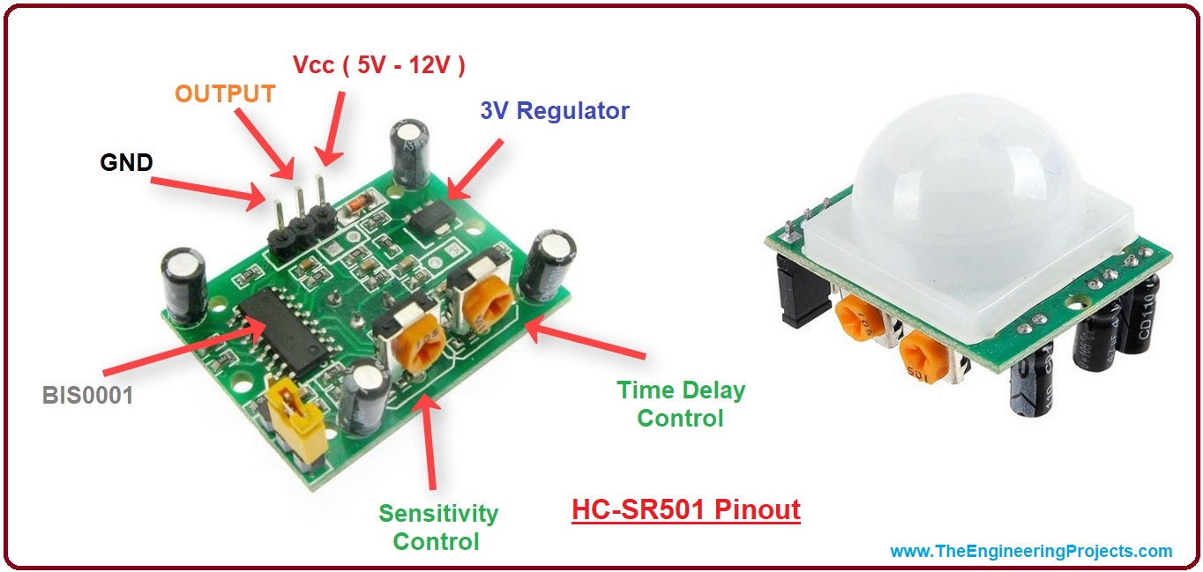

**Connection**:

* PIR’s output terminal connected to Arduino’s pin:4
* LED’s anode terminal connected to Arduino’s pin:8

**CIRCUIT**:

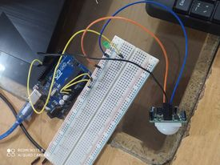

**After closing hands To the projects:**

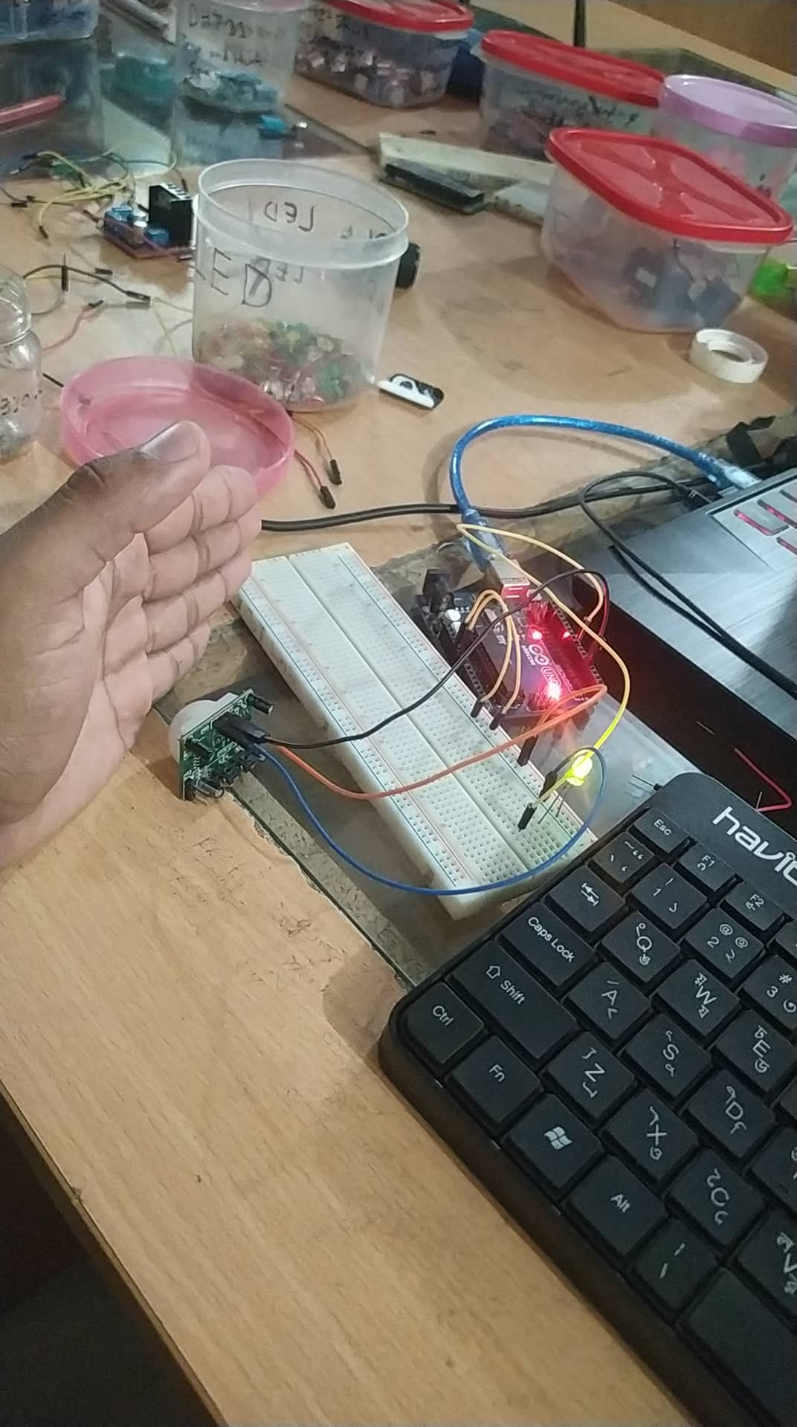

**Code**:

|  |
| --- |
| int pir=4; int buzzer=8;   void setup() {   // put your setup code here, to run once: pinMode(pir,INPUT); pinMode(buzzer,OUTPUT); Serial.begin(9600); }   void loop() {   // put your main code here, to run repeatedly: int state; state= digitalRead(pir); digitalWrite(buzzer,state); Serial.println(state); delay(1000); } |