***Connecting TFT 1.8 display to NodeMcu ESP8266***:

1st of all connect the tft display through the direction:

* D8 -> CS
* D7 -> SDA
* D5 -> CSK
* D4. -> A0
* D3 -> RESET
* Vcc -> 3.3V
* Led -> 3.3V
* GND -> GND

Circuit Connection:

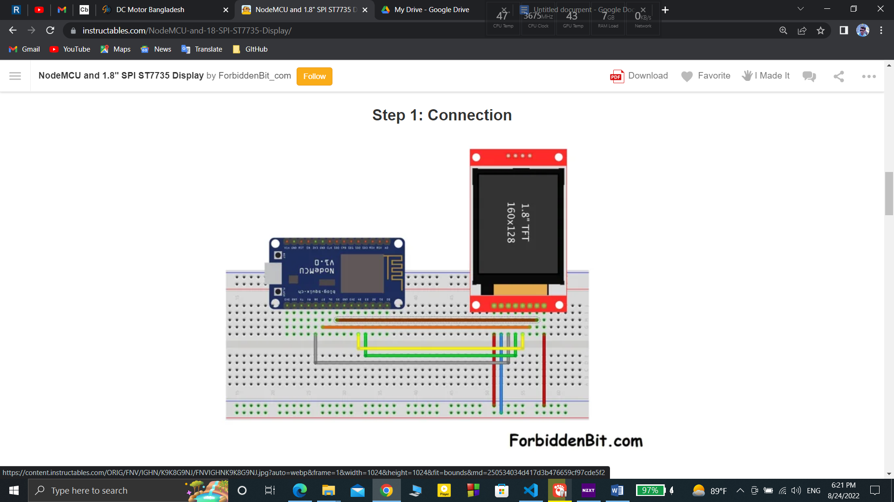

Then upload the code :

|  |
| --- |
| *  ForbiddenBit.com *   *  NodeMCU and Display ST7735 */   //  --------  Libraries required to use the Display  --------------- #include <Adafruit_GFX.h>    #include <Adafruit_ST7735.h> #include <SPI.h>   // -----------  Display pins  -------------------------------------- #define TFT_CS     15       #define TFT_RST        0 #define TFT_DC     2   void setup() {      Adafruit_ST7735 tft = Adafruit_ST7735(TFT_CS, TFT_DC, TFT_RST); //Those things are for the display   tft.initR(INITR_GREENTAB);       // --------  TEST TEXT  -------------------------------------------    tft.fillScreen(ST77XX_BLACK);   tft.setTextWrap(false);   tft.setCursor(45, 5);    //Horiz/Vertic   tft.setTextSize(2);   tft.setTextColor(ST77XX_YELLOW);   tft.print("USA");     tft.setCursor(15, 25);    //Horiz/Vertic   tft.setTextSize(1);   tft.setTextColor(ST77XX_WHITE);   tft.print("COVID-19 Tracker");     tft.setCursor(5, 45);    //Horiz/Vertic   tft.setTextSize(2);   tft.setTextColor(ST77XX_BLUE);   tft.print("Cases:");   tft.setCursor(10, 65);   tft.print("929,637");       tft.setCursor(5, 93);    //Horiz/Vertic   tft.setTextSize(2);   tft.setTextColor(ST77XX_GREEN);   tft.print("RECOVERED:");   tft.setCursor(15, 115);   tft.setTextColor(ST77XX_WHITE);   tft.print("110,504");       tft.fillRect(0, 138 , 48, 10, ST77XX_WHITE);   tft.setCursor(7, 140);    //Horiz/Vertic   tft.setTextSize(1);   tft.setTextColor(ST77XX_BLACK);   tft.print("DEATHS:  ");   tft.setCursor(55, 140);   tft.setTextColor(ST77XX_WHITE);   tft.print("52,838"); }   void loop() { } |

After uploading the Code we can see the display:

