***Bioserver Implementation Lab Project***

*Team members:*

* Adham Ebrahim – 20178013.
* Nadeen Tarek – 20178043.
* Ibrahim Adel – 20178001.
* Yomna Ayman – 20178050.
* Reham Alaa – 20168002.

*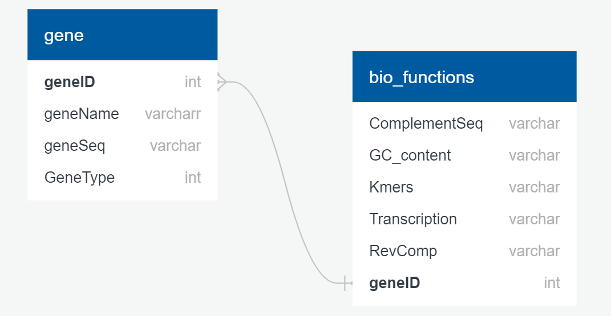Database schema:*

*Implemented biological functions:*

1. **DNA Transcription;** It’s the process of making an RNA copy of a gene sequence. This copy, called a messenger RNA (mRNA) molecule, leaves the cell nucleus and enters the cytoplasm, where it directs the synthesis of the protein, which it encodes.
2. **DNA/RNA Complement;** It’s interchanging **Adenine (A)** and **Thymine (T)** while interchanging **Cytosine (C)** and **Guanine (G)** in DNA. In RNA, it’s interchanging **Adenine (A)** and **Uracil (U)** while interchanging **Cytosine (C)** and **Guanine (G).**
3. **DNA/RNA Reverse Complement;** The reverse complement of a DNA sequence is formed by reversing the letters, interchanging A and T and interchanging C and G. Thus the **reverse complement** of ACCTGAG is CTCAGGT. The applies on RNA but we interchange Adenine(A) and Uracil(U).
4. **G-C Content (or guanine-cytosine content);** It’s the percentage of nitrogenous bases in a DNA or RNA molecule that are either guanine (G) or cytosine (C). The content of a primer should be 40%-60%.

**The formula**: Count(G + C) / Count(A + T + G + C) * 100%.

1. **Most frequent K-mer;** The term K-mer refers to a string of length K. The goal is to find out the number of occurrences of each string to know which is the most frequent one. It’s an important step in many bioinformatics applications that are used to analyze sequencing data.

*Database manipulation:*

Entering the sequence, its ID and name and choosing its type.

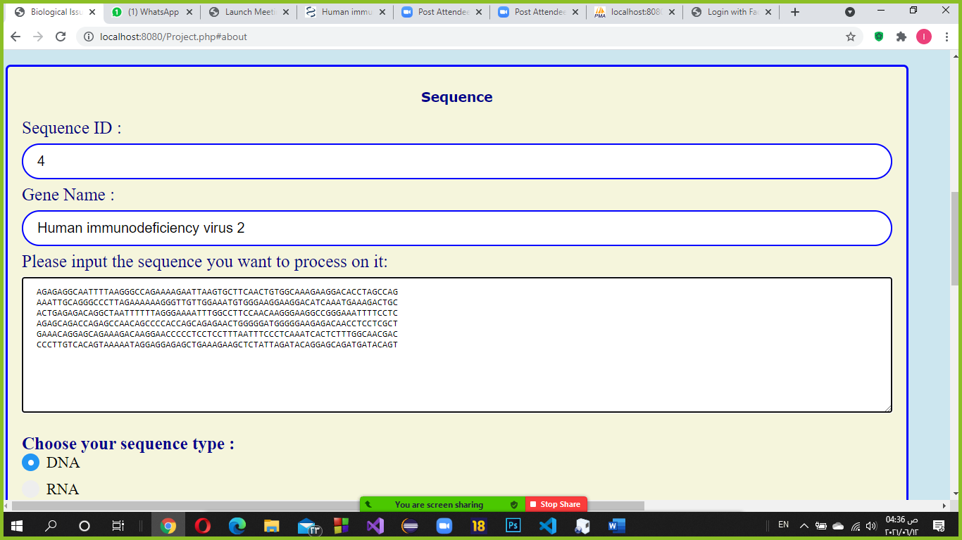

Choosing the functions we want to apply on the entered sequences then submitting it into the database.

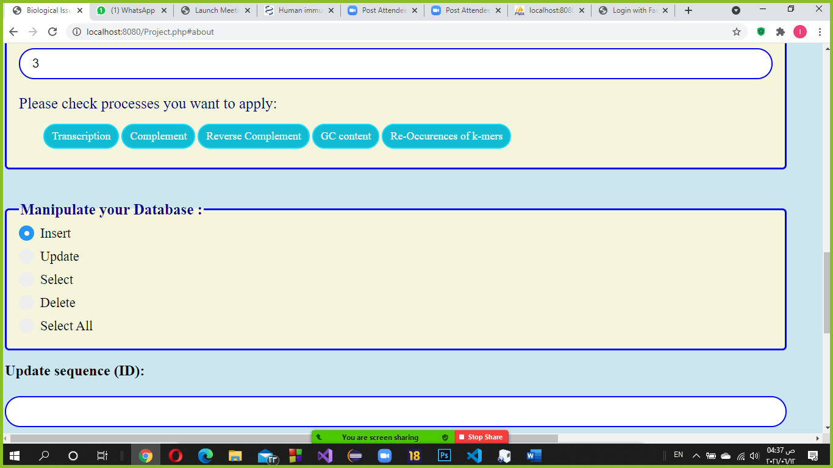

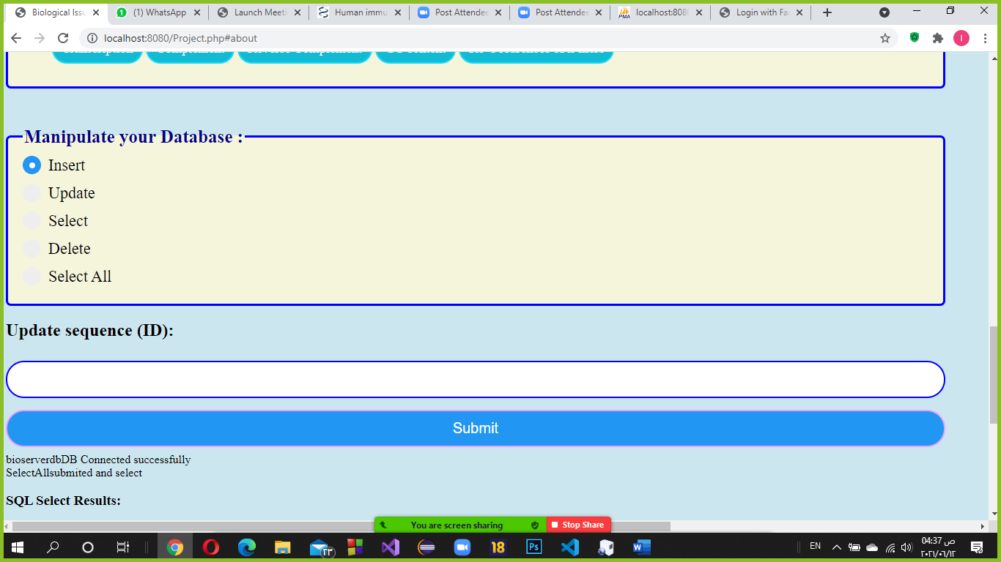

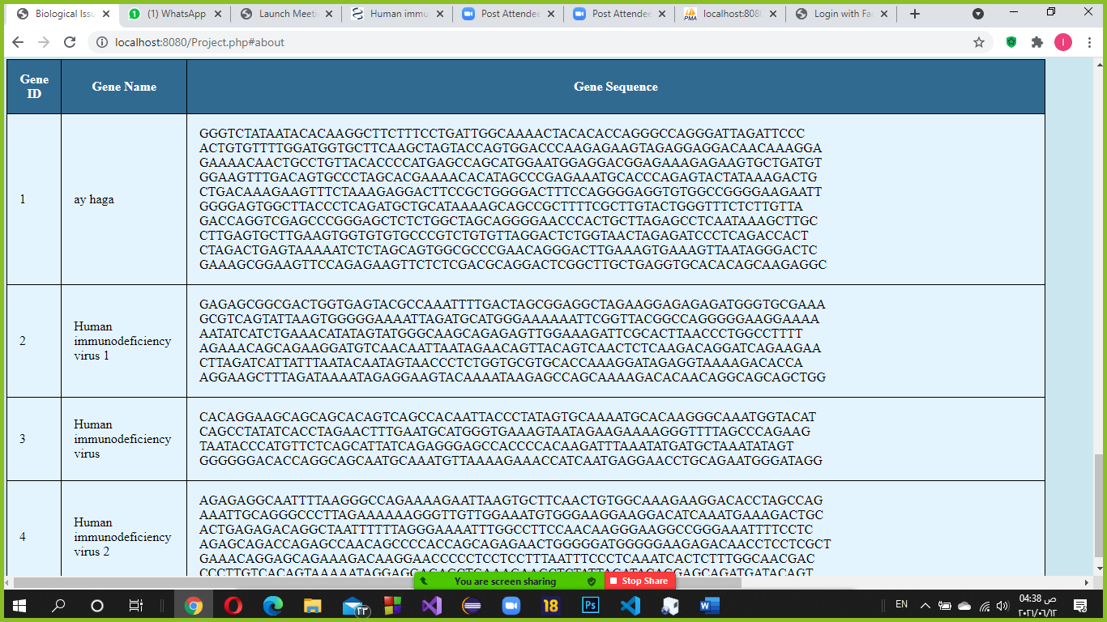

Updating the name of the first row of the database whose ID is 1.

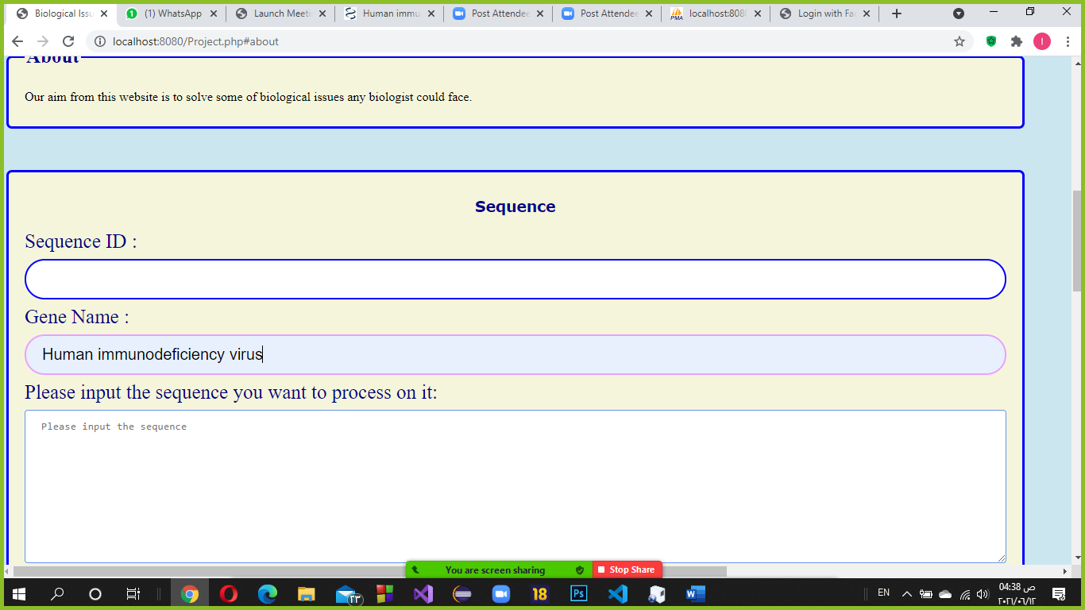

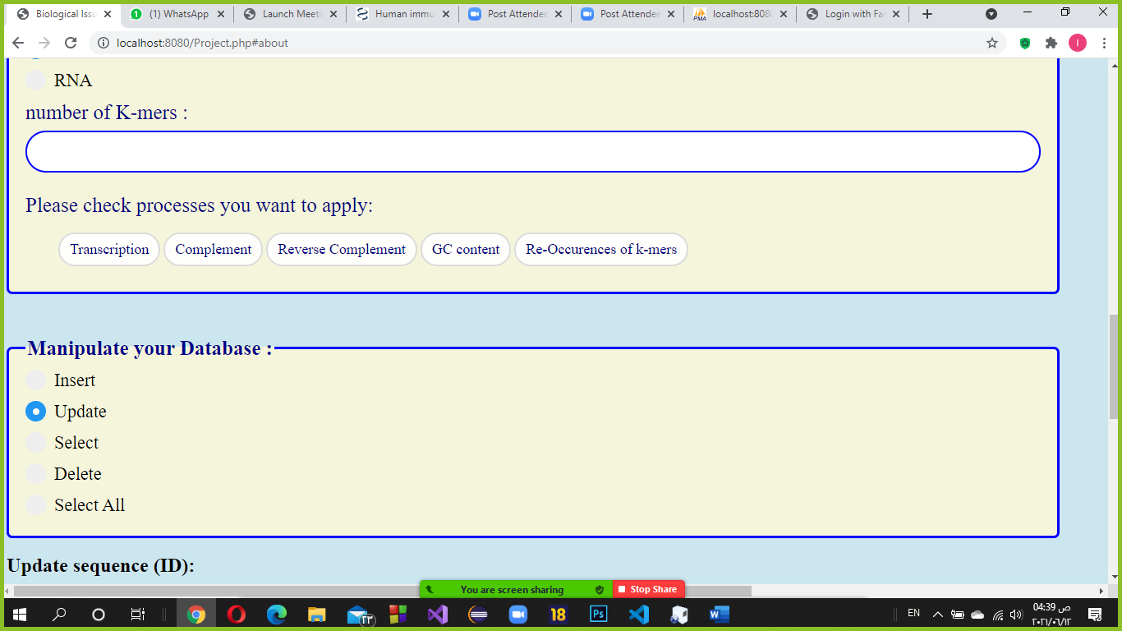

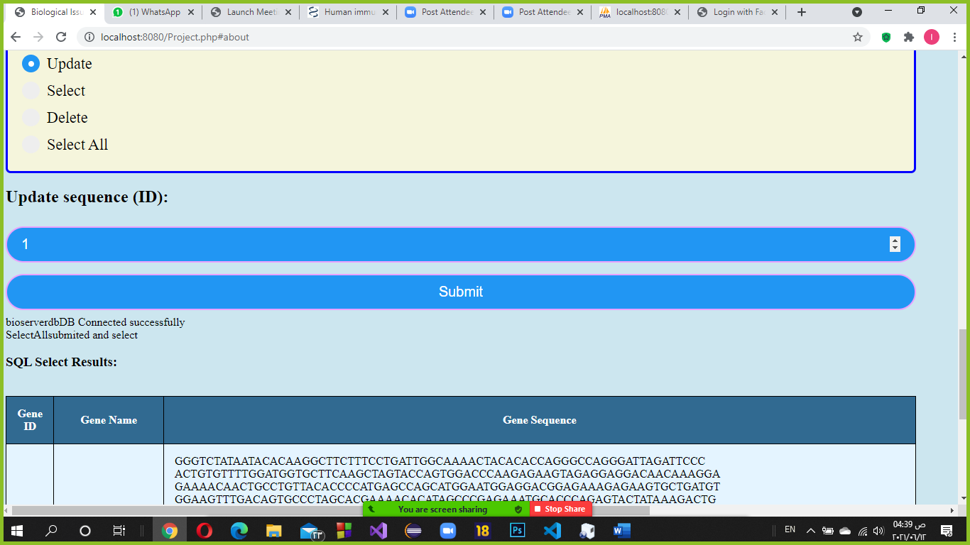

Choosing “Select All” to display all the rows after the update.

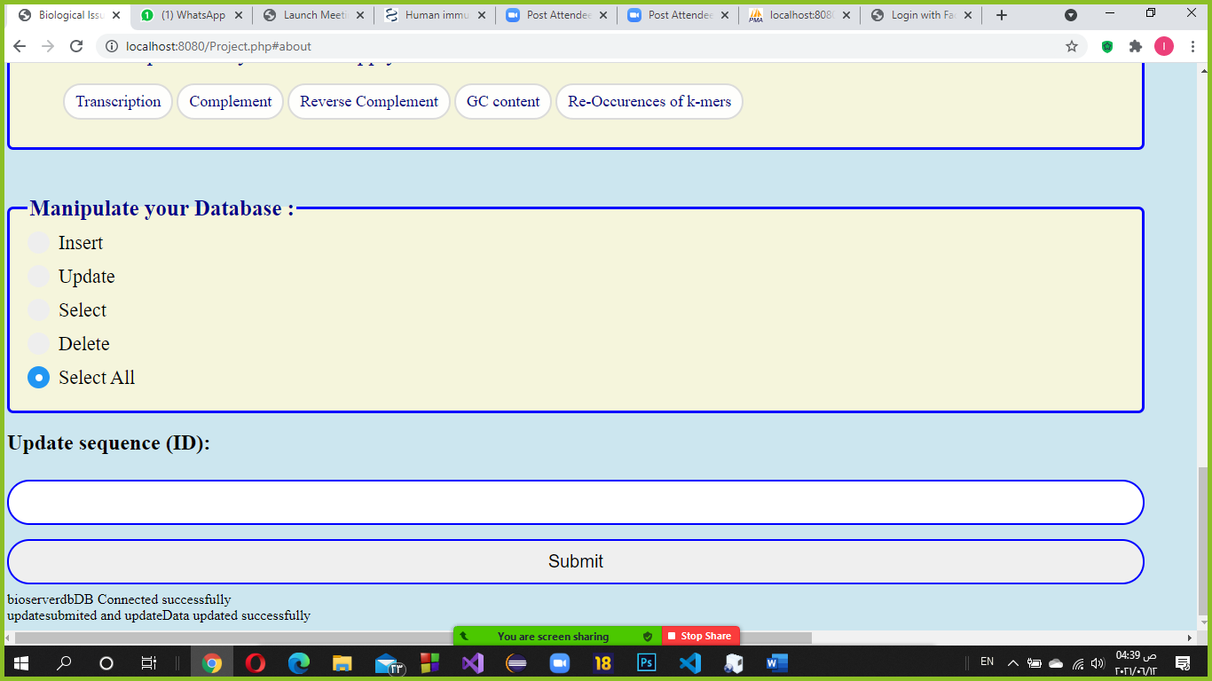

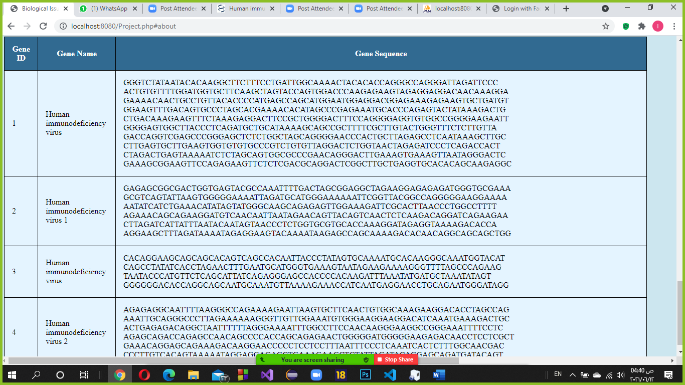

Choosing the gene that we want to display its output after applying the biological issues functions by its ID.

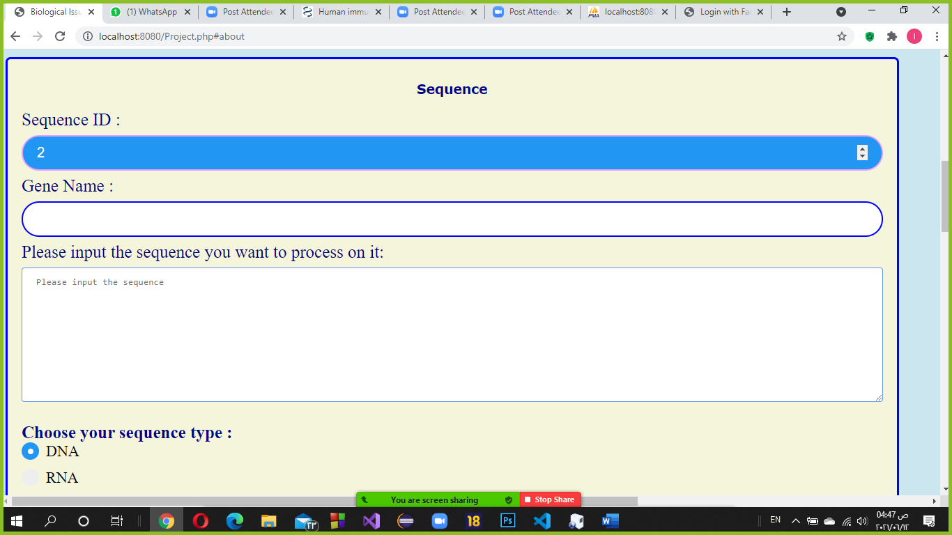

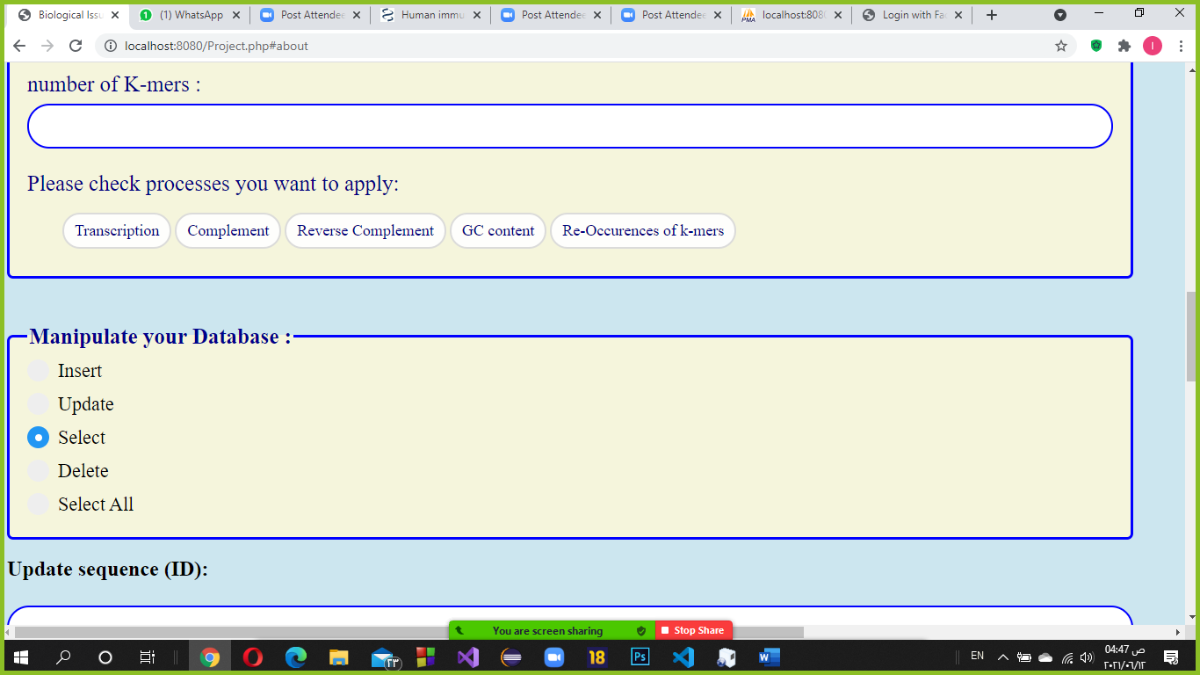

The outputs.

