Electronic Technologies Engineering

Telecommunications Project 243-699 Winter 2023

Security level based lock

Quality Inspection Report

Prepared By: Ibrahim Elyadini

Date: May 10th, 2023

# Compliance Statement

## Overview

The overall compliance to our original Contact and Planning document is captured module by module in the following sections.

|  |  |
| --- | --- |
| Module | Verified Compliance |
| RFID module | Pass |
| Tone detection module | Pass |
| Keypad module | Pass |
| Power module | Pass |
| Wireless transfer module | Pass |

**Table 1.1.1**

## Deviations from Contract

The project has deviated slightly from the original plan. The most significant change was the removal of the PLL. A new Arduino nano was also added in order to analyze the tone frequency as well as send information wirelessly. There was also the addition of 2 LCD display.

# Compliance Testing

The following parameters or functionality have been verified by Analysis (A) , Demonstration ( D) or Test (T).

The RFID module was verified through demonstration by showing the functionality of the module as well as reading the outputs from the I/O ports as well as the serial communication tab.

The tone detection module was verified through demonstration of the module and test of the output of the microphone circuit with an oscilloscope and comparing measured results with expected results from prior analysis on Multisim.

The keypad module was verified through demonstration of the module by inputting the correct numbers in the right sequence and waiting for the appropriate LED to light up.

The power module was verified through analysis of the current drawn and compared with the expected value as well as demonstration by letting it run for a period of 30 minutes (solenoids were off for a majority).

The wireless transfer module was verified through testing and recording the output from a spectrum analyzer using an antenna.

## Wireless transfer module

The wireless transfer module is situated between the Microphone circuit and the output and is only working when the microphone circuit detects the right frequency and will act following this flowchart:

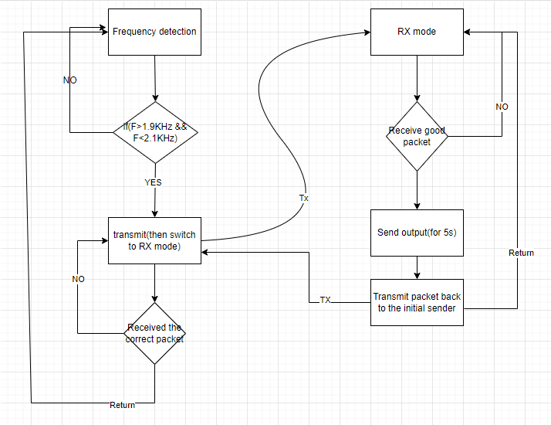

For this test, I just showed the transmission of the Tx signal and Rx signal

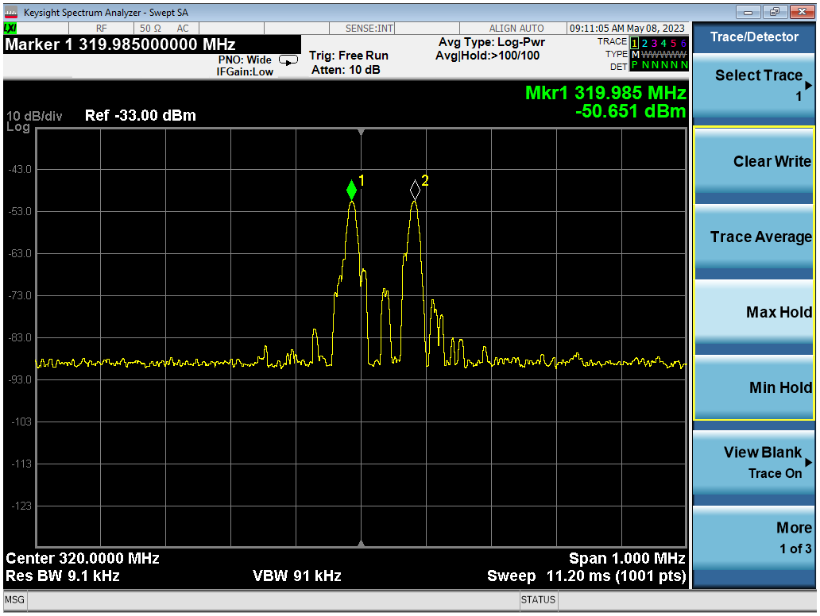

***Figure 2.1.3***

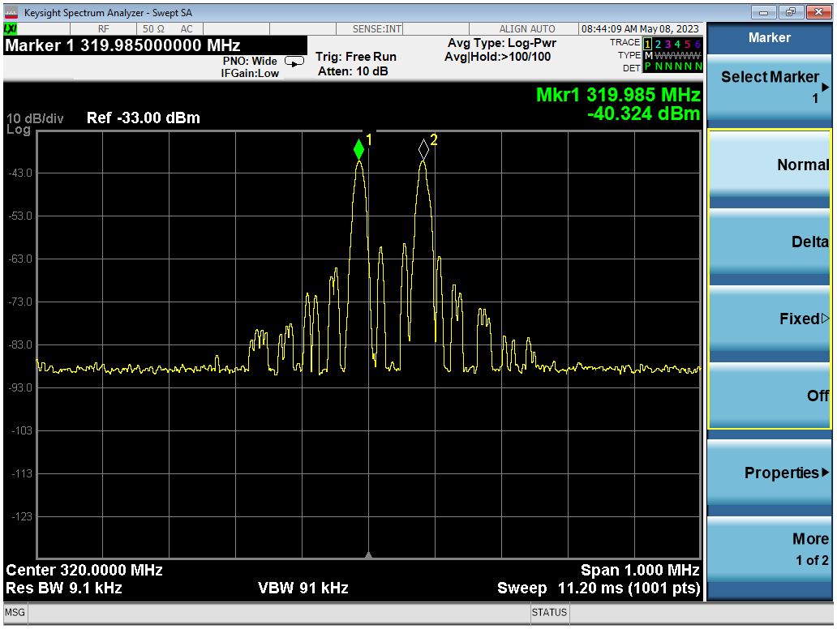

***Figure 2.1.4***

Given this spectrum analyzer capture we can conclude that the module is behaving as expected. All measurements are within specification and.

Power levels are also acceptable.

This module Passes inspection.

## RFID module

This module scan RFID tags as well as a master key card, and can grant authorized user access as well as deny them.

Here is the flow chart of the operation of this module:

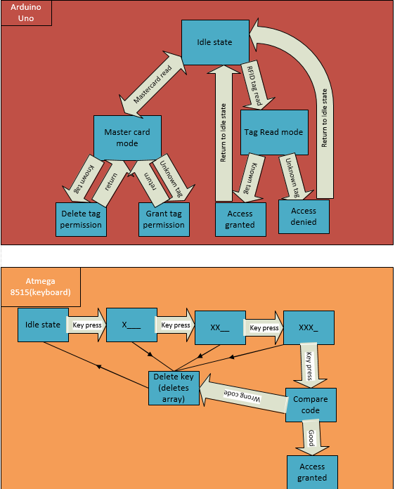

***Figure 2.2.1***

Prototype circuit that was used

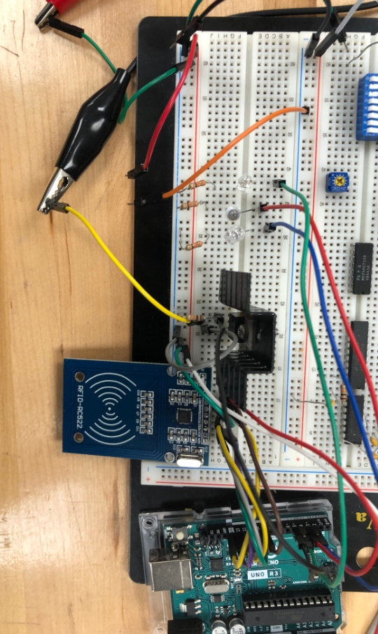

***Figure 2.2.2***

This module was shown to be working properly by demonstration of the application and works 100% of the time.

This module passes inspection.

## Keypad Module

This module reads input from a keypad and compares the inputted code with the correct code and grants access when they match.

Here is the flow chart of the operation of this module:



***Figure 2.3.1***

Prototype circuit that was used

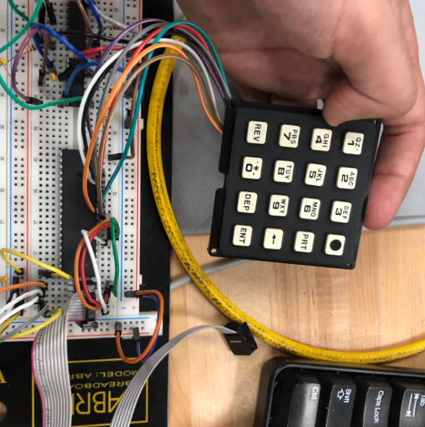

***Figure 2.3.2***

This module was shown to be working properly by demonstration of the application and works 100% of the time.

This module passes inspection.

## Tone detection module

This module reads input from a microphone that gets amplified and compares the measured frequency with a range of frequency that lets the user get access.

Here is the flow chart of the operation of this module:

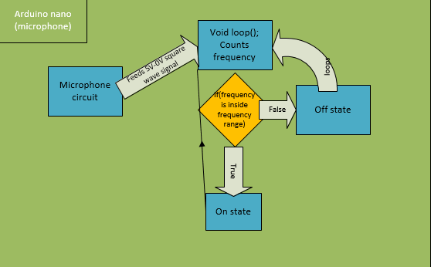

***Figure 2.4.1***

Prototype circuit that was used

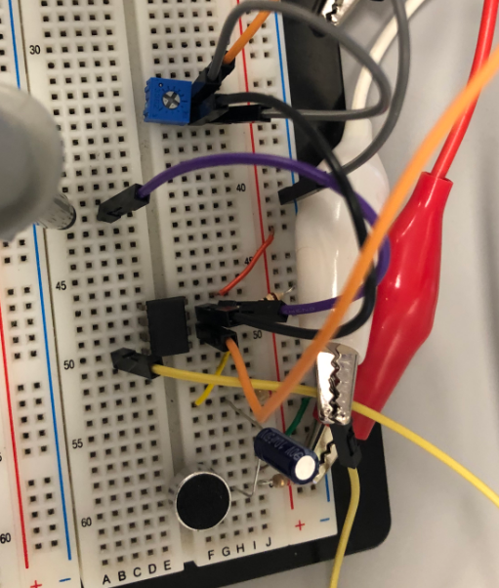

***Figure 2.4.2***

This module was shown to be working properly by demonstration of the application and works 100% of the time.

This module passes inspection.

## List of Equipment used for testing

-Spectrum analyzer

-Antenna

-Oscilloscope

-Probes

-DMM