**DOKUZ EYLUL UNIVERSITY**

**ENGINEERING FACULTY**

**DEPARTMENT OF COMPUTER ENGINEERING**

**CME2204 ALGORITHM ANALYSIS**

**Assignment 2**

REPORT

**By**

**İbrahim İsmail Erhan**

**2015510026**

**29.04.2018**

**Analysis and Explanations of CalculateOptimalInvest Function**

The recursive function that generates a tree order of investment number and it’s heigh is depend on planed year.

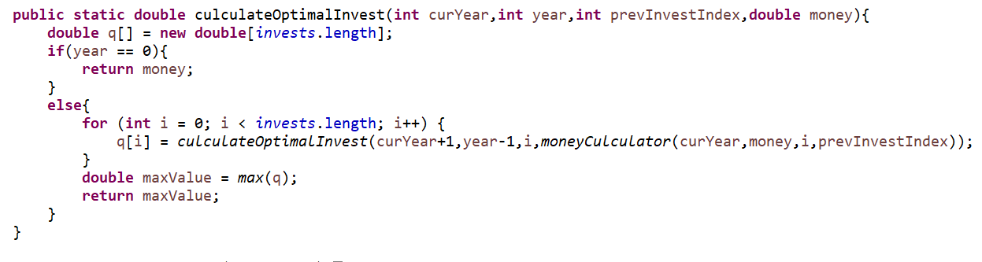

curYear : current year pointer that used in money calculation function.

year : recursive stop factor.

prevInvestIndex : points the previous index to let money culculation funtion to decide to use of f1 or f2 values.

money : the money value initially scanned from consol.

**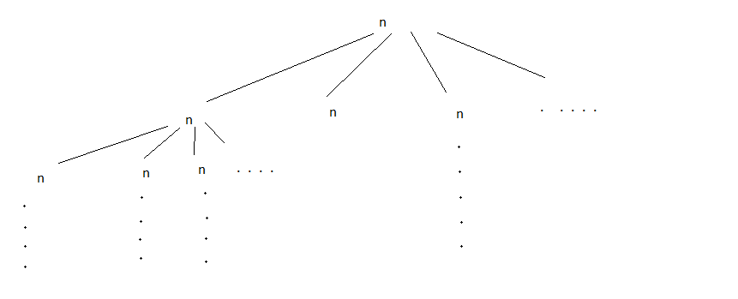*Complexsity Callculation;***

1

n x n

n x n x n

.

.

y : planed number of year

n : number of selected investments

complexsity -->> ***O(n^y)***