Networking

By Ibrahim Gunsever

Debian: Sudo Apt install net-tools

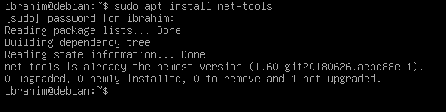

Sudo Apt install traceroute

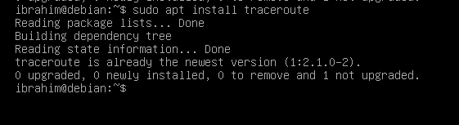

Since I already had traceroute and net-tools installed, nothing was changed. But if there was an update it would have been installed.

Sudo Apt install tcptrack

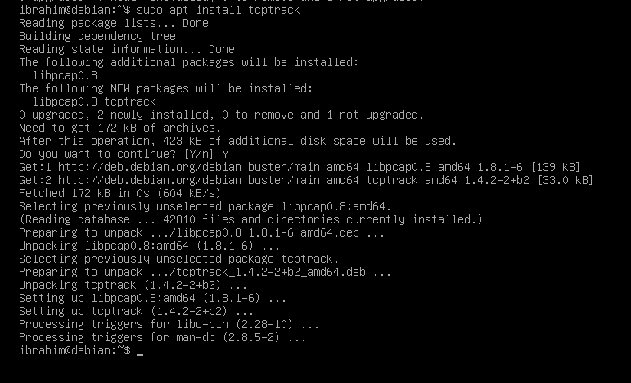

Now that everything is installed, I want to make sure my Debian server has a static IP address. To do this I run the “sudo ifconfig ens33 up” command to make sure the interface is active. You would replace ens33 with whichever interface name your server shows up as. Once that command is run you will need to run this command to set the static defaults: sudo ifconfig ens33 192.168.26.132 netmask 255.255.255.0 broadcast 192.168.26.255 . You can set these addresses to anything you desire, I just decided to keep the existing IP that it was set to.

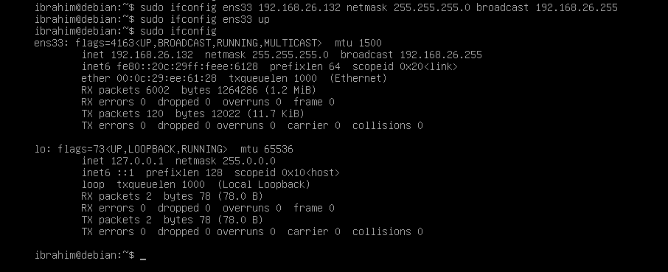

Then I install network manager and Wireshark on Debian using sudo apt install wireshark and sudo apt install network-manager

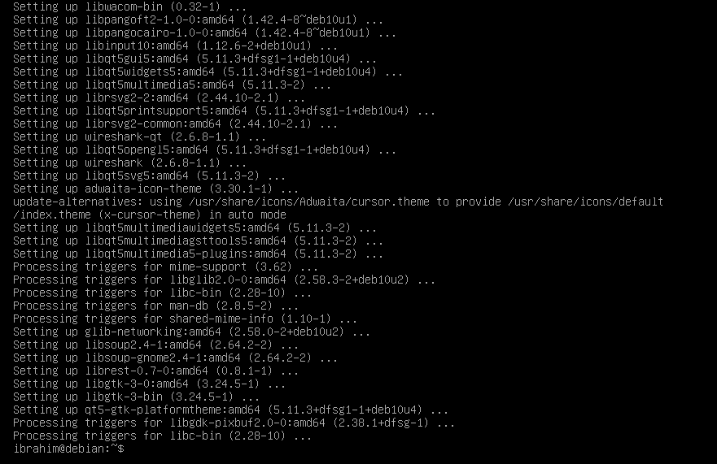

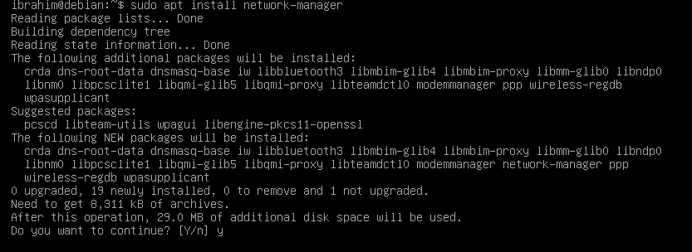

Cent OS:

Sudo yum install net-tools

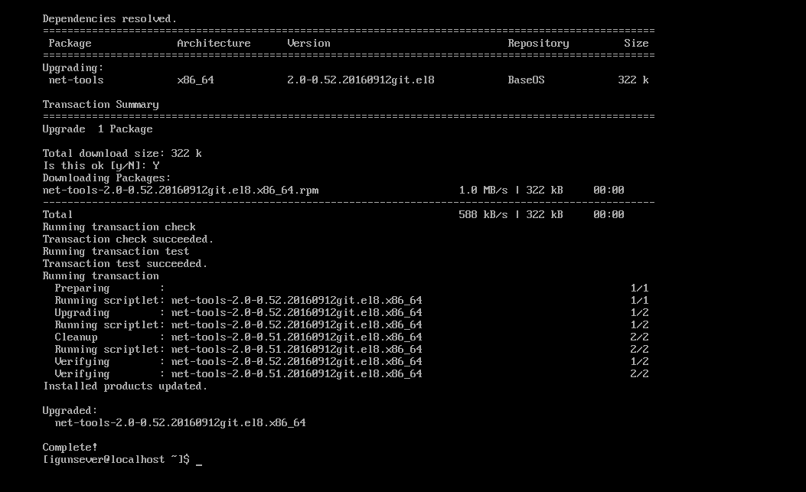

Sudo yum install traceroute

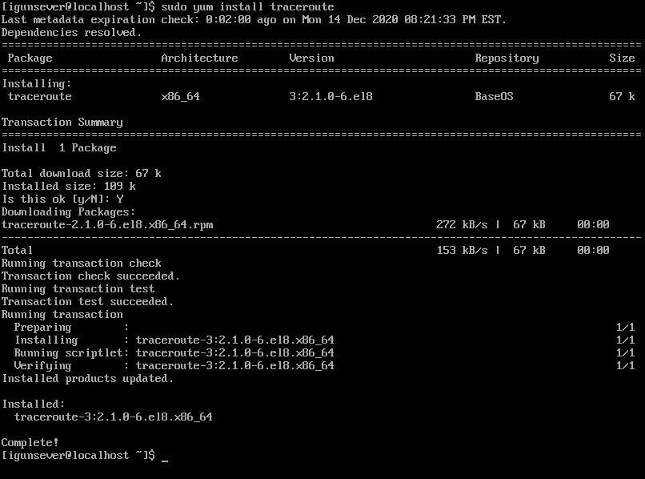

To make sure a static IP address was set up in cent os I ran the ifconfig -a command:

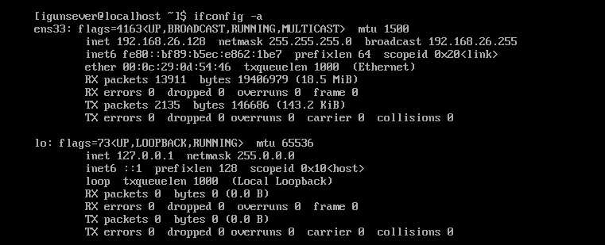

I then ran the command: sudo ifconfig ens33 192.168.26.128 netmask 255.255.255.0 broadcast 192.168.26.255. This command sets the static network info.

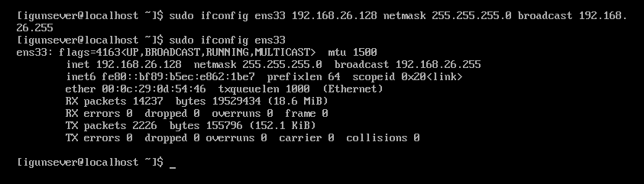

I then want to make sure network manager and wireshark is installed on CentOs.

When installing NetworkManager, Make sure to keep the capitalization or you may get an error that I received below. But to install the command is: sudo yum install network-manager

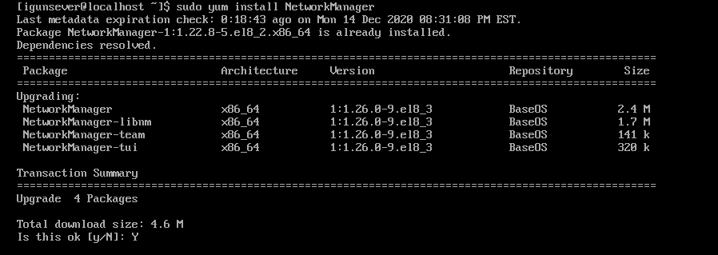

Then to install wireshark its sudo yum install wireshark

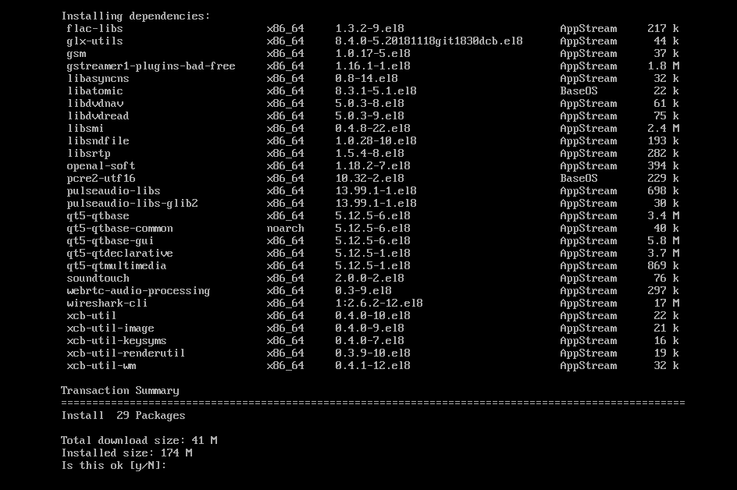

Network Scripts:

The scripts on both servers are called networkscript.sh .

To run the script head to the script directory and run the command ./networkscript.sh the results of the script will be directed to networkstatus.txt

If you are having issues executing the script then you may need to change the permissions to allow yourself to run a script:

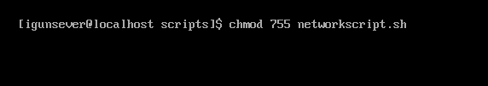

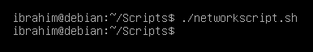

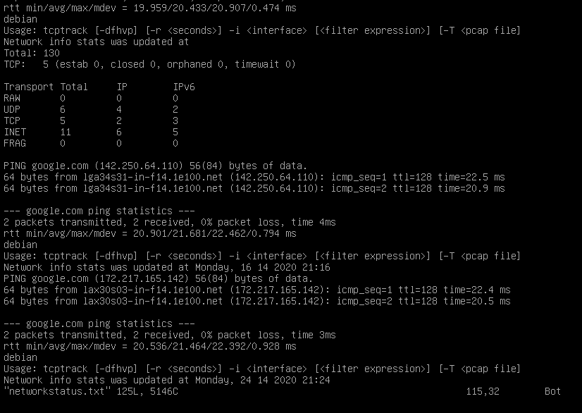

Script is located on my Git hub here: https://github.com/IbrahimG97/Linux-Admin/blob/master/networkscript.sh