Deliverable 4 – Prototype Model

Team Name: TechNova

Team Members
Name | ID | Role
Ahmed Mohamed Raed | 162023017 | Tester
Ahmed Salah Ahmed | 162023011 | Backend Developer
Ibrahim Hashem Mostafa | 162023002 | Project Manager
Al-Shimaa Ashraf Sayed | 162023041 | Frontend Developer
Amany Mahmoud Mohamed | 162023043 | Database Designer

Project Title
Library Management System

Prototype Description
This prototype shows the main pages of the Online Library Management System, including the Home page, Books Catalog, Cart, and Admin Panel.
it was created using Figma, showing basic layout and navigation

Screen Overview
Screen Name | Description | Key Elements
Home Page | Displays featured categories and Book. | Navigation bar, search bar, banner images.
Product Page | Shows Book details, History and “Add to Cart” button. | Book image, Author’s Name, price.
Cart Page | Lists selected Books and allow checkout. | Book summary, quantity, total price, checkout button.

4. Prototype Screenshots / Sketches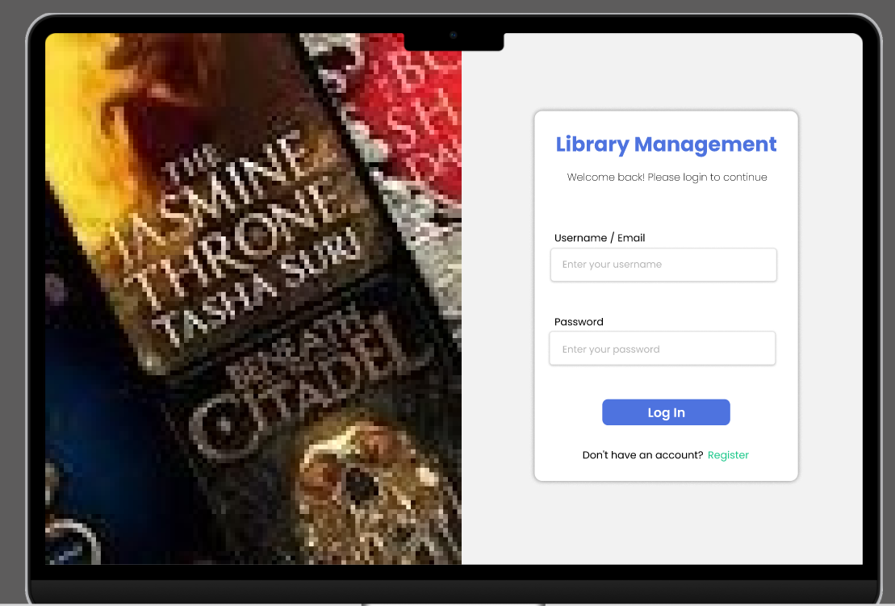 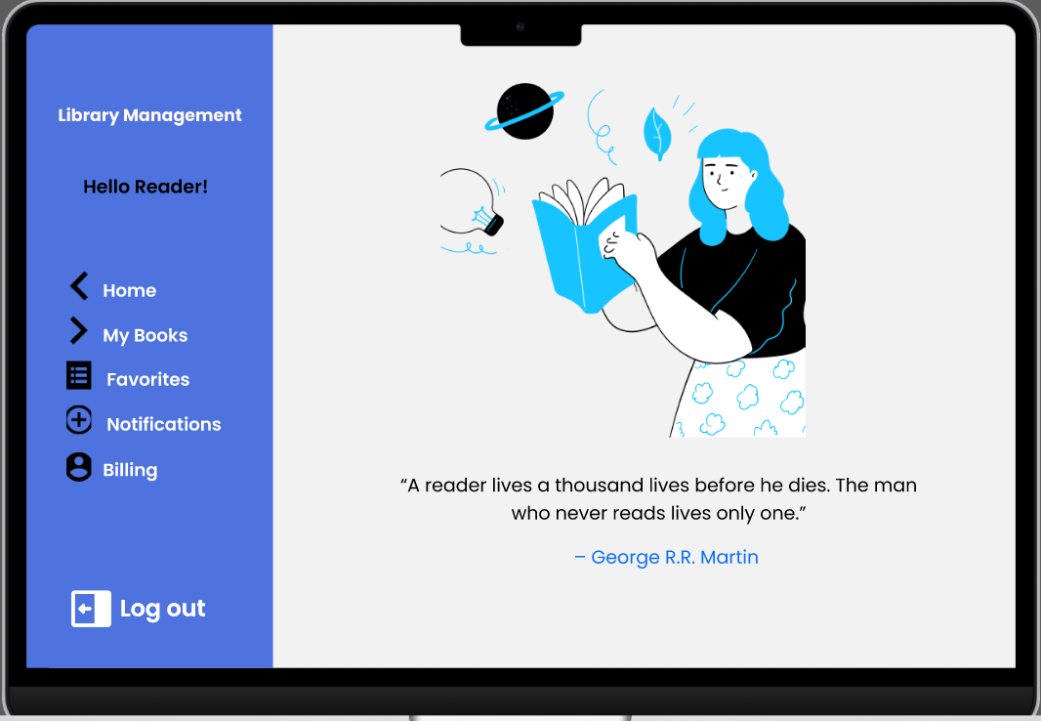 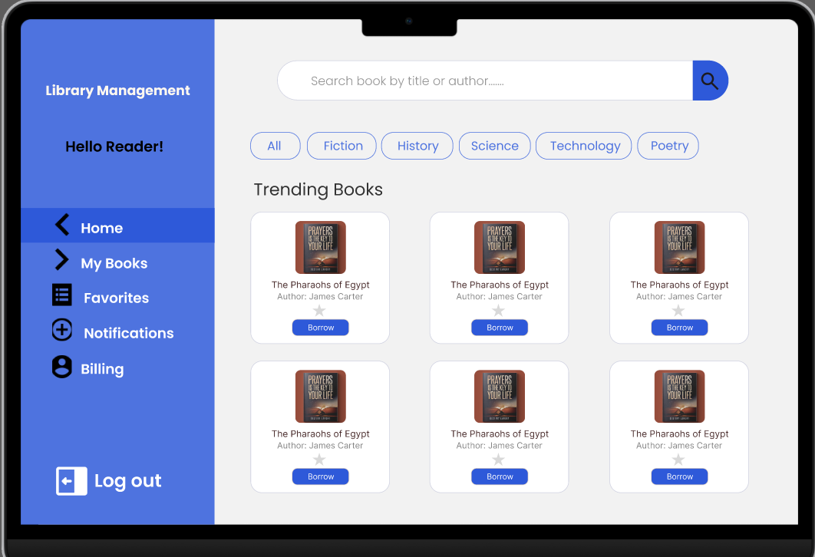 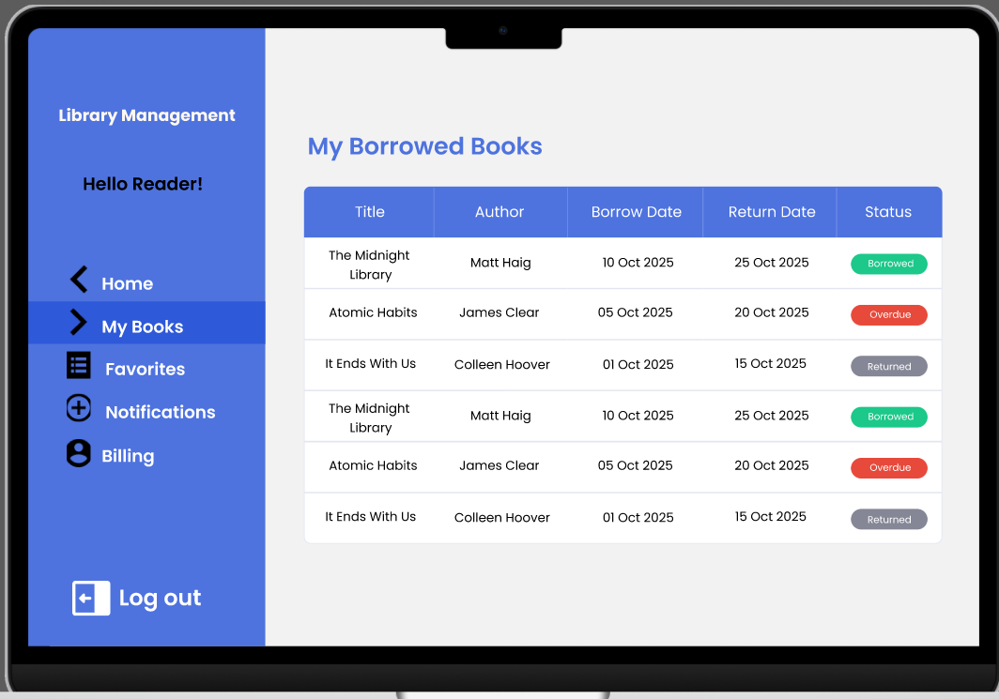 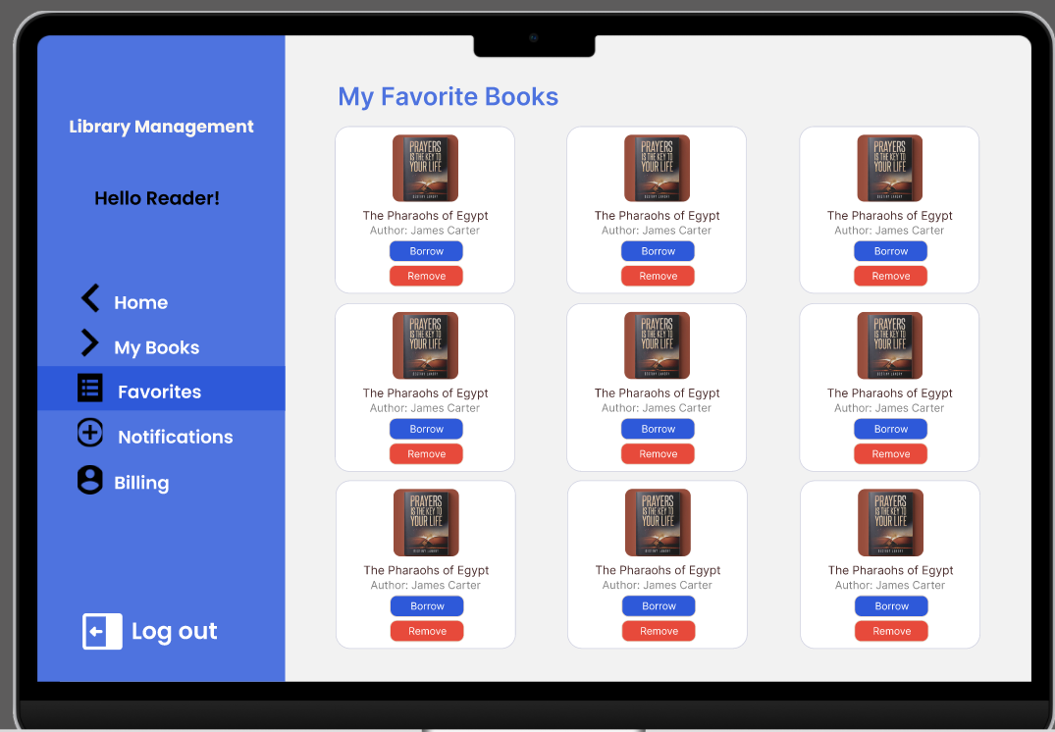 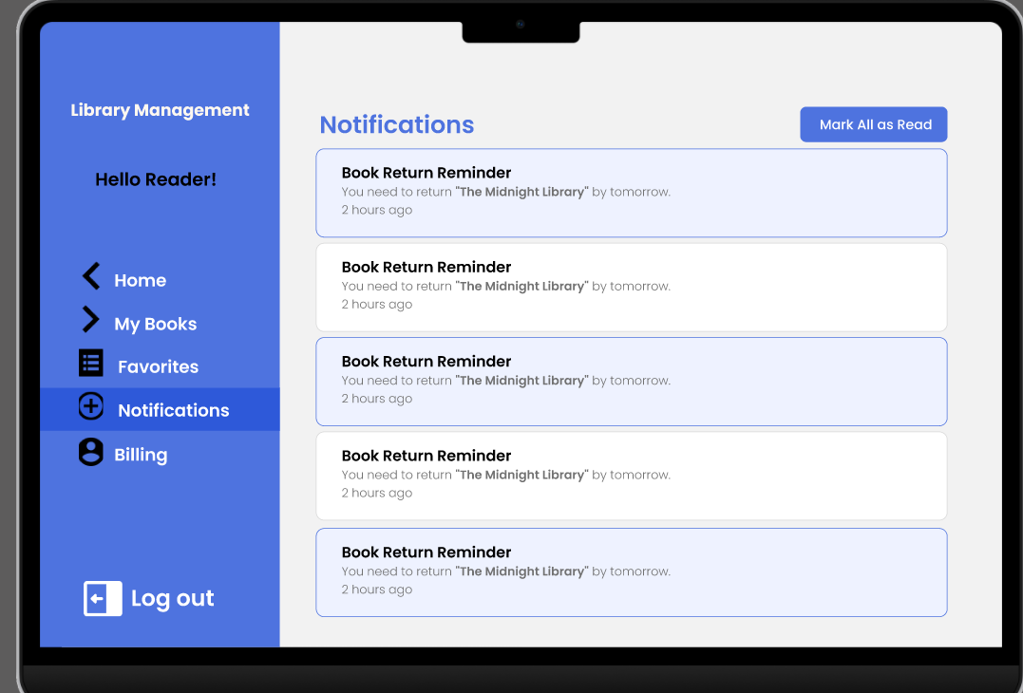 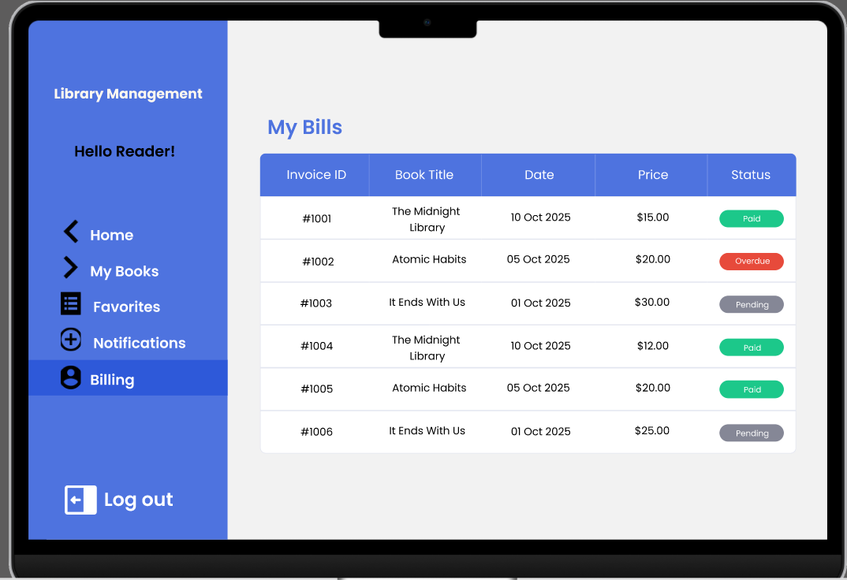

5. Navigation Flow
Reader / Student
Admins Librarians

6. References (if any)
https://www.figma.com/proto/7JsknYirGD3qzOrDG591cw/Untitled?node-id=13-823&t=xssytceTOVNBGerQ-1&scaling=scale-down&content-scaling=fixed&page-id=0%3A1&starting-point-node-id=1%3A6647. Approval Section (for Instructor use)

