

**SRI KRISHNA COLLEGE OF TECHNOLOGY**

**An Autonomous Institution | Accredited by NAAC with 'A' Grade Affiliated to Anna University | Approved by AICTE**

**KOVAIPUDUR, COIMBATORE 641042**

**ZENYOGA ACADEMY GATEWAY**

**PROJECT REPORT**

***Submitted by***

**IBRAHIM I 727821TUIT037**

**MANOJ KUMAR N 727821TUIT057**

**MOHAMED NOUFAL ANSARI T 727821TUIT060**

***in partial fulfillment for the award of the degree***

***of***

**BACHELOR OF ENGINEERING**

**IN**

**DEPARTMENT OF COMPUTER SCIENCE AND ENGINEERING**

**MARCH 2024**



**SRI KRISHNA COLLEGE OF TECHNOLOGY**

**An Autonomous Institution | Accredited by NAAC with 'A' Grade Affiliated to Anna University | Approved by AICTE**

**KOVAIPUDUR, COIMBATORE 641042**

**BONAFIDE CERTIFICATE**

Certified that this project report **“ZENYOGA”** is the bonafide work of **“IBRAHIM I, MANOJ KUMAR N, MOHAMED NOUFAL ANSARI T”** who carried out the project work under my supervision.

**SIGNATURE** **SIGNATURE**

**Mr.K.KARTHIK** **Dr.S.SIAMALA DEVI**

**HEAD OF THE DEPARTMENT**

Skill Development Engineer, Associate Professor,

Iamneo, Department of Computer Science

and Engineering

Sri Krishna College of Technology, Sri Krishna College of Technology,

Coimbatore-641042. Coimbatore-641042.

Certified that the candidates were examined by us in the Project Viva Voce

examination held on at Sri Krishna College of Technology, Kovaipudur,

Coimbatore -641042.

**INTERNAL EXAMINER** **EXTERNAL EXAMINER**

***ACKNOWLEDGEMENT***



**ACKNOWLEDGEMENT**

Dedicating this project to the **ALMIGHTY GOD** whose abundant grace and mercies enabled its successful completion.

We extend our deep gratitude to our beloved Principal, **Dr. M.G. Sumithra**, for her kindness and unwavering support throughout the project work.

We are grateful to our beloved Dean Academics affairs and assessment **Dr. R.**

**Rameshkumar**, for his tireless and relentless support.

We extend our heartfelt thanks to our beloved Dean Accreditation and Ranking **Dr. P. Manju**, for her advice and ethics inculcated during the entire period of our study.

We would like to express our deep gratitude to **Dr.R.Vidhya**, Head of Computing Science and Engineering and **Dr.S.Siamala Devi**, Programme Coordinator of Information Technology, for their exceptional dedication and care towards success of this project.

We would like to extend our heartfelt gratitude to our Project guide **Mr.S.PRANESH**, Skill Development Engineer, IamNEO for his valuable guidance and suggestions in all aspects that aided us to ameliorate our skills.

We are thankful to all those who have directly and indirectly extended their help to us in completing this project work successfully.

iv

**ABSTRACT**

ZENYOGA Yoga Academy emerges as a transformative force in the realm of online yoga course access, offering an innovative online portal meticulously crafted to simplify and elevate the user experience. With a keen focus on user-centric design, ZENYOGA presents an intuitive platform that seamlessly guides users through every step of exploring and enrolling in yoga courses. From the initial secure registration and login procedures to the exploration of a feature-rich dashboard teeming with a plethora of course options, the journey is marked by unparalleled ease and convenience.

Navigating the interface, users are empowered to make informed decisions as they peruse through various yoga courses tailored to their preferences. Whether selecting their preferred style of yoga, instructor, or course duration, ZENYOGA provides a fluid and responsive experience, ensuring enrollment is conducted swiftly and securely.

Complementing the user-facing aspects, ZENYOGA caters to administrative needs with equal finesse. Administrators wield a robust admin dashboard replete with tools for managing courses, instructors, and delving into the intricacies of enrollment history. Through this centralized hub, administrators can execute edits, updates, and analyses with efficiency, thereby facilitating seamless operations behind the scenes.

Bolstered by a resilient technology stack, with React driving frontend development, ZENYOGA stands as a beacon of innovation, redefining the landscape of online yoga course platforms. It is not merely an enrollment portal but a gateway to a more streamlined, secure, and user-centric approach to accessing yoga education. ZENYOGA beckons users to embark on a journey where convenience meets mindfulness, where every interaction is infused with the promise of holistic well-being and unparalleled satisfaction.

***INTRODUCTION***



**CHAPTER 1**

**INTRODUCTION**

In the rapidly evolving digital landscape, the demand for seamless and user-friendly solutions continues to drive innovation across various sectors. One such sector experiencing a profound transformation is online yoga education, where traditional methods are being supplanted by intuitive online platforms. Among these pioneers stands ZENYOGA Yoga Academy, a trailblazing online portal committed to revolutionizing the yoga learning experience for users.

ZENYOGA Yoga Academy is not just another yoga course platform; it represents a paradigm shift in how users interact with yoga instructors and wellness providers. With its innovative approach and robust technology stack, ZENYOGA aims to simplify and streamline the course enrollment process, offering users an unparalleled level of convenience and efficiency. From registration to course selection, every aspect of the user journey is meticulously crafted to deliver a seamless experience.

In this document, we delve into the intricacies of ZENYOGA – exploring its features, functionalities, and the technology driving its success. We will dissect the platform's user-centric design, its comprehensive suite of course offerings, and the seamless integration of cutting-edge technologies such as React for frontend development. Furthermore, we will examine how ZENYOGA caters not only to the needs of users but also to the administrative requirements, providing administrators with a robust set of tools to manage courses, instructors, and enrollment history effectively. Join us on a journey through the world of ZENYOGA Yoga Academy, where simplicity meets innovation, and the future of online yoga education unfolds before your eyes.

**1.1 PROBLEM STATEMENT**

ZENYOGA Yoga Academy is an innovative online platform aimed at providing a seamless and accessible way for users to access yoga courses. This intuitive system offers a comprehensive suite of functionalities, including user-friendly registration and login processes, a dashboard providing an overview of available courses, and a secure enrollment system for hassle-free transactions.

**1.2 OVERVIEW**

The online yoga course enrollment platform is an innovative solution catering to the increasing demand from users seeking a convenient and secure method to access quality yoga education. With a user-friendly interface, the platform allows seamless registration and authentication, enabling users to create accounts and log in securely. Providing a dashboard that acts as a central hub, the platform presents a variety of yoga course options, from selecting preferred styles to choosing instructors and course durations.

**1.3 OBJECTIVE**

The primary objective of ZENYOGA Yoga Academy is to simplify and enhance the yoga course enrollment process for users by providing an intuitive online platform that offers:

• Convenience: Enable users to register, log in securely, and enroll in yoga courses seamlessly from anywhere, at any time.

• User-Friendly Interface: Present a visually appealing and easy-to-navigate interface that guides users through the enrollment process with clarity and efficiency.

• Comprehensive Functionality: Offer a wide range of yoga course options, including various styles, instructors, and course durations, to cater to diverse user preferences.

• Secure Transactions: Ensure the safety and security of user enrollment transactions through the integration of multiple payment gateways with robust encryption protocols.

• Administrative Efficiency: Empower administrators with tools and functionalities to manage courses, instructors, and enrollment history efficiently through an intuitive admin dashboard.

• Technological Innovation: Utilize cutting-edge technologies, such as React for frontend development, to create a robust and scalable platform that delivers a superior user experience.

By achieving these objectives, ZENYOGA Yoga Academy aims to revolutionize the online yoga education experience, making it more convenient, secure, and user-centric for individuals seeking to deepen their practice and well-being.

***METHODOLOGIES***



**CHAPTER 2**

**METHODOLOGIES**

**2.1 DESCRIPTION**

In the fast-paced digital era, the demand for streamlined and accessible solutions is paramount, especially in essential services such as accessing quality yoga education. ZENYOGA Yoga Academy emerges as a beacon of innovation in this landscape, offering a revolutionary online platform designed to simplify and elevate the yoga course enrollment experience for users.

ZENYOGA Yoga Academy isn't merely an educational portal; it represents a fundamental shift in how users engage with their yoga instructors and wellness providers. Our platform is built on the foundation of user-centric design, cutting-edge technology, and a commitment to delivering unparalleled convenience and efficiency.

As we embark on this exploration of ZENYOGA, we'll delve into its myriad features, functionalities, and the underlying technology stack that powers its success. From seamless registration to secure transactions, ZENYOGA is meticulously crafted to offer a seamless journey for users.

Join us as we uncover the intricacies of ZENYOGA, where simplicity meets innovation, and the future of online yoga education unfolds before your eyes.

• Convenience: ZENYOGA Yoga Academy aims to provide users with the convenience of accessing yoga courses anytime, anywhere, through an intuitive online platform.

• User-Friendly Interface: Our platform offers a visually appealing and easy-to-navigate interface, ensuring users can enroll in courses with clarity and efficiency.

• Comprehensive Functionality: ZENYOGA offers a wide range of yoga course options, catering to diverse user preferences, including various yoga styles, instructors, and course durations.

• Secure Transactions: We prioritize the safety and security of user enrollment transactions, integrating multiple payment gateways with robust encryption protocols to safeguard user data.

• Administrative Efficiency: For administrators, ZENYOGA provides tools and functionalities to manage courses, instructors, and enrollment history efficiently through an intuitive admin dashboard.

• Technological Innovation: Leveraging cutting-edge technologies such as React for frontend development, ZENYOGA delivers a robust and scalable platform that offers a superior user experience.

**Features:**

* Secure Registration and Login
* Intuitive Dashboard Displaying Recharge Options
* Multiple Payment Gateway Integration
* Efficient Admin Dashboard for Plan Management
* Seamless User Experience Across Devices
* Responsive Customer Support
* Experience the future of online yoga education with ZENYOGA Yoga Academy,

where innovation meets simplicity, and user satisfaction knows no bounds.

**2.2 PURPOSE**

**Simplify Enrollment Process:**ZENYOGA Yoga Academy aims to streamline the traditionally cumbersome process of accessing quality yoga education by offering an intuitive online platform. Through simplified registration, easy navigation, and a seamless enrollment process, we make accessing yoga courses effortless and convenient for users of all backgrounds.

**Empower Users:** We believe in empowering users by providing them with a platform that puts them in control of their yoga journey. With a comprehensive suite of functionalities, including a diverse range of course options and secure enrollmentprocesses with confidence.

**Ensure Security:** Security is paramount in the digital age, especially when it comes to personal data. ZENYOGA prioritizes the safety and security of user information by implementing robust encryption protocols and partnering with trusted payment gateways. Users can enroll in yoga courses with peace of mind, knowing that their sensitive information is protected.

**Enhance User Experience:** At the heart of ZENYOGA is a commitment to delivering an exceptional user experience. From the moment users land on our platform to the completion of their course enrollment, every interaction is designed to be intuitive, seamless, and enjoyable. Our user-friendly interface, responsive design, and prompt customer support ensure that users have a positive experience every step of the way.

**Drive Innovation**: Innovation is at the core of ZENYOGA's mission. We continuously strive to push the boundaries of what's possible in online yoga education, leveraging emerging technologies and best practices to deliver cutting-edge solutions. By driving innovation, we aim to not only meet but exceed the evolving needs and expectations of our users.

***ENVIRONMENTAL SETUP***



**CHAPTER 3**

**ENVIRONMENTAL SETUP**

**3.1 INSTALLATION OF VSCODE**

A software package known as an integrated development environment, or IDE, integrates the essential tools required to design and test software. Developers use a range of tools for writing, creating, and testing software code. Examples of development tools include text editors, code libraries, compilers, and test environments. Developers can give commands immediately on VSC without needing to open a terminal process thanks to a built-in terminal system on VSC, which makes it easier to check for errors. The fact that VSC comes with a built-in GIT command that enables diff checking, staging files, and committing directly from the editor is another reason to choose it. Additionally, a sizable selection of libraries of extensions and plug-ins that support the coding of the most widely used programming languages in use today are available on the Visual Studio market.



**Figure No 3.1 VS Code**

***TOOLS AND TECHNOLOGIES***



**CHAPTER 4**

**TOOLS AND TECHNOLOGIES**

**4.1 REACT VITE**

React Vite is a modern build tool that leverages the power of esbuild and modern browser features to provide an incredibly fast development experience. It is built on top of Vite, an opinionated build tool that prioritizes speed by leveraging native ES module imports during development. React Vite extends the capabilities of Vite specifically for React applications, offering a seamless development experience with features tailored to the React ecosystem.

**Key Features of React Vite:**

**Instant Server Start:** With React Vite, developers can enjoy near-instantaneous server start times, thanks to its use of esbuild and native ES module imports. This drastically reduces the waiting time typically associated with server startup, enabling developers to iterate and test their code with unparalleled speed.

**Optimized Build Performance:** React Vite optimizes the build process by leveraging esbuild's blazing-fast bundling capabilities. This results in significantly reduced build times, allowing developers to build and deploy React applications with remarkable efficiency.

**Hot Module Replacement (HMR):** React Vite supports Hot Module Replacement out of the box, enabling developers to see changes reflected in the browser instantaneously as they modify their code. This dramatically speeds up the development cycle and enhances developer productivity.

**Effortless Configuration:** React Vite comes with sensible defaults and requires minimal configuration, allowing developers to focus on writing code rather than wrestling with complex build configurations. This simplicity and ease of use contribute to a more enjoyable development experience.

**Support for Modern JavaScript Features:** React Vite embraces modern JavaScript features, such as ES modules and import syntax, enabling developers to write cleaner, more maintainable code. Additionally, React Vite provides first-class support for TypeScript, enabling type-checking and improved code quality.

**4.2 CSS**

Cascading Style Sheets is the short name for CSS. CSS is used to specify the design, layout, and display variants for web pages on various devices and screen sizes. The basic organization of CSS is

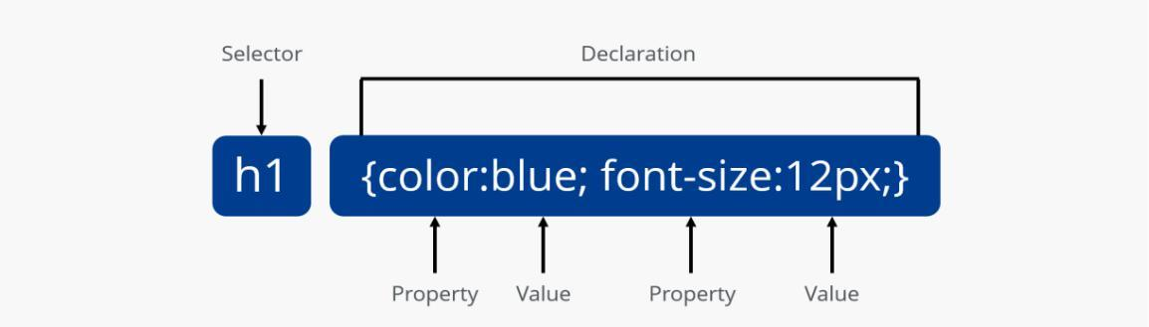

**Figure No. 4.2 CSS Structure**

***IMPLEMENTATION***



**CHAPTER 5**

**IMPLEMENTATION**

**5.1 FRONTEND**

**5.2.1 SIGN UP PAGE:**

The sign-up page for ZENYOGA Yoga Academy provides users with a seamless and secure onboarding experience. It serves as the gateway to unlocking the full potential of accessing quality yoga education. Upon visiting the sign-up page, users are greeted with an intuitive and user-friendly interface, encouraging them to create their account. They are prompted to enter their essential personal information, such as name, email address, and a secure password.



**Figure No. 5.8 Sign-up page**

**5.2.2 LOGIN PAGE:**

Logging in is usually used to enter a specific website or application which cannot be seen by trespassers or users with bad intentions. Once the user is logged in, the login token may be tracked to get the information of what actions the user has taken while staying connected to the site. The process is simple, users input their credentials on the website's login form. That information is then sent to the authentication server where the information is compared with all the user credentials on file. When a match is found, the system will authenticate users and grant them access to their accounts. After which they can access and use the website.

The type of verifications that are performed depends on the authentication mode that is being used. Form-based authentication is where a user is presented with a form allowing them to enter username and password credentials. These credentials are compared against the credentials stored on the system for this username, if they match the user is considered an authenticated user for the system. For security reasons the password for authenticating a user is stored on the system in a digested form.



**Figure No. 5.10 Login page**

**5.2.3 LANDING PAGE**

On the landing page of ZENYOGA Yoga Academy, users are greeted with a sleek and inviting interface designed to provide a seamless introduction to the platform's offerings. A visually appealing layout showcases key features such as user registration, login, and access to a comprehensive dashboard. Clear and concise sections highlight the benefits of using ZENYOGA, including convenience, security, and a wide range of yoga course options. The landing page effectively captures the essence of ZENYOGA's user-friendly design and robust functionality, enticing visitors to explore further and experience the future of online yoga education.



**Figure No. 5.11 Landing page**

**5.2.4 DASHBOARD**



**Figure No. 5.12 Dashboard**

The central dashboard of ZENYOGA Yoga Academy offers users an efficient and user-friendly interface for managing their yoga course enrollments and schedules and users availing the application. Upon logging in, users are greeted with a clear and organized display, featuring key components like the course listand an option to enroll in new courses.

**5.2.5COURSES PAGE**

On the Courses list page of ZENYOGA Yoga Academy, users are presented with a comprehensive overview of available yoga courses tailored to their needs. The page features a user-friendly interface that allows for easy navigation and selection of courses from various instructors. Each course is displayed with detailed information, including pricing, duration, style, and any additional benefits or offers. Users can filter and sort courses based on their preferences, such as yoga style, instructor, and duration. With its intuitive design and extensive range of choices, the courses list page empowers users to find the perfect yoga course to suit their requirements, ensuring a seamless and satisfying experience with ZENYOGA.

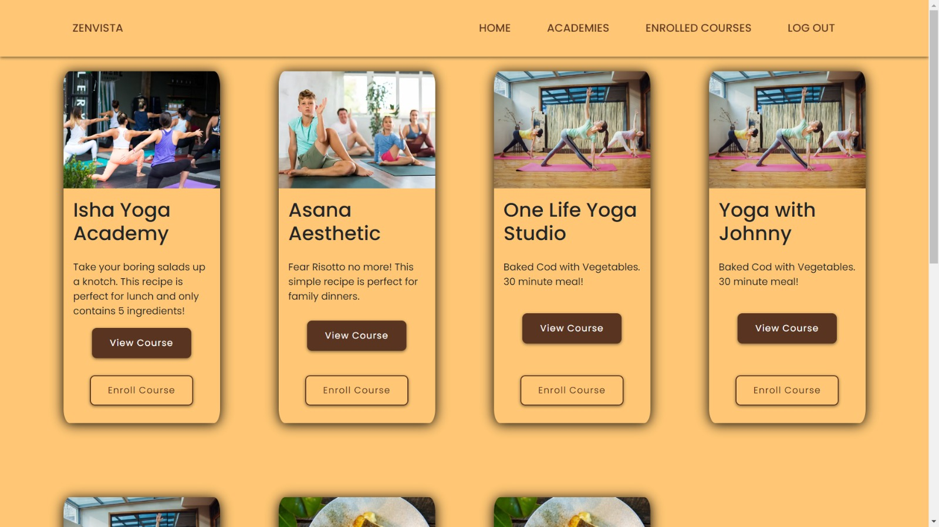

**Figure No.5.13 Courses Page**

***CONCLUSION***



**CHAPTER 6**

**CONCLUSION**

**6.1 CONCLUSION**

In conclusion, ZENYOGA Yoga Academy stands as a beacon of innovation in the realm of online yoga education, offering a seamless and user-centric platform designed to simplify the course enrollment process. With its intuitive interface, robust functionality, and commitment to security, ZENYOGA sets a new standard for convenience and efficiency in accessing quality yoga education. Whether it's selecting yoga courses, tracking enrollments, or managing account preferences, ZENYOGA empowers users with the tools they need to deepen their practice effortlessly. As we continue to evolve and enhance our platform, we remain dedicated to providing an exceptional experience that exceeds the expectations of our users. Join us on this journey, and experience the future of online yoga education with ZENYOGA Yoga Academy.

**6.2 FUTURE SCOPE**

Looking ahead, ZENYOGA Yoga Academy has a plethora of opportunities for growth and innovation in the dynamic landscape of online yoga education. As technology continues to advance, ZENYOGA envisions enhancing its platform with personalized features through the integration of sophisticated algorithms and machine learning techniques. This evolution would enable ZENYOGA to offer tailored course recommendations based on individual user behavior, preferences, and practice patterns, thereby optimizing the learning experience.

Furthermore, ZENYOGA sees potential in expanding its services beyond domestic boundaries by introducing international yoga course options. This expansion would allow users to access quality yoga education for themselves or gift it to friends and family abroad, fostering greater connectivity and well-being across borders.

**REFERENCES**

1. AlexBanks, “Learning React Modern Patterns for Developing React

Apps”, Second Edition, Kindle Edition, 2020.

1. GregLim, “Beginning React with Hooks”, KindleEdition 2020.
2. Harmeet Singh and Mehul Bhattt, “Learning Web Development with

React and Bootstrap”, December 2016.

1. Bonnie Eisenman, “Learning React Native”, O’ReillyMedia
2. React Documentation:<https://reactjs.org/docs/getting-started.html>