Name: Ibrahim Almohaimeed

Instructor: Michelle Cheatham

TA: Shimizu, Cogan

Class: CS 1181-05

**PROJECT 3**

The following test cases illustrate the average waiting time and the average lines length in different combinations, followed by the average time reduced. These tests were processed with a total number of five hundred customers.

**Case I:**

If **50%** of the grocery customers will get more than 12 item and **50%** are not.

* 3 Regular lanes: **3.87**, and average length: **5**
* 3 Regular lanes and 1 Express lanes: **1.3**, and average length: **4**
* 3 Regular lanes and 2 Express lanes: **0.5**, and average length: **2**
* 3 Regular lanes and 3 Express lanes: **0.43**, and average length: **2**
* Average time reduced with every new express line added: **1.15**

(See Chart 1)

**Case II:**

If **75%** of the customers will get more than 12 item and **25%** are not.

* 3 Regular lanes: **6.92**, and average length: **5.6**
* 3 Regular lanes and 1 Express lanes: **2.75**, and average length: **4**
* 3 Regular lanes and 2 Express lanes: **2.06**, and average length: **3**
* 3 Regular lanes and 3 Express lanes: **1.7**, and average length: **2**
* Average time reduced with every new express line added: **1.74**

(See Chart 2)

**Summery**

Throughout the process express lanes have shown their effectiveness in both the waiting time and the checkout lines length. Although, the effects were noticeably decreasing after each transaction, the express lanes are playing such a significant role in decreasing the numbers of the two elements. In conclusion, based on the good effects the express lines have shown which would ultimately increase the productivity of the store, accompanied with the pressure drop in all of the cashier lines. Finally, express lines have proved to be taken seriously, especially after the observable results in the process.

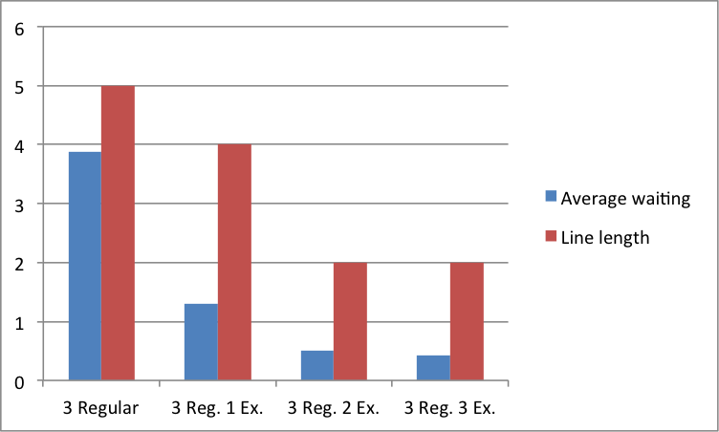

Chart 1 for Case I

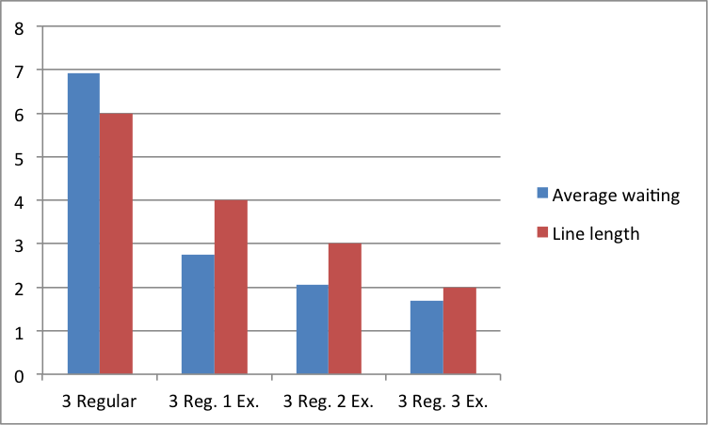

Chart 2 for Case 2