# Assignment: E-Profile website – Phase 1; 50 Marks (10%)

Construct an e-profile website for yourself. This is an individual Assignment done outside of class. You will present the website in **Week 5 during your lab.**

You have to use **HTML, CSS** style sheets for formatting and use **Forms** and **JavaScript** for scripting.

**Phase 1** of the website should be constructed as a two to three **(2-3)** **interlinked** pages. Not one scrolling page. These pages could be:

* “My hobbies”
* “All about me”
* “Places I visited” …etc.

Use of external links to real web sites (e.g., list of your favourite books, CDs, or DVDs with links to Amazon's pages describing the items)

Some use of tables - tabular data such as your HS results or something more interesting like using tables to layout a collage of images.

Be creative!

For **Forms**, create any style of form, using input type=text…etc and use **form validation**. (JavaScript Form Validation: Clicking the Submit button calls "onSubmit" that verifies the validity of the inputs to the best extent that you can manage (use alerts and prompts)).

Helpful Links for Inspiration:

<https://www.designhill.com/i/website+ideas+inspiration>

<https://www.wix.com/blog/creative/2020/03/best-portfolio-websites>

<https://www.hostgator.com/blog/creative-website-design-ideas/>

<https://weblium.com/blog/best-portfolio-website-examples/>

**Submission and Marking Criteria**

**Submit on Moodle:**

* **All Code Files in a .zip folder AND**
* **a word-doc with your code copy-pasted with screenshots of your website**

In the Word Doc: Include the structure of your website in the form of a chart, like below: <https://www.uxpin.com/studio/blog/web-structures-explained/>

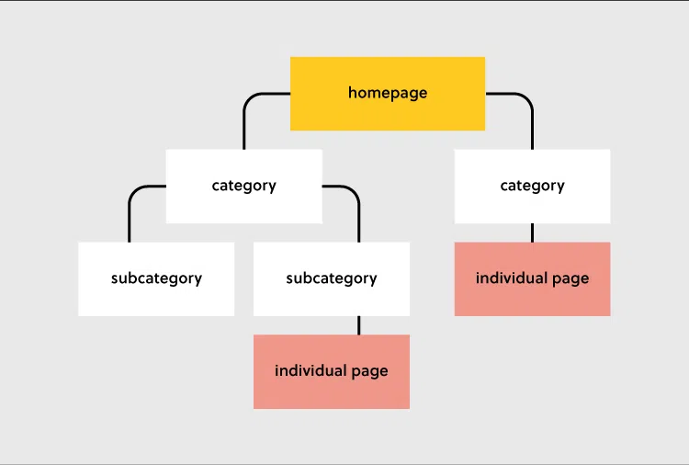

Marking Criteria (**50 marks**)

Topics               Marks

HTML                                   10

CSS                                       10

Java script                          10

Form                                 10

Present in lab sessions 10

Note that for each of the topics above optimized coding will be strictly considered.