

Military Institute of Science & Technology (MIST)
Department of Electrical, Electronic and Communication Engineering
EECE 314
Electrical Measurement, Instrumentation and Sensors Laboratory
Final Project Report
Section: B Group: 03
Project Name:
Study on Temperature Coefficient of resistance for Different type of Materials
Conducting Faculties:
- Lt Col Md Aminul Islam
- Maj Kazi Newaj Faisal
- Asst. Prof. A. A. M. Shah Sadman
- Lec Muhammed Zubair Rahman
- Lec Nazifa Nawar

Group Members:

Name | Student ID
Md. Forhaduzzaman Reyad | 202316086
Md. Zishan Kabir | 202316097
Md. Shameul Arefin Arnob | 202316099
Osama Ahmed Ibrahim | 202316126
Arkid Chakma | 202316128
Jannatul Maowa | 202316130
Mahmudur Rahman | 202316302
MILITARY INSTITUTE OF SCIENCE &TECHNOLOGY
MEASUREMENT AND INSTRUMENTATION LAB
EECE-314
EXP NO: - 01
EXP Title: - Study on Temperature Coefficient of resistance for Different type of Materials
Objective: -
- To study how the resistance of different materials (e.g., aluminum, semiconductor material etc.) changes with temperature.
- To calculate the temperature coefficient of resistance (TCR) for each material.
- To compare the TCR values and classify materials as conductors, semiconductors based on their behavior.

Introduction: -
The relationship between electrical resistance and temperature is one of the most important properties of materials in electrical engineering. When an electric current passes through a conductor, collisions occur between the flowing electrons and the vibrating atoms of the conductor. As the temperature increases, atomic vibrations also increase, which causes more collisions of electrons with atoms, thereby increasing resistance. Hence, most metals and pure conductors exhibit a positive temperature coefficient of resistance, meaning their resistance rises as temperature rises.
On the other hand, semiconductors such as silicon or germanium behave differently. When temperature increases, more charge carriers (electrons and holes) become available, leading to a negative temperature coefficient of resistance. Alloys like nichrome or constantan, however, have very low or nearly negligible TCR values, making their resistance almost constant with temperature. This property makes them suitable for heating elements and standard resistors.
Studying the temperature coefficient of resistance of different materials helps in understanding their electrical performance in real-life situations. For instance, in overhead power transmission lines, the resistance of aluminum or copper conductors increases with temperature, which can affect efficiency. Therefore, determining and understanding the TCR of materials like aluminum is not only an academic exercise but also of great practical importance in electrical and electronic engineering.

Theory: -
The resistance of a conductor at a given temperature $T$ is related to its resistance at a reference
temperature $T_{0}$ by:
$$R_{T}= R_{0}\left(1 + αΔT\right)$$
here,
- $R_{T}$= Resistance at temperature $T$
- $R_{0}$= Resistance at reference temperature $T_{0}$
- $∆T$= ($T-T_{0}$) = Change in temperature
- $α$ = Temperature Coefficient of Resistance (per °C)
From this,
$$α=\frac{R_{T}-R_{0}}{R_{0}∆T }$$

For metals like aluminum, $α$>0
For semiconductors, $α$<0
- Semiconductor Thermistor (NTC)
$$R\left(T\right)=R_{o}e^{\left[B\left(\frac{1}{T}-\frac{1}{T_{o}}\right)\right]}$$
$$B=\frac{∆\left(lnR\right)}{∆(\frac{1}{T})}$$
$$α\left(T\right)=-\frac{B}{T^{2}}$$
here,
- $R_{T}$= Resistance at temperature $T$
- $R_{0}$= Resistance at reference temperature $T_{0}$
- $∆T$= ($T-T_{0}$) = Change in temperature
- $α$ = Local Temperature Coefficient of Resistance (per °C)
- $B$=Material Constant (B value)
Apparatus Required
- Aluminum wire sample
- Semiconductor Material (Thermistor)
- Digital Multimeter
- Thermometer / Temperature sensor
- Heating arrangement (water bath or heater)
- Resistance
Procedure: -
• Prepare the Setup:
- Fix the conductor securely using a stand or clamp.
- Make sure it does not touch any surface that can conduct heat away too quickly.
• Initial Measurement:
- Measure the room temperature ($T_{0}$​) of the conductor using a thermometer.
- Set the digital multimeter to resistance (Ω) mode.
- Measure the initial resistance ($R_{0}$)​ of the conductor and record it.
• Heat the Conductor:
- Apply heat gradually using the heat source.
- Wait for the temperature to stabilize at each desired step (e.g., 30°C, 35°C, 40°C, …).
• Measure Resistance at Each Temperature:
- At each stabilized temperature T​, measure the resistance R​ using the DMM.
- Record the corresponding temperature and resistance.
• Repeat for Multiple Points:
- Take measurements at several temperature points (e.g., every 5°C ) up to the maximum temperature allowed.
- Ensure the conductor cools down before reheating if needed for repeated trials.
• Data Analysis:
- Plot Resistance vs Temperature graph using the recorded data.
- Calculate the temperature coefficient of resistance (TCR) for the material using the formula .
- For thermistors, you can optionally calculate the B-parameter using formula.
• Conclusion:
- Identify whether the material has a positive or negative TCR.
- Discuss its practical implications, e.g., suitability for heating elements, resistors, or sensors.

Data Table: -

Step | Initial Temp (°C) | Final Temp (°C) | R0 (Ω) | RT (Ω) | ΔT (°C) | α (per °C)
1 | 20 | 25 | 400.00 | 407.80 | 5 | 0.0039
2 | 20 | 30 | 400.00 | 412.62 | 10 | 0.00315
3 | 20 | 35 | 400.00 | 423.44 | 15 | 0.0039
4 | 20 | 40 | 400.00 | 435.26 | 20 | 0.0038
5 | 20 | 45 | 400.00 | 435.08 | 25 | 0.00363
6 | 20 | 50 | 400.00 | 442.90 | 30 | 0.00391
1. For a Conductor material(Aluminum)

2. Table for Semiconductor Thermistor (NTC)

Initial Temp (°C) | Final Temp (°C) | R0 (Ω) | RT (Ω) | ΔT (°C) | B (K) | α_eff (per °C)
25 | 30 | 10000 | 8294.6 | 5 | 3385 | -0.03411
25 | 35 | 10000 | 6921.9 | 10 | 3375 | -0.03078
25 | 40 | 10000 | 5809.9 | 15 | 3380 | -0.02793
25 | 45 | 10000 | 4903.4 | 20 | 3378 | -0.02548
25 | 50 | 10000 | 4160.1 | 25 | 3381 | -0.02336
25 | 55 | 10000 | 3556.8 | 30 | 3379 | -0.02143

Graphical representation :
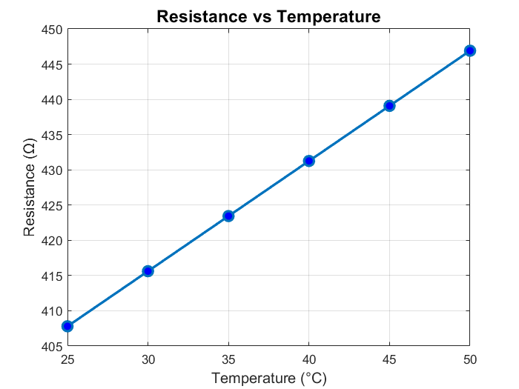
1. For a Conductor material(Aluminum)

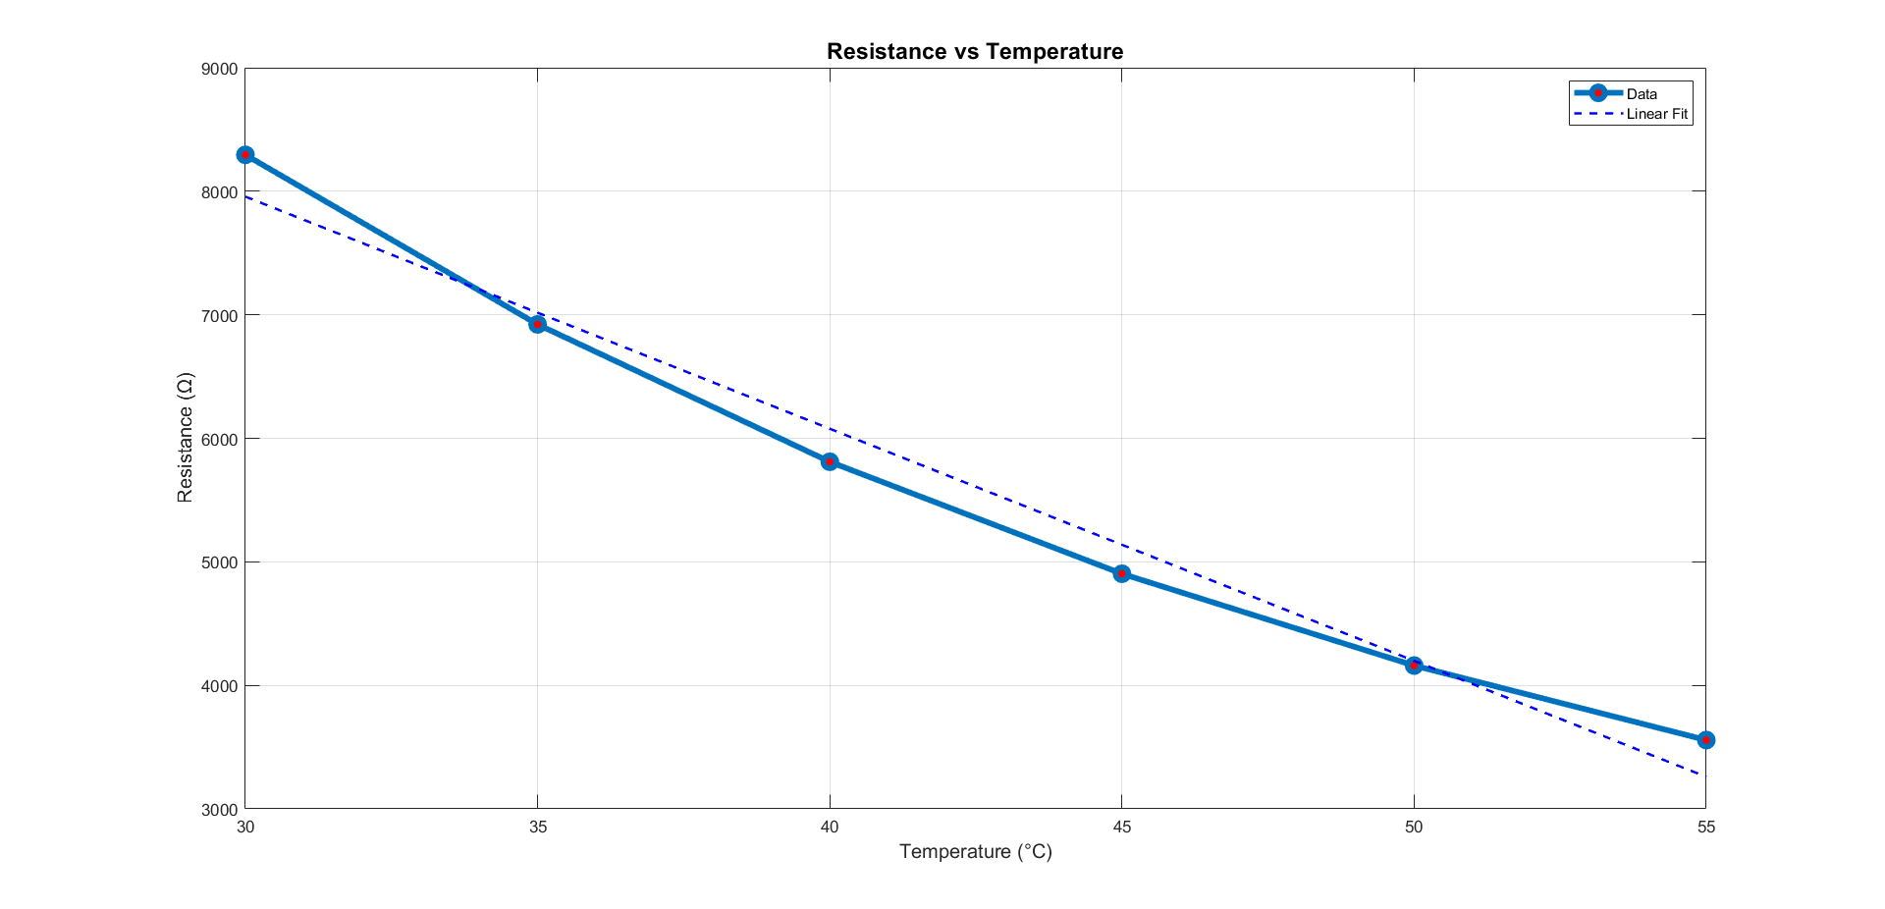
2. For Semiconductor Thermistor (NTC)

Calculation: -
For conductor material :
Here,
$R_{0}$ = 400 $Ω$ at $T_{0}$ = 20°C
$R_{T}$ = 423.44 $Ω$ at $T$ = 35°C
$∆T$ = 35-20 = 15 °C
Now,
$$α=\frac{R_{T}-R_{0}}{R_{0}∆T }$$
$$α=\frac{423.44 -400}{400*15 }$$
$$α=\frac{1.50}{500 }$$
$$α=0.0039 Per °C$$
This value is very close to the standard TCR of Aluminum ≈ 0.0039 per °C
For semiconductor material :
$R_{0}$ = 10000 $Ω$ at $T_{0}$ = 25°C
$R_{T}$ = 5809.9 $Ω$ at $T$ = 40°C
$∆T$ = 40-25 = 15 °C
$$B=\frac{∆\left(lnR\right)}{∆(\frac{1}{T})}$$
= $\frac{-0.543}{-0.000160}$
=3380 k

$$α\left(T\right)=-\frac{B}{T^{2}}$$
=$-\frac{3380}{{(313.15)}^{2}}$
= -0.02793 per k

Discussion
In this experiment, the relationship between electrical resistance and temperature of a material was investigated using a digital multimeter. The primary objective was to determine how resistance varies with temperature and to calculate the temperature coefficient of resistance (TCR) for the sample.
From the measured data, it was observed that the resistance of the conductor changed systematically with temperature. For metals, the resistance increased with rising temperature, indicating a positive temperature coefficient of resistance. This behavior is explained by the increased atomic vibrations at higher temperatures, which result in more frequent collisions between electrons and atoms, thereby reducing electron mobility and increasing resistance. Conversely, semiconductors such as thermistors exhibit a negative temperature coefficient, as higher temperatures generate more charge carriers, increasing conductivity and reducing resistance. Alloys like nichrome or constantan displayed relatively stable resistance across the temperature range, confirming their suitability for heating elements and standard resistors.
The experimental data was plotted as Resistance vs Temperature, and the temperature coefficient α was calculated. The results closely matched theoretical expectations, demonstrating the reliability of the measurements.

Sources of Error
- Measurement Error: Digital multimeter resolution limits may introduce small errors in resistance readings.
- Temperature Fluctuations: Incomplete thermal stabilization or uneven heating can cause inaccurate temperature readings.
- Contact Resistance: Loose or oxidized connections may slightly affect resistance measurements.
- Environmental Factors: Air currents, humidity, or ambient temperature variations can influence results.

Safety Precautions
- Handle the heat source with care to prevent burns or fire hazards.
- Avoid touching the hot conductor during measurements.
- Ensure all electrical connections are secure to prevent short circuits.
- Do not exceed the maximum rated temperature of the conductor to avoid damage.
Overall, this experiment provided a clear understanding of how resistance depends on temperature, highlighted differences between metals, semiconductors, and alloys, and emphasized the importance of TCR in practical applications such as power transmission lines, precision resistors, and heating elements.

Discussion Questions: -

1. Why does resistance of aluminum increase with temperature?
Because in metals like aluminum, higher temperature increases atomic vibrations, causing more collisions of free electrons, which increases resistance.
2. Why do semiconductors exhibit a negative temperature coefficient?
In semiconductors, rising temperature increases charge carriers (electrons & holes), reducing resistance instead of increasing it.
3. Compare the experimental TCR value of aluminum with its standard theoretical value. What factors may cause differences?
Experimentally we got α=0.0039/°C, while standard is about 0.0041/°C. Errors may come from instrument accuracy, heating rate, contact resistance, or uneven temperature distribution.
4. Why are alloys like nichrome preferred for heating elements despite their low TCR?
Nichrome has nearly constant resistance with temperature and high melting point, making it stable, safe, and durable for heating applications.
5. In power transmission lines, what effect does temperature rise have on aluminum conductors?
Temperature rise increases aluminum resistance, causing more power loss (I²R) and possible sagging of transmission lines.
6. How could errors in measurement (resistance or temperature) affect the accuracy of α?
Small errors in resistance or temperature readings directly affect calculated α\alphaα, leading to either underestimation or overestimation of the TCR.

