

**PROJECT REPORT**

**DEPARTMENT OF ELECTRICAL, ELECTRONIC AND COMMUNICATION ENGINEERING**

**COURSE CODE: EECE-202**

**PROJECT RRPORT OF GROUP 2**

**PROJECT NAME: Light-Dependent Switch Circuit Using BJT**

**Group Member**

|  |  |
| --- | --- |
| **Name** | **ID** |
| [Bayazid Hasan](https://www.facebook.com/bayazid.hasan.79274) | 202216036 |
| Md Humaun Kabir Nahid | 202216040 |
| Md. Forhaduzzaman Reyad | 202316086 |
| Md. Zishan Kabir | 202316097 |
| Khalid Ibna Zahir | 202316117 |
| Osama Ahmed Ibrahim | 202316126 |
| Md. Abu Sayed Siddiqi | 202316304 |

Level-2, Term-1

Electrical Electronic and Communication Engineering

Military Institute of Science and Technology.

**Table Of Contents:**

|  |  |
| --- | --- |
| **Title** | **Page Number** |
| **i. Theory and Equation** | **03** |
| **ii. Circuit diagram** | **04** |
| **iii. Apparatus** | **04** |
| **iv. Procedure** | **04** |
| **v. Experimental data table** | **05** |
| **vi.Real life applications of the circuit.** | **05** |
| **vii. Five report question with answer** | **06** |

**Theory and Equation**

A **light-dependent switch** is a circuit that can automatically turn a device on or off based on ambient light conditions. The circuit we design uses a **photoresistor (LDR)** to sense the light level and a **BJT (Bipolar Junction Transistor)** to act as a switch to control the load (device).

* **LDR (Light-Dependent Resistor):** The resistance of the LDR decreases with increasing light intensity, making it suitable for detecting changes in ambient light.
* **BJT as a switch:** A Bipolar Junction Transistor can operate in three regions: cut-off, active, and saturation. In this project, we utilize the **cut-off** and **saturation** regions to act as a switch.
  + **Cut-off region:** When no base current is applied, the transistor behaves as an open switch.
  + **Saturation region:** When sufficient base current is applied, the transistor turns on and acts as a closed switch, allowing current to flow through the collector-emitter junction.
* **Voltage Divider Equation:** The LDR and a fixed resistor (Here we used 100k potentiometer) form a voltage divider network. The output voltage from this network determines the base voltage of the BJT.



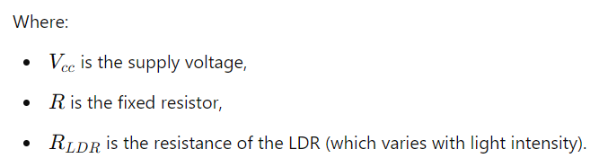 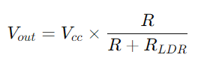



**ii. Circuit Diagram**

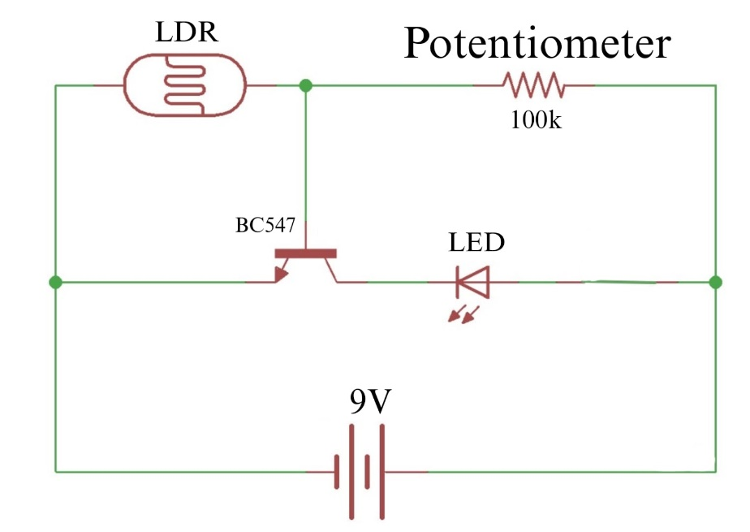

**iii. Apparatus**

1. **Light Dependent Resistor (LDR)**
2. **NPN Bipolar Junction Transistor (BJT)**
3. **LED**
4. **Power Supply** (9V battery)
5. **Breadboard and connecting wires**
6. **Potentiometer (100k)**

**iv. Procedure**

1. **Set up the circuit:** Connect the LDR and fixed resistor or potentiometer in series to form a voltage divider, with the junction of these two connected to the base of the BJT.
2. **Connect the transistor:** The emitter of the BJT should be connected to ground, and the collector should be connected to the load. The load can be an LED or another device.
3. **Test in light conditions:**

High ambient light level: The resistance of the LDR decreases. **Effect on transistor**: The decrease in LDR resistance should **reduce the base current**, keeping the transistor **off**. **Outcome**: The device (such as a light) remains **off** during high light levels.

1. **Test in darkness:**

**Low ambient light level**: The resistance of the LDR **increases**. **Effect on transistor**: The increase in LDR resistance should allow **more base current** to flow, turning the transistor **on**. **Outcome**: The device (such as a light) turns **on** when it's dark.

1. **Adjust the sensitivity:** If necessary, adjust the potentiometer to change the sensitivity of the light threshold at which the device switches.

**Experimental Data Table:**

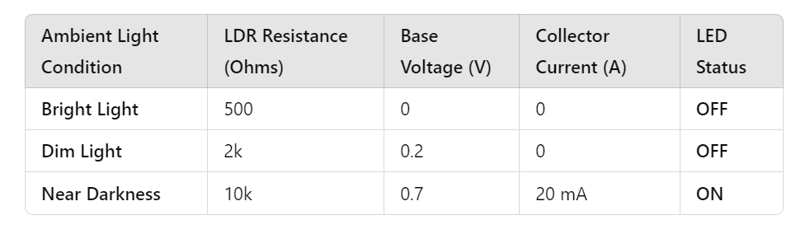

**vi. Real-Life Applications**

1. **Automatic street lighting:** The circuit can be used in streetlights to automatically turn them on at dusk and off at dawn.
2. **Garden or security lighting:** Light sensors can control lights in gardens, patios, or driveways based on ambient light levels.
3. **Energy-saving systems:** Devices that automatically shut off or turn on appliances when room light levels change.
4. **Night lights for children:** Lights that automatically turn on when the room becomes dark.
5. **Display case lighting:** Automatically turn on lights in display cases or art exhibits when someone is near, based on ambient lighting conditions.

**vii. Report Questions with Answers**

1. **What is the function of the LDR in the circuit?**
   * The LDR senses the ambient light level and changes its resistance accordingly, which is used to control the base voltage of the BJT.
2. **How does the BJT act as a switch in this circuit?**
   * The BJT operates in either the saturation region (acting as a closed switch) or the cut-off region (acting as an open switch) depending on the base current supplied by the voltage divider (LDR + fixed resistor).
3. **How does the value of the potentiometer affect the circuit?**

The potentiometer controls the circuit's light sensitivity. Lower resistance means less sensitivity (turns on in darker light), while higher resistance increases sensitivity (turns on in dimmer light).

1. **What happens to the transistor when the ambient light increases?**
   * As ambient light increases, the LDR’s resistance decreases, allowing more base current to flow, which turns the transistor on, thus powering the connected load.
2. **Can this circuit be used to control high-power devices?**
   * This basic circuit is suitable for low-power devices. For high-power applications, a relay or a power transistor would be needed to handle higher currents.