Q1)

public class Personalinformation{

    public static void main(String[] args)  {

      System.out.println("My Name is IBRAHIM JUMA NASSOR\nMy address is 234 AMANI street Stadium, ZNZ 12\nMy phone numner is 710-916-827\nMy College major is SUZA");

   }

}

Q2)

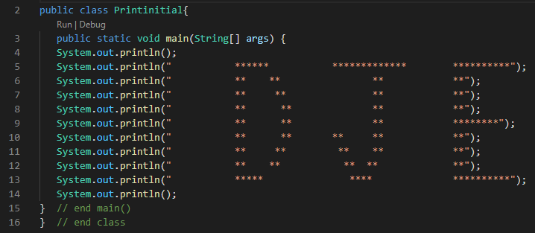

Q16)

public class Integer{

   public static void main(String[] args) {

      int x = 97, y= 2;

      int quotient = x / y;

      int remainder = x % y;

          System.out.println("Quotient is: " + quotient);

          System.out.println("Remainder is: " + remainder);

  }

  }

Q13)

import java.util.Scanner;

public class Radius{

   public static void main(String[] args) {

       // create Scanner to obtain input from command window

       Scanner input = new Scanner(System.in);

       int r;   // user input for circle's radius

       System.out.print("Enter the radius of the circle: ");    // prompt

       r = input.nextInt(); // read radius input

       System.out.printf("Diameter of the circle is %d\n", (2 \* r));    // calculates the diameter

       System.out.printf("Circumference of the circle is %.2f\n", (2\* (Math.PI) \* r));  // calculates the circumference

       System.out.printf("Area of the circle is %.2f\n", ((Math.PI) \* (r \* r)));    // calculates the area

   } // end method main

} // end class

Q12)

import java.util.Scanner;

public class Numbers{

   public static void main(String[] args) {

    int FirstNo, SecondNo;

    Scanner reader = new Scanner(System.in);

    System.out.print("Enter First No : ");

    FirstNo = reader.nextInt();

    System.out.print("Enter Second No : ");

    SecondNo = reader.nextInt();

    int sum = FirstNo + SecondNo;

    int product = FirstNo \* SecondNo;

    int difference = FirstNo - SecondNo;

    int quotient = FirstNo / SecondNo;

    System.out.println("\nSum is : " + sum);

    System.out.println("\nProduct is : " + product);

    System.out.println("\nDifference is : " + difference);

    System.out.println("\nQuotient is : " + quotient);

}

}

Q9)

import java.util.Scanner;

public class Temperature{

   public static void main(String[] args) {

        double a;

        Scanner sc = new Scanner(System.in);

        System.out.println("Enter  Fahrenheit temperature");

        a = sc.nextDouble();

        System.out.println("Celsius temperature is = " + celsius(a));

    }

    static double celsius(double f) {

        return (f - 32) \* 5 / 9;

    }

}