Values Predicted

'High density lipoprotein (HDL) cholesterol measurement':(50,70),

'Triglycerides measurement':(70,100),

'Glucose measurement':(70,100),

'Blood urea nitrogen (BUN) measurement':(10,20),

'Glomerular filtration rate (GFR) estimation':(80,120),

'Serum or plasma sodium measurement (moles/volume)':(135,145),

'Alanine aminotransferase (ALT) measurement':(20,40),

'Low density lipoprotein (LDL) cholesterol measurement':(40,80),

'Blood hematocrit (volume fraction)':(40,45),

Systolic(90,120),

Diastolic(60,80)

'Serum or plasma albumin measurement (mass/volume)':(3.5,4.5),

'Total protein measurement':(6,8),

'Serum or plasma calcium measurement (mass/volume)':(9,10),

'Serum or plasma potassium measurement (moles/volume)':(3.5,4.5),

'Serum or plasma creatinine measurement (mass/volume)':(0.7,1),

'Hemoglobin A1c measurement':(5,5.5),

Model performance on Days and First Eleven Values

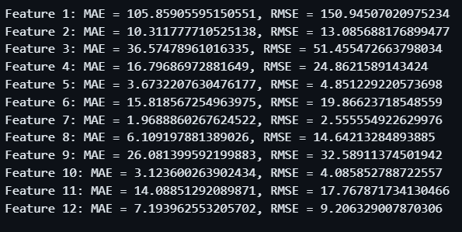

Model performance on last 6 values

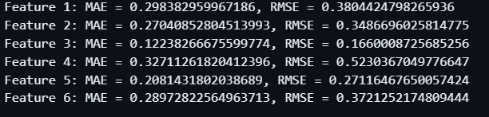

diabetes_prediction_all_patients

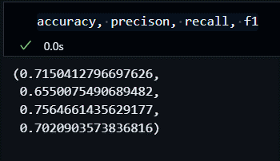

diabetes_prediction_all_patients (after knowledge driven correction)

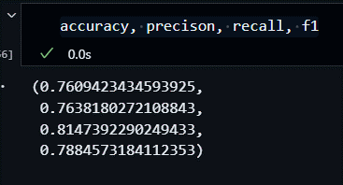

diabetes_prediction_normal_patients

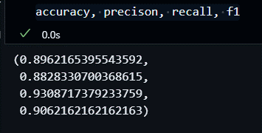

hypertension_prediction_all_patients

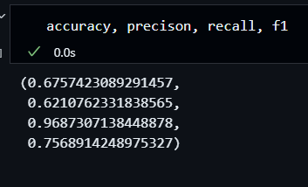

hypertension_prediction_normal_patients

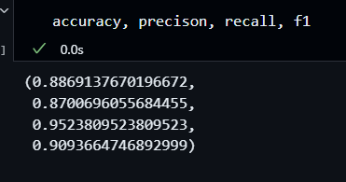

heart_prediction_all_patients

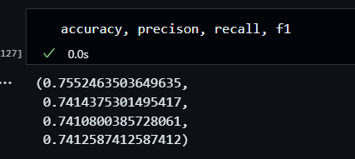

heart_prediction_normal_patients

