**University of Engineering and Technology,Taxila**

**Department of Computer Engineering**

# Lab Report 02

**For the Course of DSD lab**

**Submitted By**:Muhammad Ibrahim (21-CP-26)

**Section:** Omega

## **Lab Instructor:**Sir Shahid Ali

**Course Instructor:**Dr.Abdul rehman aslam

**Date**: 20-01-24.

## **Course Title**: DSD Lab

**Lab Tasks**

**Questions:**

1. Design and Simulate four-input OR, XOR and XNOR gates using 2 input primitive gates

**Code:**

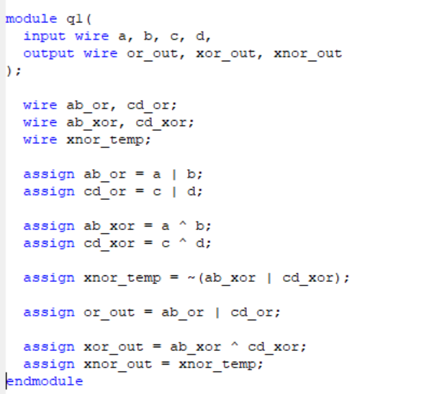

timescale 1ns / 1ps

//////////////////////////////////////////////////////////////////////////////////

// Company:

// Engineer:

//

// Create Date: 12:45:09 01/17/2024

// Design Name:

// Module Name: q1

// Project Name:

// Target Devices:

// Tool versions:

// Description:

//

// Dependencies:

//

// Revision:

// Revision 0.01 - File Created

// Additional Comments:

//

//////////////////////////////////////////////////////////////////////////////////

module q1(

input wire a, b, c, d,

output wire or_out, xor_out, xnor_out

);

wire ab_or, cd_or;

wire ab_xor, cd_xor;

wire xnor_temp;

assign ab_or = a | b;

assign cd_or = c | d;

assign ab_xor = a ^ b;

assign cd_xor = c ^ d;

assign xnor_temp = ~(ab_xor | cd_xor);

assign or_out = ab_or | cd_or;

assign xor_out = ab_xor ^ cd_xor;

assign xnor_out = xnor_temp;

endmodule

**TestBench:**

// Create Date: 13:00:06 01/17/2024

// Design Name: q1

// Module Name: C:/Users/Ibrahim/Desktop/New folder/CP21_26_Lab2_Qn1/q1test.v

// Project Name: CP21_26_Lab2_Qn1

module q1test;

// Inputs

reg a;

reg b;

reg c;

reg d;

// Outputs

wire or_out;

wire xor_out;

wire xnor_out;

// Instantiate the Unit Under Test (UUT)

q1 uut (

.a(a),

.b(b),

.c(c),

.d(d),

.or_out(or_out),

.xor_out(xor_out),

.xnor_out(xnor_out)

);

initial begin

// Initialize Inputs

a = 0;

b = 0;

c = 0;

d = 0;

// Wait 100 ns for global reset to finish

#100;

// Test sequence

// Case 1: a=0, b=0, c=0, d=0

#10 a = 0; b = 0; c = 0; d = 0;

// Case 2: a=1, b=0, c=1, d=0

#10 a = 1; b = 0; c = 1; d = 0;

// Case 3: a=1, b=1, c=0, d=1

#10 a = 1; b = 1; c = 0; d = 1;

// Add more test cases as needed

end

endmodule

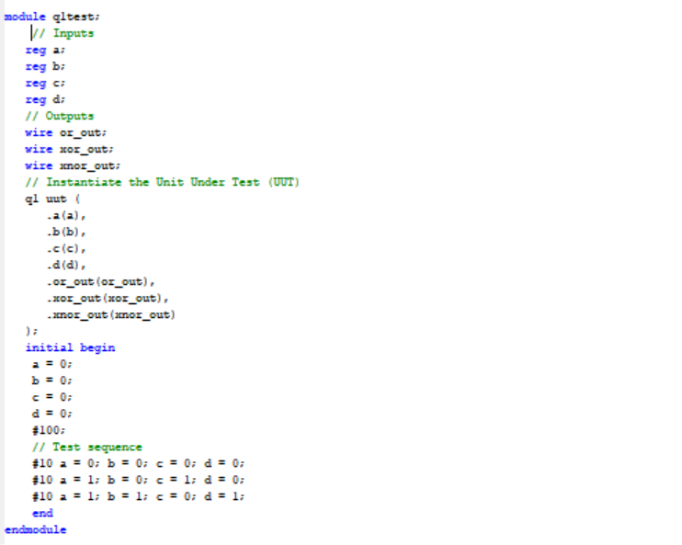

**Simulations :**

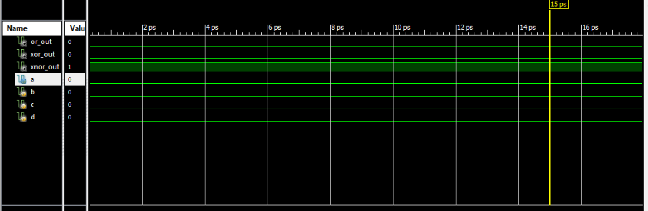

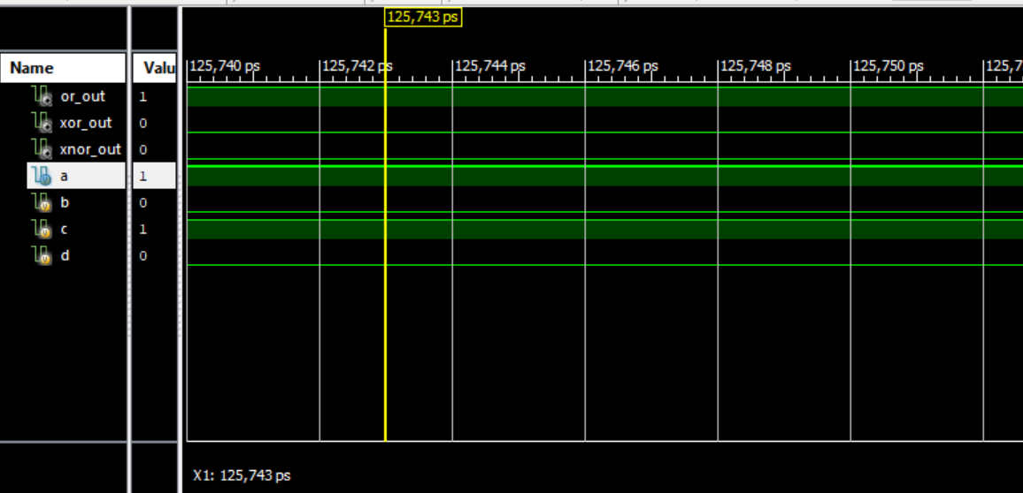

**Task 2:**

1. Simulate the design given in Figure. 1 using gate level modeling.

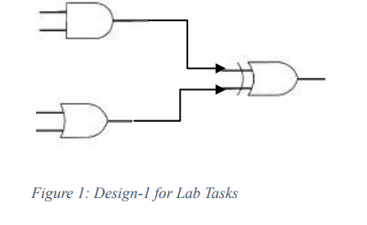

**Code:**

`timescale 1ns / 1ps

//////////////////////////////////////////////////////////////////////////////////

// Company:

// Engineer:

//

// Create Date: 13:20:54 01/17/2024

// Design Name:

// Module Name: q2

// Project Name:

// Target Devices:

// Tool versions:

// Description:

//

// Dependencies:

//

// Revision:

// Revision 0.01 - File Created

// Additional Comments:

//

//////////////////////////////////////////////////////////////////////////////////

module q2(input wire a, b, c, d,

output wire y_xor);

wire w1;

wire w2;

and a1 (w1,a,b);

or a2 (w2,c,d);

xor a3 (y_xor,w1,w2);

endmodule

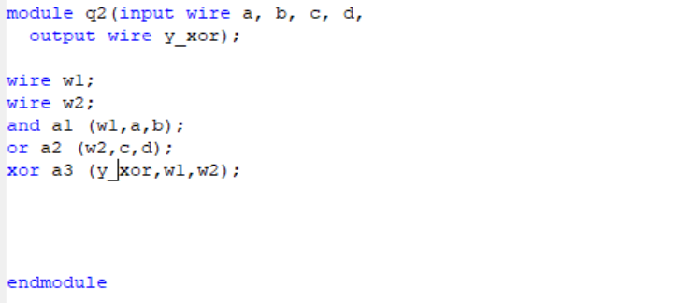

**TestBench:**

`timescale 1ns / 1ps

////////////////////////////////////////////////////////////////////////////////

// Company:

// Engineer:

//

// Create Date: 14:46:09 01/17/2024

// Design Name: q2

// Module Name: C:/Users/Ibrahim/Desktop/New folder/CP21_26_Lab1_Qn2/q2test.v

// Project Name: CP21_26_Lab1_Qn2

// Target Device:

// Tool versions:

// Description:

//

// Verilog Test Fixture created by ISE for module: q2

//

// Dependencies:

//

// Revision:

// Revision 0.01 - File Created

// Additional Comments:

//

////////////////////////////////////////////////////////////////////////////////

module q2test;

// Inputs

reg a;

reg b;

reg c;

reg d;

// Outputs

wire y_xor;

q2 uut(

.a(a),

.b(b),

.c(c),

.d(d),

.y_xor(y_xor)

);

initial begin

// Test sequence

// Case 1: a=0, b=0, c=0, d=0

#10 a = 0; b = 0; c = 0; d = 0;

// Case 2: a=1, b=0, c=1, d=0

#10 a = 1; b = 0; c = 1; d = 0;

// Case 3: a=1, b=1, c=0, d=1

#10 a = 1; b = 1; c = 0; d = 1;

// Wait 100 ns for global reset to finish

#100;

// Add stimulus here

end

endmodule

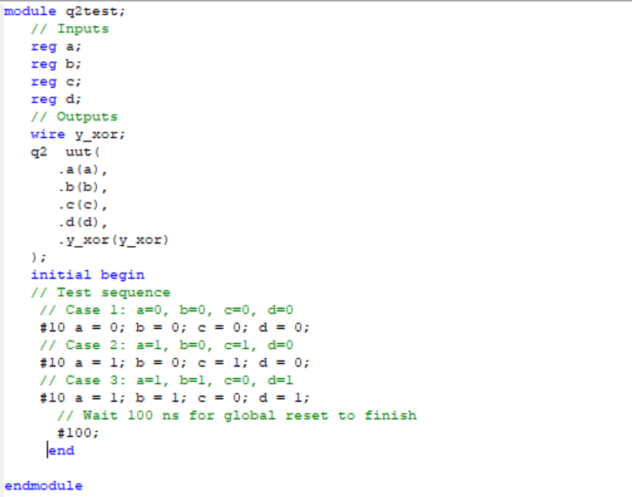

**Simulations :**

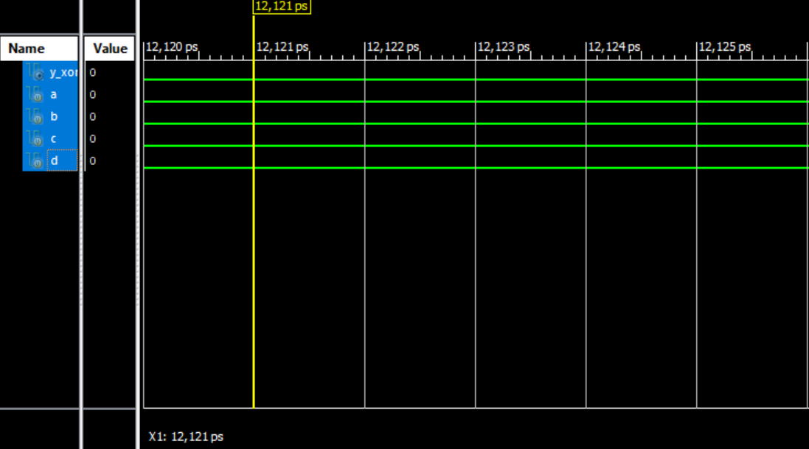

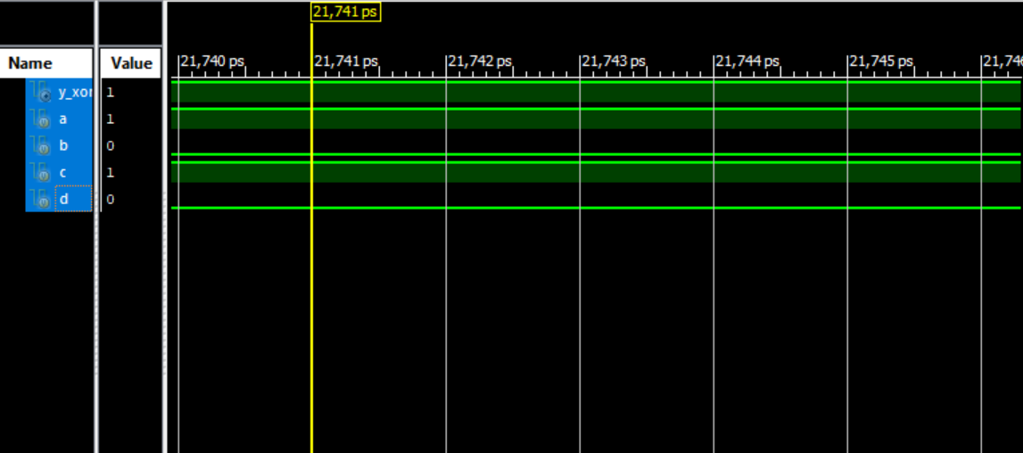

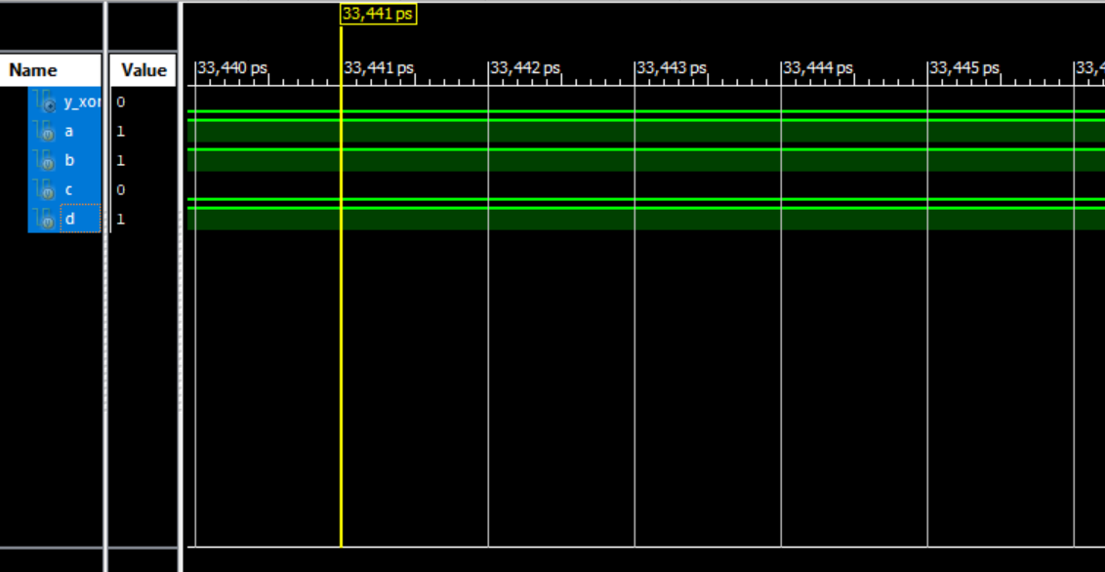

**Task 3:**

Simulate the gate level model of 4 to 1 Mux using Verilog (HDL).

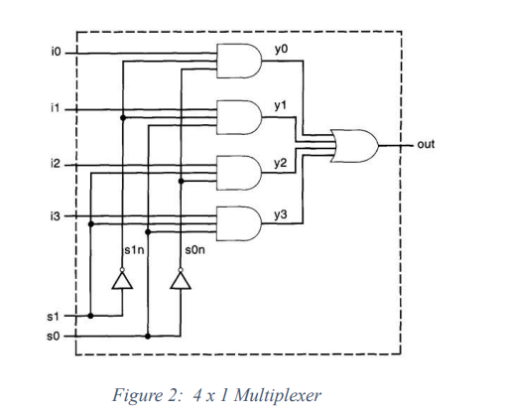

**Code:**

module q3 (

input A,B,C,D,[1:0]S,

output y

);

wire w1,w2,w3,w4,n1,n2;

not x3(n1,S[0]);

not x2(n2,S[1]);

and a1(w1,A,n1,n2);

and a2(w2,B,S[0],n2);

and a3(w3,C,n1,S[1]);

and a4(w4,D,S[0],S[1]);

or o1(y,w1,w2,w3,w4);

endmodule

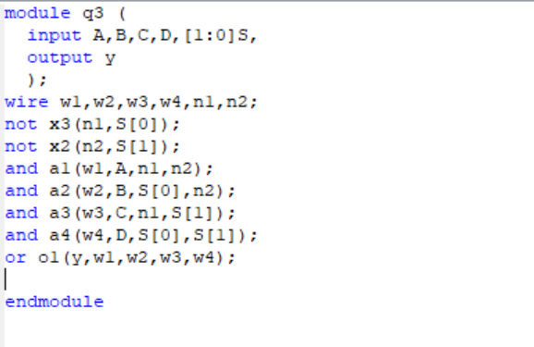

**TestBench:**

`timescale 1ns / 1ps

////////////////////////////////////////////////////////////////////////////////

// Company:

// Engineer:

//

// Create Date: 17:02:11 01/17/2024

// Design Name: q3

// Module Name: C:/Users/Ibrahim/Desktop/New folder/CP21_26_Lab2_q3/Q3test.v

// Project Name: CP21_26_Lab2_q3

// Target Device:

// Tool versions:

// Description:

//

// Verilog Test Fixture created by ISE for module: q3

//

// Dependencies:

//

// Revision:

// Revision 0.01 - File Created

// Additional Comments:

//

////////////////////////////////////////////////////////////////////////////////

module Q3test;

// Inputs

reg A, B, C, D;

reg [1:0] S;

// Output

wire y;

// Instantiate the module

q3 uut (

.A(A),

.B(B),

.C(C),

.D(D),

.S(S),

.y(y)

);

initial begin

// Initialize inputs

A = 0;

B = 1;

C = 0;

D = 1;

S = 2'b00;

#10 A = 1;

#10 B = 0;

#10 C = 1;

#10 D = 0;

#10 S = 2'b01;

end

endmodule

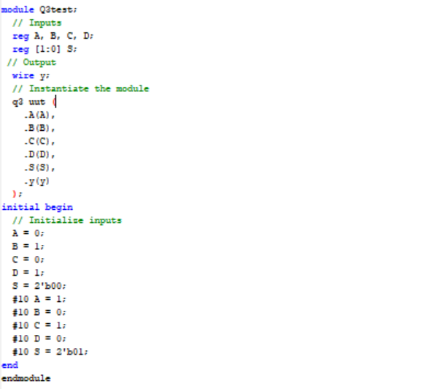

**Simulations :**

