# Lab Objective:

To know the working of some of the commands of SQL.

## Lab Tasks:

## 1): Consider the following table:

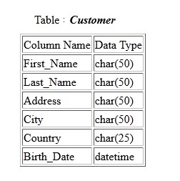

* Write an SQL statement to convert the above table into following table.

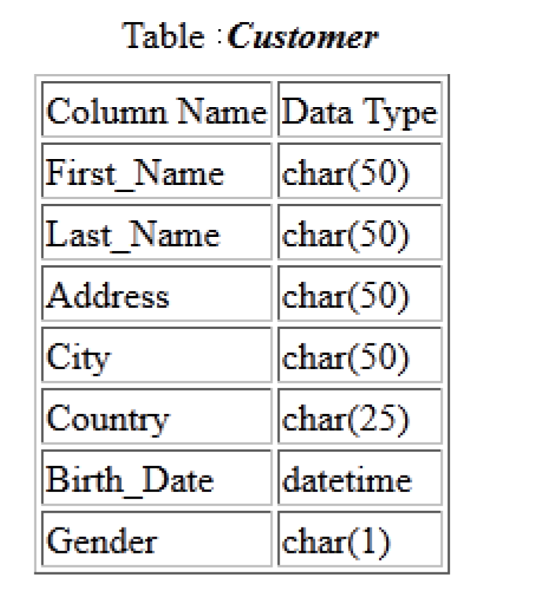

* Write SQL statement(s) to change “Birth_Date” to “Age” with data type Integer.
* Create an Index on the “Customer” table using “First_Name” and “Age”

**Code:**

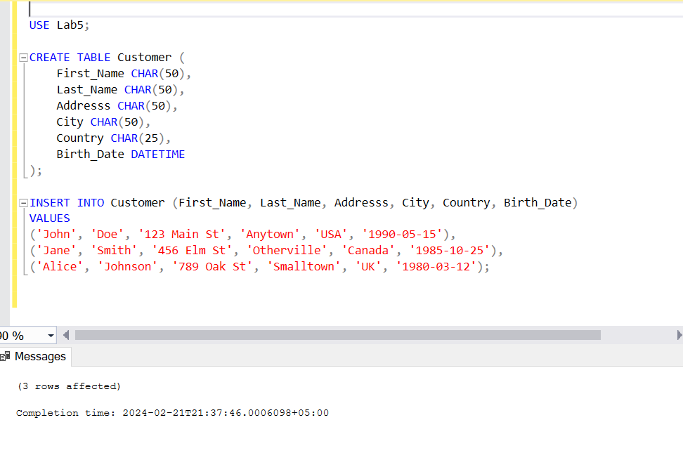

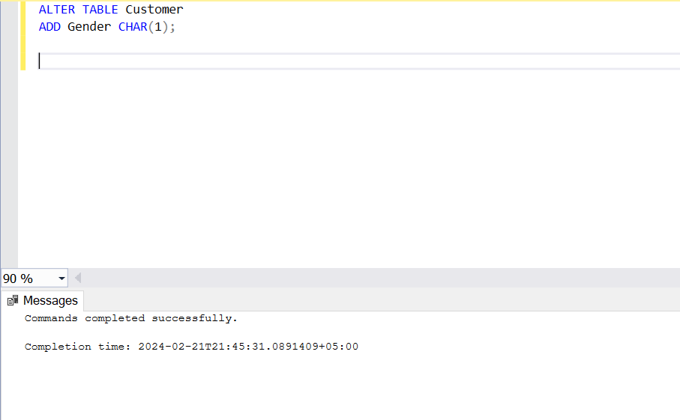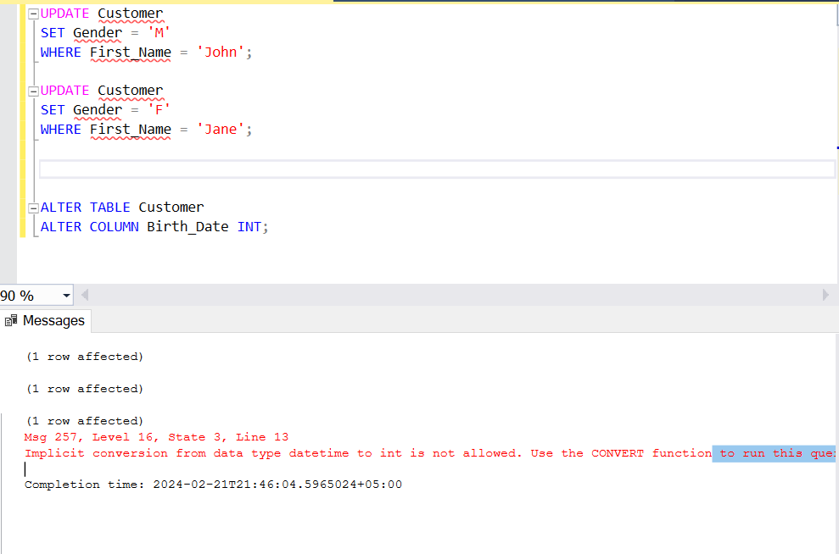

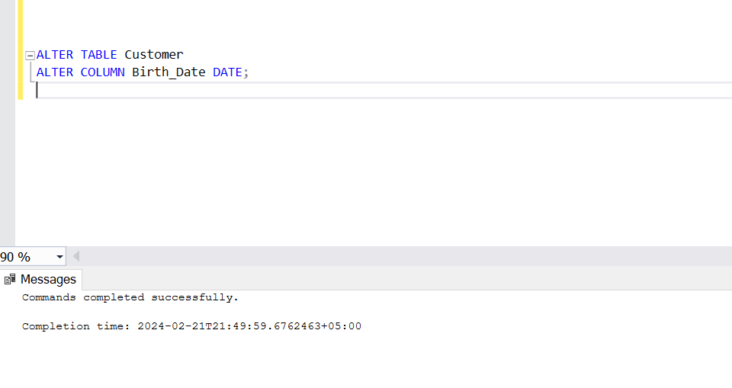

USE Lab5;

CREATE TABLE Customer (

First_Name CHAR(50),

Last_Name CHAR(50),

Addresss CHAR(50),

City CHAR(50),

Country CHAR(25),

Birth_Date DATETIME

);

INSERT INTO Customer (First_Name, Last_Name, Addresss, City, Country, Birth_Date)

VALUES

('John', 'Doe', '123 Main St', 'Anytown', 'USA', '1990-05-15'),

('Jane', 'Smith', '456 Elm St', 'Otherville', 'Canada', '1985-10-25'),

('Alice', 'Johnson', '789 Oak St', 'Smalltown', 'UK', '1980-03-12');

ALTER TABLE Customer

ADD Gender CHAR(1);

UPDATE Customer

SET Gender = 'M'

WHERE First_Name = 'John';

UPDATE Customer

SET Gender = 'F'

WHERE First_Name = 'Jane';

UPDATE Customer

SET Gender = 'F'

WHERE First_Name = 'Alice';

ALTER TABLE Customer

ALTER COLUMN Birth_Date DATE;

.

.

* Write an SQL statement to delete the **“ProductName”** entries from the table.

**CODE:**

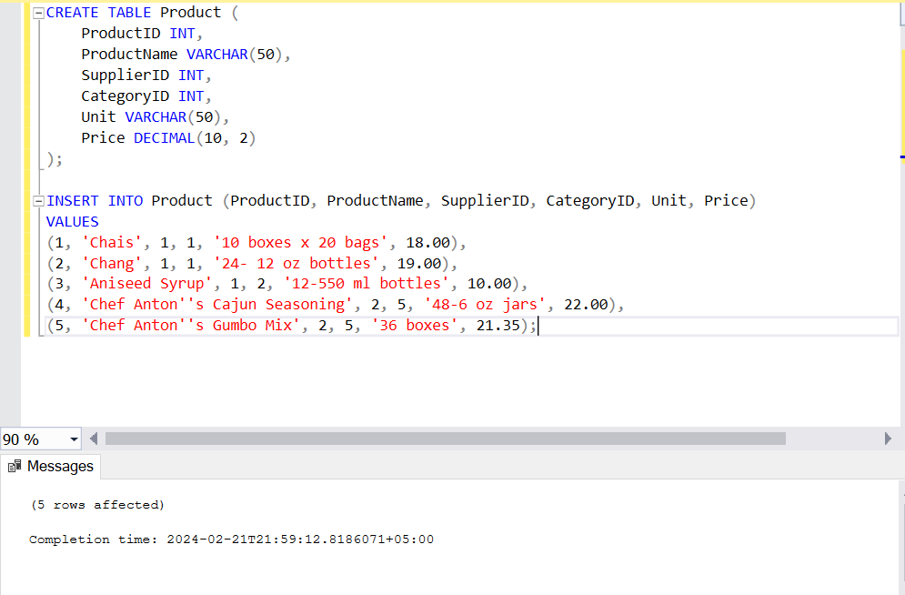

**2**

**)**

**:**

**Consider the following**

**table**

**“Product**

**”**

**:**

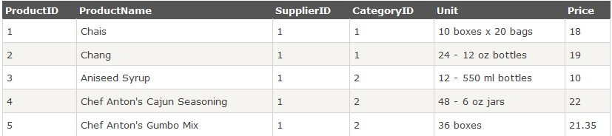

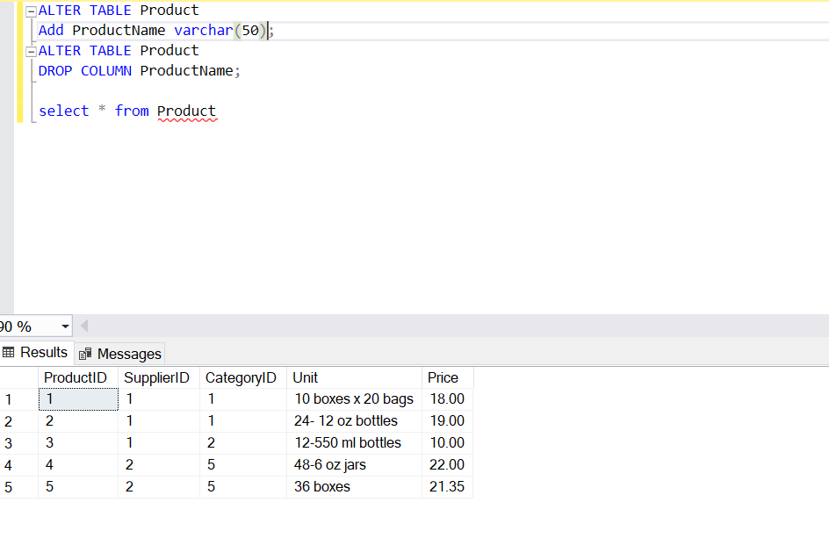

## 3): Consider the following tables:

## Student

|  |  |
| --- | --- |
| **Student_ID** | **Student_Name** |
| 38214 | Ali |
| 54907 | Ahsan |
| 66324 | Bilal |
| 70542 | Naeem |

Create the above table by keeping their first columns as primary key. After the creation of the table, solve the following:

* Write a query to add an attribute, Class to the Student table
* Write a query to change the field for Student_Name from 25 characters to 40 characters
* Write a query to add another column in the Student table with an auto increment field
* Write a query to add another column Department in the Student table. The column must not contain any value other than the values COMPUTER or SOFTWARE
* Write a query to change the auto increment field to start from 50
* Write a query to remove the Student table

**CODE**

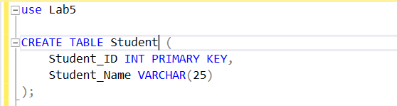

INSERT INTO Student (Student_ID, Student_Name)

VALUES

(38214, 'Ali' ),

(54907, 'Ahsan'),

(66324, 'Bilal'),

(70542, 'Naeem');

select * from Student

