Marketing Strategies:

1. Professional Referring Marketing :

You can show other doctors recommending using advanced facilities at fortis for cancer treatment and heart surgeries

1. Internet Marketing:

Promoting and displaying ads of our hospital on websites like youtube etc. (If you have ipl ka dat website uspe daal sakta hai just chota add to dekh)

1. Internal Marketing:

Testimonials, word-of-mouth advertising, promoting fortis to existing users(eg. Pay Rs 500 on ur frst 3 visits and be a lifetime member of fortis needing to pay Rs 150 only for your next each visits)

1. External Marketing:

Classified Ads on BEST buses, Railways, Societies, Radio, Newspapers.

Free health checkups.

1. Public Relations:

Interviews on our websites, Brochures to be delivered on existing users address.

Sponsoring charity events like TCS Fit for LIFE.

1. Free Media:

Various doctors writing free articles in HT, TOI etc.

**NOTE:**

**Il make the brochure and marketing plan. Also il send the pics of charity events and that marketing in society and transport.**

Images:

1. Enquire or write to a doctor:

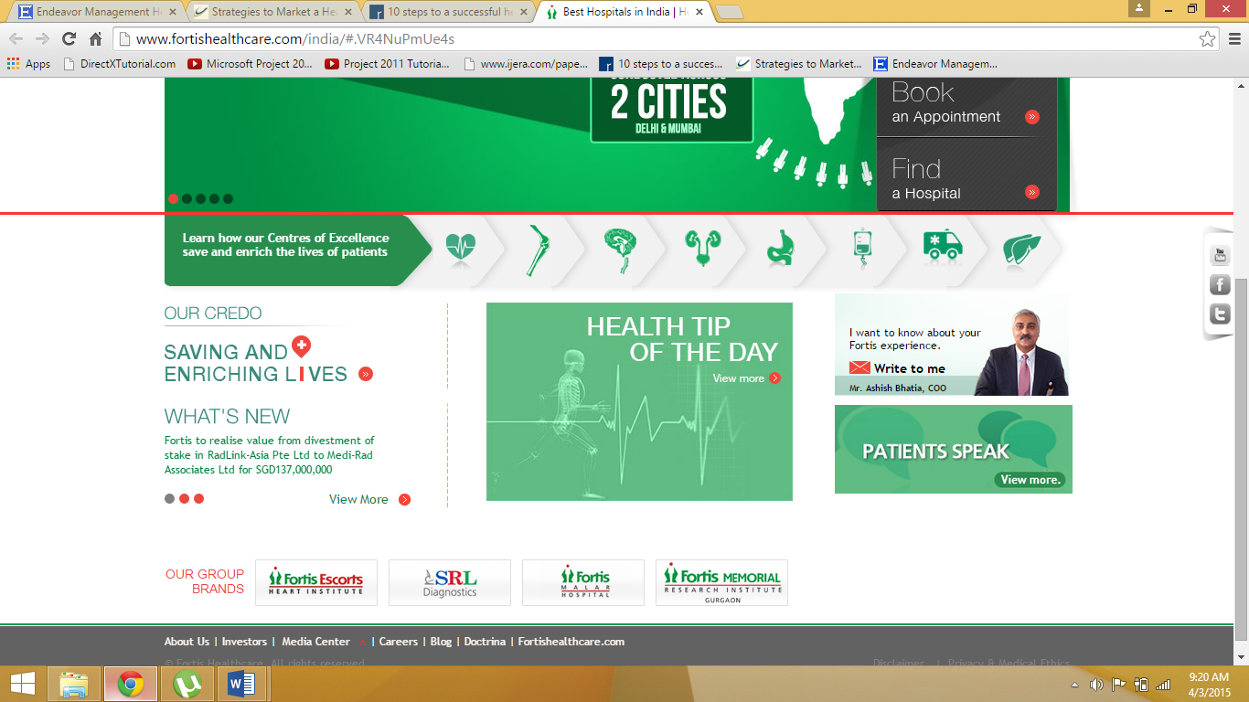

Wel use our ismdr ka wo chat thing for live queries. Ek me Fortis health care dal denge and multiple clients.