Morse Code Application

Instructor: Zahidur Rahman

BY: Ibrahim Jaber

PROG1090J-Intermediate Java Programming

June 10th, 2020

Copyrights Reserved- Ibrahim Jaber 2020.

ABSTRACT

This document is the part of the final Java Project, this report includes explanations about the application, the kind of resources that has been used in this project and possible new features in the future. The project is about Morse Code, it demonstrates how to use Morse code and provides educational resources regarding the topic as well. I have always wanted to make an encryption application, I thought the best way to start is by learning Morse Code and create an Application that can help others interested in Cryptography as well to get them started learning a bit of Cryptography.

Table of Contents

Abstract…………………………………………….2

Introduction…………………………………….4

Design Diagrams…………………………………5

-Classes UML Design……………………..5

-ERD Design…………………………………..6

Outside the curriculum tools........................... 8

-Add links and images……………………8

-Using MSSQL……………………………….9

The process of Implementing Morse code application....................10

-Logic part………………………………………10

-UI/GUI Logic part…………………………..11

Testing process ................................................... 14

What is the next step?...................................... 14

Conclusion............................................................... 15

References............................................................... 16

Graphical user Manual...................................... 18

Introduction

The Morse Code Application was inspired by my admiration for Cryptography.

Morse Code was invented by **Samuel Finley Breese Morse, He was an American inventor and painter.**

In his middle age Morse contributed to the Innovation of a single-wire telegraph system. He was Co-developer and a major contributor for the commercial use of Morse Code. I was interested in learning more of Morse Code and resulted of me making a Morse Code Application. The Application has a login page that save the user data in a Database, and the convertor section In which you can convert English words and numbers to Morse Code, along side that there are educational resources to teach Morse code. This report is Documentation and summarization of the application and the technologies that were used in the making of this Application.

Classes Diagrams (UML DESIGN).

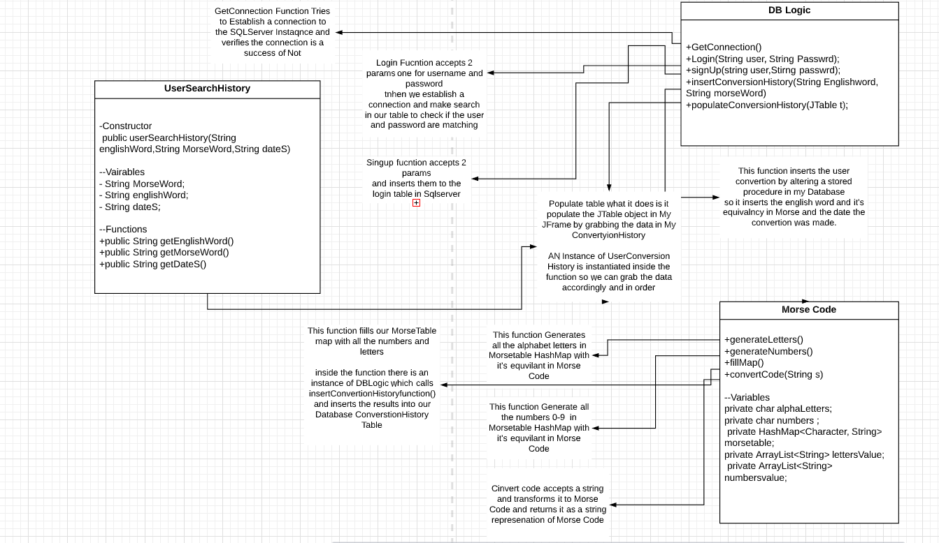

DataBase Diagrams (ERD DESIGN).

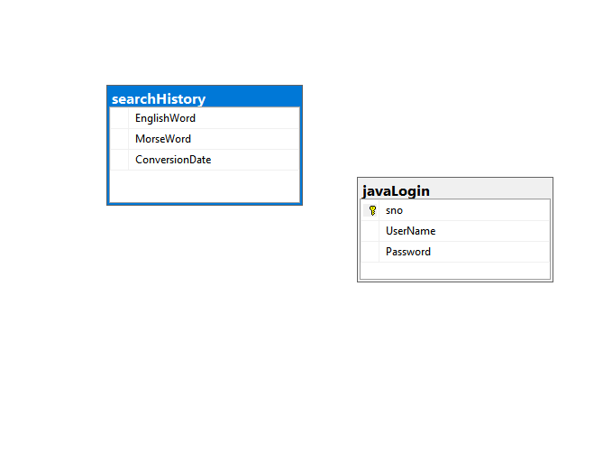

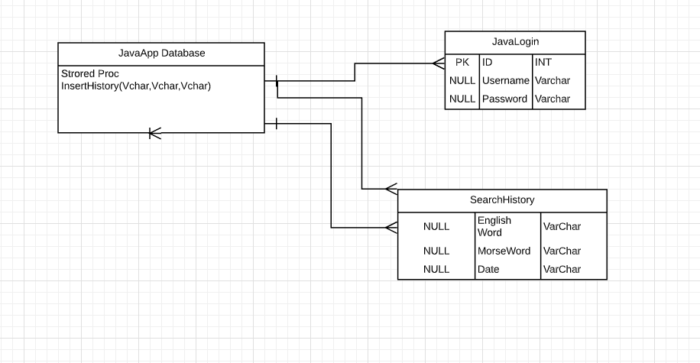

The Technologies That has been used outside the Curriculum

There has been some outside resources research that has been used to meet the expectations of application.

Adding links and Images

One the concerns in this project were how to add images and Hyperlinks to buttons and labels in the form. There was lots of option like using XML or keep using native implemented technologies within the editor. Eventually I want on to keep using the technologies that I have, so I started researching on how to attach images and links, the easiest way to attach an image was to have an icon around a JLable and stretch the image, on the other hand adding links wasn’t complicated as I imagined, it was as easy as attaching a URL to a button. The article for it was very informative the link for it is: <https://www.codejava.net/java-se/swing/how-to-create-hyperlink-with-jlabel-in-java-swing> entitled as : “How to Create hyperlink with JLable in Java Swing”

Using another DBMS (SQL Server)

Using other DBMS like MySQL, I have taken the approach of using SQL Server.

I would fairly say it was one of the most challenging parts of the project, I had to create a SQL Server Instance instead of creating a user on my machine. That toke a fairly bit of time to figure that out. Then try to establish the connection in the IDE Which was another challenging thing to do, Moreover I had to find the correct .jar file for the JDBC file to establish the connection to my SQL Server, also there has been port adjustments so the connection can be established as well as allowing TCP/IP connection which I had to do in the SQL server management Studio. A lot of articles helped me complete these obstacles.

Articles that helped me:  
<https://docs.microsoft.com/en-us/sql/connect/jdbc/step-3-proof-of-concept-connecting-to-sql-using-java?view=sql-server-ver15> entitled as “Proof of Concept connecting to SQL using Java”

<https://docs.microsoft.com/en-us/sql/connect/jdbc/using-the-jdbc-driver?view=sql-server-ver15>

entitled as “Using JDBC Driver”

<https://docs.microsoft.com/en-us/sql/relational-databases/security/authentication-access/create-a-login?view=sql-server-ver15>

entitled as “Create a Login”

<https://support.microsoft.com/en-ca/help/328476/description-of-tcp-ip-settings-that-you-may-have-to-adjust-when-sql-se>

entitle as “Description of TCP/IP settings that you may have to adjust when SQL Server connection pooling is disabled”

<https://docs.microsoft.com/en-us/sql/sql-server/install/configure-the-windows-firewall-to-allow-sql-server-access?view=sql-server-ver15>

entitled as “Configure the windows Firewall to Allow SQL Server Access”

The process of Implementing the Morse Code Application

The brainstorming process toke a bit of time, so I can implement of what I was thinking in the most easy and transparent way possible.

Logic Part

1-Data base connection and functionality

The logic part mostly consisted of trying to establish reliable connection to the database, by instantiating connection objects to connect to the SQL server instance, also making some functionality to insert and extract data from tables all this has been done in one class with member methods.

2-Morse code logic

What was mostly invested in is making the Morse Code class general as possible and simple to use, so I’ve used multiple data structures to make the conversion to Morse code operation as smooth as possible, what I did is I had a HashMap that saves all the alphabetical letters and it’s equivalence in Morse code as well as the numbers and their equivalence in Morse Code. whenever I convert from English words the look up for each letter individually will be fast.

UI/GUI Design and Logic

In total I reached a decision of having 7 forms that they are iteratively connected.

Form 1 (Login Page)

Form one has 2 text boxes and 3 labels and 1 button

The text boxes are for user login info (Password, Username),

The user gets greeted with this form, in which asks for login info

The moment the user inserts the info and click on the login button, an authentication process gets altered by calling member method in (DBLogin) class and verifies if the user info is valid or not. If the user does not have login credentials, there is the option singing up by clicking the link that leads to sign up page (Form 2).

Form 2 (Sign up)

Form 2 has 2 text boxes, 2 labels and 1 button

The user gets to insert their credentials and once they are done

They have the option to click the sing up button. when the sing up button is clicked it will alter the process of saving the user info into the Database table by calling a member method from DBLogic class. Once the process is done the user will be transferred to login page to login with the credential hat got created.

Form 3 (Morse Code History Form)

Form 3 has 1 text box, 1 Label and 4 Buttons.

Once the user logged in successfully, they will be greeted with a brief history of what Morse code. That explains whom invented it etc..

The other 4 buttons lead to the 4 forms.

Form 4 (Morse Code Alphabet & Machine sample)

Form 4 has 4 Labels and 4 buttons.

2 of the 4 labels has images attached to them that show the alphabet of Morse code and a vintage Morse Code machine that was used when people used to communicate in Morse.

Form 5 (Morse Code Convertor)

Form 5 has 3 Labels, 5 Buttons and 1 text box

This page lets the user to convert English words to Morse Code.

When the user finishes typing in the text, they can click on the convert button,

Which calls member method of (morsecode) class and converts it to Morse.

Once it has been converted, another member method will be altered from (DBLogic) class that grabs the word and the converted word and the date of which the word has been converted and inserts them to the Database table.

Form 6(Conversion History)

Form 6 has 1 Label,1 table,4 Buttons.

Once the user opens the page the table will populated of the search History of the words that has been converted and their equivalency in English as well as the date they were converted at. The table gets populated by calling one of the member methods of (DBLogic)class. The method accesses the Database table and populate the table with well organized manner by having an instance of (userSearchHistory) Instance to grab the data in order and populate it in the JTable.

Form 7(Resources)

From 7 has 7Buttons,3 Labels.

3 out of the 7 buttons have images and links to outside resource, to explain to the user more on what is Morse Code? But watching YouTube video or reading about it in Wikipedia or learn the alphabet. The initial idea was having only a video, but I thought more exposure would be beneficial for the purpose of this application.

Testing Process

The testing process was easy and not complicated, I’ve taken the approach of iterative testing. When every section is completed a set of tests are being applied and if there are any bugs, I go back and fix them. The NetBeans IDE was a major factor to troubleshoot some of the logical errors.

What is the next step?

The next step will be building a chatting system in which people will be able to communicate in Morse Code.

There a lot of improvements that could be done on the UI side, by providing more reliable Interface, more over the Morse conversion section does not recognize any punctuation, which I will be working on it later.

Conclusion

All in all, the implementation of the application was a success there was some rough edges here and there, that could have prevented the progress of this application.

For the first trying to build a desktop application it was good and enjoyable.

It opened my eyes on taking initiative and not wait for anyone to expose concepts to me, but rather go out there and try to explore more on my own which it felt fulfilling and a lot more productive.

References

How to Create Hyperlinks

<https://www.codejava.net/java-se/swing/how-to-create-hyperlink-with-jlabel-in-java-swing>

Java Connect to Microsoft SQL Server

<https://www.codejava.net/java-se/jdbc/connect-to-microsoft-sql-server-via-jdbc>

Proof of Concept connecting to SQL using Java

<https://docs.microsoft.com/en-us/sql/connect/jdbc/step-3-proof-of-concept-connecting-to-sql-using-java?view=sql-server-ver15>

Using JDBC Driver

<https://docs.microsoft.com/en-us/sql/connect/jdbc/using-the-jdbc-driver?view=sql-server-ver15>

Create a SQL Authentication Login

<https://docs.microsoft.com/en-us/sql/relational-databases/security/authentication-access/create-a-login?view=sql-server-ver15>

Description of TCP/IP settings that you may have to adjust when SQL Server connection pooling is disabled

<https://support.microsoft.com/en-ca/help/328476/description-of-tcp-ip-settings-that-you-may-have-to-adjust-when-sql-se>

Configure the windows Firewall to Allow SQL Server Access

<https://docs.microsoft.com/en-us/sql/sql-server/install/configure-the-windows-firewall-to-allow-sql-server-access?view=sql-server-ver15>

How Does Morse Code Work? Video

<https://www.youtube.com/watch?v=iy8BaMs_JuI&feature=youtu.be>

History of Morse Code. Wikipedia

<https://en.wikipedia.org/wiki/Morse_code>

Learn Morse Code. Website.

<https://morse.withgoogle.com/learn/>

Graphical User Manual

1

1

1

2

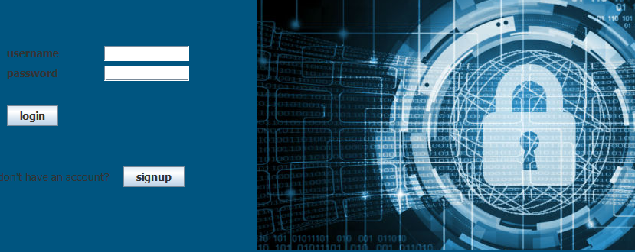1-Username field is to insert your username

2-insert password

3-press to login to the application

4-sign up if you do not have an account

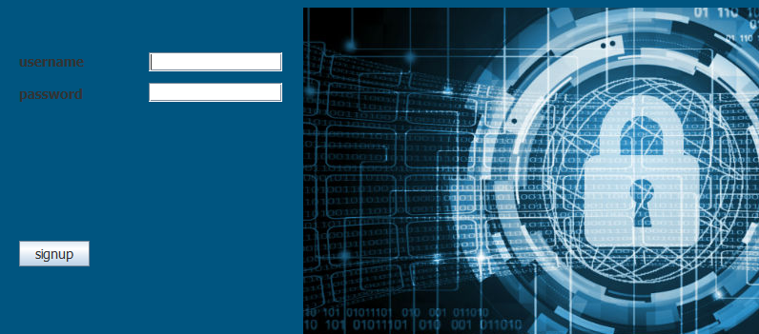1-Username field is to insert your username

1

2

3

2-insert password

3-Signup button to store your credentials and can access the application

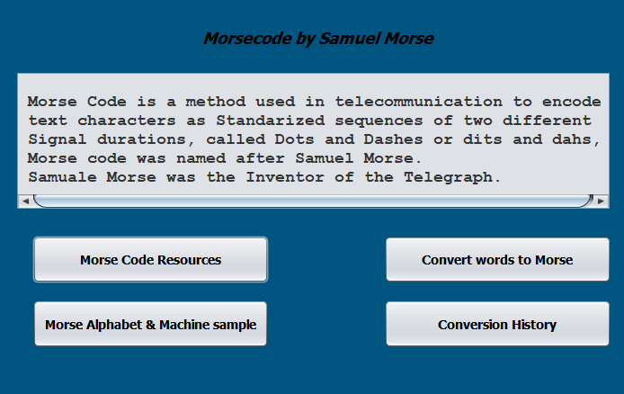

4

2

3

1

1-A button that leads to the resources page

2-A button that leads to converting words to Morse

3-A button that leads to Morse alphabet and machine image examples

4-A button that leads to the conversion history

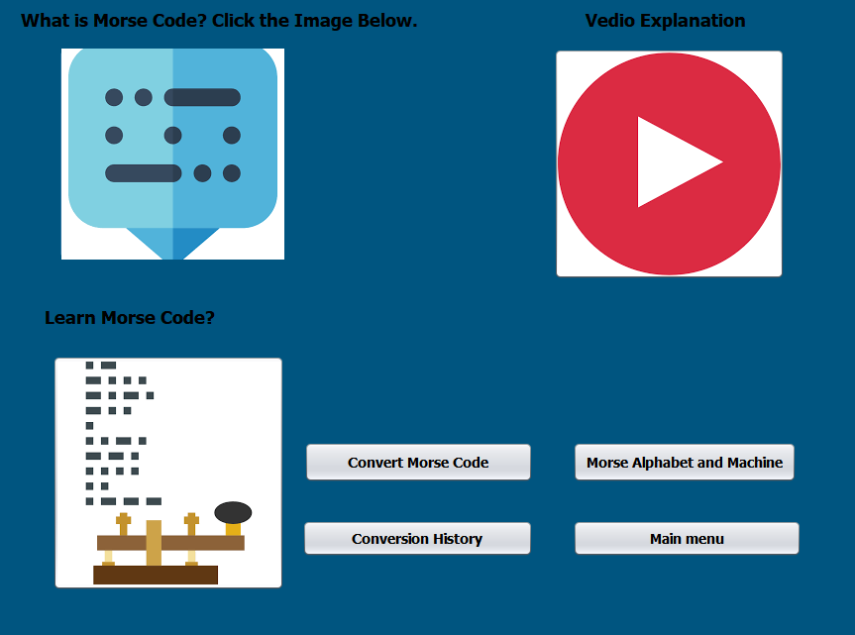

3

2

1

1-A button that leads to Wikipedia for more information about Morse Code

2-A button that leads to a YouTube video to explain what is Morse code

3-A button that leads to a website that is powered by google to teach people Morse Code

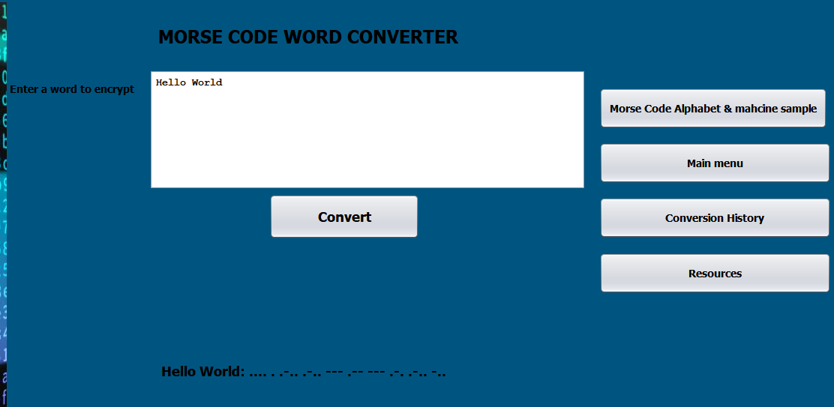

3

1

2

1-Text box for the user to input words to be converted to Morse Code

2-Convert Button once clicked the word will be clicked

3-The result will be show converted to Morse Code

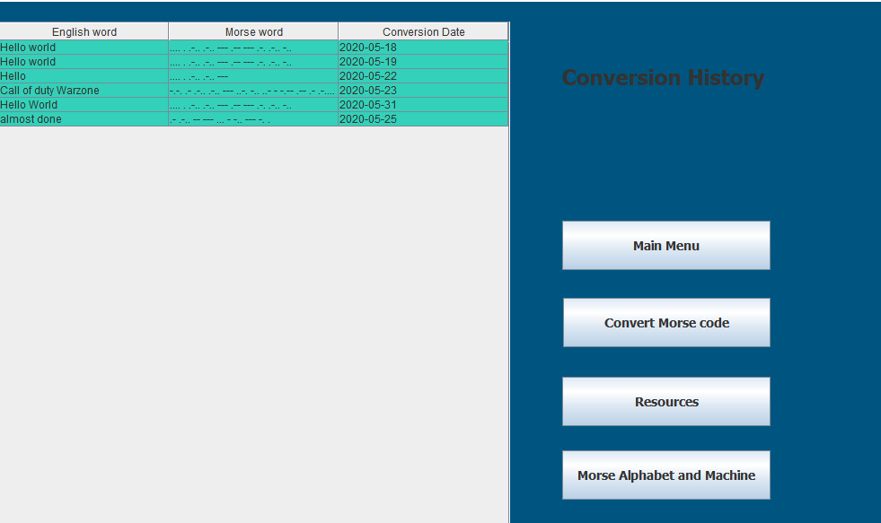

1

1-this section of the application shows the conversion history (English word, Morse code style word, date of conversion)