**NOTE:[This PDF contain all tasks will screenshots, I have also attached all php files and .sql files]**

**NAME :: IBRAR BABAR**

**ROLL NO. 19P-0104**

**DATABASE LAB**

**ASSIGNMENT#2**

**Question # 01**

source G:\4th Semester\DataBase_Lab\Assignments\Assignment#2\university.sql

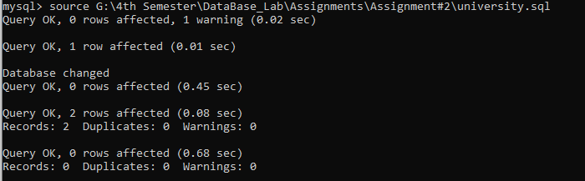

CREATE TABLE courses (

course_code varchar(10) NOT NULL,

credit_hour INT NOT NULL,

course_name VARCHAR(16) NOT NULL,

PRIMARY KEY (course_code)

);

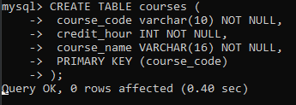

create table study(

roll_no varchar(10) not null,

course_code varchar(10) not null,

primary key(roll_no,course_code)

);

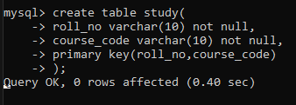

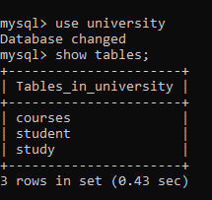

COURSE REGISTRATION FORM

<html>

<head>

 <title>Registration Form</title>

</head>

<body>

<?php if (isset($_GET['form_submitted'])){

//this code is executed when the form is submitted

?>

<h2>Thank You <?php echo "Course Registration from"; ?>

</h2>

<p>You have been registered as

 <?php echo "<br />"; ?>

 <?php echo "course_code : " . $_GET['course_code'];?>

 <?php echo "<br />"; ?>

 <?php echo "credit_hour : " . $_GET['credit_hour'];?>

 <?php echo "<br />"; ?>

 <?php echo "course_name : " . $_GET['course_name'];?>

 <?php

 $username = 'root';

 $password = '';

 try {

 $conn = new

PDO("mysql:host=localhost;dbname=university", $username,

$password);

// set the PDO error mode to exception

 $conn->setAttribute(PDO::ATTR_ERRMODE,

PDO::ERRMODE_EXCEPTION);

 echo "Connected successfully";

 } catch (PDOException $e) {

 echo "Connection failed: " . $e->getMessage();

 }

 $course_code = $_GET["course_code"];

 $credit_hour = $_GET["credit_hour"];

 $course_name = $_GET["course_name"];

 //$conn->query("insert into courses values('$course_code ',' $credit_hour ',' $course_name')");

 $conn->query("insert into courses values(' $course_code ',' $credit_hour ',' $course_name')");

?>

</p>

<p>Go <a href="/lab/assign2.php">back</a> to the

form</p>

<?php }

else { ?>

 <h2>Course Registration Form</h2>

 <form action="Assign2.php" method="GET">

 course_code:

 <input type="text" placeholder="course_code"

name="course_code">

<br> credit_hour:

 <input type="text" placeholder="credit_hour"

name="credit_hour">

 <br> course_name:

 <input type="text" placeholder="course_name"

name="course_name">

 <input type="hidden" name="form_submitted"

value="1" />

 <br>

 <input type="submit" value="Submit">

 </form>

<?php } ?>

</body>

</html>

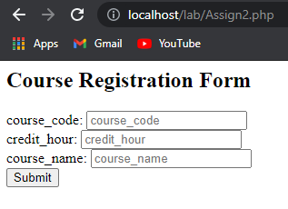

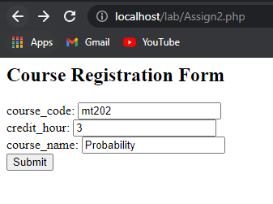

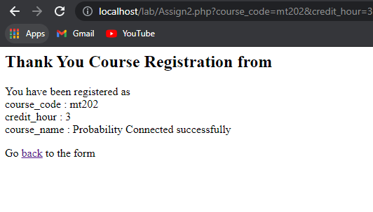

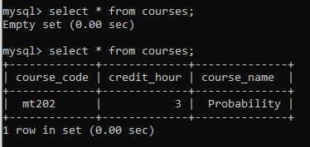

NOW I HAVE THESE THREE TABLES.

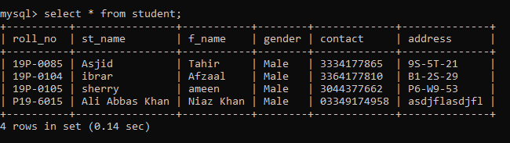

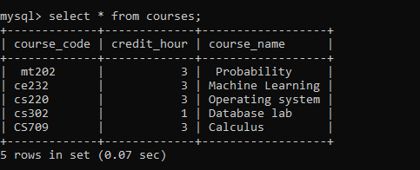

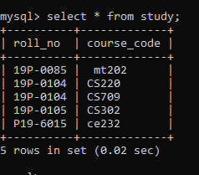

<html>

<head>

    <title>Student Information</title>

    <style type="text/css">

#side_bar{

background-color: whitesmoke;

padding: 50px;

width: 150px;

height: 150px;

}

</style>

    <link rel="stylesheet" href="https://stackpath.bootstrapcdn.com/bootstrap/4.3.1/css/bootstrap.min.css" integrity="sha384-ggOyR0iXCbMQv3Xipma34MD+dH/1fQ784/j6cY/iJTQUOhcWr7x9JvoRxT2MZw1T" crossorigin="anonymous">

</head>

<body>

<?php if (isset($_POST['roll_no'])) {

    $username = 'root';

    $password = '';

    // Check connection

    try {

        $conn = new PDO("mysql:host=localhost;dbname=university", $username, $password);

        // set the PDO error mode to exception

        $conn->setAttribute(PDO::ATTR_ERRMODE, PDO::ERRMODE_EXCEPTION);

        echo "Connected successfully";

    } catch(PDOException $e) {

        echo "Connection failed: " . $e->getMessage();

    }

    $roll_no = $_POST["roll_no"];

    // where user id = 1301 OR 1=1

    $query_1 = $conn->prepare("select * from student where roll_no = ?");

    $query_1->execute([$roll_no]);

    $result = $query_1->fetchAll(PDO::FETCH_ASSOC);

   // $query_1 = $conn->prepare("select * from study where roll_no = ?");

    //$query_1->execute([$roll_no]);

    //$result = $query_1->fetchAll(PDO::FETCH_ASSOC);

 //    die;

    ?>

    <h2>Searched Student <?php echo "Information"; ?></h2>

    <table class="table">

        <thead>

        <tr>

            <th>Roll NO</th>

            <th>Student Name</th>

            <th>Father Name</th>

            <th>Gender</th>

            <th>Contact</th>

            <th>Address</th>

        </tr>

        </thead>

        <tbody>

        <?php

        foreach ($result as $key=>$value){

            echo '<tr>

               <td>'.$value["roll_no"].'</td>

               <td>'.$value["st_name"].'</td>

               <td>'.$value["f_name"].'</td>

               <td>'.$value["gender"].'</td>

               <td>'.$value["contact"].'</td>

               <td>'.$value["address"].'</td>

            </tr>';

        }

        ?>

        </tbody>

    </table>

    <?php

                $roll_no = $_POST["roll_no"];

                $query_1 = $conn->prepare("select * from study where roll_no = ?");

                $query_1->execute([$roll_no]);

                $result = $query_1->fetchAll(PDO::FETCH_ASSOC);

        ?>

        <h2>Registered Courses</h2>

        <table class="table">

        <thead>

        <tr>

            <th>Roll NO</th>

            <th>Course Code</th>

        </tr>

        </thead>

        <tbody>

        <?php

        foreach ($result as $key=>$value){

            echo '<tr>

               <td>'.$value["roll_no"].'</td>

               <td>'.$value["course_code"].'</td>

            </tr>';

        }

        ?>

        </tbody>

    </table>

    <?php

                $roll_no = $_POST["roll_no"];

                $query_1 = $conn->prepare("select * from courses join study

                using (course_code) join student using (roll_no) where roll_no != ?");

                $query_1->execute([$roll_no]);

                $result = $query_1->fetchAll(PDO::FETCH_ASSOC);

        ?>

        <h2>Available Courses</h2>

        <table class="table">

        <thead>

        <tr>

            <th>Course Code</th>

            <th>Credit Hour</th>

            <th>Course Name</th>

        </tr>

        </thead>

        <tbody>

        <?php

        foreach ($result as $key=>$value){

            echo '<tr>

               <td>'.$value["course_code"].'</td>

               <td>'.$value["credit_hour"].'</td>

               <td>'.$value["course_name"].'</td>

               <td>

               <a href="Assign2.php" class="btn btn-primary" role="button">Register</a>

               </td>

               </tr>';

        }

        ?>

        </tbody>

    </table>

    <?php

}

else {

    ?>

<div class="row">

<div class="col-md-4" id="side_bar">

<ul>

    <h2>Search Student.</h2>

    <form action="abc.php" method="POST">

        Roll NO:

        <input type="text" name="roll_no">

        <button>Search</button>

    </form>

</ul>

</div>

</div>

    <?php

}

?>

</body>

</html>

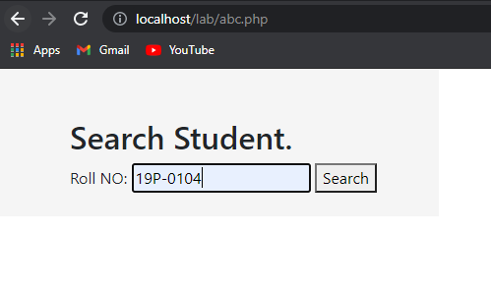

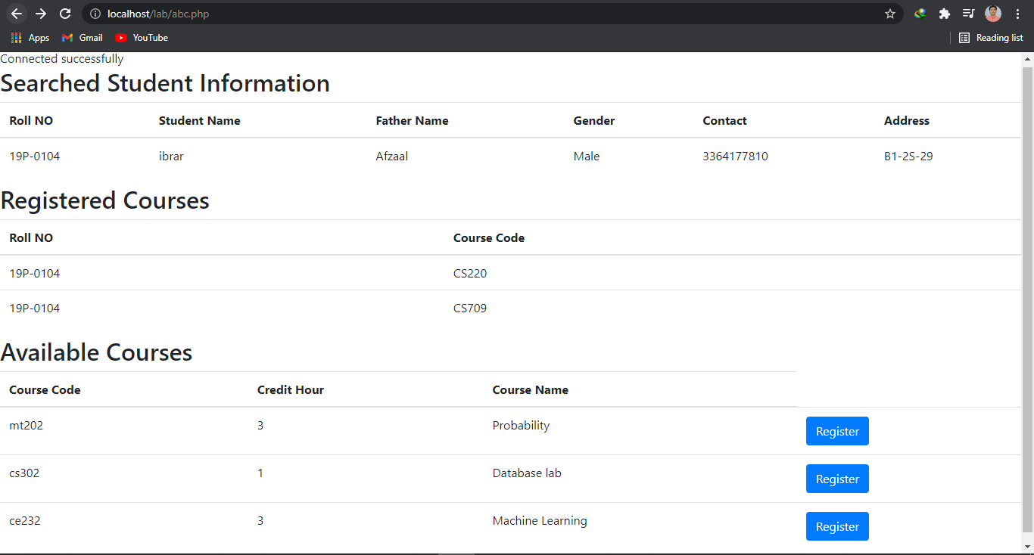

**Question # 02**

create database person;

USE PERSON;

CREATE TABLE USERS (

USER_ID MEDIUMINT(8) UNSIGNED NOT NULL AUTO_INCREMENT,

USERNAME VARCHAR(15) NOT NULL,

PASSWORD VARCHAR(20) NOT NULL,

EMAIL VARCHAR(30) NOT NULL,

PRIMARY KEY (USER_ID)

);

INSERT INTO USERS VALUES(1, 'ali', 'max', 'Am@GMAIL.COM');

INSERT INTO USERS VALUES(2,'super','user','sup@GMAIL.COM');

INSERT INTO USERS VALUES(3,'fast','exam12','fast123@GMAIL.COM');

INSERT INTO USERS VALUES(4,'nawaz','vpn68','nuces@yahoo.COM');

INSERT INTO USERS VALUES(5,'aslam','dopxyz','supreme@yahoo.COM');

INSERT INTO USERS VALUES(6,'rimsha','punjab','giki5@outlook.COM');

INSERT INTO USERS VALUES(7,'ibrar','hello','hyed@gamil.COM');

INSERT INTO SUMMARY VALUES(1,7,2,1,4);

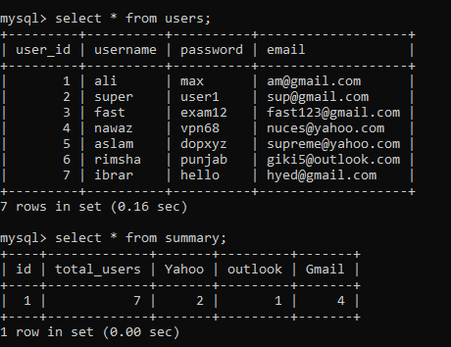

Delimiter $$

create TRIGGER updatation_abc after update on users

for each row begin

declare yahoo_count int;

declare gmail_count int;

declare outlook_count int;

set yahoo_count =(select count(email) from users where email like("%%@yahoo.com"));

set gmail_count =(select count(email) from users where email like("%%@gmail.com"));

set outlook_count =(select count(email) from users where email like("%%@outlook.com"));

update summary set

yahoo=yahoo_count,

gmail =gmail_count,

outlook =outlook_count

where id=1;

end$$

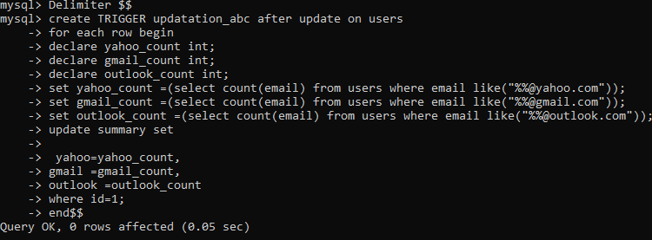

update users set email="am@outlook.com" where user_id=1;

$$

