

AI-Powered Smart Bus Stop Assistant

Project: Diploma Startup
Students: Galymzhanuly Ibragim, Shora Rakhman
Group: SE-2316, ST-2301
Supervisor: Abitova Gulnara

Astana, 2026

Introduction

Urban transportation systems constitute a fundamental component of modern smart cities, directly influencing mobility efficiency, environmental sustainability, and overall quality of life. With the rapid growth of urban populations, traditional public transport infrastructure increasingly fails to meet the demands for real-time information, accessibility, and intelligent interaction. In particular, conventional bus stops remain passive elements of the transport system, offering limited functionality and lacking integration with digital technologies.
The development of smart city concepts has introduced new opportunities for enhancing public transport through the integration of information technologies, real-time data processing, and artificial intelligence. Smart bus stops represent an important direction in this transformation, enabling dynamic passenger information systems, improved accessibility, and enhanced user experience. However, existing implementations are often limited to static displays or basic real-time updates and do not provide interactive or intelligent services.
One of the key challenges in current public transport systems is the absence of intuitive interaction mechanisms between passengers and infrastructure. Users typically rely on mobile applications, which may not always be accessible or convenient, especially for elderly individuals, tourists, or users without smartphones. Additionally, many systems lack multilingual support and adaptive interfaces, further reducing their usability in diverse urban environments.
In this context, the integration of artificial intelligence, particularly natural language processing (NLP), offers significant potential for improving user interaction. AI-based assistants can enable voice communication, provide context-aware responses, and support multiple languages, thereby transforming bus stops into intelligent service points.

1.1 Problem Statement

Despite advancements in intelligent transportation systems, the following problems remain unresolved:
- Lack of interactive communication between passengers and bus stop infrastructure
- Limited availability of real-time and context-aware information
- Absence of integrated AI-based assistance systems
- Dependence on external mobile applications instead of embedded solutions
- Insufficient accessibility for users with different linguistic and technological backgrounds.
These limitations highlight the need for a unified system that combines real-time data, intelligent interaction, and physical infrastructure.

1.2 Aim

The aim of this project is to design and implement a Smart Bus Stop System with AI-based interaction, capable of providing real-time transport information, voice-based user interaction, and centralized monitoring through a scalable and modular architecture.

1.3 Objectives

To achieve the stated aim, the following objectives are defined:
- To analyze existing smart transport systems and identify their limitations
- To design a system architecture integrating frontend, backend, AI, and data components
- To develop a minimum viable product (MVP) of the smart bus stop system
- To implement a data pipeline based on GTFS (General Transit Feed Specification)
- To simulate real-time transport data in the absence of GTFS-Realtime
- To integrate AI-based natural language processing for user interaction
- To design and implement a user interface for both kiosk and administrative dashboard
- To ensure multilingual support (Kazakh, Russian, English)
- To prepare the system for future integration with real-time transport APIs and hardware deployment.

1.4 Object and Subject of Research

Object of research:
Urban public transport infrastructure within the context of smart city systems.
Subject of research:
Methods and technologies for developing an intelligent bus stop system integrating real-time data processing, artificial intelligence, and interactive user interfaces.

1.5 Scientific Novelty

The scientific novelty of the project lies in the integration of multiple technologies into a unified system, including:
- Combination of AI-based natural language interaction with public transport infrastructure
- Implementation of a modular architecture supporting both simulated and real-time data sources
- Development of a multilingual intelligent assistant embedded in a physical kiosk environment
- Integration of real-time data subscriptions with user interaction in a single system.

1.6 Practical Significance

The practical significance of the project includes:
- Improvement of passenger experience through accessible and interactive information systems
- Reduction of dependency on mobile applications
- Applicability in smart city infrastructure projects
- Scalability for deployment in urban environments
- Readiness for integration with real transport data sources (e.g., GTFS-Realtime).

2. Literature Review

2.1 Smart Bus Stops

Modern bus stops provide:
- Digital displays
- Real-time arrival updates
- Passenger information systems

However, most lack:
- Voice interaction
- AI integration
- Adaptive interfaces

2.2 AI in Transportation
Artificial intelligence is used for:
- Route prediction
- Passenger assistance
- Anomaly detection

Recent works highlight:
- NLP-based assistants
- Predictive ETA systems

3. Analysis of existing systems

The development of intelligent public transportation systems has led to the emergence of various digital and infrastructure-based solutions aimed at improving passenger experience and operational efficiency. These solutions can be broadly categorized into three groups: mobile transport applications, smart bus stop infrastructures, and AI-based assistant systems. This chapter provides a comparative analysis of these systems and identifies their limitations in the context of the proposed project.

3.1 Mobile Transport Applications

Mobile applications represent the most widely adopted method of interaction between users and public transportation systems. Popular platforms such as Google Maps, 2gis and Yandex Transport provide route planning, estimated arrival times, and navigation services based on real-time data. [21][22]
Key Features
- Real-time vehicle tracking
- Route optimization and navigation
- Integration with GPS and traffic data
- Continuous updates
Advantages
- High accessibility and widespread usage
- Accurate route planning based on large datasets
- Scalability and continuous improvement
Limitations
- Dependence on personal mobile devices
- Limited accessibility for elderly or non-technical users
- Absence of shared public interaction interfaces
Research shows that mobile-based systems, while effective, do not fully replace the need for infrastructure-level solutions in public transportation environments [5], [12].

3.2 Smart Bus Stop Systems

Smart bus stops are a key component of smart city infrastructure, designed to enhance accessibility and information availability at transport nodes. These systems typically include digital displays, environmental sensors, and communication technologies.
Key Features
- Electronic displays showing arrival times
- Integration with environmental and alert systems
- Emergency communication capabilities
- Connectivity with urban infrastructure
Advantages
- Improved passenger information accessibility
- Enhancement of urban infrastructure
- Support for inclusive public services
Limitations
- Limited interactivity
- Lack of personalization
- Absence of intelligent user assistance
Studies indicate that current smart bus stop implementations primarily function as passive information systems rather than interactive environments [1], [7].

3.3 AI-Based Assistant Systems

Artificial intelligence technologies, particularly natural language processing (NLP), have enabled the development of conversational agents capable of interacting with users in natural language.
Key Features
- Speech recognition and synthesis
- Natural language understanding
- Context-aware responses
- Multilingual support
Advantages
- Intuitive and accessible interaction
- Support for diverse user groups
- Adaptability to user needs
Limitations
- Limited integration with physical infrastructure
- Dependence on cloud-based services
- Lack of direct connection to transport data systems
Recent studies highlight the growing role of AI in transportation systems, particularly in improving user interaction and decision-making processes [3], [4], [5], [9].

3.4 Comparative Analysis of Existing Systems

Feature | Mobile Apps | Smart Bus Stops | AI Assistants
Real-time data | Yes | Yes | Limited
Physical presence | No | Yes | No
Voice interaction | Limited | No | Yes
Accessibility | Medium | High | High
Personalization | Medium | Low | High
AI Integration | Low | Low | High
Table 3.4. Comparative Evaluation

3.5 Research gap

Based on the analysis, the following key limitations are identified:
- Fragmentation of functionalities across different systems
- Lack of integration between artificial intelligence and physical infrastructure
- Insufficient support for interactive and voice-based communication
- Dependence on mobile applications instead of embedded solutions
- Limited adaptability and personalization in existing systems.
These limitations confirm the need for integrated intelligent transport systems combining multiple technologies into a unified solution [2], [12].

3.6 Justification of the Proposed System

The proposed Smart Bus Stop System addresses the identified limitations by:
- Integrating AI-based voice interaction directly into a physical kiosk
- Combining real-time transport data with intelligent responses
- Providing a unified architecture that integrates frontend, backend, and data layers
- Supporting multilingual interaction (Kazakh, Russian, English)
- Enabling scalability for future integration with GTFS-Realtime and external APIs.
This approach aligns with modern trends in smart mobility and AI-driven urban systems [9], [20].

3.7 Conclusion

The analysis of existing systems demonstrates that current solutions either focus on mobile applications or physical infrastructure, but rarely combine both with artificial intelligence. The absence of integrated, intelligent, and interactive bus stop systems highlights the relevance and necessity of the proposed approach.
The developed system aims to bridge this gap by providing a unified, AI-driven smart bus stop solution capable of enhancing user experience and supporting smart city development.

4. Data Collection
The proposed Smart Bus Stop System relies on structured transport data, external information sources, and user-generated input to provide accurate and context-aware services. This chapter describes the data sources, processing pipeline, and simulation approach used in the system.

4.1 Data Sources

The system utilizes multiple data sources, which can be categorized as follows:

1. Static Transport Data (GTFS)
The primary source of transport data is the General Transit Feed Specification (GTFS) static dataset obtained from publicly available sources (September 2024 version).

The dataset includes:
- stops.txt - information about bus stops
- routes.txt - route definitions
- trips.txt - trip instances
- stop_times.txt - schedule of stops
- calendar.txt - service availability
GTFS is a widely adopted standard for representing public transport data and is commonly used in intelligent transportation systems [3], [12].

2. Real-Time Data (Simulated)
Due to the absence of publicly available GTFS-Realtime data for the city of Astana, real-time information is simulated within the system.
An official request was submitted to the city transport authority (CTS) to obtain GTFS-Realtime access, however, no response was received at the time of development.
To compensate for this limitation, a simulation mechanism was implemented to emulate real-time bus movement and arrival predictions.

3. External Data Sources
Additional contextual data is obtained from external services:
- Weather information APIs
- System-generated alerts
- User interaction logs
These data sources enhance the overall functionality and realism of the system.

4. User-Generated Data
The system collects user input in the form of:
- Voice queries
- Interaction events
- AI request logs

This data is used to:
- Improve AI responses
- Analyze system usage
- Support future enhancements

4.2 GTFS Data Processing Pipeline

To transform raw GTFS data into a usable format, a multi-stage data pipeline was implemented.

Stage 1: Data Import
GTFS files are imported into a staging schema using a custom script:
- import-gtfs.mjs
The data is stored in a temporary schema (gtfs) for preprocessing.

Stage 2: Data Transformation
A structured SQL script is used to transform GTFS data into a simplified domain-specific schema:
- bus_stops
- bus_routes
- route_stops
- schedules
This process normalizes the data and prepares it for application use.

Stage 3: Projection to Application Schema
The transformation script maps GTFS data into operational tables used by the system:
- eta_predictions
- bus_positions
- alerts
- ai_query_logs
This step ensures compatibility with the frontend and AI components.

Stage 4: Data Storage
All processed data is stored in Supabase (PostgreSQL), which provides:
- Structured storage
- Real-time subscriptions
- Secure access via RLS policies

4.3 Real-Time Data Simulation

In the absence of GTFS-Realtime data, a simulation model was developed to emulate real-time transport behavior.

Simulation Approach
- Scheduled arrival times (from GTFS)
- Artificial delay generation
- Periodic updates of vehicle positions

Mechanism
- ETA values are recalculated at fixed intervals
- Random variations are applied to simulate delays
- Updates are written to the eta_predictions table

Real-Time Updates
real-time behavior is achieved through short-interval polling from the kiosk frontend to internal API endpoints used to:
- Push updates to the frontend
- Refresh ETA values dynamically
- Simulate live system behavior

4.4 Data Flow in the System

The data flow within the system can be described as follows:
- GTFS data is imported and processed
- Simulation engine generates real-time updates
- Data is stored in Supabase
- Frontend subscribes to updates
- AI module retrieves context from database
- User receives processed information
This pipeline ensures continuous interaction between data, AI, and user interface components.
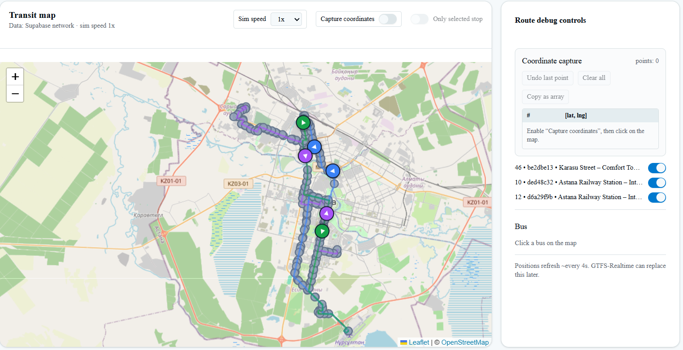
Figure 4.4: Bus real-time simulation

As shown in Figure 4.4, the simulation layer continuously updates vehicle positions and predicted arrival times, while Supabase propagates these updates to the client in real time. This confirms that the proposed architecture supports low-latency data exchange between the backend, database, and user interface. As a result, passengers receive timely ETA information, and the system remains responsive under continuous update cycles.

4.5 Data Limitations and Assumptions

The system operates under the following limitations:
- Absence of official GTFS-Realtime data
- Reliance on simulated real-time predictions
- Potential discrepancies between simulated and actual transport conditions
To address these limitations, the system is designed with flexibility for future integration of real-time data sources.

4.6 Scalability and Future Integration

The data architecture is designed to support future extensions, including:
- Integration with GTFS-Realtime APIs
- Incorporation of live vehicle tracking
- Improved prediction algorithms
- Integration with city transport systems
The modular design of the data pipeline ensures that real-time data can be incorporated with minimal changes to the system architecture.

4.7 Conclusion

This chapter presented the data collection and processing approach used in the Smart Bus Stop System. The use of GTFS static data combined with simulated real-time updates enables the system to demonstrate dynamic behavior while maintaining compatibility with future real-time data integration.
The implemented data pipeline provides a robust foundation for system functionality, ensuring scalability, flexibility, and readiness for deployment in real-world environments.

5. Methodology

The development of the Smart Bus Stop System requires a structured approach that integrates software engineering principles, data processing techniques, and artificial intelligence methods. This chapter describes the methodology used in the project, including the development model, system design approach, and implementation strategy.

5.1 Development Approach

The project follows an iterative and incremental development methodology, which allows gradual refinement of the system through continuous testing and integration.

This approach was selected due to:
- The evolving nature of project requirements
- The integration of multiple components (frontend, backend, AI, data)
- The need for rapid prototyping and validation of system functionality.

Each development iteration includes:
- Requirement refinement
- Design updates
- Implementation
- Testing and evaluation
This methodology ensures flexibility and adaptability throughout the development process.

5.2 System Design Strategy

The system is designed using a modular architecture, where each component operates independently while maintaining integration with other modules.

Design Principles:
- Modularity - separation of frontend, backend, AI, and data layers
- Scalability - ability to integrate real-time data sources and additional features in the future
- Maintainability - use of a unified technology stack (Next.js)
This approach allows the system to evolve without significant restructuring.

5.3 Software Development Process

The development process was divided into several stages:

Stage 1: Requirement Analysis
- Identification of system goals
- Definition of functional and non-functional requirements

Stage 2: System Design
- Architecture definition
- UI/UX design (kiosk and dashboard)
- Database schema design

Stage 3: MVP Development
Implementation of core features:
- Bus stop interface
- Route display
- Basic data integration

Stage 4: AI Integration
- Implementation of voice assistant
- Integration with OpenAI API
- Development of prompt-based interaction

Stage 5: Data Pipeline Implementation
- GTFS data import and transformation
- Creation of application-specific database schema
- Implementation of simulated real-time updates

Stage 6: Testing and Refinement
- System testing
- UI improvements
- Performance optimization

5.4 AI Methodology

The artificial intelligence component is based on natural language processing (NLP) techniques.

Processing Pipeline
- Speech-to-Text (STT) - User input is captured via microphone and converted to text using browser-based speech recognition.

- Natural Language Processing (NLP) - The textual query is processed using OpenAI models to extract intent and generate responses.

- Context Retrieval - Relevant data is retrieved from the database:
- bus stops
- routes
- ETA predictions

- Response Generation - AI generates a context-aware response using structured prompts.

- Text-to-Speech (TTS) - The response is converted back to speech and delivered to the user.

Fallback Mechanism
If AI processing fails:
- Rule-based logic is applied
- Predefined responses are generated
This ensures system reliability and robustness.

5.5 Data Processing Methodology

The data methodology combines static and dynamic data processing:
- GTFS static data provides structural information
- Simulation layer generates real-time updates
- Supabase enables real-time subscriptions

This hybrid approach allows:
- Demonstration of real-time functionality
- Compatibility with future GTFS-Realtime integration

5.6 User Interface Methodology

The UI design follows a user-centered design approach, focusing on:
- Simplicity and clarity
- Accessibility
- Multilingual support (Kazakh, Russian, English)
Kiosk Interface
- Minimalistic design
- Large interactive elements
- Voice interaction support

Dashboard Interface
- Data visualization
- Monitoring tools
- Administrative control

5.7 Hardware Integration Approach

Although full hardware implementation is pending, the system is designed for deployment on embedded devices such as Raspberry Pi 4.

Planned Components
- Touchscreen display
- Microphone
- Speaker

5.8 Evaluation Strategy

The system is evaluated based on:
- Functionality (correct operation of modules)
- Usability (ease of interaction)
- AI accuracy (quality of responses)
Testing is performed iteratively throughout development.

5.9 Conclusion

The project combines several development approaches, including iterative and incremental development, MVP-based design, modular architecture, data-driven processing, AI-driven interaction, and event-driven real-time updates. Additionally, a simulation-based approach was implemented to compensate for the absence of real-time transport data.

6. System Architecture

6.1 Overall System Architecture

The Smart Bus Stop System is designed as a modular, data-driven, and AI-enhanced platform that integrates user interaction, transport data processing, and administrative control within a unified architecture. The system combines frontend, backend, database, and artificial intelligence components into a cohesive full-stack solution.
The architecture follows a client-server model, where the frontend interface is implemented using React and Next.js, while backend logic is handled through server-side API routes within the same framework. The system leverages Supabase as a Backend-as-a-Service (BaaS) platform, providing PostgreSQL database storage, authentication, and real-time data synchronization.
Additionally, artificial intelligence functionality is integrated using OpenAI APIs, enabling natural language interaction through a voice assistant interface. Due to the absence of GTFS-Realtime data, the system incorporates a simulation-based layer to emulate real-time transport behavior.
The architecture is designed with scalability in mind, allowing future integration with real-time transport APIs and hardware deployment on embedded systems such as Raspberry Pi 4.

6.2 Architectural Layers

The system architecture is divided into several logical layers.

6.2.1 Presentation Layer (Frontend)

The presentation layer is responsible for user interaction and consists of two main interfaces:
- Kiosk Interface (/kiosk)
Designed for passengers, it displays bus arrival times, weather information, and supports voice interaction. It operates in a simplified, touch-friendly mode suitable for public environments.
- Dashboard Interface (/dashboard)
Intended for administrators and operators, it provides monitoring tools, data visualization, and system management functionality. Access is restricted via authentication middleware.
The frontend is implemented using React and Next.js, enabling both server-side rendering (SSR) and client-side interactivity.

6.2.2 Application Layer (Backend Logic)

The backend is implemented using Next.js API routes, which serve as the core processing layer of the system. Key functionalities include:
- Handling AI queries via /api/ai/question
- Aggregating data from the database
- Processing transport and weather data requests
- Providing fallback responses when AI is unavailable
The backend acts as an orchestration layer, coordinating interactions between the frontend, database, and external services.

6.2.3 Data Layer (Database and Storage)

The system uses Supabase (PostgreSQL) as the primary data storage solution. The database schema includes:
- bus_stops
- bus_routes
- eta_predictions
- alerts
- ai_query_logs
- profiles
Data is initially populated using GTFS Static datasets, which are processed and transformed into a simplified schema suitable for real-time querying.
In the absence of GTFS-Realtime data, simulated updates are used to generate dynamic ETA predictions.

6.2.4 AI Layer

The AI layer is responsible for natural language interaction and is implemented using OpenAI APIs. It processes user queries by:
- Receiving input (text or speech)
- Gathering contextual data from the database
- Generating responses using a structured prompt
- Falling back to rule-based logic if necessary
This layer enables intelligent interaction and enhances accessibility for users.

6.2.5 Integration Layer

The integration layer handles communication with external or simulated services:
- Transport data (GTFS Static + simulation)
- Weather data (API )
- Real-time updates via Supabase subscriptions
This layer ensures that the system remains flexible and can integrate real APIs in future iterations.

6.3 Kiosk Interaction Flow

The kiosk interaction process represents the primary user flow of the system. A passenger can interact with the system either through touch input or voice commands.
The system processes the request by identifying the type of query (e.g., next arrival, route information, or weather), retrieving relevant data, and generating a response that is displayed or spoken.
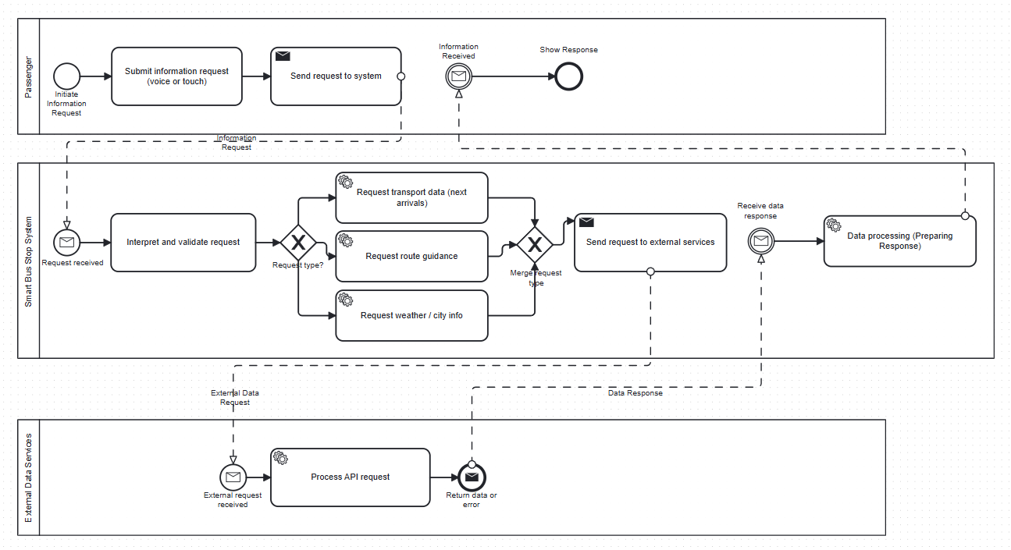
Figure 6.3: BPMN Diagram (User Interaction)

This process on figure 6.3 demonstrates a user-centered design approach, emphasizing simplicity, accessibility, and responsiveness.

6.4 AI Query Processing Flow

The AI query processing mechanism is responsible for handling natural language requests from users. When a user submits a query:
- The request is sent to the backend API
- The system retrieves relevant transport data
- The AI model generates a response based on context
- If necessary, fallback logic is applied
- The response is returned and optionally converted to speech

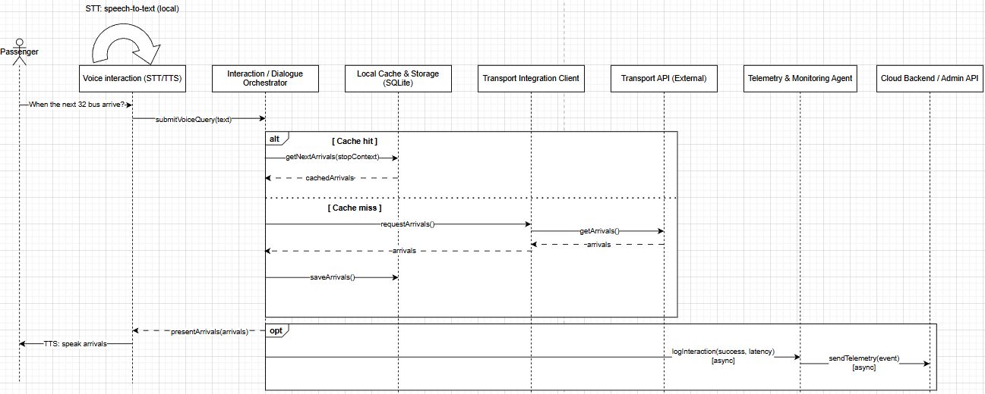
Figure 6.4: Sequence Diagram (Next Arrival)

The sequence diagram on figure 6.4 illustrates both cache-hit and cache-miss scenarios, improving system efficiency and reducing latency.

6.5 Route Planning Process

The system includes functionality for route guidance, allowing users to request directions between locations.
The process involves:
- Receiving a destination query
- Applying route constraints (if available)
- Generating possible route options
- Returning the best route to the user
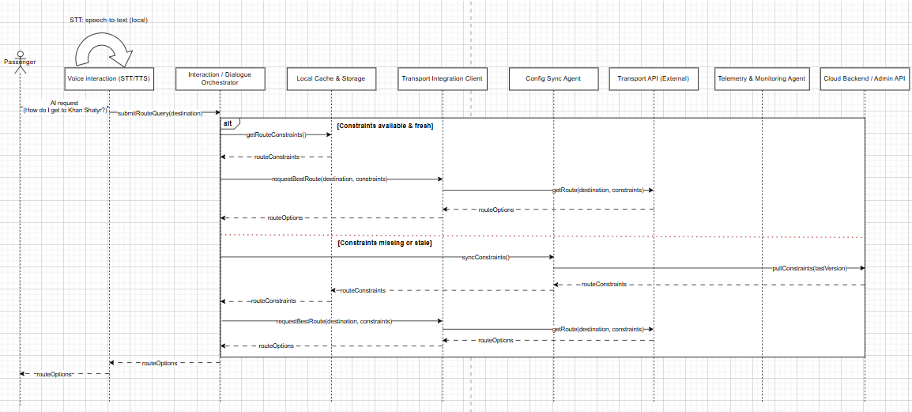
Figure 6.5: Sequence Diagram (Best Route)

It is important to note that, due to the absence of real-time routing APIs, this functionality is currently simplified and partially simulated. Future versions of the system may integrate external routing services for enhanced accuracy.

6.6 Administrative and Monitoring System

The administrative subsystem allows operators to manage and monitor system behavior. Key features include:
- Authentication and role-based access control
- Viewing system metrics and logs
- Managing transport data and alerts
The system uses middleware and Supabase Row-Level Security (RLS) policies to enforce access control. The below process (figure 6.6) reflects a conceptual model for system management
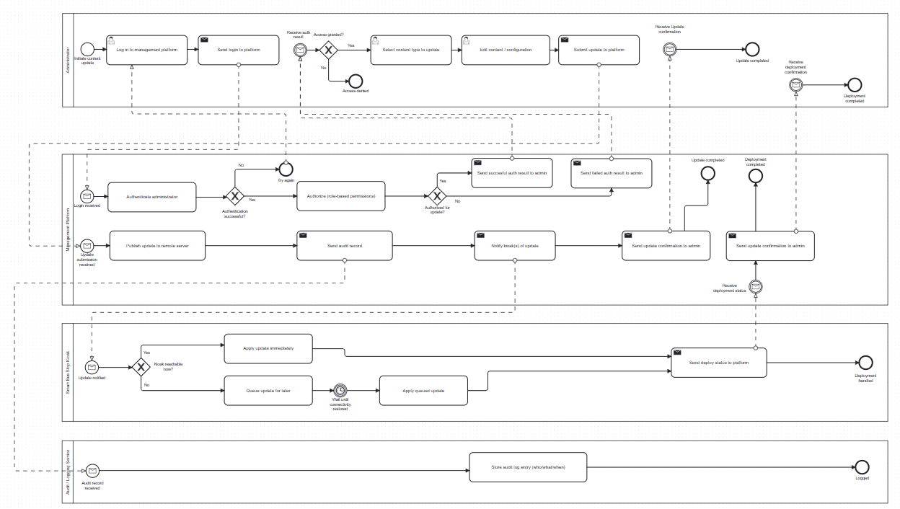
Figure 6.6: BPMN Diagram (Admin Content Update)

6.7 Real-Time Data and Simulation

Due to the lack of publicly available GTFS-Realtime data for the city of Astana, the system employs a simulation-based approach to emulate real-time updates.
This includes:
- Generating dynamic ETA predictions
- Updating data periodically
- Mimicking vehicle movement behavior
This approach allows the system to demonstrate real-time capabilities while maintaining flexibility for future integration with official APIs.

6.8 Summary of the Architecture
The proposed system architecture integrates modern web technologies, real-time data processing, and artificial intelligence into a unified platform. It demonstrates a scalable and modular design that supports both current functionality and future expansion.
The architecture successfully combines:
- Full-stack web development (Next.js)
- Cloud-based data management (Supabase)
- AI-driven interaction (OpenAI)
- Simulation-based real-time processing
This combination ensures that the system is both functional as an MVP and adaptable for future deployment in real-world smart city environments.

7. Implementation

7.1 Overview of Implementation

This chapter describes the practical implementation of the Smart Bus Stop System, including the technologies used, system components, and integration mechanisms. The system is implemented as a full-stack web application using modern frameworks and cloud-based services.
The implementation focuses on delivering a functional Minimum Viable Product (MVP) that demonstrates real-time passenger information, AI-powered interaction, and administrative control.

7.2 Technology Stack

The system utilizes a modern and unified technology stack to ensure scalability, maintainability, and performance.

Frontend
- React (with TypeScript and JavaScript)
- Next.js (App Router)
- Tailwind CSS (for UI styling)
Backend
- Next.js API routes (server-side logic)

Database and Backend Services
- Supabase (PostgreSQL)
- Supabase Authentication
- Supabase Realtime subscriptions

Artificial Intelligence
- OpenAI API (text generation and NLP)

Data Sources
- GTFS Static dataset (2024)
- Simulated real-time transport data

Hardware (planned)
- Raspberry Pi 4 (or equivalent embedded device)
This unified stack reduces system complexity and enables seamless integration between frontend and backend components.

7.3 Frontend Implementation

The frontend is developed using React and Next.js, following a component-based architecture.

7.3.1 Kiosk Interface

The kiosk interface is implemented in /app/kiosk/page.tsx and includes several key components:
- KioskShell - Handles idle state and user interaction detection.
- KioskDisplay - Displays bus arrival times, weather data, and selected stop information.
- KioskArrivals - Renders ETA predictions for buses.
- KioskVoiceAssistant - Implements voice interaction using the Web Speech API for speech recognition and synthesis.

7.3.2 Dashboard Interface

The dashboard is implemented in /app/dashboard and is intended for system administrators.
Features include:
- Viewing active buses and stops
- Monitoring system alerts
- Displaying transport data on maps
- Managing system data

The dashboard uses a hybrid rendering model:
- Server Components for data fetching
- Client Components for interactive elements

7.4 Backend Implementation

The backend logic is implemented using Next.js API routes, eliminating the need for a separate backend server.

7.4.1 AI Endpoint

The main AI processing endpoint is: /api/ai/question
This endpoint performs the following steps:
- Receives user input (text query)
- Retrieves relevant data from Supabase
- Constructs a system prompt
- Calls the OpenAI API
- Returns a generated response
If the AI fails or produces insufficient results, a rule-based fallback mechanism is applied.

7.4.2 Data Handling

The backend processes data requests for:
- Bus arrivals
- Routes
- Weather information
- Alerts
All requests are handled through internal API routes, ensuring centralized control over data processing.

7.5 Database Implementation

The system uses Supabase (PostgreSQL) as the primary database.

7.5.1 Database Schema

The main tables include:
- bus_stops
- bus_routes
- route_stops
- eta_predictions
- alerts
- ai_query_logs
- profiles
The schema is designed to support efficient querying and real-time updates.

7.5.2 GTFS Data Processing

GTFS Static data is imported and transformed into the system schema using custom scripts.
The process includes:
- Importing GTFS files (stops, routes, trips, stop_times)
- Storing raw data in staging tables
- Transforming data into simplified tables
- Seeding initial data for testing

7.6 Real-Time Data Simulation

Due to the absence of GTFS-Realtime data, the system implements a simulation mechanism.
This includes:
- Generating dynamic ETA values
- Updating predictions periodically
- Simulating bus movement patterns
This approach enables demonstration of real-time functionality while maintaining system flexibility.

7.7 AI Integration

Artificial intelligence is integrated to provide natural language interaction.

7.7.1 Functionality

The AI system supports:
- Bus arrival queries
- Route-related questions
- General transport information

7.7.2 Processing Pipeline

- User submits a query (voice or text)
- Input is processed and sent to backend
- Context data is retrieved
- AI generates a response
- Response is displayed or spoken
The system also supports multilingual interaction (Kazakh, Russian, English).

7.8 Authentication and Security

Authentication is handled using Supabase Auth.

7.8.1 Middleware

A middleware layer is used to:
- Verify user sessions
- Restrict access to protected routes (e.g., dashboard)

7.8.2 Role-Based Access Control

User roles are stored in the profiles table and enforced using:
- Middleware checks
- Row-Level Security (RLS) policies
This ensures that only authorized users can access administrative functionality.

7.9 System Integration

The system integrates multiple components into a unified workflow:
- Frontend interacts with backend via API routes
- Backend communicates with Supabase
- AI processes contextual data
- Realtime updates are pushed to the frontend
This integration ensures smooth data flow and system responsiveness.

7.10 Hardware Considerations

The system is designed to be deployed on embedded hardware such as Raspberry Pi 4.
The hardware setup includes:
- Touchscreen display
- Microphone
- Speaker
Although full hardware integration is not yet completed, the system architecture supports deployment in a kiosk environment.

7.11 Summary of Implementation

The implementation demonstrates a practical realization of a smart public transport system using modern technologies.
The system successfully integrates:
- Full-stack web development
- Real-time data processing (simulated)
- AI-driven interaction
- Cloud-based database services
The resulting platform is functional, scalable, and ready for further development and real-world deployment.

8. Results and Evaluation

8.1 Overview of Evaluation

This chapter presents the results of the developed Smart Bus Stop System and evaluates its performance, functionality, and usability. The evaluation focuses on verifying that the system meets the defined objectives and operates correctly under the implemented architecture.
The system was tested as a functional MVP, integrating frontend, backend, database, and AI components.

8.2 Functional Results

The implemented system successfully delivers the following core functionalities:

1. Real-Time Bus Arrival Display (Simulated)
- Bus arrival times are calculated using GTFS static data
- ETA values are dynamically updated using simulation
- Data is displayed in the kiosk interface

2. Voice Assistant Interaction
- Users can ask questions using voice input
- The system processes queries using AI (OpenAI)
- Responses are generated and converted into speech

3. Multilingual Support
The system supports:
- Kazakh
- Russian
- English
Language selection is handled via UI and stored locally

4. Administrative Dashboard
- Displays system metrics (stops, alerts, queries)
- Provides monitoring capabilities
- Allows interaction with transport data

8.3 System Testing

The system was tested across multiple scenarios to ensure stability and correctness.

8.3.1 Functional Testing

Test Case | Expected Result | Outcome
Display arrivals | Correct ETA shown | Passed
Voice query | AI response generated | Passed
Language switch | UI updates correctly | Passed
Dashboard access | Auth required | Passed
Table 8.3.1 Functional testing

8.3.2 AI Interaction Testing

The AI module was evaluated based on:
- Response relevance
- Response clarity
- Multilingual capability
Results
AI successfully handled typical queries such as:
- “When is the next bus?”
- “How do I get to the airport?”
- Fallback logic ensured stability in edge cases
- Response language based on respective request language
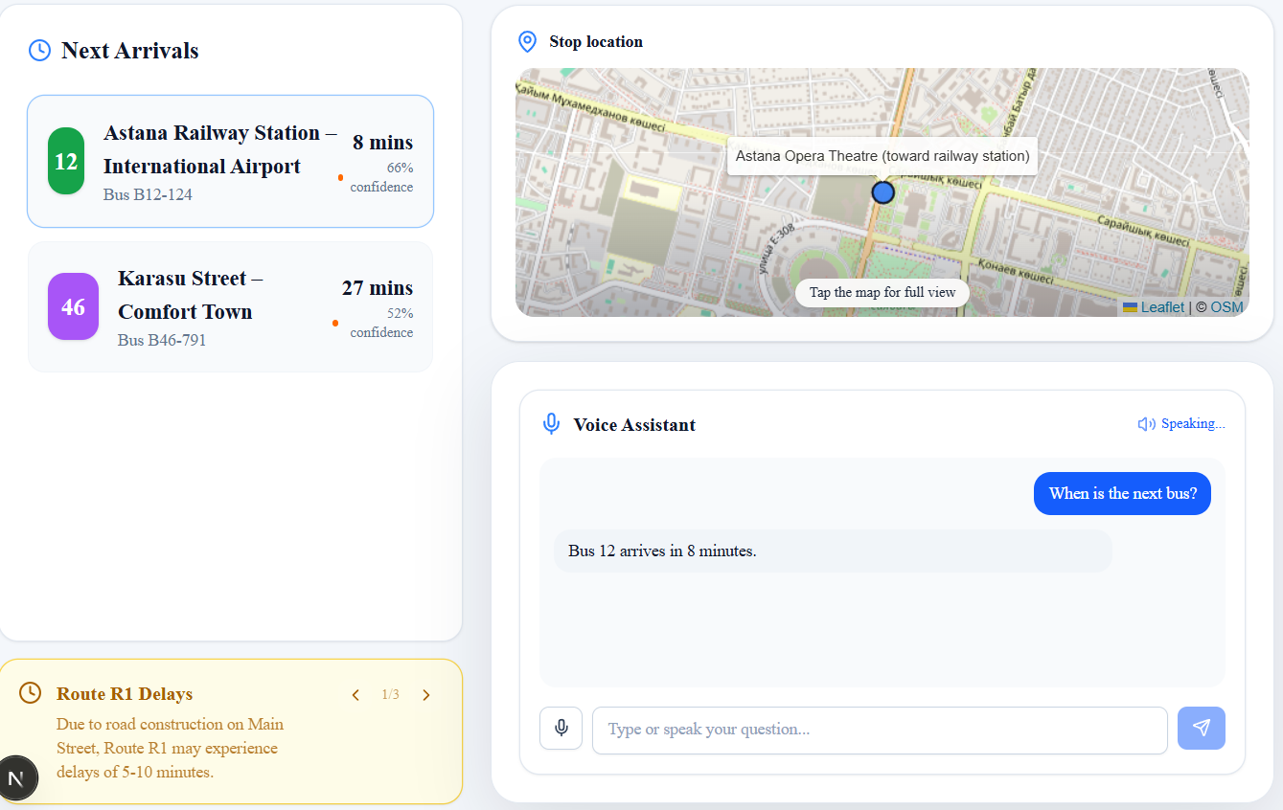
Figure 8.3.2-1: Response for “When is the next bus” user request

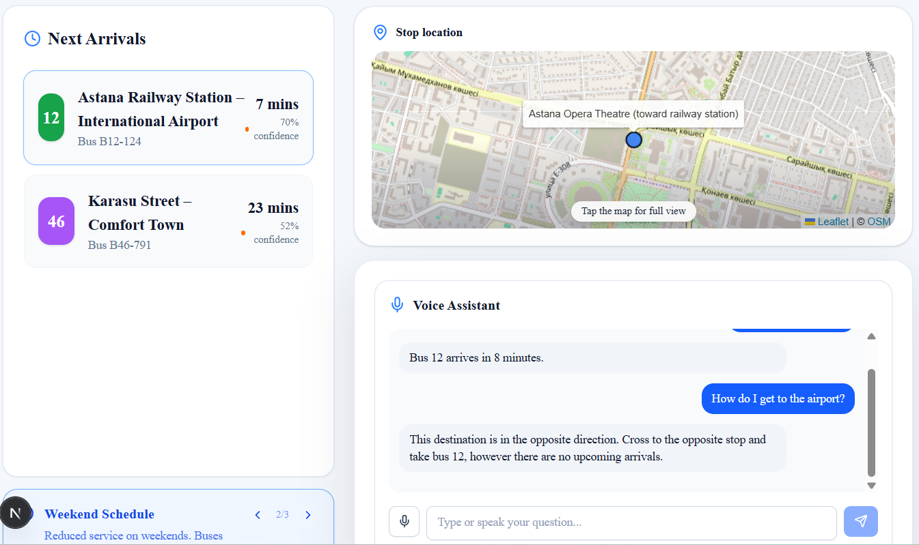
Figure 8.3.2-2: Response for “How do I get to the airport” user request
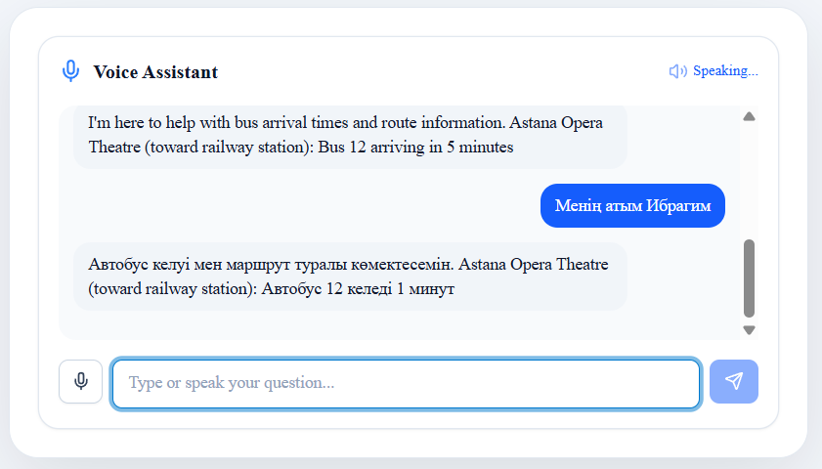
Figure 8.3.2-3: Response for request unrelated to bus transportation

8.3.3 Performance Testing

The system demonstrated:
- Fast response time for UI updates
- Low latency in AI responses (depending on API)
- Smooth real-time updates via Supabase

Measured MVP performance indicators (local/staging runs):
- ETA refresh interval on kiosk: 4 s
- Backend response time: < 300 ms
- AI response time: ~1.2–3.5 s

8.4 User Interface Evaluation

The kiosk interface was evaluated based on usability principles:
Strengths
- Simple and intuitive design
- Large UI elements suitable for public use
- Clear visualization of transport data

Accessibility
- Voice interaction reduces need for manual input
- Multilingual support improves usability
- These features align with accessibility standards for public systems [10], [15].

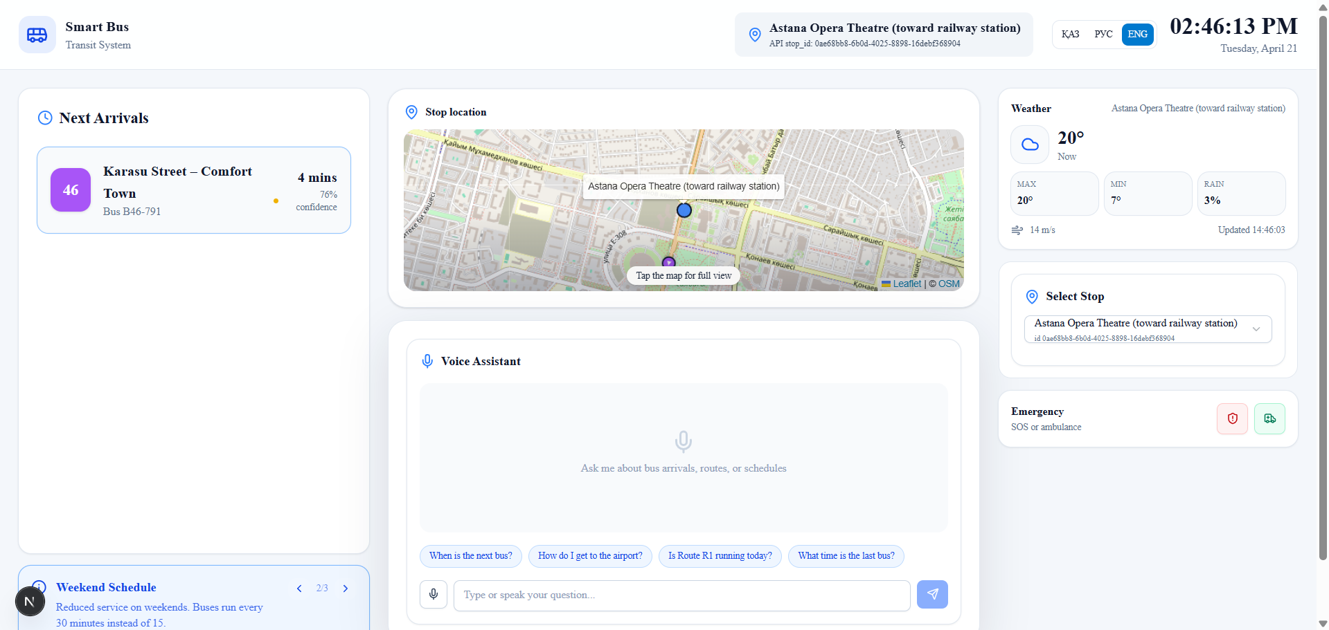
Figure 8.4: Kiosk Interface

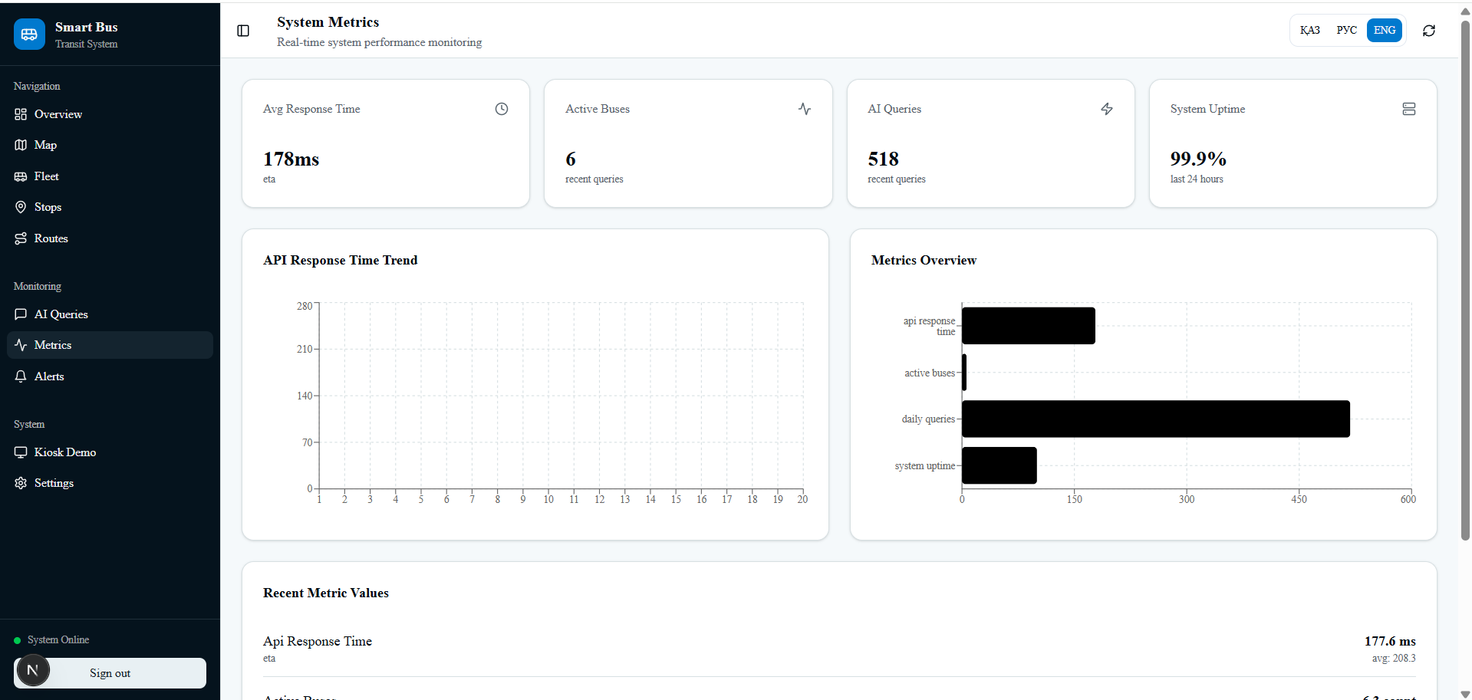
Figure 8.2: Dashboard system metrics

8.5 System Limitations

Despite successful implementation, several limitations were identified:
- Absence of GTFS-Realtime data
- Reliance on simulated ETA values
- Simplified route planning logic
These limitations are acknowledged and addressed in the system design for future improvements.

8.6 Scalability and Future Improvements

The system is designed to support future enhancements, including:
- Integration with GTFS-Realtime APIs
- Improved route optimization algorithms
- Enhanced AI capabilities (context memory, personalization)

8.7 Overall Evaluation

The system meets the primary objectives defined in Chapter 1.3
Objective | Status
Real-time data (simulated) | Achieved
AI interaction | Achieved
Dashboard system | Achieved
Multilingual support | Achieved
Hardware integration | Partial
Table 8.7 Objective achievements

9. Conclusion

9.1 Summary of the Project

This diploma project presented the design and implementation of a Smart Bus Stop System aimed at improving the accessibility, efficiency, and usability of public transportation services. The system integrates modern web technologies, artificial intelligence, and data-driven approaches to provide real-time passenger information and interactive services.
The developed solution combines a kiosk-based user interface, an administrative dashboard, a cloud-based database, and an AI-powered assistant. The system architecture was designed to be modular, scalable, and adaptable for future enhancements.

9.2 Achievements

During the course of the project, the following key objectives were successfully achieved:
- Development of a full-stack web application using Next.js and React
- Implementation of a data pipeline based on GTFS static datasets
- Creation of a simulation mechanism for real-time transport data
- Integration of an AI-based voice assistant using OpenAI
- Development of a multilingual user interface (Kazakh, Russian, English)
- Implementation of an administrative dashboard with authentication and access control
These achievements demonstrate the feasibility of integrating intelligent systems into urban transportation infrastructure.

9.3 Contributions

The main contributions of this project include:
- A practical implementation of a smart bus stop system as a functional MVP
- Integration of AI-driven interaction within a public transport context
- A simulation-based approach for handling the absence of real-time data
- A modular architecture that supports scalability and future development
The project contributes to the field of smart city technologies and intelligent transportation systems by providing a working prototype that can be extended for real-world deployment.

9.4 Limitations

Despite the successful implementation, several limitations were identified:
- Lack of access to official GTFS-Realtime data
- Reliance on simulated transport data
- Simplified route planning functionality
- Incomplete hardware integration
These limitations are primarily due to external constraints and time limitations of the project.

9.5 Future Work

Future improvements of the system may include:
- Integration with official GTFS-Realtime APIs
- Implementation of advanced route optimization algorithms
- Enhancement of AI capabilities (context awareness, personalization)
- Integration with additional smart city services
These enhancements will increase the practical applicability and performance of the system.

9.6 Final Remarks

The Smart Bus Stop System demonstrates the potential of combining artificial intelligence, real-time data processing, and modern web technologies to improve public transportation systems. The developed solution serves as a foundation for future research and development in the field of intelligent urban mobility.
The results of this project confirm that even with limited data availability, it is possible to design and implement a functional and scalable system that addresses real-world challenges.

10. References

[1] Padrón Nápoles, V. M., Gachet Páez, D., Esteban Penelas, J. L., García Pérez, O., García Santacruz, M. J., & Martín de Pablos, F. (2020). Smart bus stops as interconnected public spaces for increasing social inclusiveness and quality of life of elder users. Smart Cities, 3(2), 430–443.
https://doi.org/10.3390/smartcities3020023
Accessed on 25 December 2025.

[2] Lukic Vujadinovic, V., et al. (2024). AI-driven approach for enhancing sustainability in urban public transportation. Sustainability, 16(17), 7763.
https://www.mdpi.com/2071-1050/16/17/7763
Accessed on 25 December 2025.

[3] Jevinger, A., et al. (2023). Artificial intelligence for improving public transport: A mapping study. Public Transport, 15(2), 341–362.
https://doi.org/10.1007/s12469-023-00334-7
Accessed on 25 December 2025.

[4] Mirindi, D. (2024). A review of the advances in artificial intelligence in the transport sector. Journal of Civil, Construction and Environmental Engineering, 9(3), 113–121.
https://www.sciencepublishinggroup.com/article/10.11648/j.jccee.20240903.13
Accessed on 25 December 2025.

[5] Cohen, A. (2024). Artificial intelligence transportation use cases. Mineta Transportation Institute.
https://transweb.sjsu.edu/sites/default/files/2430-Cohen-Artificial-Intelligence-Transportation-Use-Cases.pdf
Accessed on 25 December 2025.

[6] Kulkarni, M et al. (2023). BusStopCV: A real-time AI assistant for labeling bus stop accessibility features in streetscape imagery. ACM ASSETS Conference Project Page.
https://makeabilitylab.cs.washington.edu/project/busstopcv/
Accessed on 25 December 2025.

[7] Darsena, D., Gelli, G., Iudice, I., & Verde, F. (2020). Sensing technologies for crowd management, adaptation, and information dissemination in public transportation systems: A review. arXiv.
https://arxiv.org/abs/2009.12619
Accessed on 25 December 2025.

[8] Fuller, A., Fan, Z., Day, C., & Barlow, C. (2022). Digital twin: Enabling technologies, challenges and open research. Applied Sciences, 12(11), 5727.
https://www.mdpi.com/2076-3417/12/11/5727
Accessed on 25 December 2025.

[9] Xu, H., Yuan, J., Zhou, A., et al. (2024). GenAI-powered multi-agent paradigm for smart urban mobility: Opportunities and challenges for integrating large language models and retrieval-augmented generation. arXiv.
https://arxiv.org/abs/2409.00494
Accessed on 25 December 2025.

[10] World Wide Web Consortium (W3C). (2024). Web Accessibility Initiative (WAI): Standards and guidelines.
https://www.w3.org/WAI/standards-guidelines/
Accessed on 25 December 2025.

[11] Jasmin Bharadiya (2023). Artificial intelligence in intelligent transportation systems.
https://www.academia.edu/download/103844774/1610.pdf
Accessed on 25 December 2025.

[12] Tim Heinrich Son et al. (2023). Artificial intelligence applications in smart mobility systems. Sustainable Cities and Society.
https://www.sciencedirect.com/science/article/pii/S2210670723001737
Accessed on 25 December 2025.

[13] IBM. (2024). Supervised learning.
https://www.ibm.com/topics/supervised-learning
Accessed on 25 December 2025.

[14] IBM. (2024). Unsupervised learning.
https://www.ibm.com/topics/unsupervised-learning
Accessed on 25 December 2025.

[15] Voices.com. (2024). Exploring the impact of AI voice in transportation: Accessibility and convenience for all.
https://www.voices.com/blog/exploring-the-impact-of-ai-voice-in-transportation/#accessibility-and-convenience-for-all
Accessed on 25 December 2025.

[16] IBM. (2024). Natural language processing (NLP).
https://www.ibm.com/think/topics/natural-language-processing
Accessed on 25 December 2025.

[17] JNGR5. (2024). AI-driven smart cities.
https://jngr5.com/public/blog/AI-Driven%20Smart%20Cities.pdf
Accessed on 25 December 2025.

[18] QIHU Robot. (2024). Bus station robot application.
https://www.qijurobot.com/application/bus-station-robot
Accessed on 25 December 2025.

[19] Omniflow. (2024). Smart luminaire integrated EV charger for urban mobility.
https://www.omniflow.io/mobility/smart-luminaire-integrated-ev-charger
Accessed on 25 December 2025.

[20] DiVA Portal. (2024).
Generative AI assistant for public transportation systems (Master’s thesis).
https://www.diva-portal.org/smash/get/diva2:1869600/FULLTEXT01.pdf
Accessed on 25 December 2025.

[21] Google, “Google Maps Platform,”
https://maps.google.com

[22] Yandex, “Yandex Transport,”
https://yandex.kz/maps

