Assignment 6

Test Environment
Parameter | Value
Operating System | Windows x64-bit
Browser | Google Chrome
Programming Language | Python
Automation Tool | Selenium WebDriver
Test Framework | PyTest
Excel library | openpyxl

Test site: https://practicetestautomation.com/practice-test-login/

Task 1: Data-Driven Automated Testing

Installed openpyxl
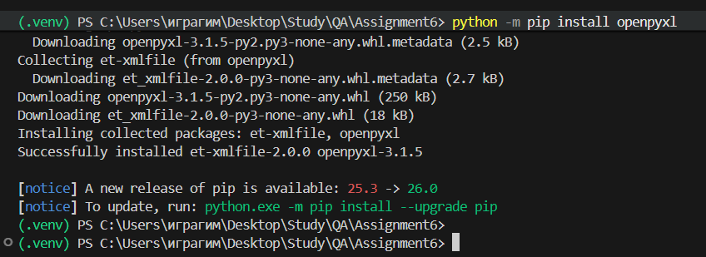

Created conftest.py. Configuring the local driver
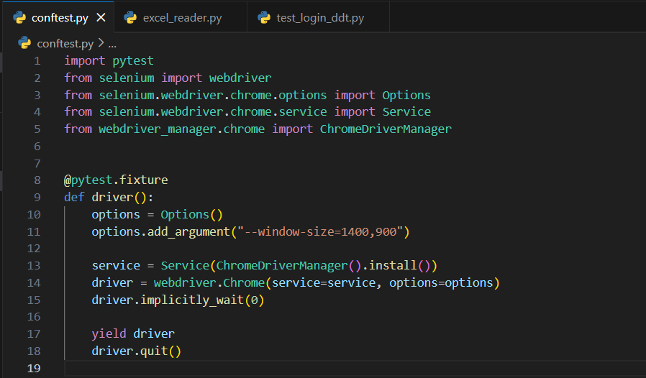

Created excel_reader.py
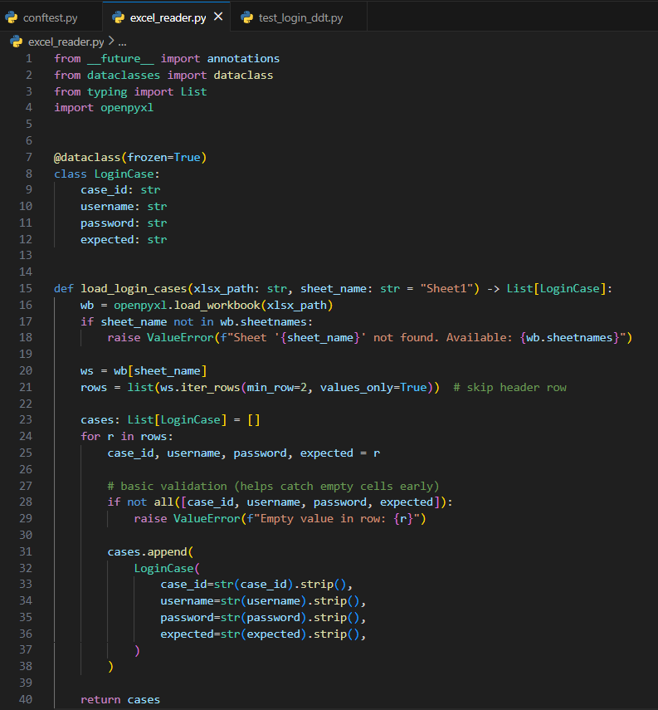

Excel_reader.py file importing the data from excel file, containing test cases, making it easy for developers to decrease amount of configured test files
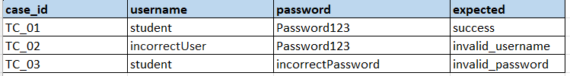
Created test_login_ddt.py. To configure test scenarios, imported from excel
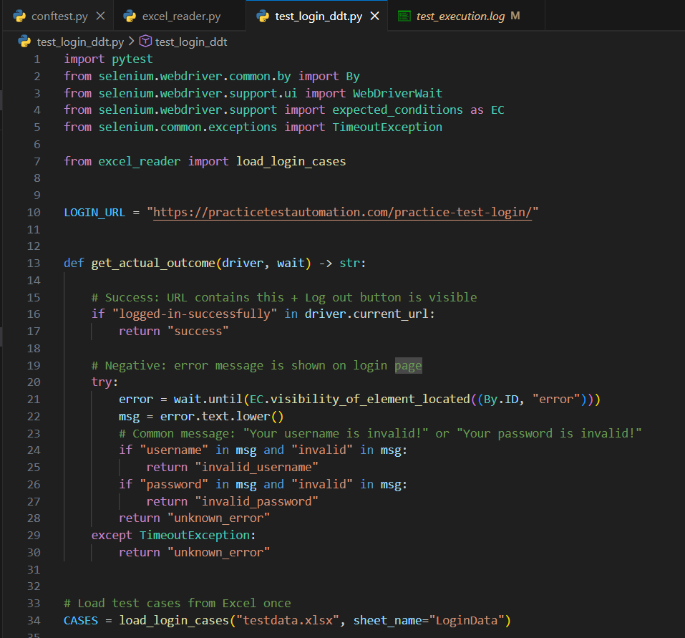

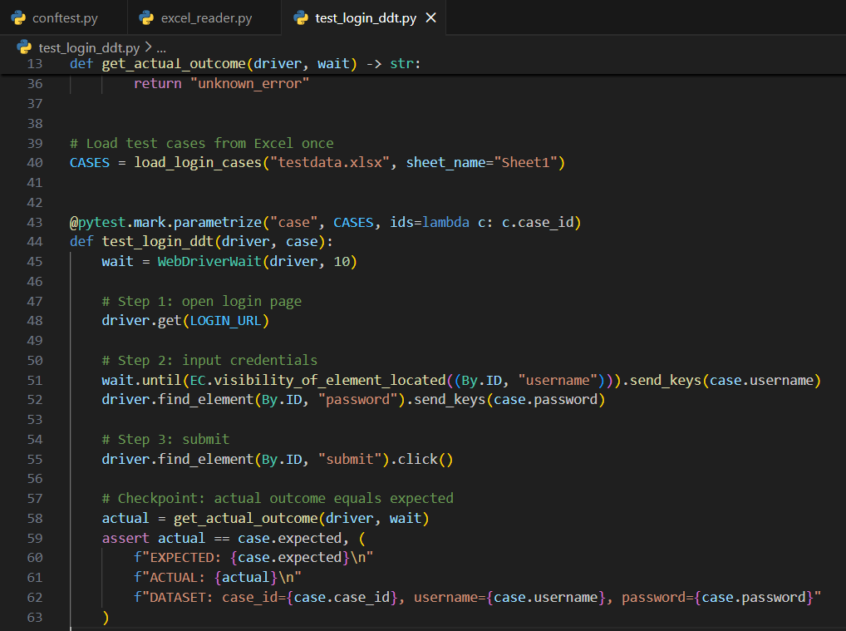
Running results
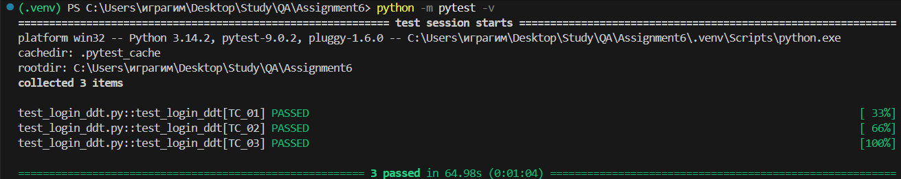

Locally the autotests passed succesfully and logged in local test_execution.log file
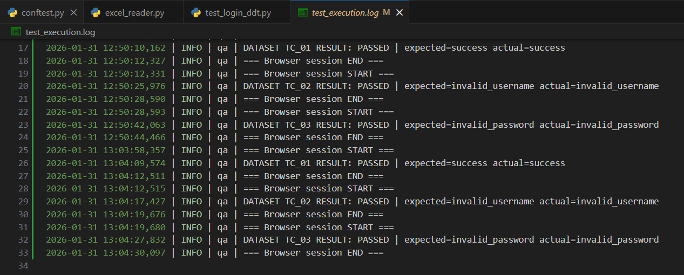
Task 2. Cross-Browser Testing in Cloud

Updated conftest.py
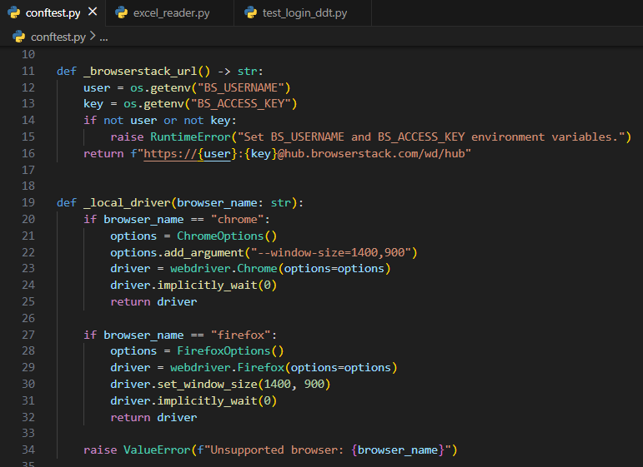
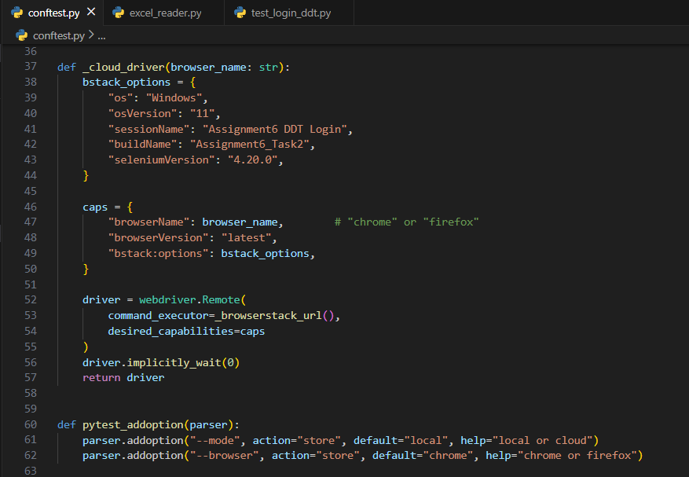

New version of conftest.py file provides a option for tester to choose an environment whether the test should be completed in local/cloud and chrome/firefox browser. Tester should define this settings in terminal like:
By default it will be opened on chrome and locally.
SauceLabs
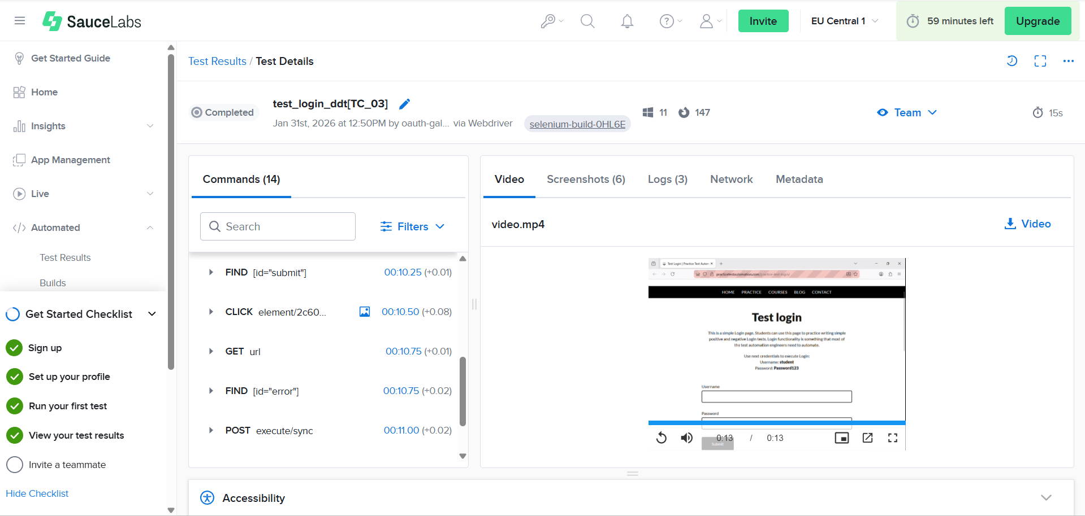

The whole steps and optional log are stored in SauceLab cloud. So the tester can view the videos and screenshots of each test.

