Assignment 4

Test Environment
Parameter | Value
Operating System | Windows x64-bit
Browser | Google Chrome
Programming Language | Python
Automation Tool | Selenium WebDriver
Test Framework | PyTest

Test site: https://demoqa.com/

Copied conftest.py from Assignment3
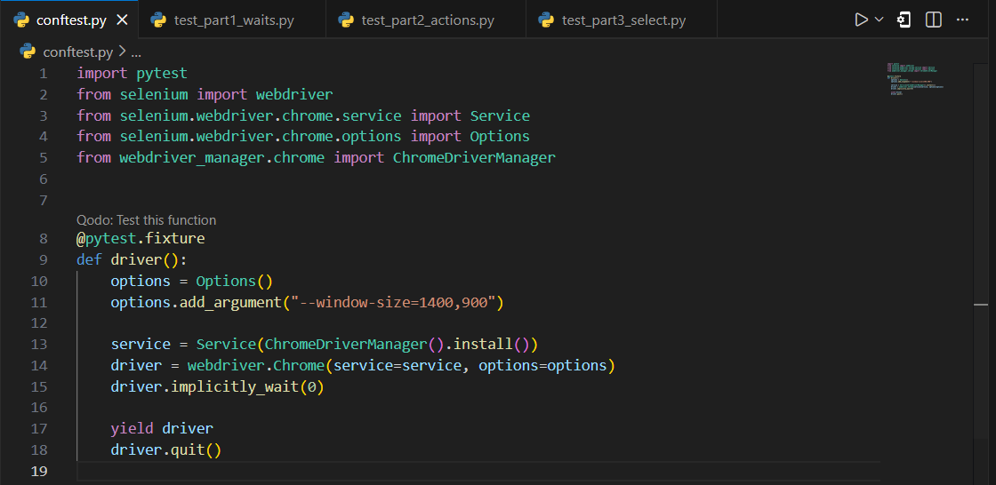

Created virtual environment .venv folder

Activated the virtual environment

Installed Selenium WebDriver (Already installed)
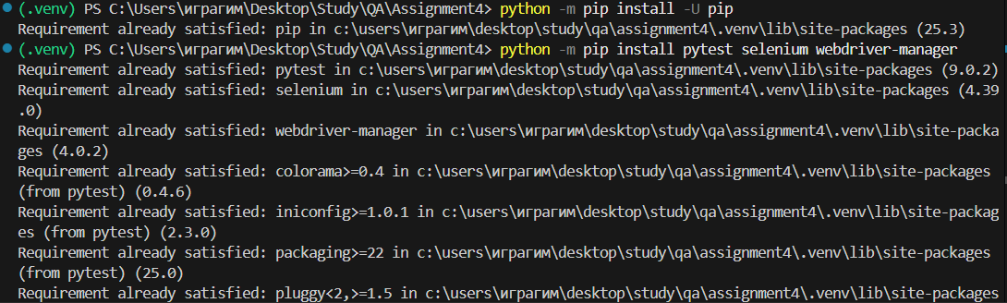

Part 1. Implement implicit wait, explicit wait and fluent wait

Created test_part1_waits.py file
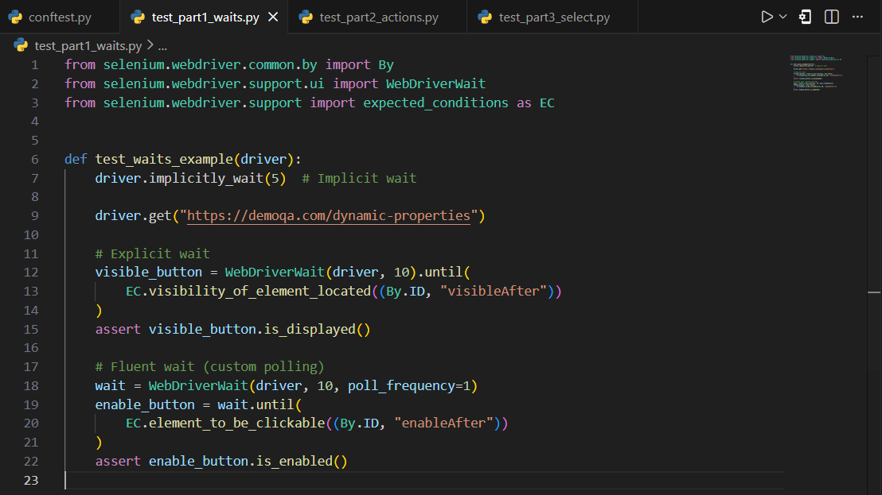

Implicit, Explicit, and Fluent waits were implemented to handle dynamically loaded elements and synchronize test execution with the application state. Explicit and Fluent waits were preferred for specific elements to ensure precise control over waiting conditions and to improve test stability and reliability.

Part 2. Implement actions

Created test_part2_actions.py file
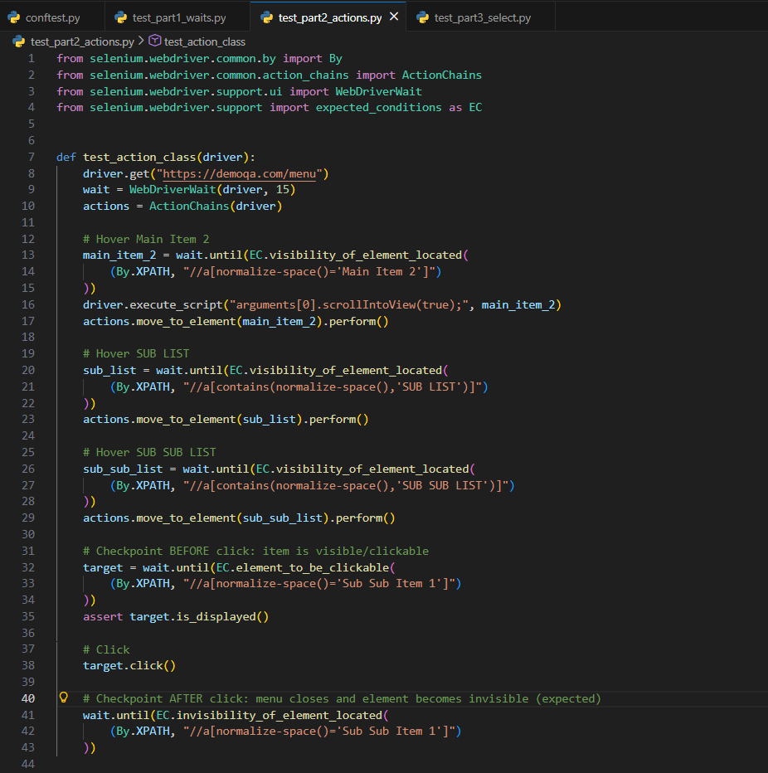

Mouse hover actions were performed to navigate through a multi-level menu, followed by a click on a nested menu item. Checkpoints were added before and after the action to validate correct UI behavior. XPath locators were used to identify menu elements by their visible text, as CSS selectors do not support text-based element selection.

Part 3. Implement Selects

Created test_part3_select.py file
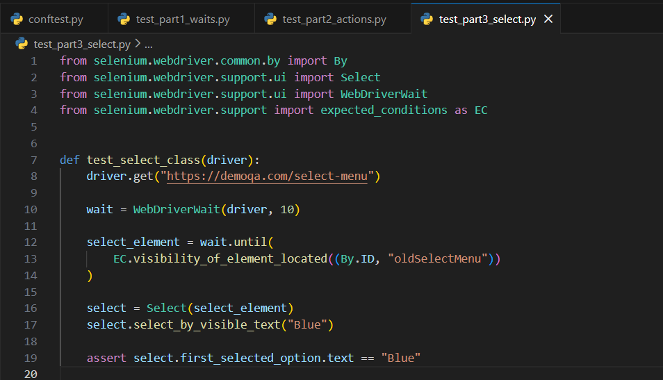

The Select class was used to interact with a standard HTML dropdown by selecting an option based on visible text. This approach provides a clear and reliable way to handle dropdown elements and verify the selected value in a user-oriented manner.

Conclusion
This assignment demonstrated the effective use of advanced Selenium WebDriver features, including waits, action chains, and dropdown handling. All tests executed successfully, confirming correct automation behavior and stable test design.

