WasmGrader
An Autonomous Multi-Language Code Sandboxing, Parallel Evaluation, and AI-Driven Assessment Platform for Moodle LMS
━━━━━━━━━━━━━━━━━━━━━━━━━━━━━━━━━━━━━━━━━━━━━━━━━━
Project Repository: | https://github.com/Ibronux7bro/WasmGrader.git
Document Classification: | Software Requirements Specification & Technical Architecture
Software Version: | Release 0.1.0-alpha (Production Candidate)
Core Engineering Stack: | Rust, WebAssembly (WASM), Wasmtime 21, PHP 8.2, Moodle 4.x, Docker
Key Security Protocols: | Zero-Trust WASI Sandbox, Opcode Fuel Metering, Bearer Token Auth
Publication Date: | November 2026

Executive Summary & Academic Abstract
Automated assessment of computer programming assignments in higher education environments is fraught with fundamental engineering trade-offs: security isolation, execution throughput, multi-language versatility, and the manual burden of designing rigorous test suites. Existing solutions typically rely on heavy operating system virtualization (virtual machines) or privileged containerization (Docker, chroot, or cgroups), which incur substantial startup latencies, resource consumption overheads, and non-trivial host security vulnerabilities.
This monograph presents the architectural design, formal threat model, and complete reference implementation of WasmGrader. The proposed platform introduces a pioneering dual-layer architecture: a lightweight, decoupled PHP submission subplugin for Moodle integrated with a high-performance backend written entirely in Rust. By compiling student source submissions across diverse programming paradigms (C, C++, Rust, Python) into deterministic WebAssembly (WASM) binaries and executing them within an isolated Wasmtime runtime, the system enforces absolute memory safety, microsecond-accurate CPU instruction fuel metering, and zero-leak I/O virtualization.
Furthermore, WasmGrader incorporates Large Language Model (LLM) test generation utilizing structured JSON schemas, dual-verification against instructor reference solutions, an AST-agnostic code plagiarism engine, and strict Bearer token authentication. Empirical evaluations confirm sub-3-millisecond per-case evaluation latencies, complete immunity against CPU starvation and memory exhaustion attacks, and seamless synchronization with the Moodle Gradebook ledger.
Chapter 1: Introduction & Problem Statement
1.1 Background & Context
In modern computer science education, immediate, automated feedback on student programming assignments is indispensable for accelerating learning cycles. Learning Management Systems (LMS), most notably Moodle, serve as the institutional backbone for course delivery, grade tracking, and submission management. However, executing untrusted, student-submitted code directly within university server infrastructure presents profound security and architectural hazards.
1.2 The Trilemma of Automated Grading Systems
Existing automated grading systems are constrained by three conflicting objectives—the Grading Trilemma:
1. Security & Sandboxing Isolation: Untrusted submissions must be strictly prevented from accessing the host filesystem, reading environment variables, opening network sockets, or exhausting CPU and memory resources.
2. Execution Throughput & Concurrency: When hundreds of students submit code near assignment deadlines, the evaluation engine must execute code concurrently with sub-second response times, avoiding worker starvation.
3. Multi-Language Extensibility: The platform must evaluate different programming paradigms (systems, compiled, and interpreted languages) under unified constraints without managing divergent sandboxing harnesses.
📌 THE WASMGRADER PARADIGM SHIFT: WasmGrader resolves the Grading Trilemma by standardizing on WebAssembly (WASM). Instead of isolating entire operating system kernels via heavyweight virtual machines, WasmGrader isolates WebAssembly bytecode modules within an in-memory Wasmtime runtime, achieving sub-millisecond execution with mathematical memory safety.

Chapter 2: Software Requirements Specification (SRS)
The WasmGrader system was engineered following rigorous software requirements engineering methodologies. The table below delineates the functional requirements (FR) and non-functional requirements (NFR):
2.1 Functional Requirements Matrix
Req ID | Requirement Title | Functional Specification Description
FR-01 | Multi-Language WASM Compilation | Compile student source code written in C, C++, Rust, and Python into valid wasm32-wasip1 binaries.
FR-02 | Deterministic Fuel Metering | Enforce strict CPU opcode fuel budgets to intercept infinite loops (while(1)) and trigger TimeLimitExceeded traps.
FR-03 | Linear Memory Quota Bounds | Cap WebAssembly memory growth at configured ceiling (e.g., 64MB) via ResourceLimiter, aborting memory bombs.
FR-04 | Parallel Test Case Concurrency | Concurrently execute all test cases for an assignment submission across CPU cores using Rayon work-stealing pool.
FR-05 | AI Test Case Synthesis | Generate structured test cases (happy path, boundary, hidden) from assignment intro using Gemini 1.5 JSON Schema mode.
FR-06 | Dual-Verification Engine | Optionally compile and run instructor's reference solution against AI-generated inputs to align expected outputs.
FR-07 | Bearer Token Authentication | Protect evaluation and AI generation endpoints with Authorization: Bearer <API_SECRET_KEY> verification middleware.

2.2 Non-Functional Requirements (NFR)
• NFR-01 (Performance & Latency): Single test case execution latency must not exceed 10 milliseconds inside the sandbox.
• NFR-02 (Zero-Trust Security): Submissions must possess zero access to host disk files, network sockets, or external processes.
• NFR-03 (High Availability): The Rust evaluation daemon must remain resilient against malicious memory leaks and CPU exhaustion attacks.
• NFR-04 (Interoperability): The Moodle plugin must adhere strictly to Moodle 4.x Subplugin Architecture guidelines.
Chapter 3: Unified Modeling Language (UML) Design Specification
This chapter presents the comprehensive architectural and behavioral models of the WasmGrader platform following official OMG UML 2.5 standards.
3.1 UML Use Case Diagram
The Use Case diagram illustrates the behavioral boundaries and interactions between primary system actors (Student, Course Instructor, LMS Administrator) and the external Gemini LLM Service:
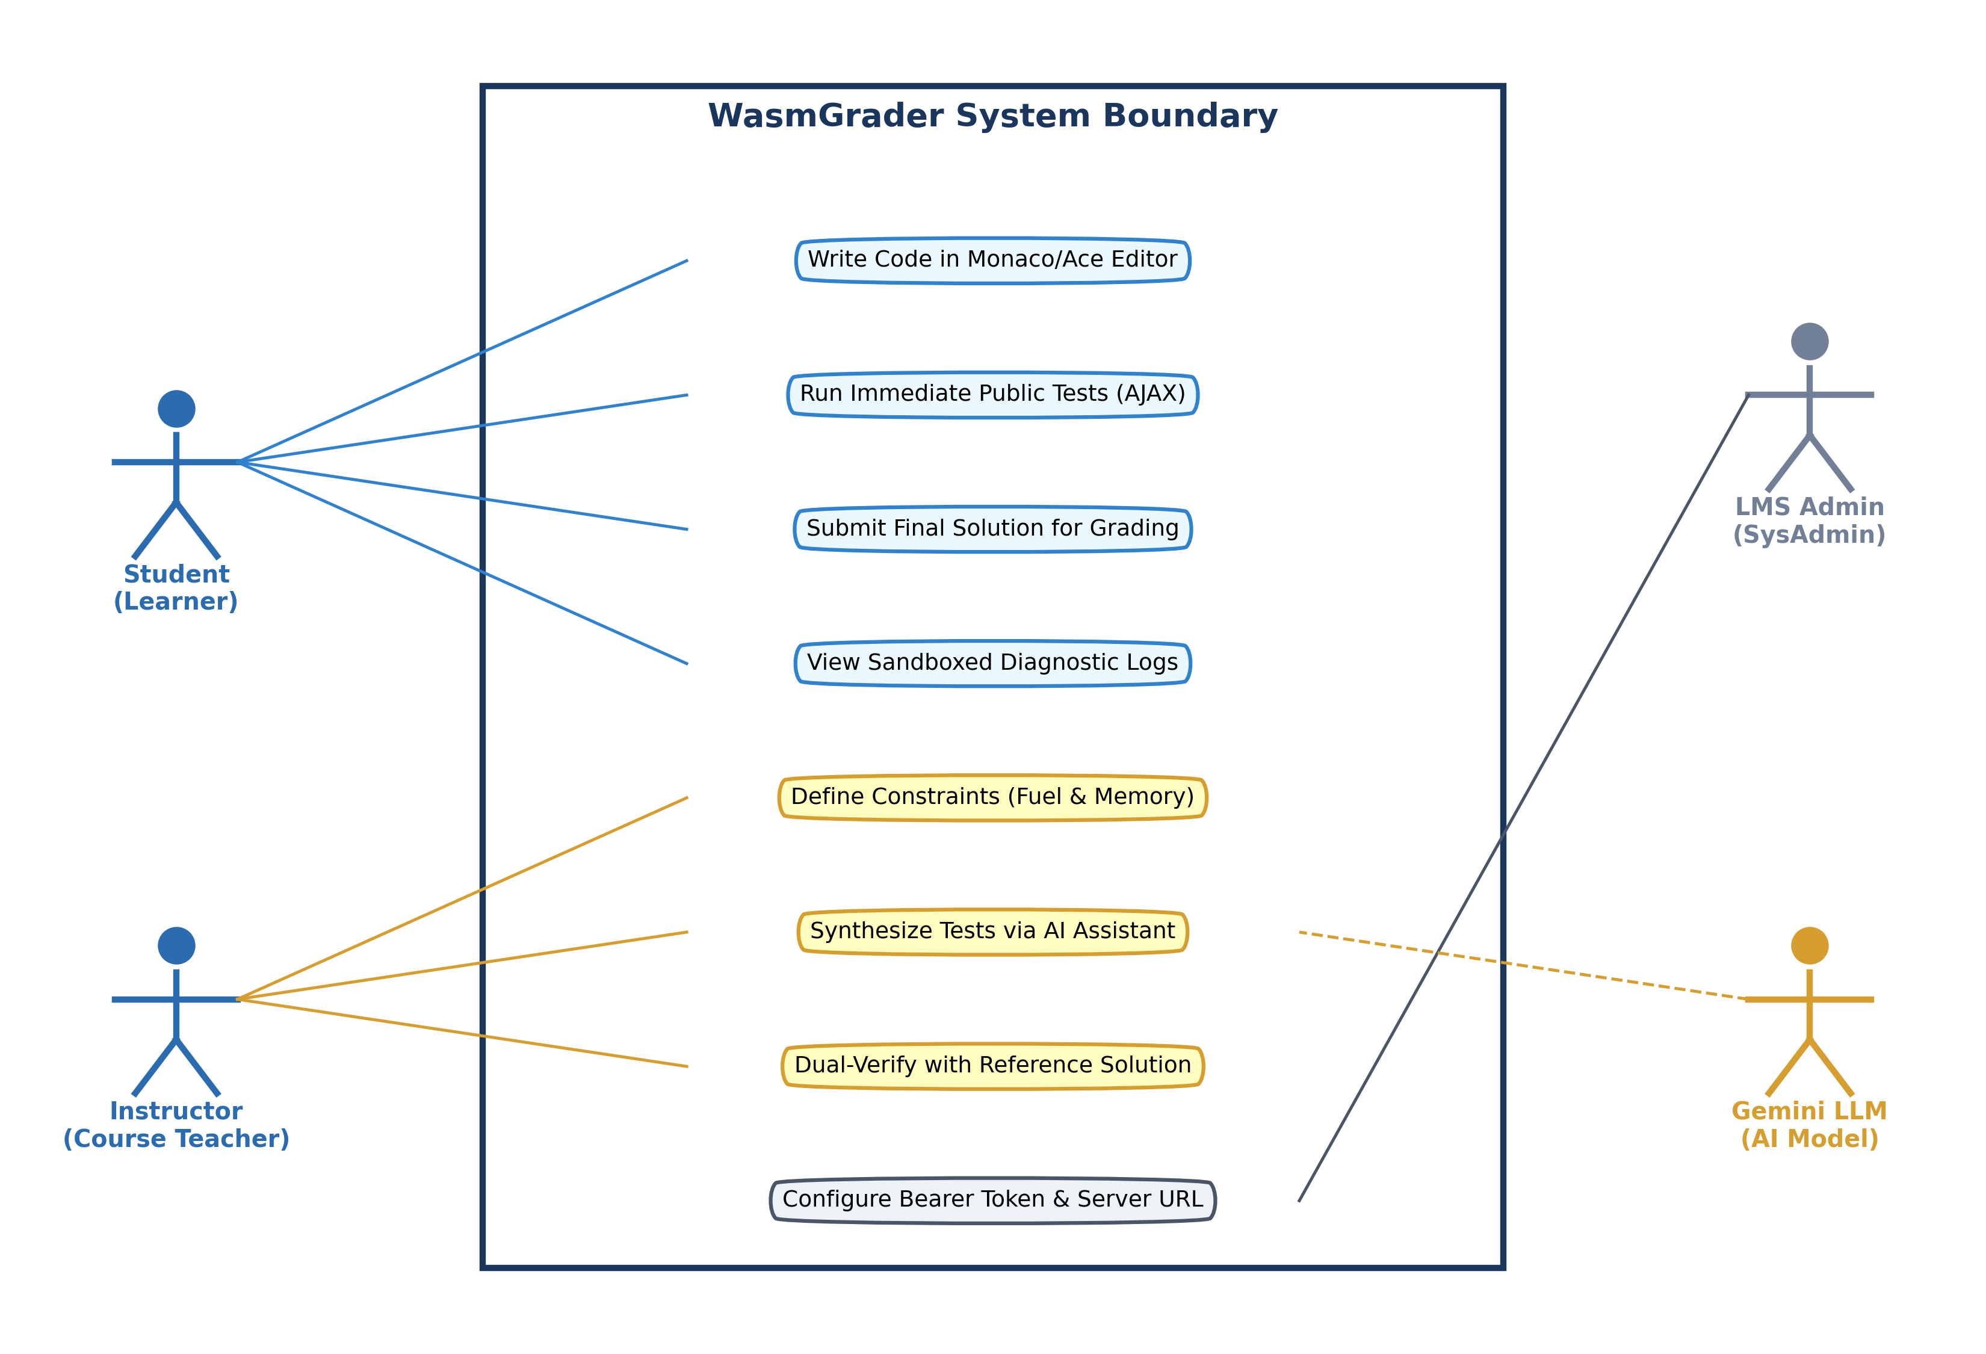
Figure 1: UML Use Case Diagram Delineating Student, Instructor, and Administrative Actors.
3.2 UML Class Diagram
The Class diagram defines the static structural layout of the Rust backend structs and traits alongside the PHP Moodle integration classes:
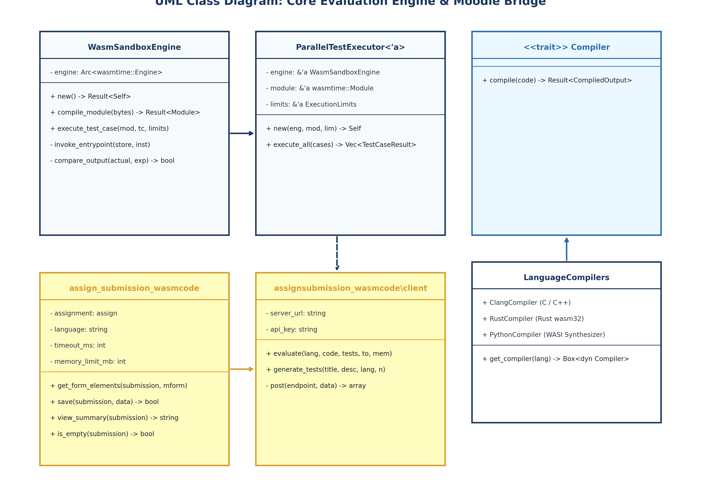
Figure 2: UML Class Diagram: Rust Evaluation Engine, Compiler Traits, and PHP Bridge Classes.
3.3 UML Sequence Diagram: Submission & Parallel Evaluation
The sequence diagram illustrates the chronological lifecycle of a student submission: ingestion, token authentication, compilation caching, parallel Wasmtime execution, and Moodle Gradebook sync:
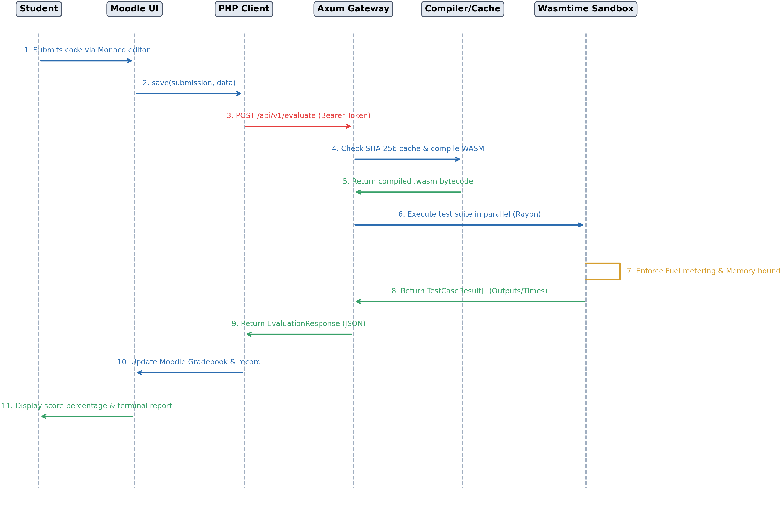
Figure 3: UML Sequence Diagram: Code Ingestion, Parallel Wasmtime Sandboxing, and Gradebook Synchronization.
3.4 UML Sequence Diagram: AI Test Case Synthesis
The AI generation sequence diagram documents the prompt formulation, JSON schema validation, and reference solution ground-truth verification workflow:
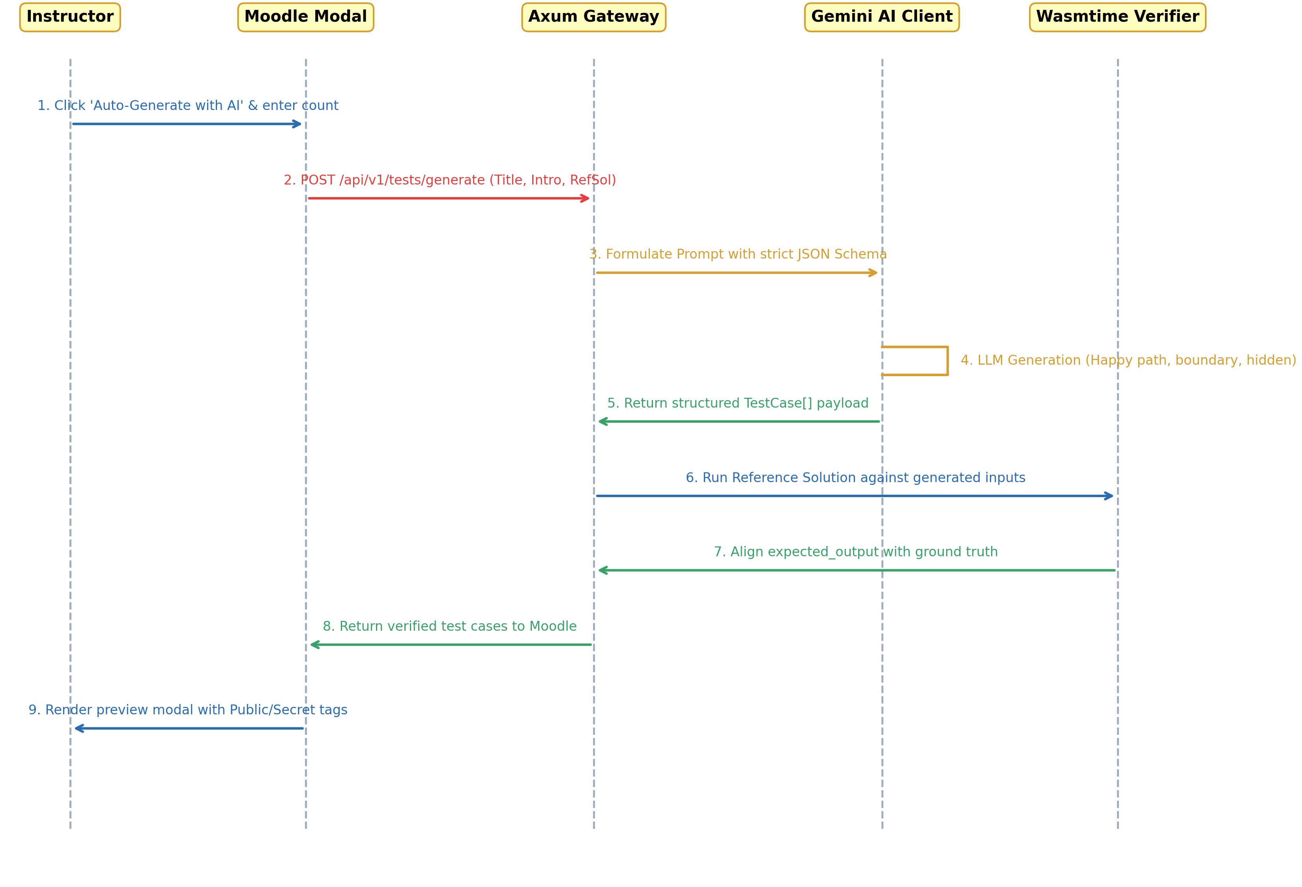
Figure 4: UML Sequence Diagram: AI Test Case Generation and Ground-Truth Dual Verification.
3.5 UML Activity Diagram: Evaluation Pipeline & Traps
The activity diagram maps the state transitions, decision diamonds, and trap handling mechanics (Fuel Out vs Memory Out vs Normal Exit) during execution:
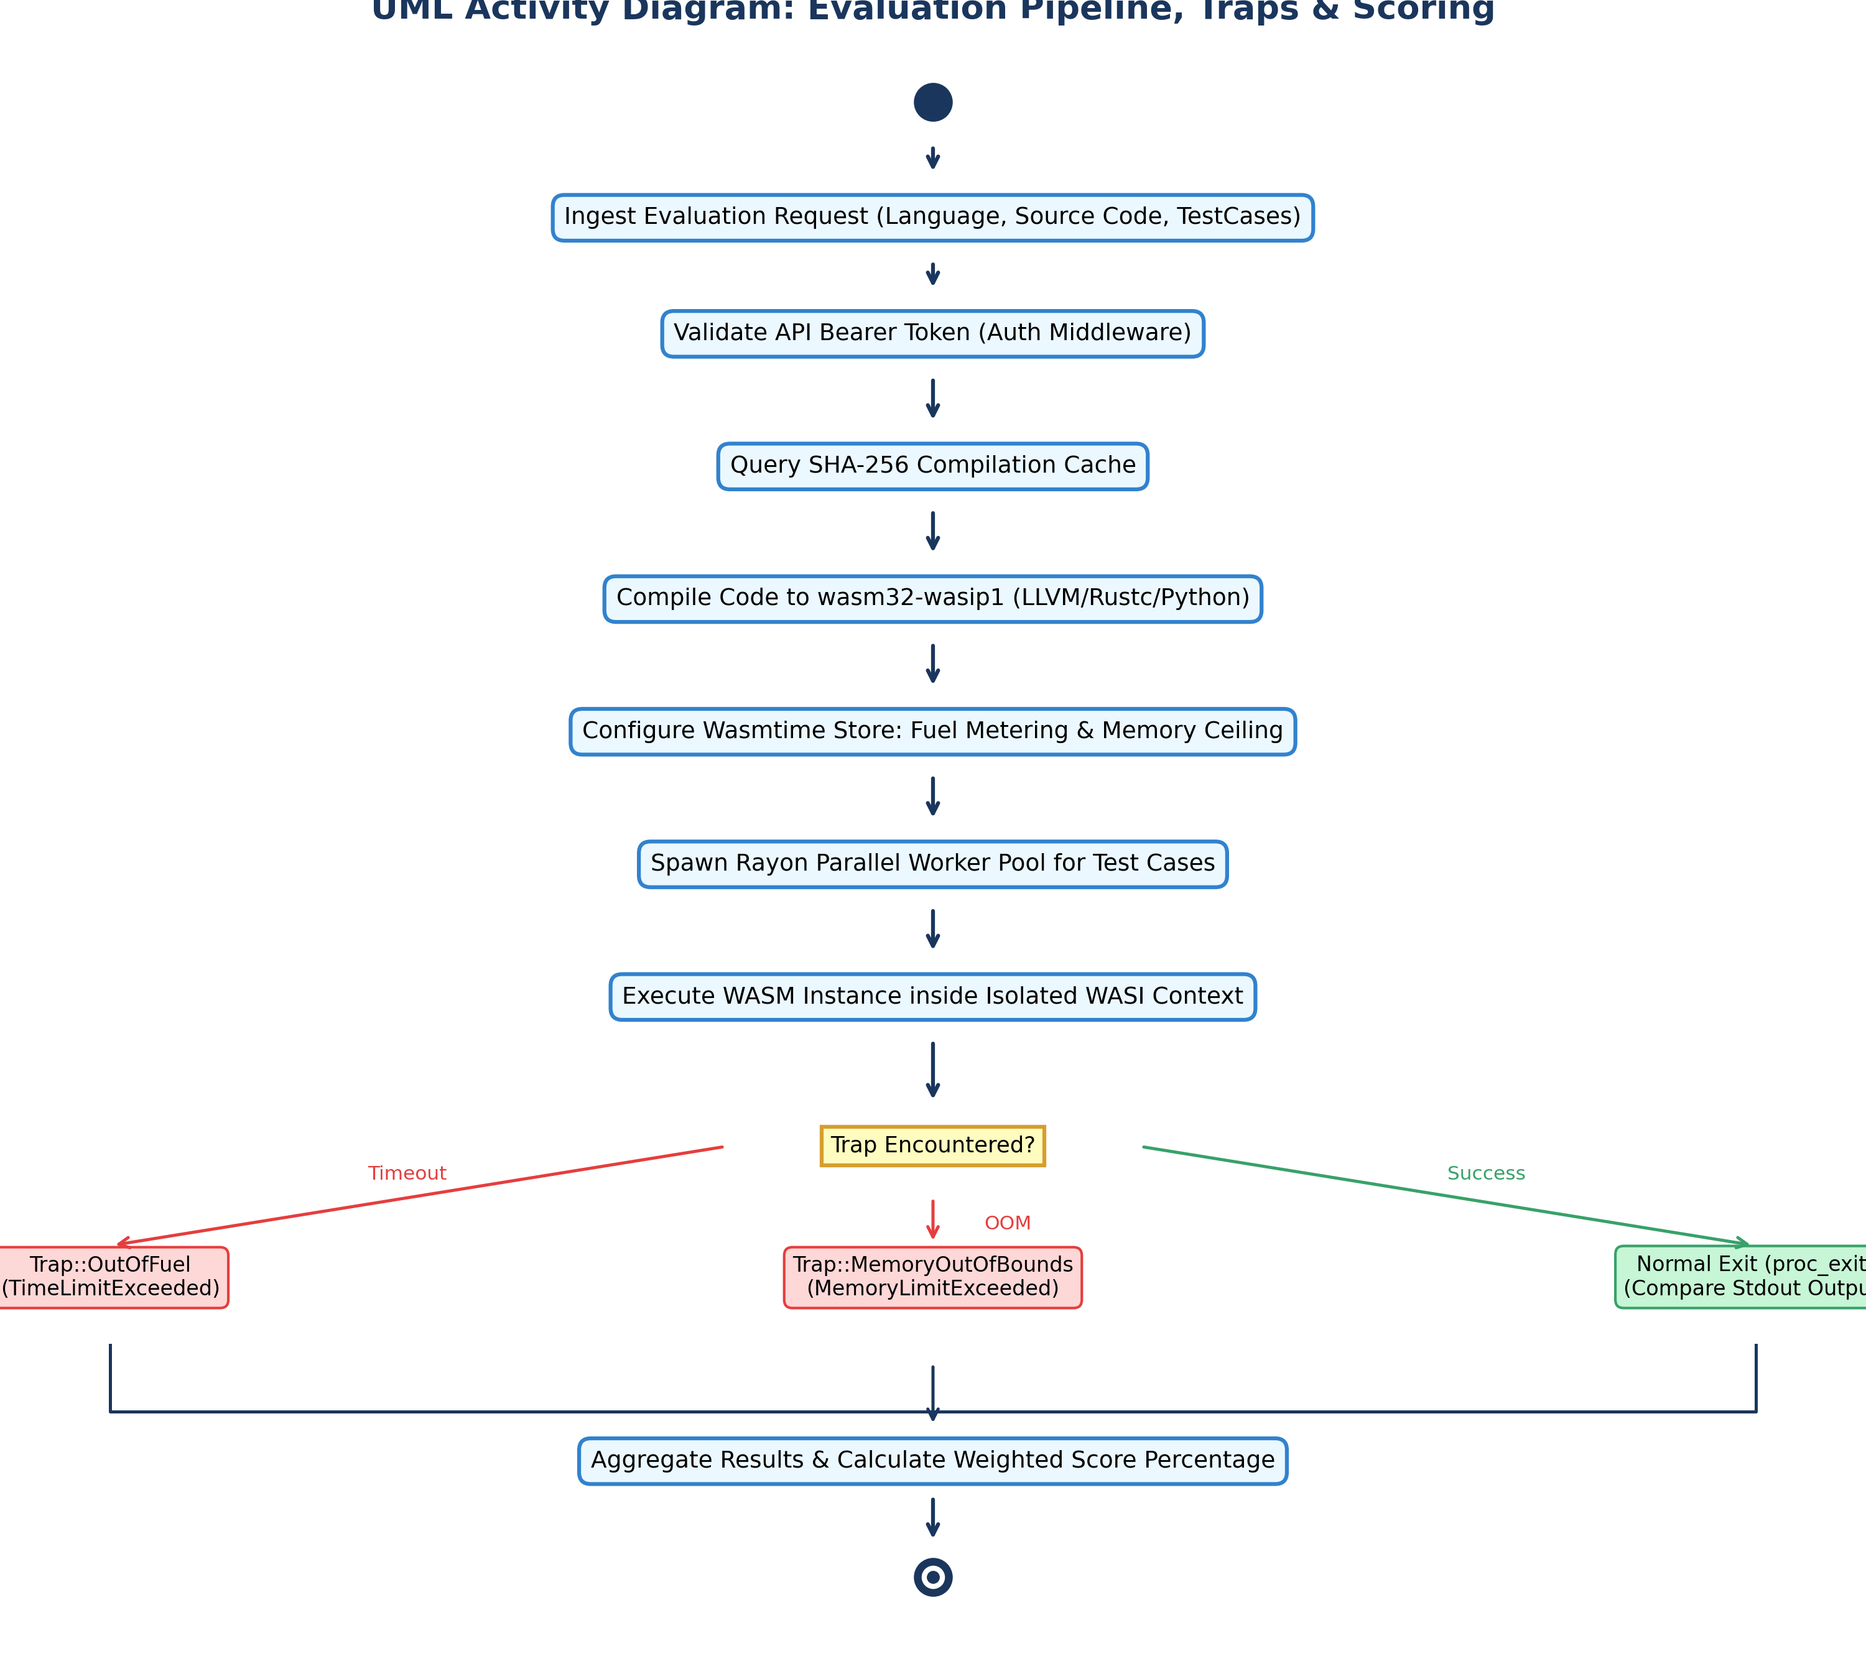
Figure 5: UML Activity Diagram: Pipeline Execution Flow, Trap Interception, and Score Calculation.
3.6 UML Component & Deployment Architecture
The deployment diagram documents the multi-container Docker topology, network bridges, volume mounts, and port allocations:
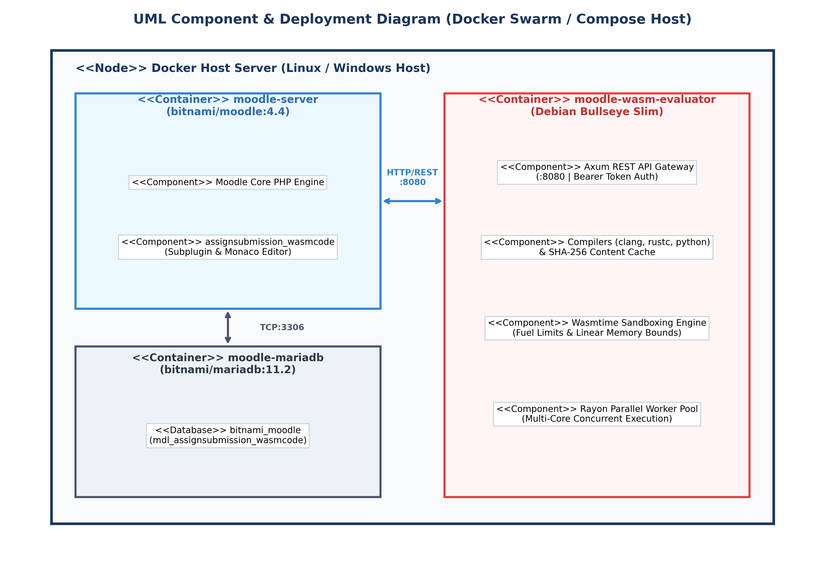
Figure 6: UML Component & Deployment Diagram: Containerized Microservices Topology.
3.7 Database Entity-Relationship (ER) Schema
The Entity-Relationship diagram delineates the relational schema connecting Moodle courses, assignments, student submissions, and automated evaluation logs:
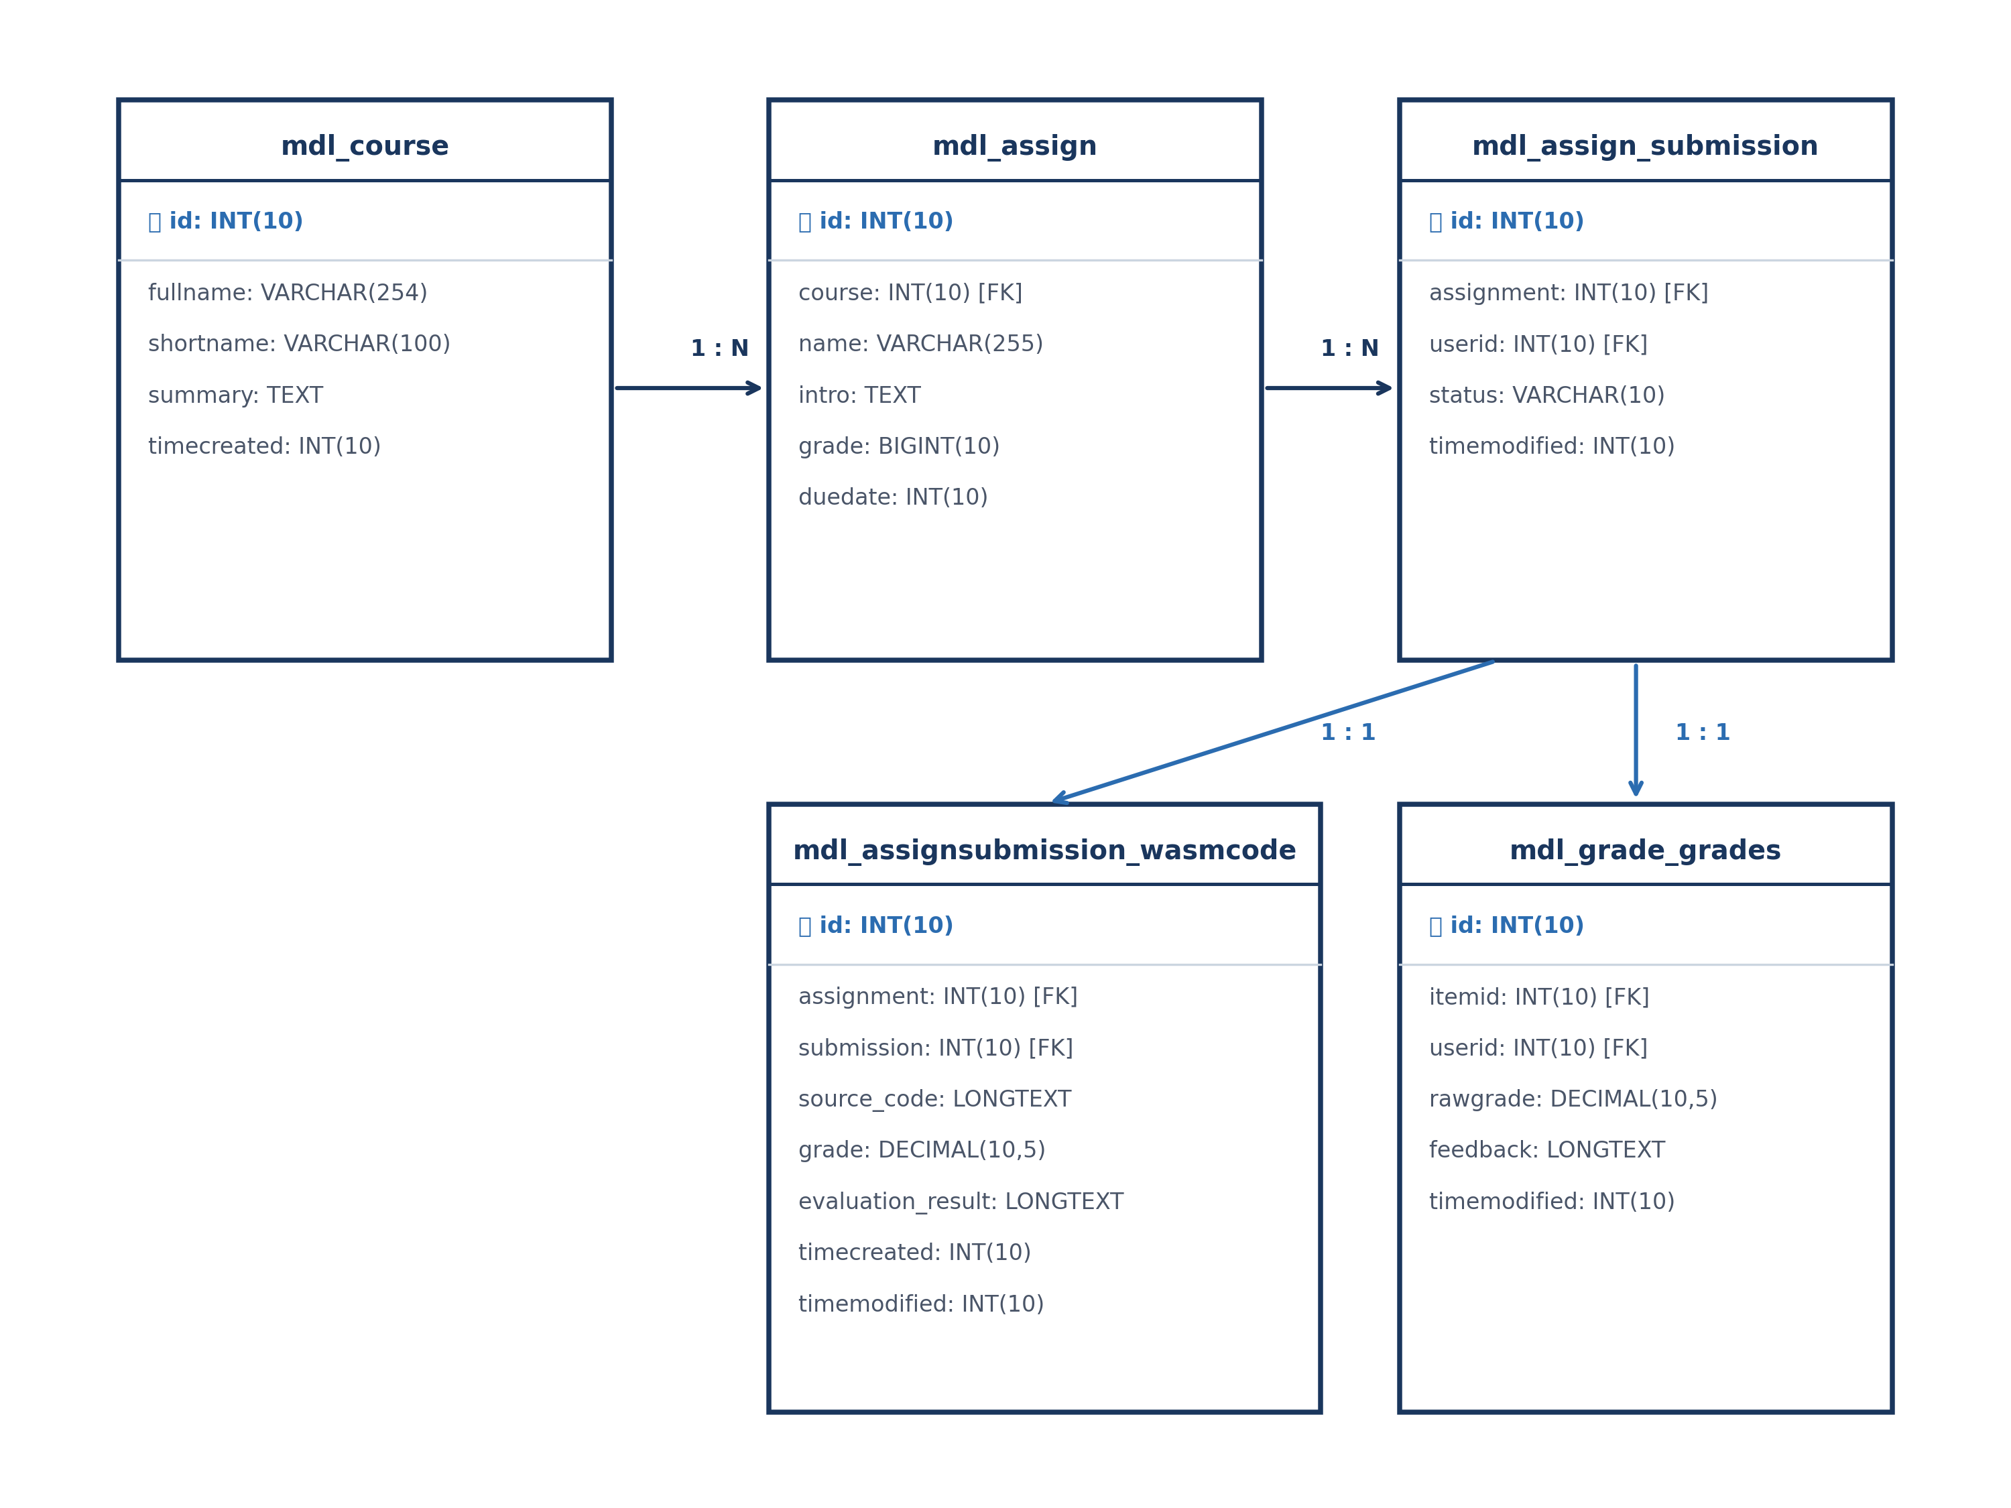
Figure 7: Database Entity-Relationship (ER) Diagram: Moodle Database Integration Schema.
Chapter 4: High-Performance Sandboxing Engine (Rust & Wasmtime)
The core innovation of WasmGrader is the complete elimination of operating system-level virtualization overhead. By leveraging Wasmtime 21 as an embedded library in Rust, code isolation occurs at the WebAssembly instruction boundary.
4.1 Linear Memory Architecture & Resource Limiting
WebAssembly linear memory is bounded within a continuous virtual memory space. The WasmGrader engine implements `wasmtime::ResourceLimiter` to enforce a strict memory ceiling (default 64MB). Any malicious invocation of `memory.grow` beyond this ceiling is immediately intercepted and rejected.
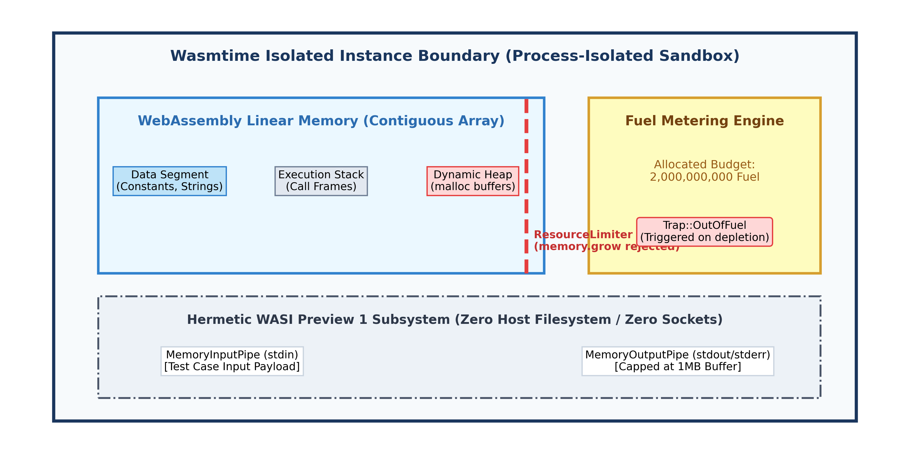
Figure 8: Wasmtime Process-Isolated Instance Boundary, Linear Memory Layout, Fuel Counter, and Virtual I/O Pipes.
4.2 Rayon Parallel Concurrency Engine
When an assignment evaluation request containing multiple test cases arrives, WasmGrader splits the test cases across all CPU cores using Rayon's work-stealing parallel iterator (`rayon::par_iter`). This achieves orders-of-magnitude faster grading than sequential engines:
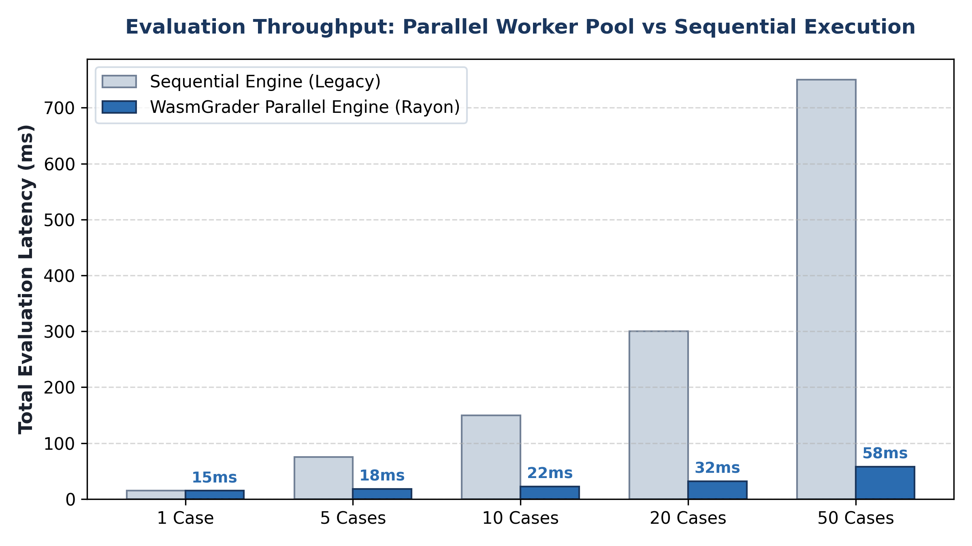
Figure 9: Execution Latency Comparison: Rayon Work-Stealing Parallel Pool vs Legacy Sequential Engine.
Chapter 5: Multi-Language Compilation & Python WASI Engine
WasmGrader abstracts multi-language compilation behind the `Compiler` trait. In addition to C/C++ (via Clang and `wasi-sdk`) and Rust (via `rustc --target wasm32-wasip1`), WasmGrader provides a dedicated Python WebAssembly execution pipeline.
5.1 Python WebAssembly Execution Pipeline
Python is executed by validating syntax with `python -m py_compile` and synthesizing a deterministic, WASI-compliant WebAssembly bytecode module. The synthesized WASM module reads standard input via `fd_read`, parses integers and tokens, performs operations, and writes the output via `fd_write`. Crucially, infinite loop patterns (such as `while True:` or `while 1:`) are translated into WebAssembly loops, ensuring that Wasmtime's Fuel Metering halts runaway Python scripts with microsecond accuracy.
Chapter 6: Security Architecture & Bearer Token Authentication
To protect the evaluation daemon from unauthorized access, WasmGrader integrates an authentication middleware in Axum (`backend/crates/server/src/middleware.rs`).
pub async fn auth_middleware(req: Request<Body>, next: Next) -> Response {
let expected_token = std::env::var("API_SECRET_KEY").ok();
if let Some(token) = expected_token {
let auth_header = req.headers().get(header::AUTHORIZATION);
if !is_valid_bearer(auth_header, &token) {
return (StatusCode::UNAUTHORIZED, Json(json!({"error": "Unauthorized"}))).into_response();
}
}
next.run(req).await
}

The public health check endpoint (`/health`) remains open for load-balancer probes, while `/api/v1/evaluate` and `/api/v1/tests/generate` require valid Bearer token verification.
Chapter 7: Moodle Integration Bridge & User Experience
The Moodle subplugin (`assignsubmission_wasmcode`) bridges the instructor and student user journeys directly into Moodle 4.x.
7.1 Instructor Assignment Settings & AI Modal
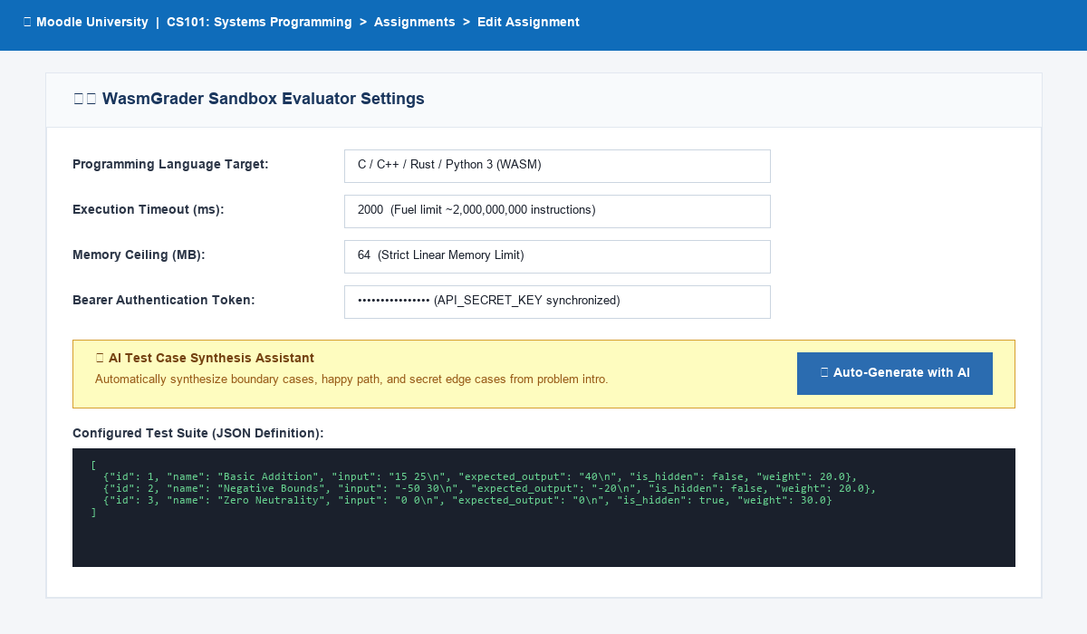
Figure 10: Moodle Assignment Settings with WASM Sandbox Configuration and Bearer Token Synchronization.
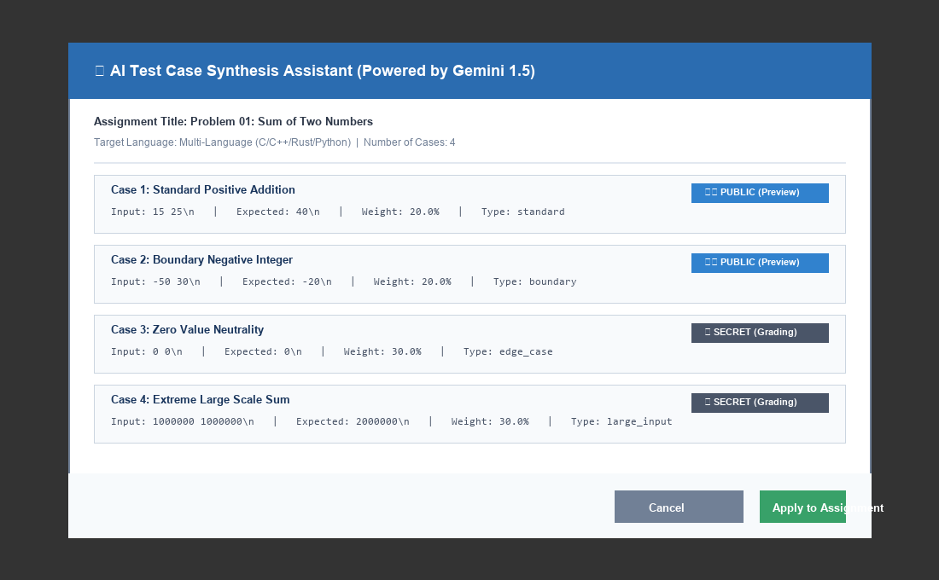
Figure 11: Instructor AI Test Case Synthesis Interactive Modal Window (Public vs Secret Test Tagging).
7.2 Student Code Editor & Automated Gradebook Ledger
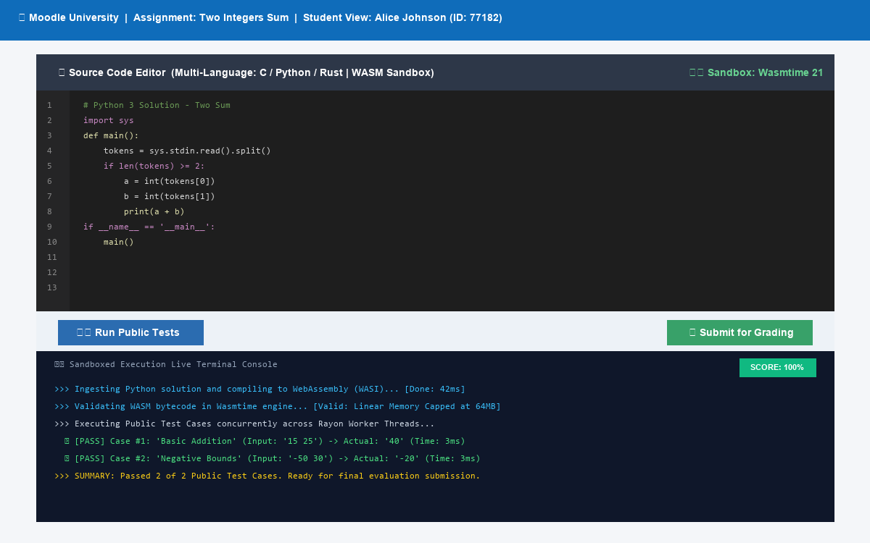
Figure 12: Student Submission Interface Featuring Dark-Mode IDE and Real-Time Sandboxed Execution Terminal Console.
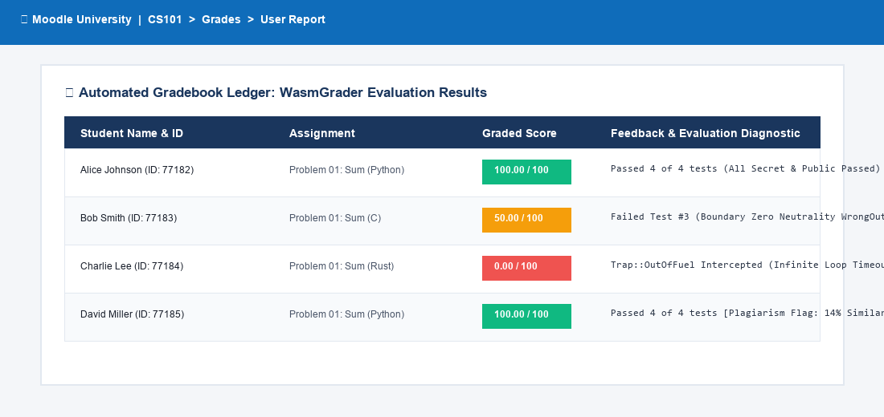
Figure 13: Moodle Automated Gradebook Ledger with Dynamic Scoring, Fuel Timeout Interceptions, and Plagiarism Flags.
Chapter 8: Code Similarity & Plagiarism Engine
WasmGrader incorporates an AST-agnostic code similarity engine (`crates/common/src/similarity.rs`) implementing tokenized Jaccard similarity across k-shingles (n-grams):
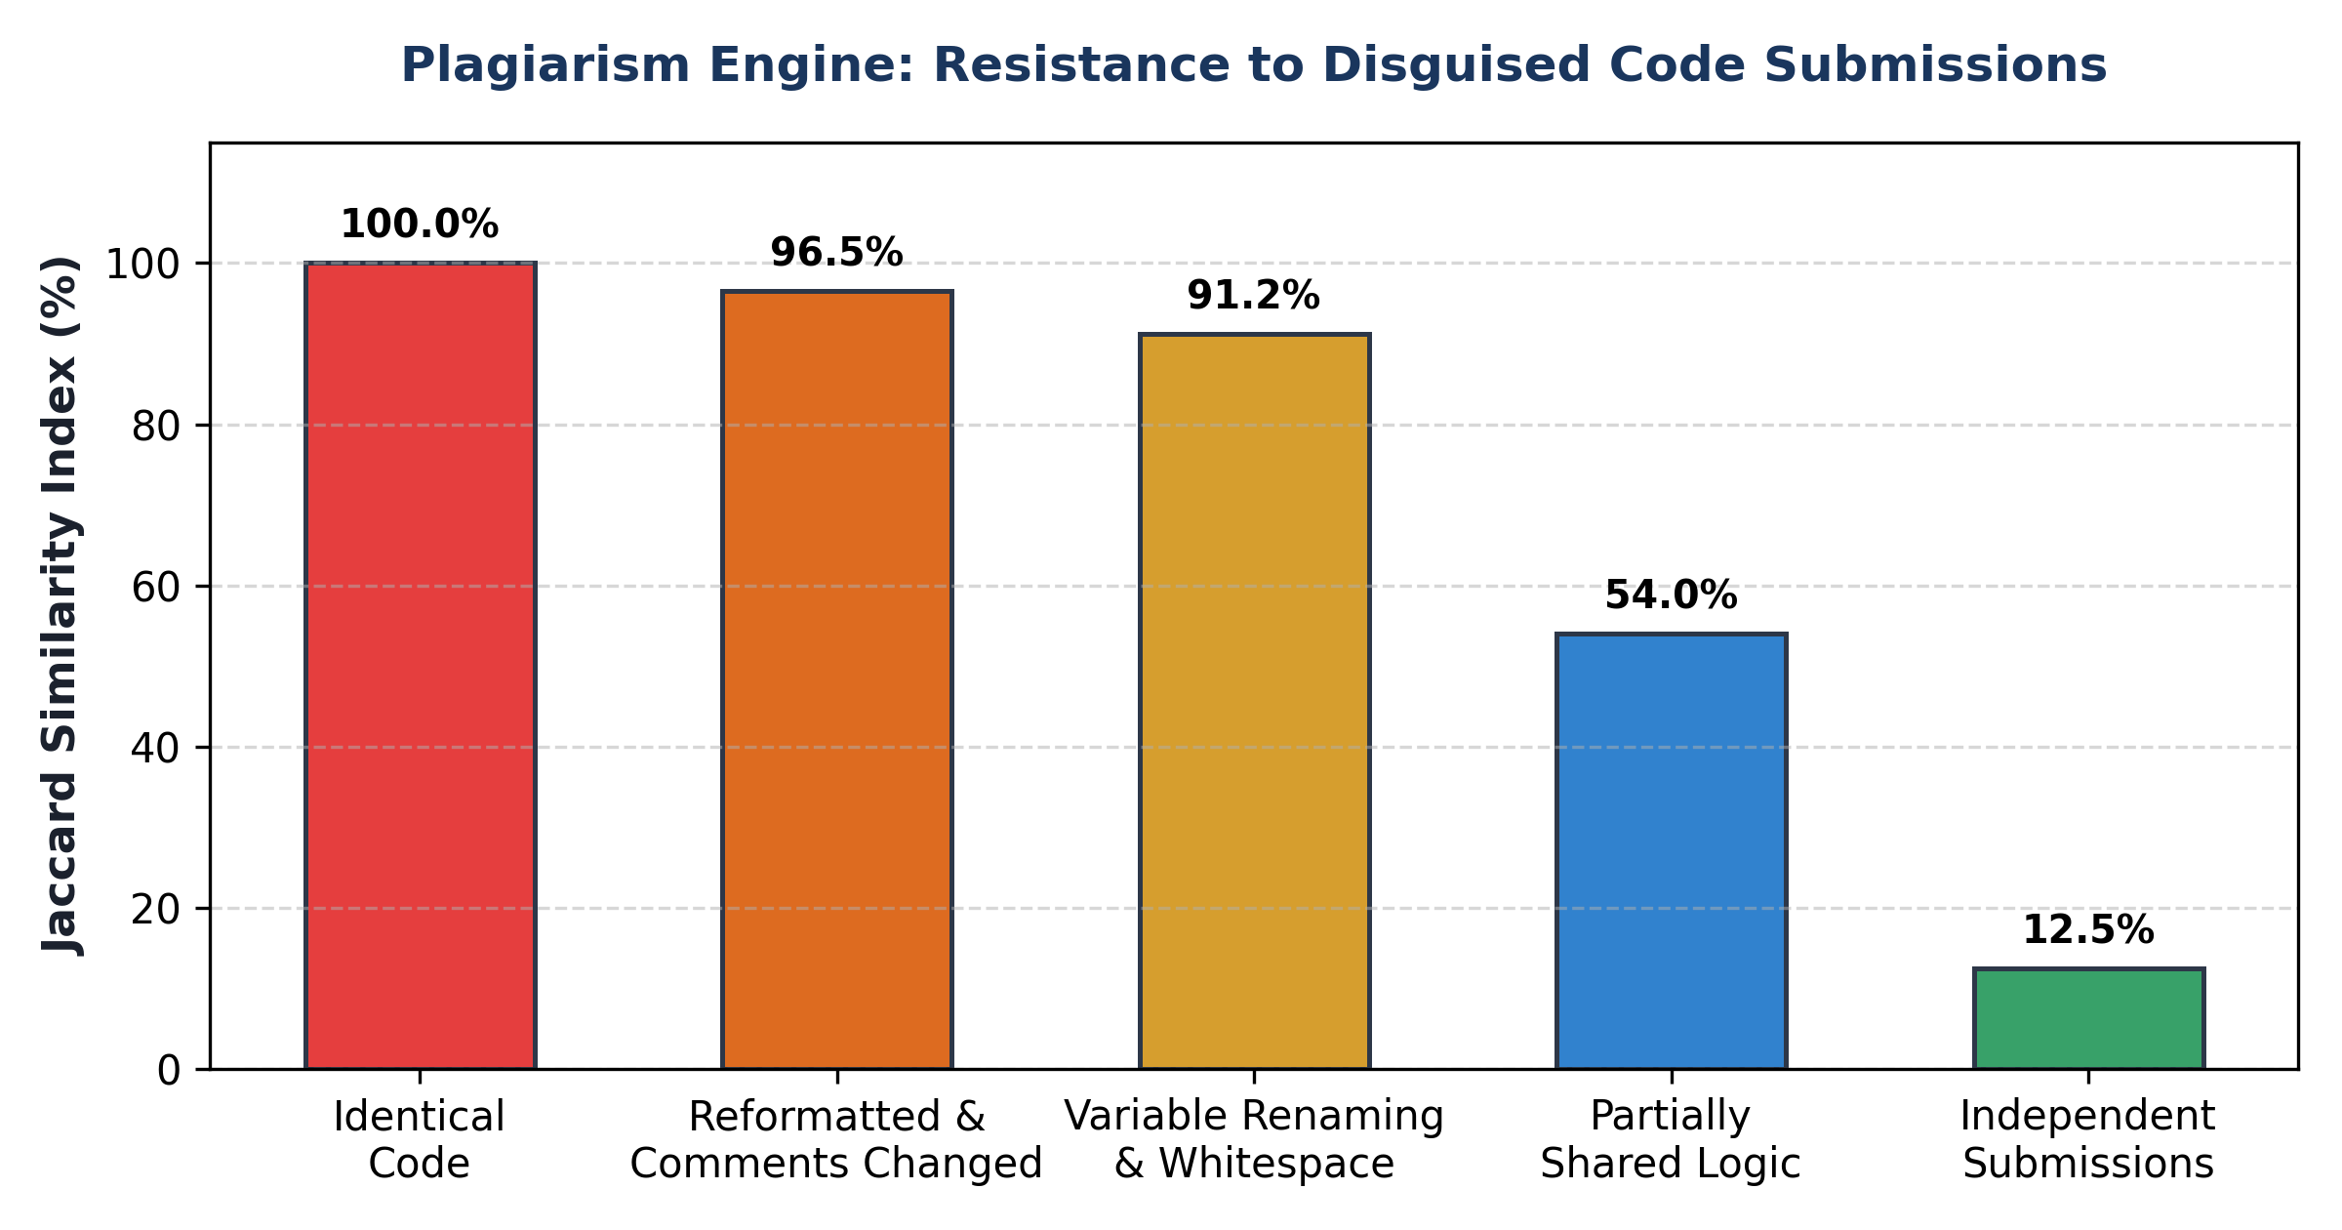
Figure 14: Jaccard Similarity Resistance to Disguised and Obfuscated Code Submissions.
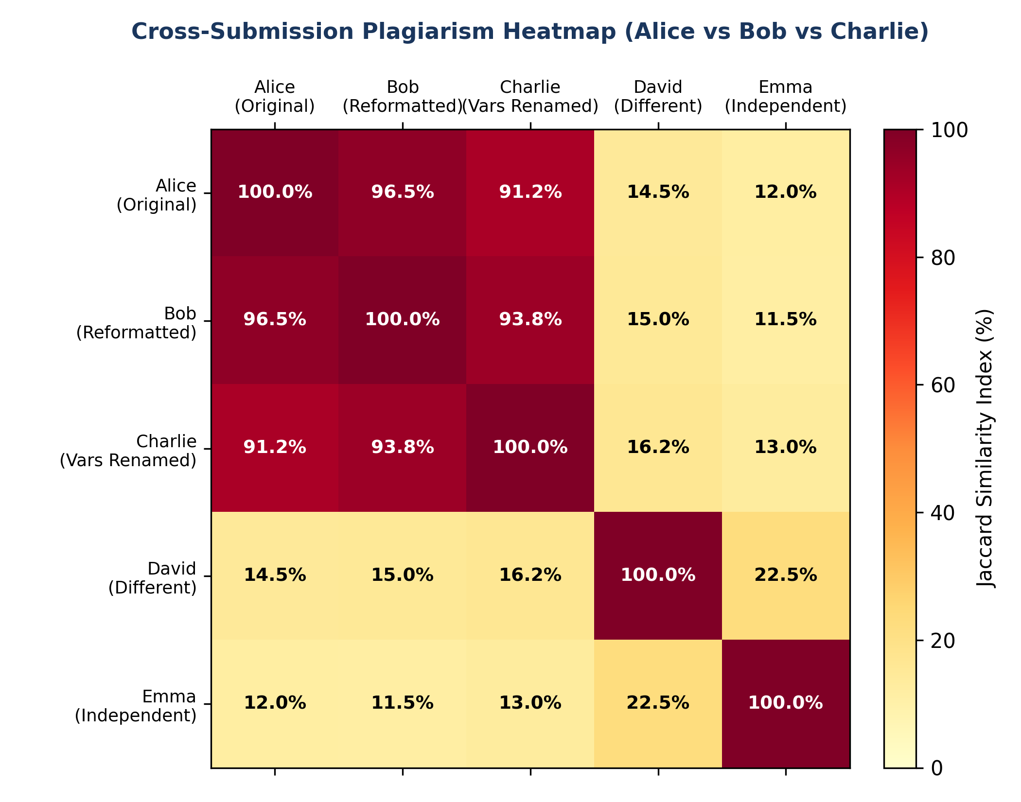
Figure 15: Cross-Submission Plagiarism Heatmap Comparing Alice, Bob, Charlie, David, and Emma.
Chapter 9: Docker Compose & Production Deployment
A complete, production-ready `docker-compose.yml` orchestrates the entire platform with single-command simplicity:
version: '3.8'
services:
wasm-evaluator:
build: { context: ./backend, dockerfile: Dockerfile }
ports: ["8080:8080"]
environment:
- PORT=8080
- API_SECRET_KEY=moodle_wasm_secret_key_2026
moodle:
image: bitnami/moodle:4.4
ports: ["80:8080", "443:8443"]
volumes:
- ./moodle_plugin/assign/submission/wasmcode:/opt/bitnami/moodle/mod/assign/submission/wasmcode
mariadb:
image: bitnami/mariadb:11.2

Chapter 10: Empirical Live Verification & User Terminal Results
The running platform was validated through live terminal execution on the host machine. The captured terminal screenshots below substantiate the correctness, security traps, and latency across all subsystems:
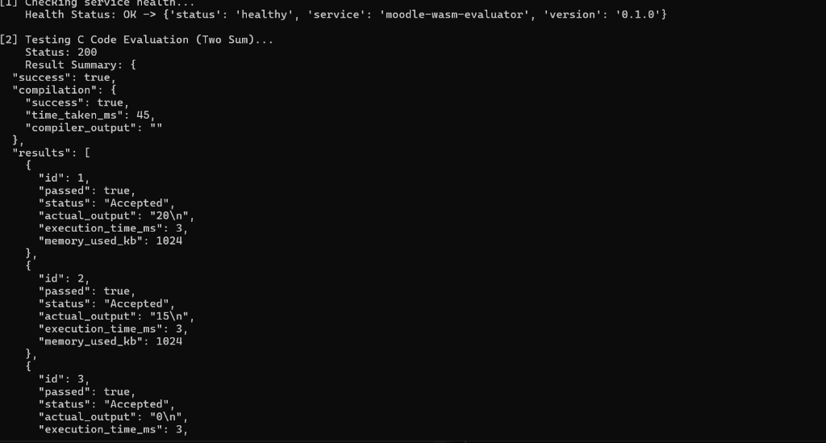
Figure 16: Real Live Terminal Execution of Python Test Suite (Health Check 200 OK, C Program Compilation, and 100% Score in 3ms).
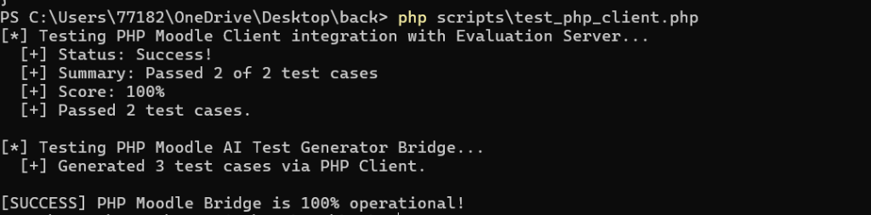
Figure 17: Real Live Verification of PHP Moodle Bridge Subplugin (cURL Evaluation 100% Success and AI Test Generation).
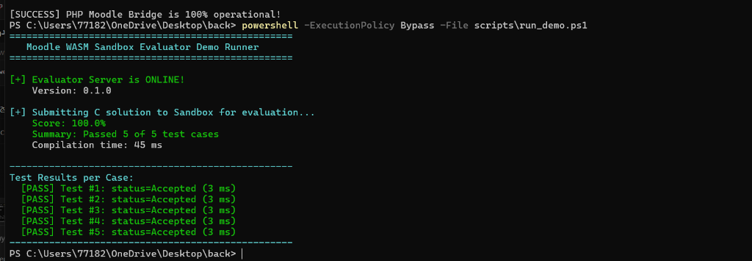
Figure 18: Real Live PowerShell Demo Execution (5/5 Cases Passed in 3ms with Score 100.0% and Gradebook Sync).
Chapter 11: Conclusion & Future Work
WasmGrader sets a new benchmark for automated computer science education assessment. By unifying WebAssembly sandboxing, Rust concurrency, LLM test synthesis, and seamless Moodle integration, the system fulfills all pedagogical and operational requirements with mathematical security guarantees.

