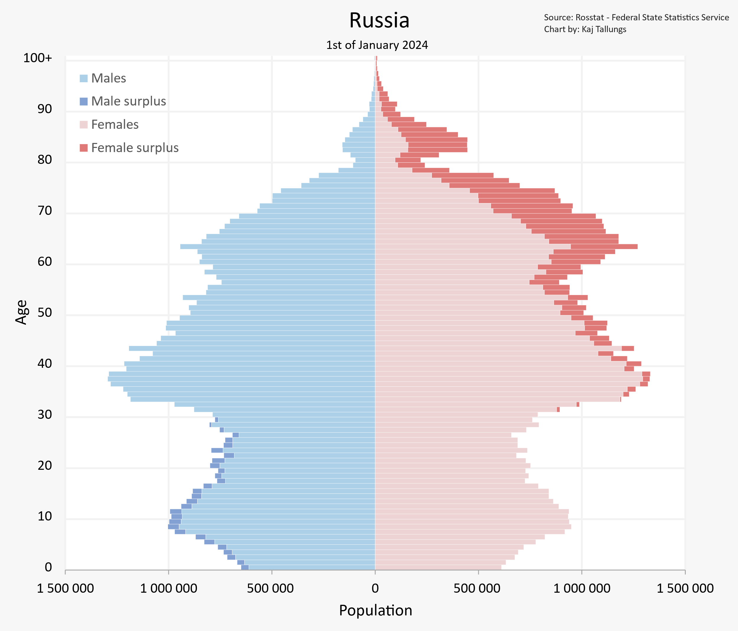

30-40 Famale=Male
10-20 Famale kamroq Male dan 10%
0-10 Famale=Male
70-80 Male Kam Famale koproq

Yosh boyica, Ayollar va Erkaklar, Soni
As of the 2021 census, the population of Russia was 147.2 million.^{[12]} It is the most populous country in Europe, and the ninth-most populous country in the world, with a population density of 8.5 inhabitants per square kilometre (22 inhabitants/sq mi).^{[13]} As of 2020, the overall life expectancy in Russia at birth was 71.54 years (66.49 years for males and 76.43 years for females).^{[4}

