Beyond Forecast Accuracy: Decision-Centric Evaluation of Demand Forecasting for Inventory Replenishment under Intermittent and Shifting Retail Demand
Md Ibtashamur Rahman
Md Ibtashamur Rahman
Department of Industrial and Production Engineering, Shahjalal University of Science and Technology, Sylhet 3114, Bangladesh
Corresponding author: Md Ibtashamur Rahman (sole author)
Data and code availability. The study uses only the public M5 competition data. Complete code, configuration files, result tables and a one-command reproduction script accompany the paper; every number in the manuscript is generated by that code.
Author contribution. Md Ibtashamur Rahman: conceptualisation, methodology, software, formal analysis, writing.

Highlights
- Forecast accuracy and inventory cost rank forecasters differently, and the choice of forecaster matters little once the decision rule is fixed.
- The forecaster picked on accuracy and run through a textbook normal-theory base-stock rule costs 140% more than the cost-optimal pairing, at lower service.
- A normal-theory rule given every tuning freedom (safety factor, refreshed dispersion, daily (s,S) structure) still costs 26% more than the best pairing.
- Calibrating quantiles after the fact raises cost by 22%. Training the quantile model cuts it by 29%.
- Choosing a pairing per SKU backfires (+35% against one portfolio-level choice), and demand regime does not change the optimum.

Abstract
Organisations invest heavily in demand-forecasting accuracy, yet the business case runs through inventory decisions, not error metrics. We measure the gap between the two on 3,999 real retail series from the M5 data, simulating a lost-sales, periodic-review replenishment system with a margin-based cost model. Nine point forecasters, one trained quantile forecaster and three calibrated empirical-interval variants are paired with four replenishment policies, giving 59 forecaster–policy pairings (56 distinct decisions). All selection uses a validation year, and results are reported on a held-out test block of 140 days.
Four findings emerge. First, accuracy and cost rankings disagree. Within the standard normal-theory base-stock rule the rank correlation between error and cost is high (Spearman ρ = 0.72–0.87), yet the forecaster chosen on out-of-sample RMSSE and run through that rule has a total inventory cost 140.4% above the cost-optimal pairing on test data (95% CI [128.8, 153.4]), with a lower fill rate (95.6% versus 99.8%). Second, the gap comes almost entirely from the decision rule. Replacing the forecaster inside the rule gains 0.4% on test (CI [−1.5, +2.5]; 3.4% on validation), replacing the rule gains 58.4% (CI [56.3, 60.5]). A normal-theory rule that is tuned on validation data (safety factor, dispersion refresh, daily (s,S) structure) closes most of the gap but stays 25.8% (CI [20.2, 32.5]) above the optimum. Third, adding uncertainty is not by itself a remedy. A quantile of a post-hoc calibrated empirical interval raises cost by 21.8% (CI [4.3, 44.6]), whereas a trained quantile model lowers it by 28.9% (CI [25.8, 32.0]). Fourth, per-SKU selection is counter-productive: it costs 34.9% more than a single portfolio-level choice on test data, and a gradient-boosted selector that fits 99% of its training labels costs 32.6% more, even though an unattainable oracle would save 19.7%.
The cost-optimal pairing is the same in every demand regime we label (level shifts up and down, volatility rise, no history), and the size of the gap persists across ten decision environments (excess cost of the accuracy-driven default 75–307%). An independent second sample reproduces the result. We conclude that accuracy-led evaluation optimises the wrong objective for replenishment, and we describe a cheap decision-cost selection protocol.
Keywords: demand forecasting; inventory control; intermittent demand; decision-focused evaluation; quantile forecasting; retail operations

1. Introduction

1.1 Motivation
The dominant way to evaluate demand forecasts is by error. The M5 competition, the largest forecasting exercise run on retail data, ranked submissions by a weighted root mean squared scaled error computed over a 12-level sales hierarchy (Makridakis, Spiliotis & Assimakopoulos, 2022a). Industrial platforms report MAPE, WAPE or bias, and academic benchmarks report MASE. All of these rest on an assumption that a smaller error produces a better downstream decision.
That assumption is a claim about the structure of the decision problem, and it fails in general. For a newsvendor with asymmetric overage and underage costs, the optimal order is a specific quantile of demand, not its mean. A model trained under squared error estimates the conditional mean, so it targets the wrong functional however small its error. An organisation can therefore improve accuracy, deploy the gain into an unchanged replenishment rule, and see little benefit.
The argument is old (Gneiting, 2011; Kolassa, 2016; Fildes, Ma & Kolassa, 2022 survey the evaluation side), but managers still lack evidence on how much it matters on a large real retail panel, and where the loss comes from: the forecast, the way uncertainty is turned into a buffer, or the policy structure. We supply that evidence.

1.2 What this paper does
We take a decision-centric view and measure it at scale. Concretely, we:
- build a lost-sales, periodic-review inventory simulator with a cost model grounded in observable retail economics (price, margin, holding rate, per-line ordering cost) rather than arbitrary cost ratios;
- state the critical ratio that this cost model implies when holding is charged per unit per day (Section 3.3);
- evaluate nine point forecasters, one trained quantile forecaster and three calibrated empirical-interval variants under four policy families, 59 pairings in all;
- decompose the accuracy-to-decision gap into four steps, with a paired bootstrap for every headline comparison;
- test whether a normal-theory rule with every degree of freedom tuned closes the gap, so the headline is not an untuned straw man;
- test selection methods (per-SKU choice, restricted menus, shrinkage, a trained meta-classifier) under a strict validation/test separation, and check out of sample whether demand regimes change the best pairing;
- stress-test the conclusions across ten decision environments and an independent second sample.

1.3 Contributions
- A decomposition of the gap. We separate “choose a better forecaster”, “estimate uncertainty differently” and “change the policy” and attach confidence intervals to each.
- An honest tuned baseline. The untuned textbook rule is 140% above the optimum; a fully tuned normal-theory rule is 26% above. Both numbers matter, and reporting only the first would overstate the case.
- A negative result on post-hoc calibration. Replacing normal-theory safety stock with a quantile of a calibrated empirical interval raised cost on this panel.
- A negative result on per-SKU selection. Optimal pairings differ across SKUs, but that heterogeneity could not be harvested from one validation year.
- A null result on regimes. The best pairing did not change across demand regimes in either block, including for series without history.
- A protocol. Simulate a few candidate pairings on a validation window under the organisation’s own cost model, pick one, and deploy it portfolio-wide.

1.4 A note on the size of M5
M5 is often said to contain 42,840 time series. That is the number of series across all 12 aggregation levels used for the WRMSSE metric (1 + 3 + 10 + 3 + 7 + 9 + 21 + 30 + 70 + 3,049 + 9,147 + 30,490). Replenishment decisions are made at the bottom level, which has 30,490 item–store series, and we work at that level.

2. Related work
Evaluating forecasts by decisions. The case for judging forecasts by their use, not by a generic error, is well established. Gneiting (2011) shows that quantiles are the optimal point forecasts under asymmetric piecewise-linear loss, which is the structure of the stockout-versus-holding trade-off. Kolassa (2016) evaluates predictive count distributions for retail sales and shows that the choice of evaluation measure changes which method looks best. Fildes, Ma and Kolassa (2022) review retail forecasting and note the gap between accuracy and operational value. Our contribution is empirical and quantitative: a decomposition of where the loss arises on a large retail panel, an assessment of selection methods, and a check against a tuned classical baseline.
Intermittent demand. Croston (1972) split intermittent demand into intervals and sizes. Syntetos and Boylan (2005) corrected a bias in his estimator, and Syntetos, Boylan and Croston (2005) proposed the ADI–CV² categorisation that we use to stratify the sample. Teunter, Syntetos and Babai (2011) replaced the interval estimator with a direct estimate of demand probability to handle obsolescence. Kourentzes (2014) showed that the cost function used to optimise and select intermittent-demand models matters, and Willemain, Smart and Schwarz (2004) developed a bootstrap approach to the lead-time demand distribution. Prak, Teunter and Syntetos (2017) show that using forecast-error variance estimates in safety-stock rules affects inventory performance. Boylan and Syntetos (2006) argued for accuracy-implication metrics, which tie error to inventory outcomes, and Syntetos, Babai and Gardner (2015) compared parametric and bootstrap methods for intermittent inventory demand. We reproduce the familiar finding that the best method depends on the demand pattern, and show that this dependence is second-order for the decision.
Inventory control with uncertain demand. Silver, Pyke and Thomas (2016) and Zipkin (2000) give the base-stock and (s,S) results on which our policies rest. The practical difficulty is that normal-theory safety stock is badly specified when demand has an atom at zero and a heavy tail, as in most of M5. Beutel and Minner (2012) integrate forecasting and inventory decisions through regression for safety stock, Ban and Rudin (2019) learn the newsvendor decision directly from data, and Oroojlooyjadid, Snyder and Takáč (2020) use deep networks for the same problem. Miclo et al. (2019) compare MRPII with demand-driven MRP, and Wallström and Segerstedt (2010) evaluate error measures for intermittent demand; our P4 policy follows the buffer logic in Ptak and Smith (2016).
Machine learning and probabilistic forecasting. The M5 accuracy results were dominated by gradient-boosted trees (Makridakis et al., 2022a), and the M5 uncertainty competition established quantile forecasting at retail scale (Makridakis et al., 2022b). Deep probabilistic models such as DeepAR (Salinas et al., 2020) and the Temporal Fusion Transformer (Lim et al., 2021) offer alternatives. The predict-then-optimise literature trains models directly on decision loss (Elmachtoub & Grigas, 2022; Bertsimas & Kallus, 2020). We do not pursue that route. We ask what an organisation with off-the-shelf forecasters gains by re-pairing them with a different rule, which is a far cheaper intervention. Our oracle analysis bounds only what selection among our 59 pairings could gain per SKU, not what an end-to-end method could achieve, since such a method would not be limited to our menu.
Selection. Meta-learning for forecaster selection uses dataset features to choose among methods. We apply it to inventory-policy selection per series and find that it overfits; the failure is an instance of the winner’s curse when a minimum is taken over many noisy estimates.

3. Problem setting and cost model

3.1 The replenishment system
We manage $n$ SKU–store series independently as single-echelon, periodic-review, lost-sales systems. Lost sales is the right model for retail, since a shopper who finds an empty shelf usually leaves. Modelling unmet demand as backorders would flatter policies that under-stock. On day $t$ the manager observes on-hand and pipeline stock and may order, with delivery after a deterministic lead time $L$ days. Demand $D_{t}≥0$ then realises and sales are $min\left(D_{t},I_{t}\right)$. The simulation starts with on-hand stock equal to the initial order-up-to level, and leftover stock at the end of a block receives no credit.

3.2 Costs
Let $p_{i}$ be the shelf price of series $i$ (observed in M5), $ρ$ the purchase-cost ratio, and $κ$ the annual holding rate. Then
$$c_{i}=ρ p_{i}, h_{i}=\frac{κ c_{i}}{365} \text{(per unit per day)}.$$
The stockout penalty $π_{i}$ is charged once per unit of unmet demand. We run two economies. In margin economics (primary), $π_{i}=m \left(p_{i}−c_{i}\right)$ is the forgone gross margin with multiplier $m=1$, so every input is observable or a standard accounting rate and the critical ratio is an output. In target-CR economics (sensitivity), $π_{i}$ is set so that the critical ratio equals 0.90. A fixed cost $K$ is charged per order line. The baseline uses $ρ=0.60$, $κ=0.25$, $K=\$0.50$, $L=2$ days and review interval $R=7$ days.

3.3 The critical ratio under per-day holding cost
Because $h_{i}$ is charged per unit per day, raising the order-up-to level by one unit under periodic review with interval $R$ costs about $h_{i}R$ in expectation: the unit is carried for roughly one cycle if it is not needed. The underage cost is $π_{i}$. Minimising
$$C\left(S\right)=hR E{\left(S−X\right)}^{+}+π E{\left(X−S\right)}^{+}$$
over $S$, where $X$ is protection-interval demand, gives
$$CR=\frac{π}{π+hR}, S^{*}=F_{X}^{−1}\left(CR\right).$$
Under our margin economics with $R=7$ this gives $CR=0.9929$. If the daily charge $h$ were used where the per-cycle charge $hR$ belongs, the implied ratio would be 0.9990, which overstates the service level the economics support. Appendix A gives the derivation and its first-order nature. The ratio depends on $R$: a policy reviewed daily faces a higher optimal service level than one reviewed weekly. We therefore sweep a grid of quantile levels for every distributional policy instead of imposing a common service target.

3.4 The protection interval and quantile aggregation
The order-up-to level covers demand over the protection interval $P=L+R$. Given daily quantile forecasts $Q_{h}\left(τ\right)$, $h=1,…,H$, the protection-interval quantile is not h​Qhτ: summing marginal quantiles is exact only under comonotonicity and otherwise overstates the tail. We use the blend
Sτ=λh≤P​Qhτ+1−λm+h≤P​Qhτ−mPP, m=h≤P​Qh0.5,
with $λ=0.5$. This interpolates between the comonotonic bound and the independence rule and is an approximation. The calibrated empirical methods, by contrast, estimate the quantile of realised $P$-day sums directly. This asymmetry is a confound for comparing them with the trained model, and Section 6.2 discusses it. Whenever a sensitivity run changes $L$ or $R$, $P$ and all protection-interval quantities are recomputed for the new value.

4. Data, protocol and methods

4.1 The M5 panel
M5 contains daily unit sales for 3,049 products in 10 Walmart stores in three US states from 2011-01-29 to 2016-06-19 (1,969 days), with a calendar of events and SNAP days and weekly selling prices. The panel has 30,490 bottom-level series and 68,156,315 recorded units; 32.2% of series-days have non-zero demand. Table 1 gives the demand-pattern diagnostics, using the Syntetos–Boylan–Croston categorisation (ADI = 1.32, CV² = 0.49).
Table 1. Structure of the M5 bottom-level panel (n = 30,490)
Statistic | Value
Lumpy (ADI ≥ 1.32, CV² ≥ 0.49) | 27,711 series (90.9%)
Erratic (ADI < 1.32, CV² ≥ 0.49) | 2,320 (7.6%)
Smooth (ADI < 1.32, CV² < 0.49) | 459 (1.5%)
Median average inter-demand interval | 2.71 days
Median CV² of daily demand | 2.77
Median share of zero-demand days | 63.1%
Median mean daily demand | 0.61 units
With a median of 0.61 units per day and 63% zero-demand days, the daily demand distribution has a large atom at zero and a long right tail, so a normal approximation to protection-interval demand will be badly specified. Because 90.9% of series are lumpy, this is not a niche subpopulation.

4.2 Sample
We use 3,999 series (13.1% of the panel), drawn by proportional stratified sampling on the SBC class so that the panel’s pattern mix is preserved: 3,635 lumpy, 304 erratic, 60 smooth. Series are also split into scale terciles by mean daily demand. The sampling seed is fixed, and Appendix C reports an independent second draw. The SBC class, scale tercile and category labels used for stratified reporting are descriptive and computed over the whole period; they are never used as inputs to any forecaster, pool or selector (those use history-only quantities, Section 4.4).

4.3 Temporal protocol
Table 2. Blocks and their use
Block | Day indices | Calendar | Length | Use
TRAIN | [0, 1465) | 2011-01-29 … 2015-02-01 | 1,465 d | forecaster fitting
VAL | [1465, 1829) | 2015-02-02 … 2016-01-31 | 364 d = 13 × 28 d | all tuning and selection
TEST | [1829, 1969) | 2016-02-01 … 2016-06-19 | 140 d = 5 × 28 d | reporting only
Forecasts are produced at rolling origins every 28 days with horizon $H=28$. Machine-learning models are fitted once per block on data strictly before the block’s first day, using the four trailing 28-day origins and, to respect the memory cap, a random subsample of 2,321 of the 3,999 series (259,952 training rows); prediction covers all series. Features are recomputed at every origin from realised demand, as happens when a model is retrained periodically. Every tuned quantity (quantile level, policy family, pairing, meta-model, safety factor) is chosen on VAL. TEST is used only to report.
Leak-free construction. Everything that depends on a series’ demand history is computed from data before the relevant origin: the calibration pools and per-series level ratios used by the calibrated methods, the meta-features of the selector, and the regime labels. In earlier internal runs these descriptors used full-panel statistics, which let information from VAL and TEST days reach the pools; we removed that and report only the leak-free results.

4.4 Forecasters
Point forecasters (9). naive (last observation); snaive (same-weekday mean over the trailing four weeks); ma28 (28-day mean shaped by the weekly profile); croston, sba and tsb (vectorised, α = 0.10, shaped by the weekly profile); hw (damped-trend Holt–Winters with weekly additive seasonality; hyper-parameters shared across series and selected by grid search on a 250-series subsample within each block, β = 0, γ = 0.05, φ = 0.90, α = 0.05 on VAL and 0.15 on TEST); comb (equal-weight average of snaive, ma28, sba, tsb); lgbm_mean (a global LightGBM regressor, Ke et al., 2017; squared loss, 65 features).
The feature set comprises lags at 7/14/28/56/91/182/364 days; rolling means, standard deviations, maxima, non-zero shares and trend ratios over seven windows; history-only per-series statistics; the same-weekday trailing mean; and calendar and price information known in advance (horizon index, current and log price, weekday, month, SNAP indicators, event codes).
Trained quantile forecaster (1). lgbm_q: six global LightGBM regressors with the quantile objective at $τ∈\{0.50,0.75,0.90,0.95,0.99,0.995\}$, made monotone in $τ$ by a running maximum. The monotonisation raises 0.0–4.2% of forecasts, mostly at $τ=0.95$ (Appendix B). In every pairing the $τ=0.995$ forecasts produced exactly the same decisions as $τ=0.99$, so the grid has five effective levels (Section 6.2).
Calibrated empirical-interval forecasters (3). cal_comb, cal_sba, cal_lgbm: the level of a point forecast combined with the empirical distribution of protection-interval demand pooled within groups defined from history at each origin (SBC class from history × history-scale tercile, up to twelve pools, thin pools merged), and rescaled per series by a clipped ratio of the current forecast level to the trailing historical level. Series with no sale yet borrow the pool of low-volume lumpy items. This is what a practitioner would do to obtain decision-relevant uncertainty without distributional training.

4.5 Policies
Table 3. Policy families
ID | Policy | Review | Level uses
P1 | Base stock with normal safety stock, $S={\hat{μ}}_{P}+z \hat{σ}\sqrt{P}$, $z=Φ^{−1}\left(CR\right)$ | every $R$ days | point forecast and trailing σ
P2 | Base stock at the CR-quantile of protection-interval demand | every $R$ days | full distribution
P3 | $\left(s,S\right)$ with $s=0.5 S$ | weekly or daily | full distribution
P4 | DDMRP-style buffer: $S=\overset{‾}{d} \left(L+R\right)+\text{buffer}$, $s=\overset{‾}{d}L+\text{red}$ | daily | point forecast
P1 is the accuracy-driven default. It is what a forecast-accuracy project naturally produces, because it needs only a point forecast and a dispersion estimate. Its σ is the trailing 56-day standard deviation measured at the start of the block. P4 uses only the forecast level and isolates how much of the benefit of distributional forecasting survives a simple buffered rule. For each distributional policy we sweep all six $τ$ values. The grid holds 59 pairings: 9 for P1, 24 for P2 (4 distributional forecasters × 6 levels), 24 for P3 (2 reviews × 2 forecasters in the P3 set, 6 levels) and 2 for P4. Because $τ=0.995$ duplicates 0.99, there are 56 distinct decisions.

4.6 Regime labels
For each (series, origin) we compare the trailing 56 days with the preceding 364 and assign new (no demand in the baseline window), level_up (mean ratio ≥ 1.5), level_down (≤ 0.67), vol_up (dispersion ratio ≥ 1.5 at a stable level), otherwise stable. Labels use only past data.

4.7 Metrics and inference
Accuracy: RMSSE and MASE with the M5-style naive scaling factor (flat-history series excluded rather than floored; 99.8% of series remain), plus MAE, RMSE, WAPE, bias, and pinball loss and coverage for the quantile forecasters. Decision quality: total cost (holding + stockout penalty + ordering), fill rate (units satisfied ÷ units demanded), period service level (share of 28-day periods without a stockout), average on-hand units, and cost as a share of revenue. Inference: a paired bootstrap over series (2,000 replicates) for each headline comparison. Both strategies are evaluated on the same series and the same realised demand. “Change” is the relative cost difference of the alternative against the reference, and “excess” is the reference’s cost over the alternative’s, divided by the alternative’s cost, so the two have different denominators and are not mirror images. We report differences and intervals instead of ratios of gains, because a ratio with a near-zero denominator is unstable.

4.8 Implementation
Python 3.11, NumPy, pandas, LightGBM, scikit-learn, SciPy; simulation loops are vectorised across series. The full experiment (both blocks, two economies, 59 pairings, the tuned-rule sweep) runs on two cores within a 1 GB memory cap. Code, configuration and all result tables accompany the paper, and random seeds are fixed.

5. Results

5.1 Accuracy does not order strategies by cost
Table 4. Point-forecast accuracy, TEST block (3,999 series, 5 origins × 28 days). Bold marks the best value in each column other than the rank.
Rank (RMSSE) | Method | RMSSE | WAPE | MAE | RMSE | MASE | Bias
1 | lgbm_mean | 0.795 | 0.751 | 1.056 | 2.408 | 1.229 | -0.104
2 | hw | 0.814 | 0.746 | 1.048 | 2.219 | 1.188 | -0.045
3 | comb | 0.822 | 0.755 | 1.061 | 2.248 | 1.184 | -0.042
4 | ma28 | 0.822 | 0.755 | 1.061 | 2.271 | 1.186 | -0.035
5 | tsb | 0.824 | 0.752 | 1.057 | 2.248 | 1.188 | -0.021
6 | sba | 0.831 | 0.767 | 1.078 | 2.301 | 1.190 | -0.075
7 | croston | 0.836 | 0.777 | 1.092 | 2.308 | 1.205 | -0.005
8 | snaive | 0.863 | 0.780 | 1.097 | 2.347 | 1.210 | -0.035
9 | naive | 1.044 | 0.995 | 1.397 | 3.161 | 1.448 | +0.244
Table 5. Cost-optimal and accuracy-driven choices, TEST block, margin economics
Pairing | Total cost (USD) | Fill rate | Period CSL | Avg on-hand | Cost, % revenue
lgbm_q + P3 (s,S) daily @ τ=0.99 | 35,209 | 0.9981 | 0.9942 | 25.7 | 1.42%
lgbm_q + P3 (s,S) daily @ τ=0.95 | 43,982 | 0.9881 | 0.9415 | 15.6 | 1.77%
lgbm_q + P3 (s,S) weekly @ τ=0.99 | 46,602 | 0.9786 | 0.9460 | 24.0 | 1.88%
lgbm_q + P3 (s,S) daily @ τ=0.9 | 56,193 | 0.9773 | 0.8445 | 12.1 | 2.27%
lgbm_q + P2 quantile base stock @ τ=0.99 | 60,176 | 0.9931 | 0.9887 | 30.2 | 2.43%
lgbm_mean + P1 normal base stock (accuracy-driven default) | 84,646 | 0.9562 | 0.7960 | 13.5 | 3.41%
hw + P1 normal base stock (best P1 forecaster on TEST) | 84,306 | 0.9581 | 0.7775 | 14.1 | 3.40%
naive + P1 normal base stock (worst) | 121,427 | 0.9259 | 0.6455 | 18.8 | 4.89%
The forecaster selected on out-of-sample RMSSE (lgbm_mean) and run through the standard normal-theory base-stock rule costs 140.4% more than the cost-optimal pairing (95% CI [128.8, 153.4]), and delivers a lower fill rate (95.6% versus 99.8%). The default is dominated on both axes, so this is not a cost-for-service trade. P1 holds 13.5 units on average against 25.7 for the optimum, yet it runs out more often, because a symmetric buffer around a conditional mean cannot represent a distribution with a 63% atom at zero and a heavy right tail. Across all 59 pairings the costliest costs 12.9 times the cheapest.
Selecting on WAPE or MAE gives a different forecaster (hw), so the “most accurate forecaster” is not even well defined, and the ambiguity does not wash out.
Table 6. Rank agreement between accuracy and cost across the nine point forecasters, within the P1 family (VAL block, margin economics)
Metric | Spearman ρ | p | Kendall τ | p | Accuracy-best | Cost-best | Agree?
RMSSE | 0.717 | 0.030 | 0.500 | 0.075 | lgbm_mean | tsb | No
WAPE | 0.867 | 0.002 | 0.722 | 0.006 | hw | tsb | No
MAE | 0.867 | 0.002 | 0.722 | 0.006 | hw | tsb | No
The rank correlation is high, which is the trap. A strong correlation within one policy family invites the inference that accuracy is a good proxy for decision quality. It is not, for two reasons. First, the winner changes with the metric: RMSSE selects lgbm_mean, WAPE and MAE select hw, and cost selects tsb on VAL and hw on TEST. Second, and more important, the spread inside P1 is small next to the spread across rules.
Table 7. Selection leverage: forecaster choice versus rule choice
Quantity | VAL | TEST
Reference: accuracy-driven default (USD) | 209,719 | 84,646
Best forecaster within P1 (ex post) | 202,620 (tsb) | 84,306 (hw)
Gain from optimising the forecaster | 3.38% (CI [+2.0, +4.8]) | 0.40% (CI [-1.5, +2.5])
Worst forecaster within P1 (USD) | 284,522 | 121,427
Spread within P1 (worst ÷ best − 1) | 40.4% | 44.0%
Best pairing overall (USD) | 88,253 | 35,209
Gain from optimising the decision rule | 57.9% (CI [+56.6, +59.3]) | 58.4% (CI [+56.3, +60.5])
Choosing the best forecaster inside P1 ex post gains 3.4% on VAL (CI [2.0, 4.8]) and only 0.4% on TEST (CI [−1.5, +2.5]), and the TEST interval includes zero. Choosing the rule gains 58% on both blocks. The within-P1 spread of 40–44% shows that a bad forecaster (naive) is genuinely costly, but marginal improvements at the top of the accuracy ranking are worth little once the standard rule is in place. Stated as differences, the gain from the rule exceeds anything the forecaster delivers by more than fifty percentage points on either block; we do not quote a ratio, because it is 17 on VAL and over 100 on TEST only because the TEST denominator is near zero.
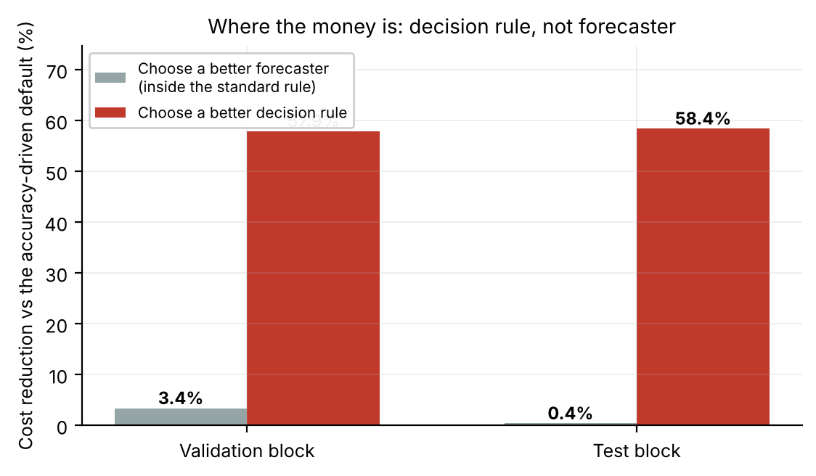
Selection leverage: cost reduction against the accuracy-driven default from choosing a better forecaster inside the standard rule (grey) versus choosing a better rule (red).
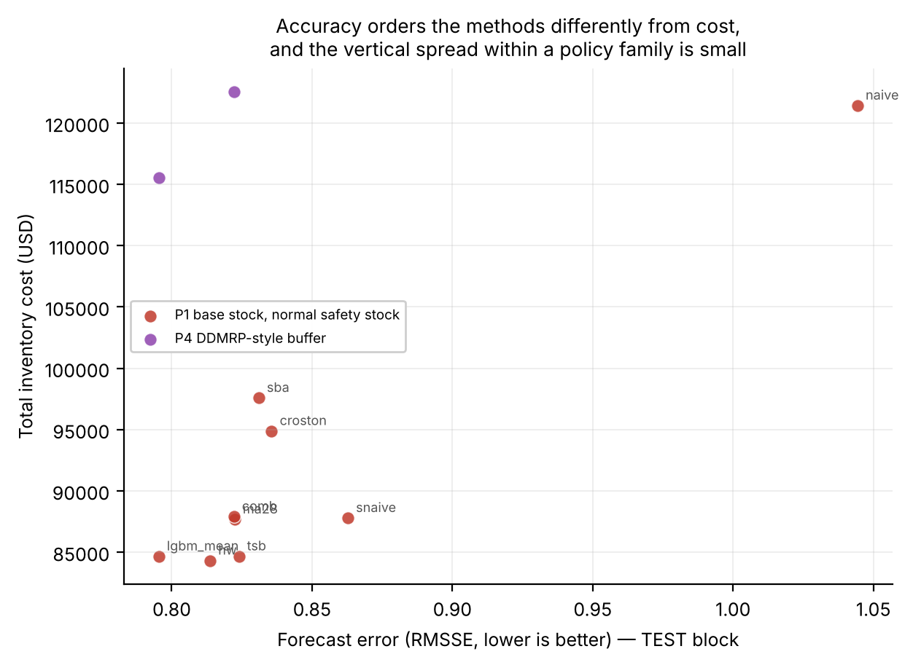
Forecast accuracy versus inventory cost, TEST block, by policy family.

5.2 Where the gap comes from
Table 8. Decomposition of the accuracy-to-decision gap. “vs A” is the paired change in cost relative to step A with its 95% bootstrap CI (negative = cheaper).
Step | VAL pairing | VAL cost | VAL vs A | TEST pairing | TEST cost | TEST vs A | Fill (TEST) | On-hand (TEST)
A Accuracy-driven default | lgbm_mean + P1 normal base stock | 209,719 | — | lgbm_mean + P1 normal base stock | 84,646 | — | 0.956 | 13.5
B Best point forecaster, same rule | tsb + P1 normal base stock | 202,620 | -3.4% [-4.8, -2.0] | hw + P1 normal base stock | 84,306 | -0.4% [-2.5, +1.5] | 0.958 | 14.1
C Calibrated quantile rule | cal_comb + P2 quantile base stock @ τ=0.99 | 254,213 | +21.2% [+6.6, +39.4] | cal_comb + P2 quantile base stock @ τ=0.99 | 103,127 | +21.8% [+4.3, +44.6] | 0.957 | 63.8
D Trained quantile rule | lgbm_q + P2 quantile base stock @ τ=0.99 | 147,690 | -29.6% [-31.7, -27.5] | lgbm_q + P2 quantile base stock @ τ=0.99 | 60,176 | -28.9% [-32.0, -25.8] | 0.993 | 30.2
E Cost-optimal pairing | lgbm_q + P3 (s,S) daily @ τ=0.99 | 88,253 | -57.9% [-59.3, -56.6] | lgbm_q + P3 (s,S) daily @ τ=0.99 | 35,209 | -58.4% [-60.5, -56.3] | 0.998 | 25.7
Step B (best point forecaster, same rule) is the only step that changes the forecast and not the rule, and it is worth 3.4% on VAL and 0.4% on TEST. Step C is the most practically important result. Replacing normal-theory safety stock with a quantile of an empirically calibrated protection-interval distribution, the natural cheap upgrade when a team adopts probabilistic forecasting, makes cost significantly higher: +21.8% on TEST (CI [4.3, 44.6]) and +21.2% on VAL (CI [6.6, 39.4]), at about the same fill rate (0.957). The calibrated rule holds 63.8 units on average, against 13.5 for P1 and 30.2 for the trained quantile rule. Pooling empirical quantiles within groups imports the group’s tail into every member, and at a critical ratio near 0.993 the group-level quantile of a lumpy distribution is large. Step D shows that a directly trained quantile model does not do this: it cuts cost by 28.9% (CI [25.8, 32.0]) and raises fill to 0.993. Pinball loss tells the same story (TEST mean over the five common levels: 0.272 for lgbm_q versus 0.369 for cal_comb), so the trained model’s advantage is not an artefact of the cost metric. Step E changes the rule from weekly base stock to daily-review (s,S) with the same quantile forecaster and level, and cuts a further 41.5% (from 60,176 to 35,209). Daily review with an (s,S) trigger reacts within a day instead of waiting up to a week and, because the per-line ordering cost is small against unit value, the extra orders are cheap. The ordering C ≻ A ≻ D ≻ E in cost is the same in both blocks.
“Distributional forecasting” is therefore not one intervention. How the distribution is obtained, and how it is converted to an order-up-to level, determines whether it helps. Because lgbm_q and the calibrated methods also differ in how they aggregate over the protection interval (Section 3.4), step C compares two pipelines and does not isolate estimation quality alone.
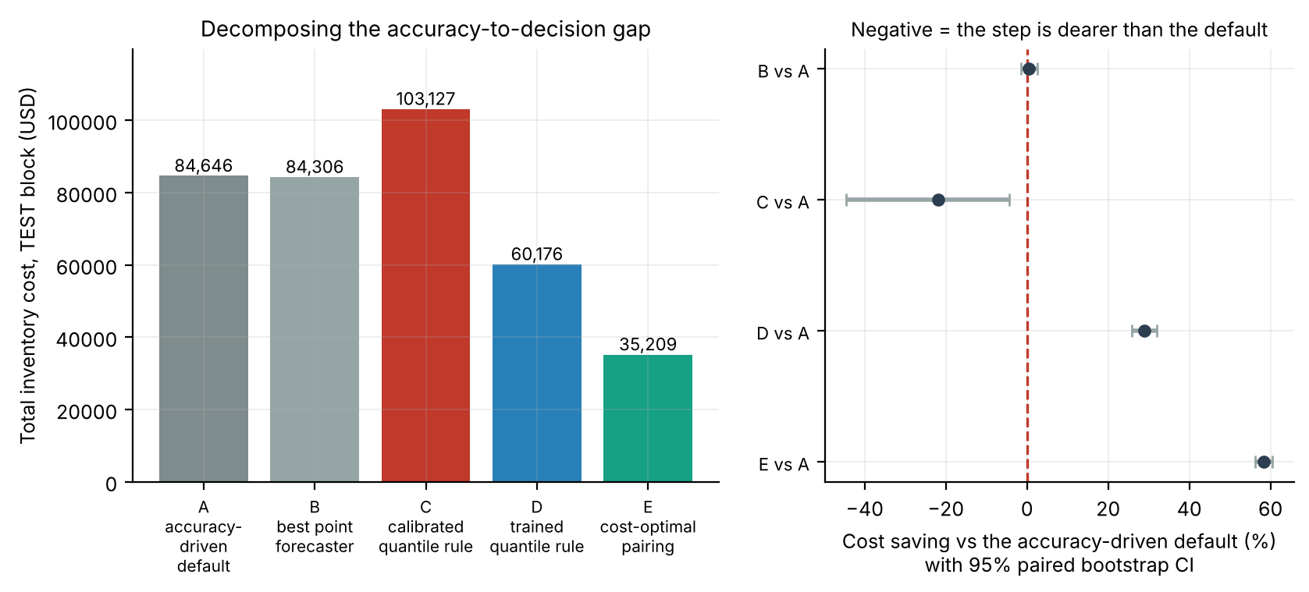
Left: cost of each decomposition step on the TEST block. Right: cost saving of each step relative to the accuracy-driven default with 95% paired bootstrap intervals (negative = the step is dearer than the default).

5.3 How much of the gap survives tuning the normal-theory rule?
The untuned P1 fixes $z$ at the critical-ratio normal quantile (about 2.5) and measures σ once at the start of a block. A sceptical reader will ask whether the headline gap comes from that, so we gave the normal-theory family every degree of freedom a practitioner could use: a grid of safety factors $z∈\left[0,10\right]$ (13 values), σ either fixed at the start of the block or refreshed at every forecast origin, and the rule structure (weekly base stock, daily base stock, or daily-review (s,S)). For each variant the forecaster and $z$ are chosen on VAL cost only, and the choice is then evaluated on TEST.
Table 9. Normal-theory rules with tuned $z$ (selected on VAL), TEST block, margin economics. “Excess” is the cost above the cost-optimal pairing; intervals are paired bootstrap 95% CIs.
Configuration | Selected on VAL | TEST cost | Fill | vs default | Excess over cost-optimal
Accuracy-driven default (untuned) | lgbm_mean + P1 normal base stock | 84,646 | 0.956 | — | +140.4% [+128.8, +153.4]
Normal theory, weekly review, sigma fixed, z tuned | tsb, z=5 | 73,921 | 0.978 | -12.7% [-15.7, -9.7] | +109.9% [+99.1, +123.9]
Normal theory, weekly review, sigma refreshed, z tuned | lgbm_mean, z=5 | 65,734 | 0.983 | -22.3% [-24.6, -20.2] | +86.7% [+79.6, +95.2]
Normal theory, (s,S) daily review, sigma fixed, z tuned | lgbm_mean, z=6 | 46,959 | 0.989 | -44.5% [-46.5, -42.5] | +33.4% [+27.5, +40.3]
Normal theory, (s,S) daily review, sigma refreshed, z tuned | lgbm_mean, z=6 | 44,288 | 0.990 | -47.7% [-49.6, -45.8] | +25.8% [+20.2, +32.5]
Normal theory, daily review, sigma fixed, z tuned | hw, z=6 | 159,966 | 0.976 | +89.0% [+81.4, +96.4] | +354.3% [+340.9, +369.6]
Normal theory, daily review, sigma refreshed, z tuned | lgbm_mean, z=8 | 147,992 | 0.986 | +74.8% [+66.9, +82.5] | +320.3% [+310.8, +330.6]
Trained quantile base stock (lgbm_q, P2, tau selected on VAL) | lgbm_q + P2 quantile base stock @ τ=0.99 | 60,176 | 0.993 | -28.9% [-32.0, -25.8] | +70.9% [+68.2, +74.1]
Cost-optimal pairing | lgbm_q + P3 (s,S) daily @ τ=0.99 | 35,209 | 0.998 | -58.4% [-60.5, -56.3] | +0.0% [+0.0, +0.0]
Three things stand out. First, tuning matters: moving $z$ from 2.5 to 5–6 (a sign of how badly the normal approximation fits lumpy demand) and refreshing σ lowers cost by 22% in the weekly rule, and by 48% when the structure is also changed to daily-review (s,S). Second, the structure matters more than the distribution: a daily base-stock rule, which orders on almost every demand event, is far worse than the default (+75% to +89%) because every order pays the line fee, whereas the same point forecast under (s,S) is the cheapest normal-theory option. Third, the trained-quantile pairing still wins. The best tuned normal-theory rule (daily (s,S), refreshed σ, $z=6$) costs 44,288 against 35,209, an excess of 25.8% (CI [20.2, 32.5]). The forecaster’s value given a good rule is therefore about a quarter of cost, not zero. The trained quantile base stock (step D, 60,176) is more expensive than the tuned normal-theory (s,S) rule, so most of the step from D to E is policy structure and not distribution. After tuning, the cost spread across the nine point forecasters shrinks to 1–16% depending on the structure.
The honest summary is two numbers. The accuracy-driven default as normally deployed is 140% above the best pairing, and a normal-theory rule tuned on a validation year is 26% above it. Practitioners who do not tune the rule leave the larger gap on the table, and the residual 26% is the value of the trained quantile forecast once the rule is good.

5.4 Demand patterns, scale and regimes
Table 10. Excess cost of the accuracy-driven default by stratum (VAL block). “Best P1 forecaster” is chosen ex post within each stratum.
Stratum | Best pairing | Best cost | Best P1 forecaster | P1 cost | Excess
SBC class: lumpy | lgbm_q + P3 (s,S) daily @ τ=0.99 | 73,016 | tsb | 170,365 | +133.3%
SBC class: erratic | lgbm_q + P3 (s,S) daily @ τ=0.99 | 12,332 | croston | 27,096 | +119.7%
SBC class: smooth | lgbm_q + P3 (s,S) daily @ τ=0.99 | 2,905 | tsb | 4,491 | +54.6%
Scale tercile: small | lgbm_q + P3 (s,S) weekly @ τ=0.99 | 17,110 | lgbm_mean | 39,855 | +132.9%
Scale tercile: large | lgbm_q + P3 (s,S) daily @ τ=0.99 | 43,609 | tsb | 99,657 | +128.5%
Scale tercile: mid | lgbm_q + P3 (s,S) daily @ τ=0.99 | 27,095 | tsb | 61,821 | +128.2%
Category: FOODS | lgbm_q + P3 (s,S) daily @ τ=0.99 | 45,352 | tsb | 108,027 | +138.2%
Category: HOUSEHOLD | lgbm_q + P3 (s,S) daily @ τ=0.99 | 29,795 | tsb | 69,351 | +132.8%
Category: HOBBIES | lgbm_q + P3 (s,S) daily @ τ=0.99 | 13,106 | tsb | 25,242 | +92.6%
The excess is large in every stratum and not uniform: it is greatest for lumpy and FOODS series (+133% to +138%) and smallest for smooth and HOBBIES series (+55% to +93%). The best P1 forecaster differs by stratum (tsb, croston, lgbm_mean), the pattern dependence the intermittent-demand literature predicts, but it remains second-order for the decision.
Table 11. Best pairing by demand regime. The pairing is chosen on VAL cells only and evaluated on TEST cells of the same regime; “regime-blind” is the single best pairing on all of VAL.
Regime | VAL cells | VAL best pairing | VAL regime-blind penalty | TEST cells | TEST gain of regime-specific choice
level_down | 11,388 | lgbm_q + P3 (s,S) daily @ τ=0.99 | 0.0% | 3,676 | +0.0%
level_up | 11,551 | lgbm_q + P3 (s,S) daily @ τ=0.99 | 0.0% | 4,034 | +0.0%
stable | 27,599 | lgbm_q + P3 (s,S) daily @ τ=0.99 | 0.0% | 12,075 | +0.0%
vol_up | 366 | lgbm_q + P3 (s,S) daily @ τ=0.99 | 0.0% | 145 | +0.0%
new (no demand in baseline year) | 1,083 | lgbm_q + P3 (s,S) daily @ τ=0.99 | 0.0% | 65 | +0.0%
Demand-regime shifts did not change which pairing was best. In every regime the cheapest pairing on VAL is the same lgbm_q + daily (s,S) at τ = 0.99 that is optimal overall, and a regime-specific choice therefore gains exactly 0.0% over the regime-blind one on the TEST cells. An earlier in-sample reading of the regime table suggested an exception for cold-start (new) series, where a pooled empirical distribution seemed to win by 17%; with leak-free pools that exception disappears (the new regime has 1,083 VAL and only 65 TEST cells, so it is thin evidence either way). A regime-aware meta-classifier given the regime label did no better than the fixed choice (Section 5.5). We therefore see no case here for building a regime detector for policy selection, with the caveat that our regime definitions are simple and our TEST block is short.

5.5 How to select, and how not to
Table 12. Selection strategies. Selection uses VAL only; costs are evaluated on the held-out second half of VAL (VAL-B) and on TEST.
Strategy | Selection rule | VAL-B cost | TEST cost | vs S1 (VAL-B) | vs S1 (TEST) | Distinct choices
S1 Fixed, pooled best | one pairing, chosen on all of VAL | 48,571 | 35,209 | +0.0% | +0.0% | 1
S2 Fixed, split-half | one pairing, chosen on VAL-A | 48,571 | 35,209 | +0.0% | +0.0% | 1
S3 Per-SKU, all of VAL | argmin per SKU on VAL | 41,772 | 47,481 | -14.0% | +34.9% | 41
S4 Per-SKU, split-half | argmin per SKU on VAL-A | 73,730 | 64,995 | +51.8% | +84.6% | 51
S5 Menu: policy families | per SKU, forecaster fixed | 43,866 | 42,146 | -9.7% | +19.7% | 14
S6 Menu: forecasters | per SKU, policy fixed | 47,240 | 36,983 | -2.7% | +5.0% | 2
S7 Shrinkage λ=0.25 | blend SKU and pooled cost | 47,465 | 36,703 | -2.3% | +4.2% | 5
S7 Shrinkage λ=0.5 |  | 45,972 | 38,660 | -5.4% | +9.8% | 10
S7 Shrinkage λ=0.9 |  | 42,863 | 42,340 | -11.8% | +20.3% | 21
S8 Accuracy-driven default | best RMSSE + P1 | 115,698 | 84,646 | +138.2% | +140.4% | 1
S9 Oracle on VAL-B | (unattainable) | 39,495 | 57,407 | -18.7% | +63.0% | 48
S9 Oracle on TEST | (unattainable) | 74,590 | 28,275 | +53.6% | -19.7% | 49
Every per-SKU or learned selector is worse on TEST than a single fixed pairing. Per-SKU selection on all of VAL (S3) looks 14.0% cheaper on the validation data it was selected on and is 34.9% dearer on TEST. S4, whose selection and evaluation windows are disjoint inside VAL, is already 51.8% worse on VAL-B and 84.6% worse on TEST. This is the winner’s curse at SKU level: with 59 candidate pairings and 13 validation periods, the minimum of a noisy per-SKU cost is a biased estimator. Shrinkage towards the pooled cost (S7) moves smoothly between the extremes and never beats the pooled choice. Restricting the menu (S5, S6) reduces the damage without removing it. The accuracy-driven default (S8) is 140.4% above the fixed pairing on TEST.
A gradient-boosted meta-classifier trained to predict the VAL-best pairing from history-only series features reaches a training top-1 accuracy of 0.990 (59 classes) and then costs 46,699 on TEST, 32.6% more than the fixed pairing (35,209). Its most important features are cv2, sd_daily, adi, total_units and mean_daily: exactly the demand-pattern descriptors one would expect, and the ones that fail to generalise.
Headroom. An unattainable per-SKU oracle on TEST costs 28,275 against 35,209 for the fixed pairing, so 19.7% of headroom exists within our menu. None of the selectors captured any of it (every learned selector lost money against the fixed choice). Whether the headroom is harvestable with more validation history, stronger shrinkage, or an end-to-end objective is open.
What works. Selecting at the portfolio level on decision cost, using a validation window and the organisation’s cost model, picks lgbm_q + daily (s,S) at τ = 0.99 on VAL, and this is also the TEST optimum (Table 5). Selecting on accuracy picks lgbm_mean + P1, which is 140.4% more expensive. Both procedures cost the same to run, so the difference is entirely in the criterion.
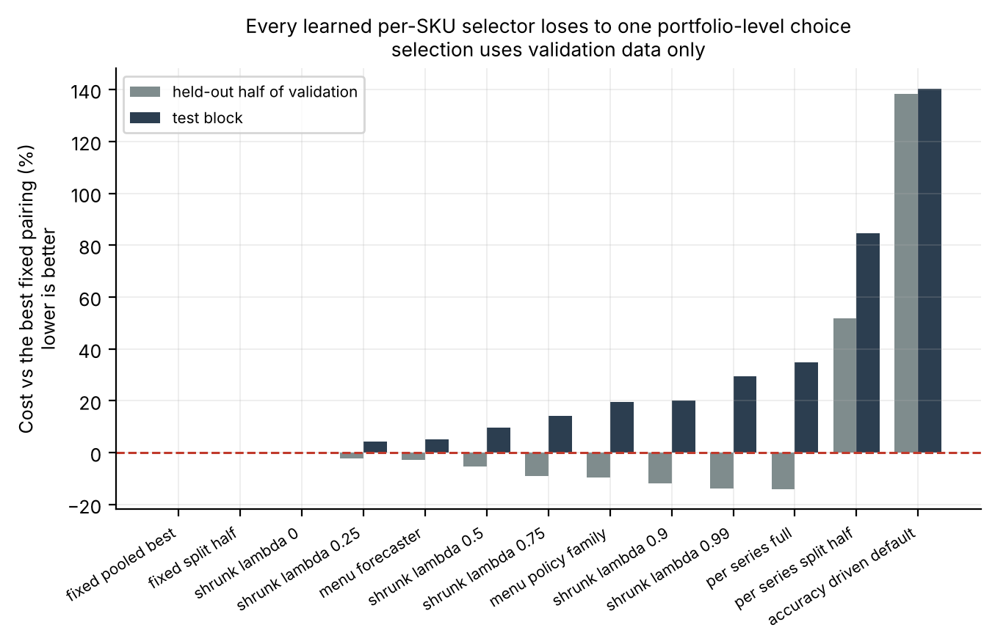
The selection strategies scored on the held-out second half of validation and on the test block.

5.6 Robustness to the decision environment
Table 13. Sensitivity suite (TEST block, margin economics). Forecasts are held fixed; the review interval, lead time and costs change, and all protection-interval quantities are recomputed for the new $P=L+R$.
Configuration | Best pairing | Best cost | Default cost | Default excess | Within-rule gain | Across-rule gain | Accuracy-best = cost-best in P1?
Baseline (L=2, K=$0.50, R=7, hold 25%, cost 60%) | lgbm_q + P3 (s,S) daily @ τ=0.99 | 35,209 | 84,646 | +140.4% | 0.4% | 58.4% | No
Lead time 7 d | lgbm_q + P3 (s,S) daily @ τ=0.99 | 45,117 | 99,634 | +120.8% | 2.5% | 54.7% | No
Lead time 14 d | lgbm_q + P3 (s,S) daily @ τ=0.99 | 62,752 | 110,037 | +75.4% | 2.2% | 43.0% | No
Order cost $5.00 per line | lgbm_q + P3 (s,S) weekly @ τ=0.99 | 139,428 | 367,165 | +163.3% | 2.7% | 62.0% | No
Review interval 14 d | lgbm_q + P3 (s,S) daily @ τ=0.95 | 39,246 | 78,248 | +99.4% | 0.7% | 49.8% | No
Holding rate 40% | lgbm_q + P3 (s,S) daily @ τ=0.99 | 47,691 | 93,396 | +95.8% | 0.2% | 48.9% | No
Purchase cost 75% of price | lgbm_q + P3 (s,S) daily @ τ=0.99 | 39,903 | 73,446 | +84.1% | 0.5% | 45.7% | No
Stockout penalty = 3× margin | lgbm_q + P3 (s,S) daily @ τ=0.99 | 37,913 | 154,231 | +306.8% | 0.0% | 75.4% | Yes
(s,S) reorder point 0.30×S | lgbm_q + P3 (s,S) daily @ τ=0.99 | 32,471 | 84,646 | +160.7% | 0.4% | 61.6% | No
DDMRP buffer 0.80 | lgbm_q + P3 (s,S) daily @ τ=0.99 | 35,209 | 84,646 | +140.4% | 0.4% | 58.4% | No
- The size of the gap changes, and the sign does not. The accuracy-driven default is more expensive than the cost-optimal pairing in all ten environments, by 75% to 307%. The gain from choosing the rule is 43–75% and the gain from choosing the forecaster inside P1 is 0.0–2.7% in every environment.
- The best structure is mostly stable, with one change. The same pairing (lgbm_q + daily (s,S) at τ ≈ 0.99) is best in eight of ten environments. With a per-line fee of $5, weekly (s,S) wins, and with a 14-day review interval the best level is τ = 0.95. The gap shrinks as lead time grows (75% at 14 days), possibly because a longer protection interval dilutes the benefit of a more responsive rule (we did not test this). An earlier run in which the 14-day lead-time optimum switched to a buffer rule and the 14-day review gap reached +496% was an artefact of leaving $P$ at its baseline value in the sensitivity runs. Those cases are corrected here.
- Accuracy-based and cost-based forecaster selection within P1 disagree in nine of ten environments (they agree only when the stockout penalty is tripled), so an organisation that selects on accuracy is relying on its cost parameters.
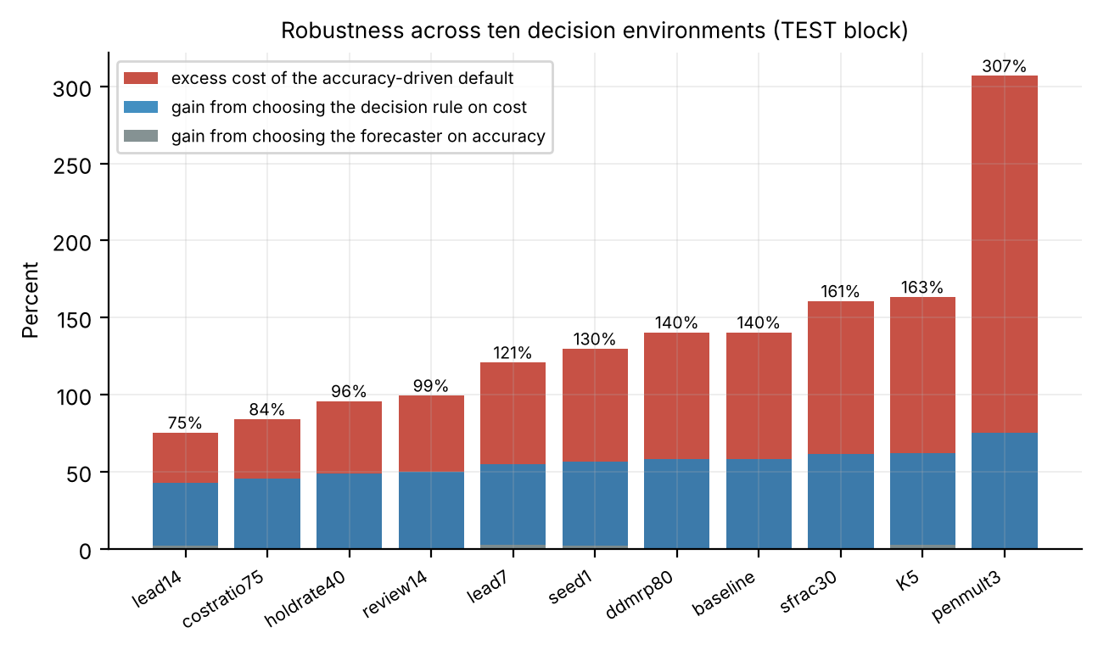
Sensitivity suite: excess cost of the default (red), gain from choosing the rule on cost (blue), and gain from choosing the forecaster on accuracy (grey) across ten environments, plus the seed-1 replication (Appendix C).

5.7 The cost–service frontier
Sweeping $τ$ for each distributional policy gives a frontier that answers a service-constrained question without any stockout-penalty estimate: what is the cheapest configuration that reaches a given fill rate? On VAL, lgbm_q + daily (s,S) attains fill rates of 0.978 at τ = 0.90, 0.989 at τ = 0.95 and 0.998 at τ = 0.99, at costs of 132,353, 104,357 and 88,253. The best fill rate the untuned P1 family reaches is 0.957, at a cost of 202,620. At a 95% fill obligation both families can comply, but the cheapest configuration costs 88,253 and the cheapest untuned-P1 one costs 202,620, so meeting the same service obligation costs 130% more with the accuracy-driven rule on VAL (on TEST: 84,306 versus 35,209, 139% more). Beyond 0.96 fill the untuned family has no configuration at all; a tuned $z$ (Section 5.3) removes that limit.
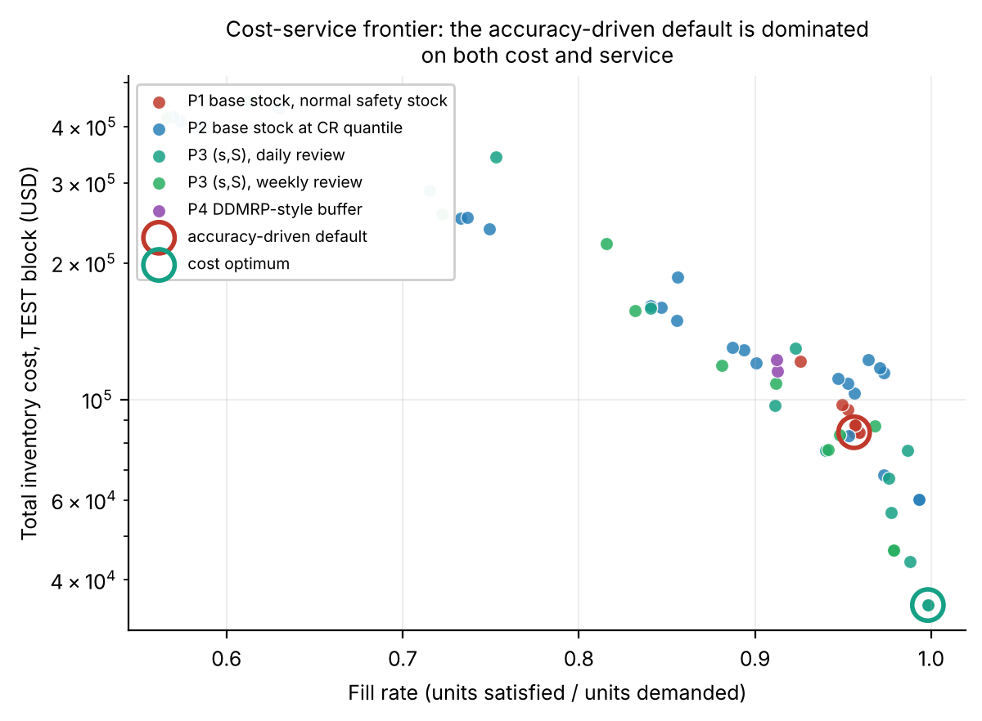
Cost–service frontier over all 59 pairings on the TEST block (log cost axis). The accuracy-driven default (red ring) is dominated by the cost optimum (green ring).

6. Discussion

6.1 Why the accuracy-driven pipeline fails here
Three mechanisms compound.
(i) Wrong functional. Squared-error training targets the conditional mean, but replenishment needs a high quantile of protection-interval demand. For a symmetric unimodal distribution a mean plus a normal buffer is a reasonable proxy. For a distribution with a 63% atom at zero and a heavy tail it is not, and the tuned $z$ of 5–6 in Table 9 shows how far a normal buffer has to be stretched to compensate.
(ii) Wrong aggregation. Even with correct daily quantiles, the protection-interval quantile is not their sum. Our blend is an approximation, which is one reason the calibrated methods, which use realised $P$-day sums, behave differently.
(iii) Wrong responsiveness. A weekly base-stock rule has to cover a full review interval plus the lead time. A daily-review (s,S) rule can react within a day, so the same forecasts are used with a shorter effective exposure. When the per-line cost is small relative to unit value, as it is here, responsiveness is cheap and buffering is expensive. Table 9 shows this mechanism in isolation: it involves no change in the forecast and it is invisible to any accuracy evaluation.

6.2 Threats to validity
- Aggregation confound. lgbm_q aggregates daily quantiles by an approximate rule, while cal_* estimates sums directly. Part of the C-versus-D difference may be aggregation and not estimation quality. A direct test would train the model on $P$-day cumulative demand.
- Duplicate quantile level. The 0.995 and 0.99 forecasts gave identical decisions in every pairing, so the effective grid has five levels and the optimum (0.99) sits on its upper edge. The theoretical critical ratio (0.9929) lies between 0.99 and 0.995, so the optimum is probably close to it, but we could not test a higher level.
- Cost parameters. The holding rate (25% per year) and the per-line ordering cost ($0.50) are assumptions. Table 13 varies them, with the penalty multiplier and the cost ratio, and the sign of the gap survives. The service-constrained comparison (Section 5.7) removes the penalty assumption.
- Selection of tuned rules. The tuned normal-theory rules are chosen on VAL from 13 safety factors, 9 forecasters and 6 variants, which is a mild form of the same winner’s curse; TEST performance is nonetheless reported only for the selected configuration.
- Sample. 3,999 of 30,490 series, stratified and reproduced on an independent draw (Appendix C). A full-panel replication is a natural extension.
- Single dataset, single sector. M5 is US big-box grocery and general merchandise. The mechanisms (atoms at zero, skew, review frequency) should transfer to intermittent retail data, but a second corpus is needed.
- Lost sales, deterministic lead time. Lost sales is right for retail but makes understocking dearer than under backorders, which favours the high-service rules that win. Real lead times are stochastic and supplier-specific; that likely understates the value of distributional forecasting, but we did not test it.
- One ML family. LightGBM only. Neural quantile models were not tried.
- Bundled review frequency. Review frequency is part of what we call “decision rule”, so Section 5.2 step E combines a change in trigger and in review interval.
- Simulation conventions. The simulation starts at the initial order-up-to level and gives no terminal-inventory credit. For P3 at daily review the order-up-to level is sized for the 9-day interval used at weekly review.
- Short test block. TEST is 140 days. Differences of a few percent between close pairings, and the regime results in particular, should be read with that in mind.

6.3 Managerial implications
- Evaluate forecasting models on simulated inventory cost, not only on error. The two procedures cost the same to run and select different strategies, differing by 140% of inventory cost here.
- Treat the pairing as the unit of decision. The 59 pairings span a 12.9-fold cost range on TEST. Tune the rule (safety factor, dispersion refresh, review structure) before buying forecast accuracy.
- “Add uncertainty” is not a plan. A calibrated empirical quantile raised cost by 22%; train the quantile model and check how it is aggregated over the protection interval.
- Select once, at portfolio level. Per-SKU selection is attractive and counter-productive (Table 12).
- Do not build a regime detector for policy selection on the evidence here. Spend the effort on review frequency and rule tuning.
- Know your ordering cost. Daily versus weekly review is worth tens of percent at $0.50 per line and reverses at $5.

7. Future work
The largest open question is the 19.7% oracle headroom with no capture. Possible routes are more validation history, hierarchical or empirical-Bayes shrinkage of per-SKU costs, and end-to-end training on the inventory cost. Beyond this: replication on a second corpus (Favorita, Rossmann), direct training of protection-interval quantiles, stochastic lead times, a backorder variant, a multi-echelon extension, and hierarchical reconciliation as an extra forecaster arm.

8. Conclusion
We asked which forecasting and replenishment strategies minimise inventory cost without sacrificing availability. On 3,999 real retail series, the forecaster chosen on out-of-sample accuracy and deployed through a standard normal-theory base-stock rule cost 140.4% more than the cost-optimal pairing at lower service. Improving the forecaster inside that rule was worth 0.4% on the test block (3.4% on validation), and changing the rule was worth 58.4%. A normal-theory rule tuned on a validation year recovers most of the gap but remains 25.8% above the optimum, which is the value of the trained quantile forecast once the rule is sound. Adding uncertainty after the fact raised cost by 21.8%; a trained quantile model combined with a responsive (s,S) policy lowered it, and that choice held across demand regimes and ten decision environments, apart from the ordering-cost and review-interval cases noted in Section 5.6. Selecting a pairing per SKU was harmful (+34.9%). Selection should happen once, on decision cost, on a validation window.
Forecast accuracy is a means. When it is mistaken for the end, the cost in this dataset, a more-than-doubling of inventory cost at worse service, is avoidable.

Appendix A. Derivation of the critical ratio under per-day holding cost
Consider a periodic-review base-stock policy with interval $R$, deterministic lead time $L$ and protection interval $P=L+R$. Let $X$ be demand over the protection interval and $S$ the order-up-to level. To first order, a unit ordered above realised demand is carried for about one review cycle, so its excess cost is $hR$; a unit of unmet demand incurs the penalty $π$ once. The expected cost per cycle is
$$C\left(S\right)=hR E{\left(S−X\right)}^{+}+π E{\left(X−S\right)}^{+}.$$
Using $\frac{d}{dS}E{\left(S−X\right)}^{+}=F_{X}\left(S\right)$ and $\frac{d}{dS}E{\left(X−S\right)}^{+}=−\left(1−F_{X}\left(S\right)\right)$,
$$C′\left(S\right)=hR F_{X}\left(S\right)−π \left(1−F_{X}\left(S\right)\right)=0 ⇒ F_{X}\left(S^{*}\right)=\frac{π}{π+hR}=CR.$$
$C$ is convex since $C″\left(S\right)=\left(hR+π\right)f_{X}\left(S\right)≥0$, so $S^{*}=F_{X}^{−1}\left(CR\right)$. Two corollaries: (a) CR rises with $R$ for fixed $π,h$; (b) substituting $h$ for $hR$ gives a higher ratio, 0.9990 instead of 0.9929 at $R=7$ in our margin economics.
Remark. The derivation is first order. Under lost sales an unsold unit is carried until it is sold, not for exactly one cycle, and unmet demand does not accumulate, so $π$ is a one-off charge per lost unit. The simulator implements exactly this accounting and checks internally that the daily cost ledger sums to the window total for every run. The critical ratio therefore guides the grid of quantile levels, but the results do not depend on it being exact, since $τ$ is chosen on cost.

Appendix B. Forecaster and policy inventory
Point forecasters (9). naive, snaive, ma28, croston, sba, tsb, hw, comb, lgbm_mean. Quantile forecaster (1). lgbm_q at six $τ$ (0.995 duplicates 0.99). Calibrated variants (3). cal_comb, cal_sba, cal_lgbm.
Policies (59 pairings, 56 distinct). P1 normal-theory base stock (9 point forecasters); P2 quantile base stock (4 distributional methods × 6 levels); P3 (s,S) at weekly and daily review (2 methods × 2 reviews × 6 levels); P4 DDMRP-style buffer (2 point forecasters). The tuned normal-theory sweep (Section 5.3) adds six variants × 9 forecasters × 13 safety factors, reported only for the VAL-selected configuration of each variant.
LightGBM. 250 trees, learning rate 0.06, 63 leaves, min_child_samples 60, row subsample 0.8, column subsample 0.7, L2 = 1.0, 2 threads; four trailing 28-day training origins, subsampled to 2,321 of 3,999 series (259,952 rows). Quantile monotonisation. The share of forecasts raised by the running maximum, VAL (TEST): 0.0% at τ = 0.50, 2.0% (2.0%) at 0.75, 1.2% (0.9%) at 0.90, 4.2% (3.6%) at 0.95, 0.4% (0.4%) at 0.99 and 0.995.

Appendix C. Robustness to the sampling seed
The main experiment uses a proportional stratified sample with seed 0. We repeated the whole pipeline with an independent draw of the same size and stratification (seed 1), refitting all models. The two seeds draw different series, so this is an out-of-sample replication and not a re-run.
Table C1. Seed robustness (TEST block, margin economics)
Quantity | Seed 0 | Seed 1
Cost-optimal pairing | lgbm_q + P3 (s,S) daily @ τ=0.99 | lgbm_q + P3 (s,S) daily @ τ=0.99
Its total cost | 35,209 | 36,819
Accuracy-driven default | lgbm_mean + P1 normal base stock | lgbm_mean + P1 normal base stock
Its total cost | 84,646 | 84,576
Excess cost of the default | +140.4% [+128.8, +153.4] | +129.7% [+119.4, +141.6]
Gain from swapping the forecaster within P1 | 0.4% [-1.5, +2.5] | 2.2% [-1.5, +7.0]
Gain from swapping the decision rule | 58.4% | 56.5%
Spread within P1 (worst ÷ best − 1) | 44.0% | 41.2%
Step C vs default | +21.8% [+4.3, +44.6] | +20.8% [+6.5, +38.5]
Step D vs default | -28.9% [-32.0, -25.8] | -25.1% [-27.9, -22.1]
The headline conclusions replicate: the same pairing is optimal, the default is 130% above it, and swapping the forecaster inside P1 is worth 2% against 56% for swapping the rule. The sign and rough size of steps C (+21%) and D (−25%) replicate too.

Appendix D. Reproducibility
Seeds are fixed throughout (sampling seed 0; LightGBM random_state 0; bootstrap seed 0). The environment is Python 3.11 with NumPy, pandas, LightGBM, scikit-learn and SciPy, on two CPU cores with a 1 GB memory cap. The shipped reproduce.sh regenerates every table and figure, including the seed-1 replication, the sensitivity suite, the tuned-rule analysis and the out-of-sample regime check.

References
Ban, G.-Y., & Rudin, C. (2019). The big data newsvendor: Practical insights from machine learning. Operations Research, 67(1), 90–108.
Bertsimas, D., & Kallus, N. (2020). From predictive to prescriptive analytics. Management Science, 66(3), 1025–1044.
Beutel, A.-L., & Minner, S. (2012). Safety stock planning under causal demand forecasting. International Journal of Production Economics, 140(2), 637–645.
Boylan, J. E., & Syntetos, A. A. (2006). Accuracy and accuracy-implication metrics for intermittent demand. Foresight: The International Journal of Applied Forecasting, 4, 39–42.
Croston, J. D. (1972). Forecasting and stock control for intermittent demands. Operational Research Quarterly, 23(3), 289–303.
Elmachtoub, A. N., & Grigas, P. (2022). Smart “predict, then optimize”. Management Science, 68(1), 9–26.
Fildes, R., Ma, S., & Kolassa, S. (2022). Retail forecasting: Research and practice. International Journal of Forecasting, 38(4), 1283–1318.
Gneiting, T. (2011). Quantiles as optimal point forecasts. International Journal of Forecasting, 27(2), 197–207.
Ke, G., Meng, Q., Finley, T., Wang, T., Chen, W., Ma, W., Ye, Q., & Liu, T.-Y. (2017). LightGBM: A highly efficient gradient boosting decision tree. Advances in Neural Information Processing Systems, 30, 3146–3154.
Kolassa, S. (2016). Evaluating predictive count data distributions in retail sales forecasting. International Journal of Forecasting, 32(3), 788–803.
Kourentzes, N. (2014). On intermittent demand model optimisation and selection. International Journal of Production Economics, 156, 180–190.
Lim, B., Arık, S. Ö., Loeff, N., & Pfister, T. (2021). Temporal Fusion Transformers for interpretable multi-horizon time series forecasting. International Journal of Forecasting, 37(4), 1748–1764.
Makridakis, S., Spiliotis, E., & Assimakopoulos, V. (2022a). M5 accuracy competition: Results, findings, and conclusions. International Journal of Forecasting, 38(4), 1346–1364.
Makridakis, S., Spiliotis, E., Assimakopoulos, V., Chen, Z., Gaba, A., Tsetlin, I., & Winkler, R. L. (2022b). The M5 uncertainty competition: Results, findings and conclusions. International Journal of Forecasting, 38(4), 1365–1385.
Miclo, R., Fontanili, F., Lauras, M., Lamothe, J., & Milian, B. (2019). An empirical comparison of MRPII and demand-driven MRP. International Journal of Production Research, 57(1), 166–181.
Oroojlooyjadid, A., Snyder, L. V., & Takáč, M. (2020). Applying deep learning to the newsvendor problem. IISE Transactions, 52(4), 444–463.
Prak, D., Teunter, R., & Syntetos, A. (2017). On the calculation of safety stocks when demand is forecasted. European Journal of Operational Research, 256(2), 454–461.
Ptak, C., & Smith, C. (2016). Demand Driven Material Requirements Planning (DDMRP). Industrial Press.
Salinas, D., Flunkert, V., Gasthaus, J., & Januschowski, T. (2020). DeepAR: Probabilistic forecasting with autoregressive recurrent networks. International Journal of Forecasting, 36(3), 1181–1191.
Silver, E. A., Pyke, D. F., & Thomas, D. J. (2016). Inventory and Production Management in Supply Chains (4th ed.). CRC Press.
Syntetos, A. A., & Boylan, J. E. (2005). The accuracy of intermittent demand estimates. International Journal of Forecasting, 21(2), 303–314.
Syntetos, A. A., Babai, M. Z., & Gardner, E. S. (2015). Forecasting intermittent inventory demands: Simple parametric methods vs. bootstrapping. Journal of Business Research, 68(8), 1746–1752.
Syntetos, A. A., Boylan, J. E., & Croston, J. D. (2005). On the categorization of demand patterns. Journal of the Operational Research Society, 56(5), 495–503.
Teunter, R. H., Syntetos, A. A., & Babai, M. Z. (2011). Intermittent demand: Linking forecasting to inventory obsolescence. European Journal of Operational Research, 214(3), 606–615.
Wallström, P., & Segerstedt, A. (2010). Evaluation of forecasting error measurements and techniques for intermittent demand. International Journal of Production Economics, 128(2), 625–636.
Willemain, T. R., Smart, C. N., & Schwarz, H. F. (2004). A new approach to forecasting intermittent demand for service parts inventories. International Journal of Forecasting, 20(3), 375–387.
Zipkin, P. H. (2000). Foundations of Inventory Management. McGraw-Hill.

