# **Sir Syed University of Engineering & Technology (SSUET)**

# **Software Engineering Department**

***Course Name: Deep learning***

***Semester: 6th***

***Batch: 2021F***

***Section: “B”***

**PROJECT REPORT**

***Project Title: Object Classifier (Name and Color Through Voice )***



***Submitted To:***

***Engr. Sanober Soomro***

***Submitted By:***

**STUDENT’S NAME: Ashhad Bin Nasir 2021F-SE-397**

**STUDENT’S NAME: Ibtehaj Siddiqui 2021F-SE-067**

**STUDENT’S NAME: Ali Raza 2021F-SE-051**

**TEAM PROFILE**

1. **Ashhad Bin Nasir (2021F-SE-397)**

(Frontend and Backend)

1. **Ali Raza (2021F-SE-051)**

(Backend)

1. **Ibtehaj Siddiqui (2021F-SE-067)**

(Backend and Frontend)

1. **Problem Domain:**

The specific area or challenge your project addresses. In this case, it involves creating an object classifier that identifies objects by their color and name through voice input using Python. The problem domain encompasses tasks like real-time object detection, color recognition, and text-to-speech synthesis.

1. **Proposed Treatment:**

The methodology or solution approach applied in the code to tackle the problem domain. It includes utilizing computer vision techniques (like object detection using MobileNetSSD) for object recognition, color detection through image processing (using OpenCV), and voice interaction (using pyttsx3) for providing auditory output.

1. **Plan of Work:**

**Ashhad Bin Nasir**

(Frontend Coding and Backend Library)

**Ali Raza**

(Backend main works Connection Btw Code)

**Ibtehaj Siddiqui**

(Backend Coding and Frontend Coding)

1. **Software and Hardware Specifications:**

Software:

1. Intelli J

Hardware:

1. Processor: Minimum 1 GHz; Recommended 2GHz or more
2. Hard Drive: Minimum 32 GB; Recommended 64 GB or more
3. Memory (RAM): Minimum 1 GB; Recommended 4 GB or above
4. Sound card w/speakers
5. Laptop (Built-in Camera)

## **BLOCK DIAGRAM**

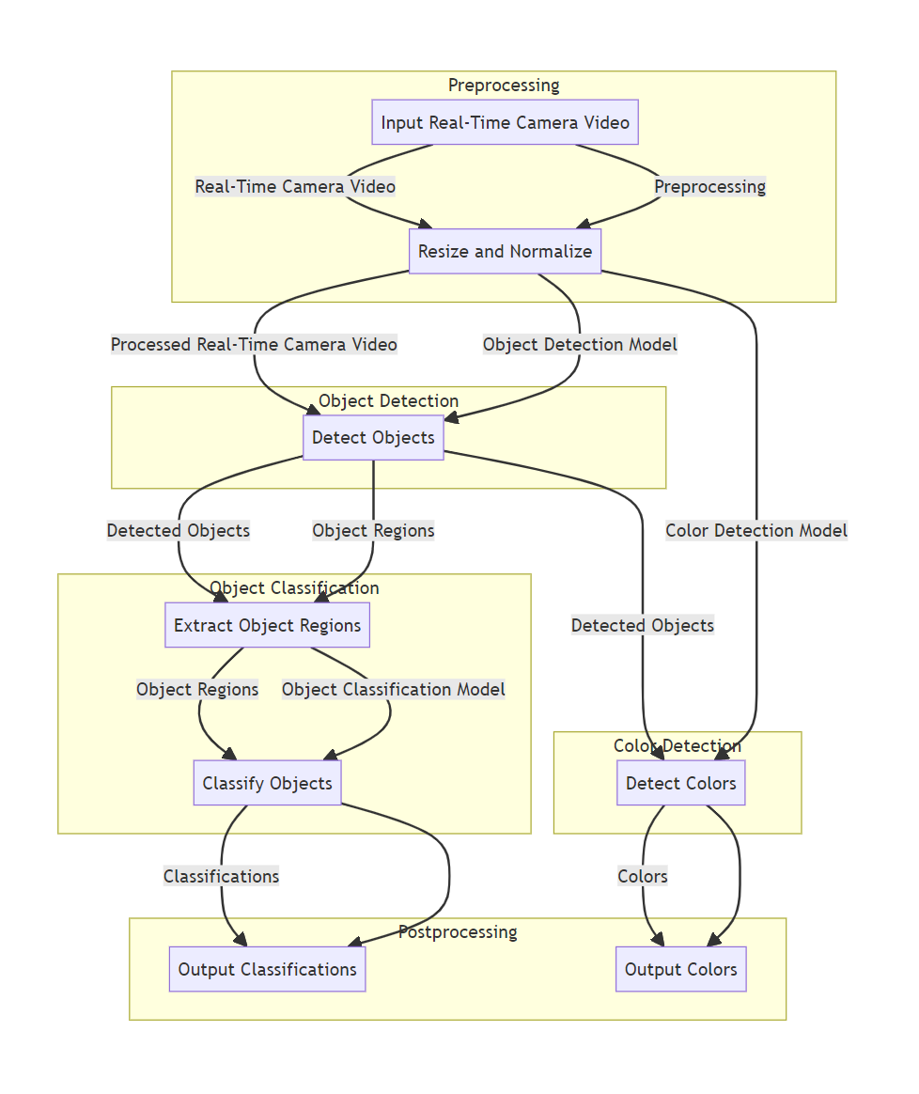

## **SYSTEM FLOW DIAGRAM**

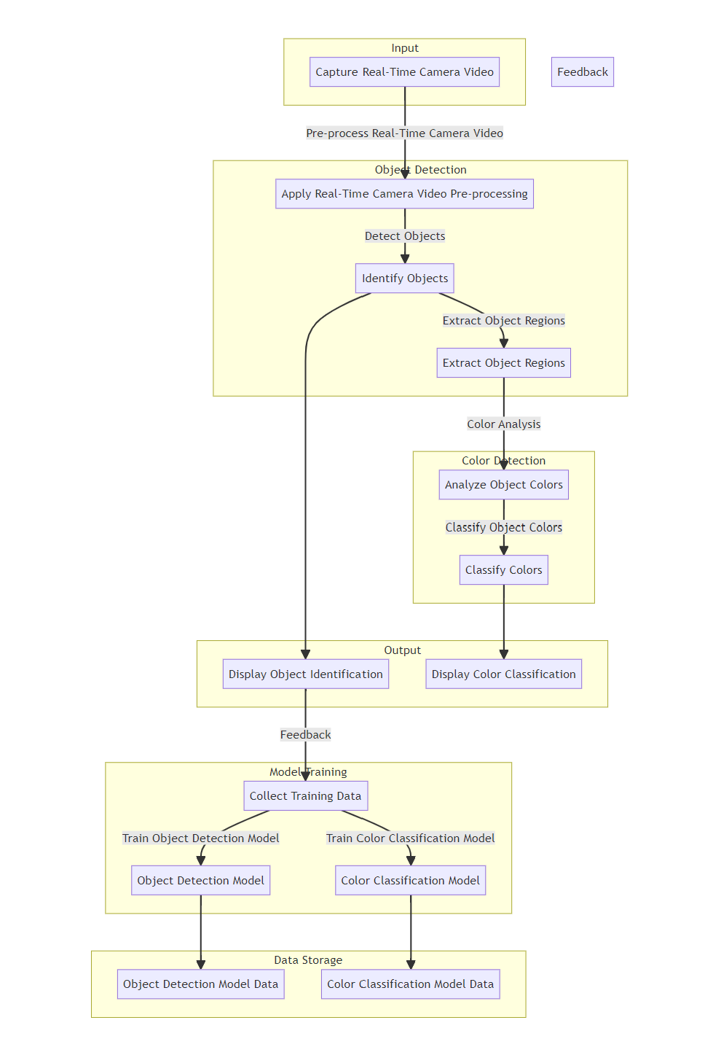

**User Guide: Object Classification & Color Detection**

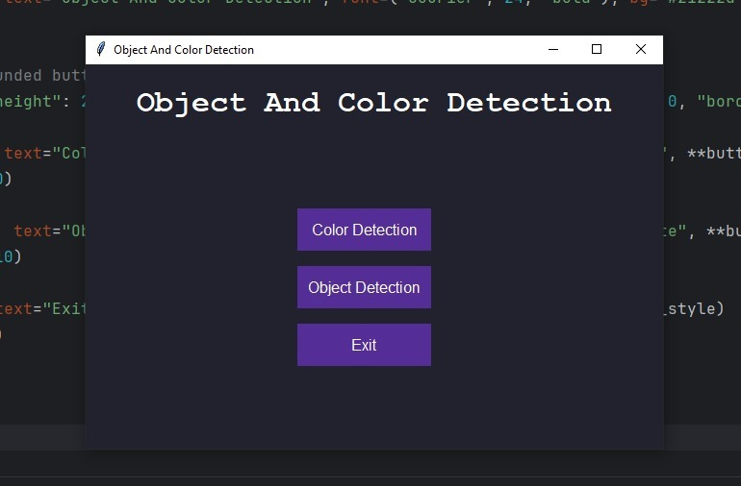

**Here is the starting Window ,where we can either choose color detection or object detection in which each will open a separate window one at a time. We can also exit the application using exit button.**