**MODELLING MUSICAL INSTRUMENTS**

**Project Proposal**



**Spring 2022**

**CSE301L Signals & Systems Lab**

**Submitted by: Nida Nizar, Ebtihaj Abdullah, M.Awais Khan**

**Registration_No.: 20PWCSE1891, 20PWCSE1885, 20PWCSE1871**

**Class Section: A**

**“On my honor, as student of University of Engineering and Technology, I have neither given nor received unauthorized assistance on this academic work.”**

**Submitted to:**

**Mam Durr-e-Nayab**

**DATED: 19/ June/ 2022**

**Department of Computer Systems Engineering**

**University of Engineering and Technology, Peshawar**

**ABSTRACT:**

Musical Instruments are widely popular among masses nowadays and are mainly used for commercial purposes. However, Due to high production cost and other factors, not everyone can afford to buy musical instruments. The goal is to model some musical instruments using MATLAB. MATLAB excels in audio wave frequency tuning as well as production and analysis. We use these properties of MATLAB to synthesize longitudinal sound waves that resemble those produced by real life musical instruments.

**INTRODUCTION:**

MATLAB is a vast programming field. We use it from frequency analysis to app development. We will be using MATLAB to mimic a real-life musical instrument. It will have all the features of a simple real-life musical instrument. The modelled musical instruments include;

* Guitar
* Piano

As these are the most commonly used musical instruments.

**PROPOSED METHODOLOGY:**

Musical instrument modelling is done in MATLAB using MATLAB app. It is a special section of MATLAB where we can make GUI based app with assigning each section a backend code. We will write separate codes for Guitar and the Piano.

**FLOW CHART:**

The flowchart for modelling an instrument is;

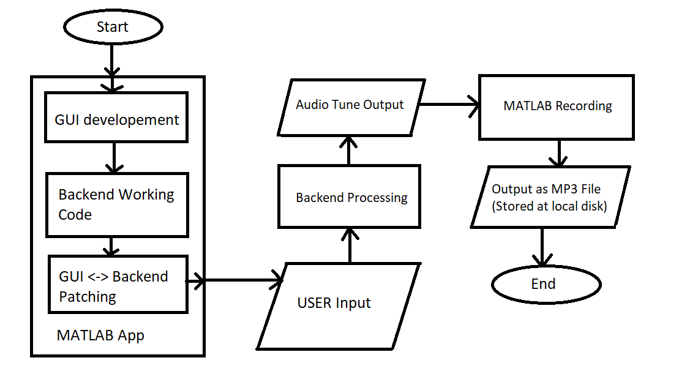

**CONCLUSION:**

We will be able to model a piano and a guitar in this project using basic MATLAB app development.