**SECURITY ALARM BASED ON PIR SENSOR**

Project Proposal To

**Engr. FAIZULLAH** and **Dr SALMAN AHMAD**

For

**CSE-103** and **CSE-103L**

**Department of Computer Systems Engineering**

**UET Peshawar**



**PROPOSAL BY:**

* Tameem ud din 20PWCSE1866
* M.Awais Khan 20PWCSE1871
* Ebtihaj Abdullah 20PWCSE1885

**ABSTRACT:**

In this tircuit PIR (Passive infrared ) motion sensor is used which is used as a motion Detector. When any person, animal or any object comes in the range of the sensor, it detects that person or thing and triggers a buzzer sound.

**CIRCUIT SCHEMATICS:**

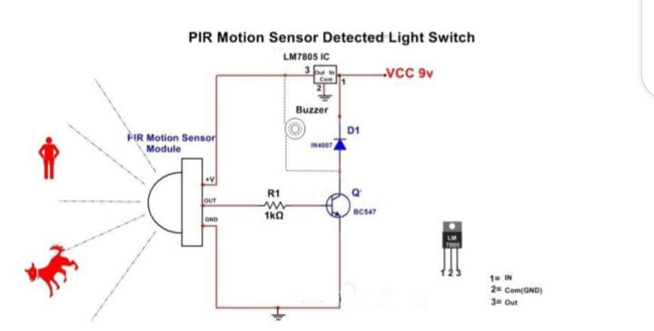

**CONCLUSION:**

After successful applying this circuit practically, we will have made a fully functional mini-security alarm system working on a PIR sensor.