MEMORANDUM OF UNDERSTANDING (MOU)
Between
<<Partner Company Logo>>

<<Partner Company Name>>

And

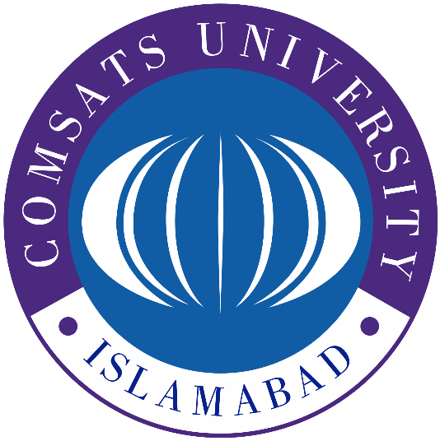
COMSATS University Islamabad, Abbottabad Campus
Department of Computer Science
MEMORANDUM OF UNDERSTANDING (MOU)
This Memorandum of Understanding ("MOU") is made on this ____ day of ________ 2025
Between:
COMSATS University Islamabad, Abbottabad - Dhamtour Campus
Department of Computer Science
Dhamtour Road, Abbottabad
(Hereinafter referred to as “the University”)
And
[Partner Organization Name]
[Address of Partner]
(Hereinafter referred to as “the Partner”)
Collectively referred to as the “Parties.”
Preamble
WHEREAS the University aims to foster academic-industry collaboration to enhance the employability and practical skills of its students through real-world exposure, training, and internship opportunities;
AND WHEREAS the Partner is a recognized entity in the [Industry/Sector] and wishes to collaborate with the University to nurture talent, support education, and contribute to the development of future professionals;
NOW, THEREFORE, the Parties hereby express their mutual understanding as follows:
1. PURPOSE
This MOU establishes a framework for a long-term academic-industry collaboration aimed at delivering professional specialization training, industry-level exposure, real-world project experience, and structured internship opportunities to students of COMSATS University Islamabad, Abbottabad Campus. This initiative is designed to integrate students into the industry from an early stage, ensuring they graduate with both academic knowledge and market-ready experience.
2. DURATION
This MOU shall become effective on the date of signature by both Parties and shall remain in force unless terminated by either Party with thirty (30) days’ prior written notice.

3. ROLES AND RESPONSIBILITIES
3.1 The Partner shall:
- Serve as a preferred professional training and industry engagement partner for students of the University, beginning from their fourth semester onward.
- Offer domain-specific specializations, workshops, or training tracks in areas relevant to the Partner’s expertise (e.g., software development, data science, digital marketing, engineering, etc.).
- Provide structured internship opportunities (on-site, virtual, or hybrid) for eligible students, preferably during summer or winter breaks, in alignment with university policies.
- Facilitate real-world project opportunities allowing students to apply academic knowledge in practical industry contexts under supervision.
- Offer mentorship, guest lectures, webinars, and career preparation sessions to enhance students’ professional readiness.
- Where applicable, provide stipends or incentives to top-performing interns or project contributors.
- Issue certificates of completion or participation for students who successfully complete training modules, projects, or internships.
3.2 The University shall:
- Facilitate the enrollment and participation of eligible students in the Partner’s programs, in coordination with academic schedules and departmental planning.
- Promote the Partner’s training tracks, internships, and events through official university channels, including newsletters, social media, and student portals.
- Provide access to university facilities (e.g., labs, seminar halls, auditoriums) for co-organized workshops, training sessions, or career events, as mutually agreed.
- Encourage faculty involvement in mentoring, monitoring, and aligning academic goals with industry engagements offered through this partnership.
- Appoint a designated faculty coordinator to liaise with the Partner for smooth implementation and communication.

4. RESOURCES
4.1 The Partner will provide:
- Skilled trainers, industry experts, and access to relevant tools/platforms for training and projects.
- Internship placements, project assignments, and supervision as per mutual agreement.
- Certifications, learning materials, and assessment frameworks aligned with industry standards.
- Stipends or rewards for outstanding student contributions, where applicable.
4.2 The University will provide:
- A consistent pipeline of eligible and motivated students for training and internships.
- Promotion and logistical support for collaborative activities.
- Access to institutional infrastructure for joint events, as agreed.
- Academic oversight and credit alignment where applicable.
5. SPECIAL PROVISIONS
- This MOU is non-financial in nature unless otherwise agreed in writing.
- Internships facilitated through this partnership will adhere to the University’s internship policy and be approved by relevant departmental committees.
- Intellectual property (IP) and revenue-sharing matters arising from student-contributed projects will be handled through separate formal agreements on a case-by-case basis.
- Any sponsorship or financial contribution for specific events (e.g., competitions, workshops) will be covered under a separate sponsorship addendum.
6. CONFIDENTIALITY
Both Parties agree to keep confidential any proprietary or sensitive information shared during the course of this collaboration, unless required by law to disclose.

7. COMMUNICATION
Designated Points of Contact:
University:
Dr. Muhammad Ibtisam Gul
Convener Industrial Liaison, Internships & Alumni Affairs
Email: ibtisamgull@cuiatd.edu.pk
Partner:
[Name of Contact Person]
[Designation]
Email: [Email Address]
Regular meetings shall be held to review progress, feedback, and future opportunities.
8. AMENDMENTS
This MOU may be amended at any time with mutual written agreement of both Parties.
9. TERMINATION
Either Party may terminate this MOU with thirty (30) days’ prior written notice. Ongoing student engagements at the time of termination shall be completed unless otherwise agreed.
10. NON-BINDING CLAUSE
This MOU is intended as a statement of mutual intent and is not legally binding, except with respect to confidentiality and termination. A formal agreement may be executed separately if required.
11. GOVERNING LAW
This MOU shall be governed by the laws of Pakistan.
IN WITNESS WHEREOF, the authorized representatives of both Parties have signed this MOU.
For COMSATS University Islamabad, Abbottabad Campus:
Name: ________________________
Designation: Head of Department (Computer Science)
Signature: ________________________
Date: ________________________
For [Partner Organization Name]:
Name: ________________________
Designation: ________________________
Signature: ________________________
Date: ________________________

