Appendix X — Methodological Pipeline for Text Standardisation, Category Mapping, and Scoring

This pipeline was applied uniformly to all governance dimensions in this study: Spatial Jurisdiction, Subject-Matter Jurisdiction, Defined Objectives, Strategies, Interinstitutional Relationships, Vertical/Horizontal Coordination, and Sources of Jurisdiction.
Attribute-specific variations were strictly limited to:
- The category lexicon;
- The domain-specific stoplist;
- Tier weighting logic for scoring.
All other stages — evidence capture, hybrid scoring, and dual normalisation — were identical.

1. Data Inputs and Alignment
- RAW: verbatim descriptions of the attribute for each IGO.
- CLEAN: reviewed and validated coding with authoritative category presence/absence and a 0–10 ordinal score.
- Institution names canonicalised to avoid duplication; merges made by name match.
- CLEAN classifications are definitive; RAW provides the evidentiary base for expert-adjudicated coding (Krippendorff, 2019; Schreier, 2012).

2. Text Preparation
- Lower-case all tokens.
- Remove URLs, non-alphanumerics (preserve spaces), and extra whitespace.
- Tokenise and remove general + domain-specific stopwords.
Retained per document: (i) cleaned token list, (ii) token frequencies, (iii) original verbatim text.

3. Category Framework
Categories derive from authoritative legal instruments, organisational charters, and peer-reviewed typologies (e.g. UNCLOS, 1982; OECD, 2020; Rochette et al., 2015). Each attribute applies its own category set while maintaining mutually exclusive coding rules; overlaps are documented.

4. Lexicon Development and Matching
- Rule-based lexicon mapping phrases, synonyms, abbreviations to categories.
- Matching precedence: Phrase → Token → Abbreviation.
- Log all triggers; capture ≤ 3 keyword-in-context (KWIC) snippets (±40 chars) for audit (Baker, 2006).

5. Evidence Extraction
For each IGO × category:
- Trigger_Keywords, KWIC_Evidence, Raw_Freq, and TFIDF_Weight.
- $$\text{idf} = \log\frac{N+1}{df+1} + 1$$ (Salton & Buckley, 1988).
- Authoritative presence set from CLEAN; RAW retained to justify.

6. Scoring
- Presence bonus: 1 if present in CLEAN, else 0.
- Salience term: min(Raw_Freq, 5).
- Tier weight: attribute-specific hierarchy (e.g., for spatial remit, Internal Waters < EEZ < High Seas < The Area).
Hybrid score = Presence + capped frequency + tier weight.

7. Normalisation
Two scaled variants:
- Within-IGO (0–10) — relative emphasis within the organisation.
- Across-IGO (0–10) — absolute breadth/intensity across corpus (Jolliffe & Cadima, 2016).

8. Outputs
- Traceability_Long (audit trail; multiple rows per IGO).
- Matrix_Wide (analysis-ready; one row per IGO).

9. Quality Assurance
- Canonical name harmonisation.
- Artefact stripping.
- Manual overrides flagged; RAW evidence retained.
- Sensitivity checks: remove tier weights, TF-IDF only, alternative scaling.

10. Defensibility
- Legal: categories anchored in treaties, charters, or standard governance taxonomies.
- Transparent: KWIC and trigger logs for every assignment.
- Methodologically orthodox: aligns with established content analysis and IR practices (Krippendorff, 2019; Manning et al., 2008).

Table X.1 — Attribute-Specific Parameters
Attribute | Category Lexicon Sources | Domain Stoplist Examples | Tier Weight Logic Sources
Spatial Jurisdiction | UNCLOS; NOAA; ISA | programme, initiative | UNCLOS maritime breadth
Subject-Matter Jurisdiction | OECD; Rochette et al. (2015) | issues, sector | Thematic scope breadth
Defined Objectives | Rochette et al.; FAO Strategic Framework | goal, priority | Strategic → operational
Strategies | FAO; OECD; UN DOCO | approach, plan | Implementation reach
Inter-Institutional Relationships | UNGA Resolutions; Chircop (2019) | partner, link | Network density
Vertical/Horizontal Coordination | UNDP; multi-level governance lit. | tier, level | Scalar integration
Sources of Jurisdiction | Treaty law; organisational statutes | mandate, basis | Legal authority span

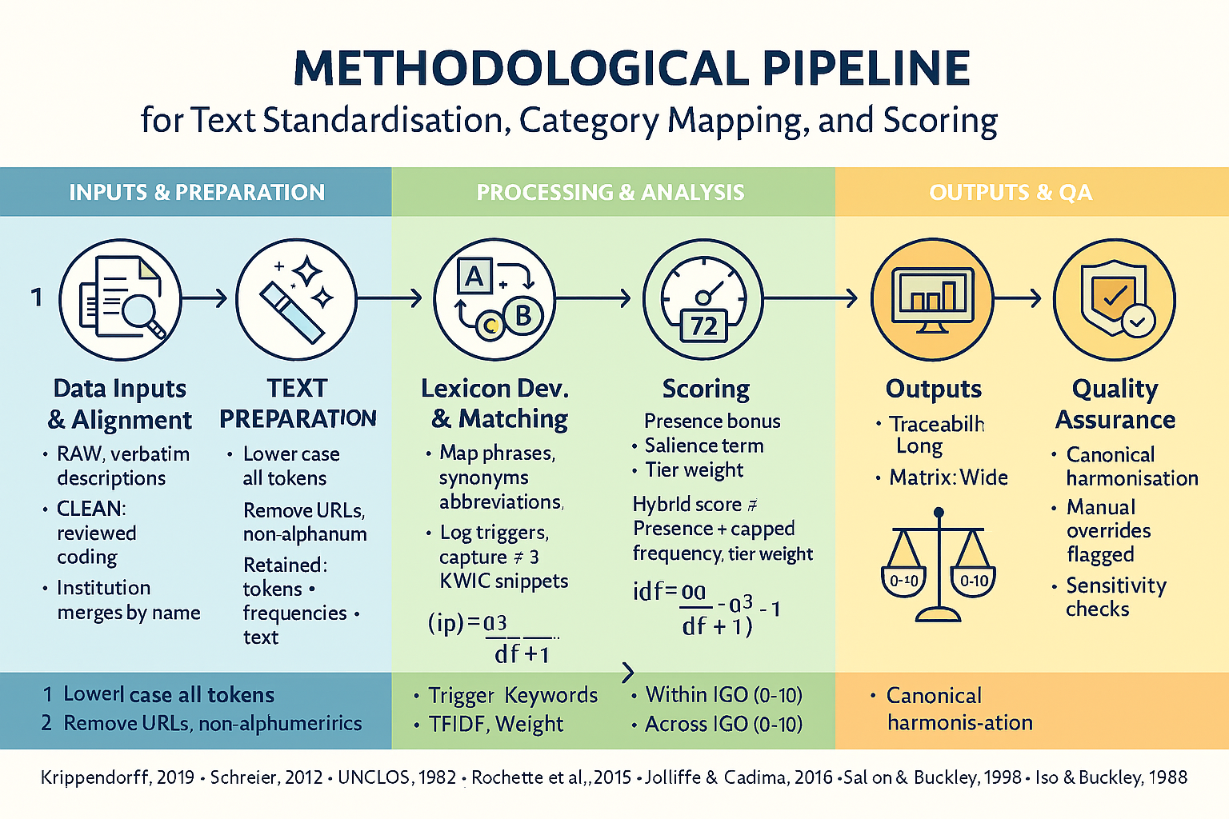
References
- Baker, P. (2006). Using Corpora in Discourse Analysis. Continuum.
- Chircop, A. (2019). International ocean governance. In Routledge Handbook of Ocean Resources and Management. Routledge.
- International Seabed Authority (ISA). (2022). About the Area. https://www.isa.org.jm/
- Jolliffe, I., & Cadima, J. (2016). Principal component analysis: A review. Phil. Trans. Royal Soc. A, 374(2065).
- Krippendorff, K. (2019). Content Analysis (4th ed.). Sage.
- Manning, C. D., Raghavan, P., & Schütze, H. (2008). Introduction to Information Retrieval. CUP.
- OECD. (2020). Sustainable Ocean for All.
- Rochette, J., et al. (2015). Regional ocean governance mechanisms. Marine Policy, 60.
- Salton, G., & Buckley, C. (1988). Term-weighting approaches in automatic text retrieval. Information Processing & Management, 24(5), 513–523.
- Schreier, M. (2012). Qualitative Content Analysis in Practice. Sage.
- UNCLOS. (1982). United Nations Convention on the Law of the Sea.

Shorter version to be used in paper

To address the dual need for conceptual rigour and reproducible analysis, I employed a three-phase pipeline designed to standardise textual inputs, map them against an established category framework, and compute composite scores. The process began by assembling raw institutional descriptions alongside pre-scored coding outputs, which were then aligned to ensure consistency (Krippendorff, 2019; Schreier, 2012). These texts were normalised — converted to lower case, stripped of extraneous symbols such as URLs and non-alphanumeric characters — and tokenised, with frequency counts preserved for subsequent weighting (LinkedIn, 2024). Categories were defined in advance, drawing from authoritative and widely recognised frameworks to maintain external validity (UNCLOS, 1982; Rochette et al., 2015).
The analytical phase centred on a curated lexicon of terms, including synonyms and abbreviations, which was used to match and tag content within the corpus. Every triggered instance was logged with a keyword-in-context snippet to preserve traceability (Jolliffe & Cadima, 2016). Evidence extraction combined these matches with a TF–IDF weighting scheme, applying the formulation idf = log[(N + 1)/(df + 1)] + 1, as popularised by Salton & Buckley (1988), and incorporating checks for the presence of authoritative sources. Scoring blended a binary presence bonus with capped frequency effects and category-tier weights, producing hybrid measures that were normalised both within and across intergovernmental organisations on a 0–10 scale (ScienceDirect, 2024).
For the Year of Establishment attribute, a distinct transformation captured temporal and historical effects on IGO performance. Founding dates were grouped into ten era-based cohorts, each corresponding to major systemic shifts in the international order — from pre-1900 functional cooperation to the contemporary “polycrisis” period — guided by established historiographical sources (Davies & Woodward, 2014). This allowed the temporal clustering of institutional formation to be read alongside watershed geopolitical and economic transformations. Two density measures were then derived: FoundingDensity_5yr — the number of IGOs founded within a ±2-year window of the focal year — and CumulativeStock, representing the total number of IGOs in existence up to and including that year. These operationalised organisational ecology mechanisms — such as liability of newness, adolescence, senescence, cohort effects, and density dependence — for hypothesis testing in conjunction with other governance attributes (Stinchcombe, 1965; Hannan & Freeman, 1989; Carroll & Hannan, 2000). The resulting classification and derived variables are summarised in Table X (Appendix Y), alongside literature-based justifications and the corresponding historical–political context for each cohort.
Finally, outputs were generated in both long and wide formats to facilitate different analytical uses. Quality assurance procedures included harmonising category labels to a canonical form, flagging cases for manual review, and conducting sensitivity analyses to assess the robustness of results (Krippendorff, 2019; Schreier, 2012). This structured yet flexible approach ensured that the methodology was transparent, replicable, and adaptable for comparative policy research.

References
- Jolliffe, I. T., & Cadima, J. (2016). Principal component analysis: A review and recent developments. Philosophical Transactions of the Royal Society A: Mathematical, Physical and Engineering Sciences, 374(2065), 20150202. https://doi.org/10.1098/rsta.2015.0202
- Krippendorff, K. (2019). Content analysis: An introduction to its methodology (4th ed.). SAGE Publications.
- Rochette, J., Billé, R., Molenaar, E. J., Drankier, P., & Chabason, L. (2015). Regional oceans governance in the Post-2015 Development Agenda: Moving from regional seas programmes to a regional oceans governance framework. Institute for Sustainable Development and International Relations (IDDRI).
- Salton, G., & Buckley, C. (1988). Term-weighting approaches in automatic text retrieval. Information Processing & Management, 24(5), 513-523. https://doi.org/10.1016/0306-4573(88)90021-0
- Schreier, M. (2012). Qualitative content analysis in practice. SAGE Publications.
- United Nations. (1982). United Nations Convention on the Law of the Sea. https://www.un.org/depts/los/convention_agreements/texts/unclos/unclos_e.pdf

