Account Settings
Product Requirements Document
Version 1.0 | April 2026 | Author: Ibung
Date | Desc | Version | Creator
2026/08/04 | Initial draft | V.1 | Ibung
Prototype: https://account-settings-prototype.vercel.app/

Section 1: Account Settings

0. Module Objectives and Scope

0.1 Objective: Define the Account Settings screen for the V1 launch. The settings screen uses a collapsed-header navigation pattern: on open, the user sees only section headers (General, Account, Notifications, Terms and Policies) and a standalone Logout button. Tapping a header navigates to a sub-screen showing that section’s items. This pattern is designed for scalability; new items can be added to any section in future versions without changing the top-level UI.

0.2 Scope:
- A) Settings screen IA, collapsed-header navigation with drill-down sub-screens
- B) UX behaviour for Terms and Policies items (webview redirects)
- C) UX behaviour for Delete Account (soft delete with 30-day grace period)
- D) Compliance notes and known deferred risks
E) Notification Manager — grouped toggle UI for activity notifications (master “All” + granular types); persistence and server sync defined with backend.
1. Feature List
Feature | Type
Terms & Conditions | Static webview redirect
Privacy Policy | Static webview redirect
Do Not Sell My Data | Static webview redirect
About onemore (moved) | Static webview redirect
Notification Manager | Sub-screen with toggles
Delete Account | Action — soft delete
Clickable Section Headers | Navigation — push to sub-screen

2. Updated Settings Screen Layout

The Settings screen opens in a collapsed state: the user sees only tappable section headers and a standalone Logout button (no section header). Tapping a header pushes a sub-screen that displays only that section’s items. Order from top to bottom: General, Account, Notifications, Terms and Policies, Logout.

Section Header | Items
General | Language — English & Bahasa Indonesia only. Additional languages (e.g. Spanish) planned for future version.
Account | Delete Account
Notifications | Notification Manager — master “All notifications” toggle plus per-activity toggles (Likes, Comments, Remixes, Mentions, Followers). See §5.
Terms and Policies | Terms & Conditions | Privacy Policy | Do Not Sell My Data | About onemore (existing, moved)
— (no header) | Logout — standalone button, no section header

3. Terms and Policies — UX Behaviour

2.1 Navigation Pattern — Clickable Section Headers
Default state: When the Settings screen opens, all sections are collapsed. The user sees only the section headers (General, Account, Notifications, Terms and Policies) displayed as tappable rows with a trailing chevron (›), plus a standalone Logout button at the bottom with no section header.
Tap behaviour: Tapping a section header navigates (push transition) to a new sub-screen that shows only that section’s items. The sub-screen has a back button returning to the main Settings screen.
Scalability rationale: This pattern allows new items (e.g. notification preferences, linked accounts, privacy settings) to be added to any section in future versions without changing the top-level Settings UI.
All four items under Terms and Policies share identical UX behaviour. The only difference is the URL each one opens.
Entry Point
Settings > Terms and Policies (header tap → sub-screen) > [item name] — tappable row with trailing chevron (›)
Behaviour
- Tapping opens an in-app WebView pointed at the corresponding legal URL
- WebView has a visible close / back button returning the user to Settings
- No login required to view any document
- URLs are managed by the web/legal team — app only needs the URL string, no backend work

Error State
If the URL fails to load: display — 'Unable to load. Please try again.' with a Retry button.

4. Delete Account
Entry Point
Settings > Account (header tap → sub-screen) > Delete Account — tappable row with red/warning text styling (not a standard chevron row).
Step-by-Step Behaviour
Step | Action
1 | User taps 'Delete Account'
2 | Confirmation modal appears with warning copy and two CTAs: Cancel and Delete Account
3 | If user confirms: account status set to pending_deletion; deletion_scheduled_at timestamp recorded
4 | User is immediately logged out and redirected to the login screen
5 | During 30-day grace period: account hidden from all public surfaces (feed, search, profile)
6 | If user logs back in during grace period: account automatically restored; reactivation banner shown
7 | After 30 days with no reactivation: scheduled BE job performs hard delete of all account data

Confirmation Modal Copy
Element | Copy
Title | Delete your account?
Body | Your account and content will be deactivated for 30 days. After that, everything will be permanently deleted and cannot be recovered.
Primary CTA | Delete Account [destructive / red styling]
Secondary CTA | Cancel
Edge Cases
- Upload in progress: complete or cancel before deletion is processed
- Active credits: forfeited on confirmed deletion — no refund
- Username during grace period: reserved for 30 days, released after hard delete
- Reactivation banner: 'Welcome back! Your account has been reactivated.'
- User cancels modal: no action taken, user stays on Settings screen

Delete Account — Full Flow

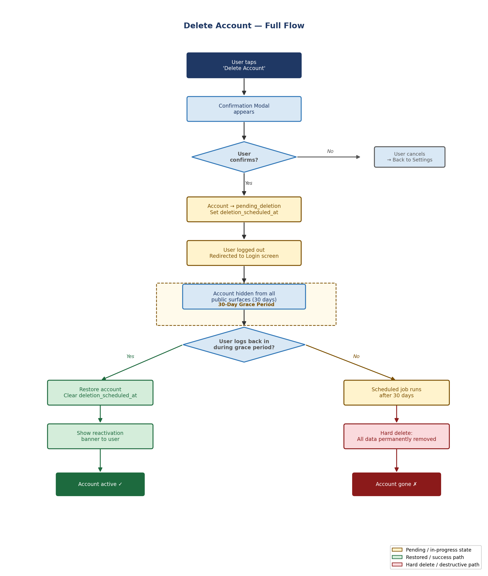
Figure 1 — Delete Account Flow (soft delete with 30-day grace period)
5. Notifications
The Notification Manager sub-screen is accessible from Settings → Notifications. It follows the same information architecture as a standard grouped “Notifications” screen (master “All” switch, then activity-type rows), but is visually styled for onemore: dark background, Inter typography, rounded grouped panels, separators, and mint accent for active toggles (see §5.3). Full notification delivery, triggers, and push infrastructure are owned by a separate PRD; this section covers the in-app preferences UI only.
5.1 Entry Point
Settings root > Notifications (header tap → sub-screen)
5.2 Components

Toggle | Label | Sublabel | Default / Behaviour
All (master) | All | Turn off all notifications | ON. When toggled OFF: all individual toggles visually disabled/greyed out. Last state preserved.
Likes | Likes | When someone likes your video | ON
Comments | Comments | When someone comments on your video | ON
Remixes | Remixes | When someone remixes your video | ON
Mentions | Mentions | When someone mentions you in a comment | ON
Followers | Followers | When someone follows you | ON
5.3 Layout & visual design (onemore)
Structure mirrors a grouped list: (1) section label “ALL NOTIFICATIONS” with one row — title “All”, sublabel “Turn off all notifications”, trailing switch; (2) section label “ACTIVITY” with five rows (Likes, Comments, Remixes, Mentions, Followers), each with primary label, gray sublabel describing the trigger, and trailing switch. Visual language matches the Account Settings prototype: black page background (#000000), content on raised rounded-rect panels (#1c1c1e) with subtle border/separator lines (rgba white ~8%), Inter 16–17px labels, muted gray (#9a9aa3) for sublabels and section headers, mint accent (#42d3a5) for ON switches and focus. Optional one-line intro under the nav bar in muted text: e.g. “Manage what notifications you receive from activity.” Not a light iOS System Settings clone — stay on-brand with the dark onemore UI.
5.4 Interaction behaviour
Back chevron in the nav bar returns to the main Settings screen (same push/stack behaviour as other sections). Master “All”: OFF greys out and disables the five activity toggles (non-interactive); their previous on/off values remain stored so turning “All” back ON restores prior choices. Individual toggles: changing any single type updates only that preference; they do not automatically flip “All” unless the implementation chooses to derive master state (recommended: master OFF only when all children OFF; master ON if any child ON — document in QA). Accessibility: each row exposes label + sublabel to the screen reader; switches have explicit accessibility states.
6. Out of Scope (V.1)
- A) Age gate at signup — deferred to V1.2 (documented as known compliance risk below)
- B) Feedback / bug report form — deferred
- C) Blocked accounts list and other social-safety tooling — future versions. (Per-activity notification toggles are in scope for V1 — see §5.)
- D) Full COPPA legal review — requires external counsel, planned pre-scale

7. Compliance Notes
7.1 What This Version Covers
- Terms & Conditions — accessible in-app via WebView
- Privacy Policy — accessible in-app via WebView
- Do Not Sell My Data — accessible in-app via WebView (CCPA requirement for California users)
- Account deletion — available in-app with soft-delete grace period (Google Play mandatory requirement)

7.2 Known Risks
Legal counsel should review all items below before onemore exceeds 1,000 users or launches paid user acquisition.

Risk | Detail | Mitigation
COPPA — AI training on user data | 2025 COPPA amendment requires separate parental consent before using personal data for AI training. Vibe coding engine uses user inputs. | Legal review required pre-scale. Flag to counsel before V1.2.
Age gate at signup | No age verification exists. If a known minor signs up, COPPA obligations are triggered. Acceptable risk at <100 user launch scale. | Add birth-year gate at signup in V1.2.
SDK audit (AppsFlyer) | AppsFlyer collects device identifiers. Needs audit for COPPA kids-safe mode before scaling. | SDK audit before V1.2 scale-up.
State App Store Accountability Acts | TX, CA, UT, LA passed laws requiring age assurance for all apps. Compliance dates through 2026. | Monitor. Not a launch blocker for April 2026.

