NAMA : Ica ajwa auliah

KELAS :XI RPL 3

NAMA DATABASE :Kasir_ica

PASSWORD :ajwa

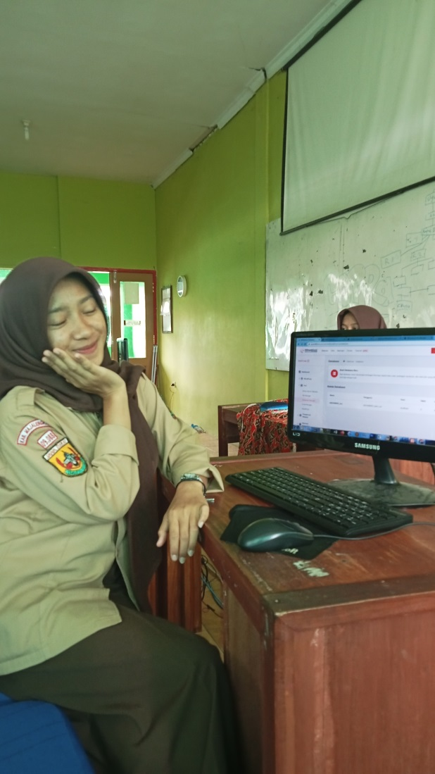 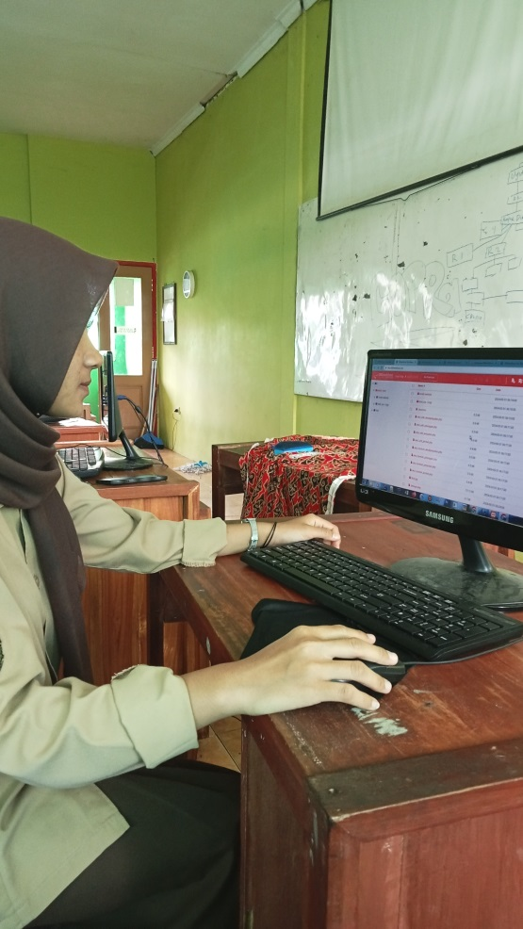

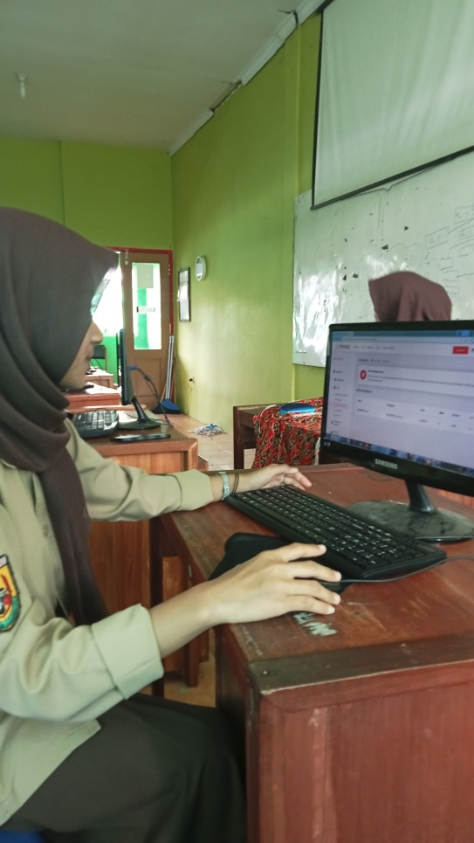 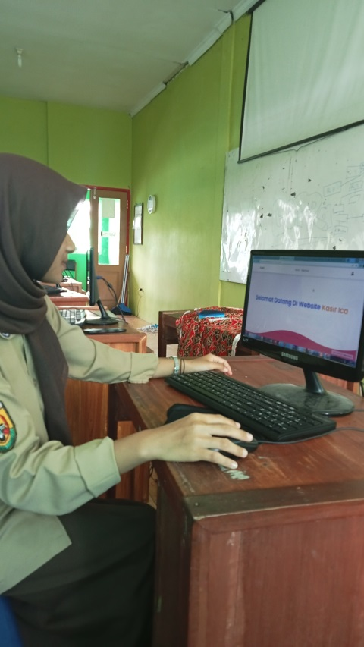

TANDA TANGAN GURU

..................................

