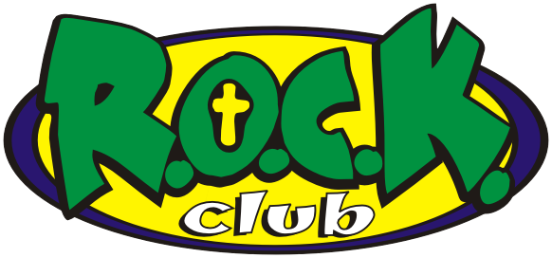

Items That Need to be Returned Before Your Child can Start:

\*Registration Form (Every Line must be filled in even if it is N/A)

\*Immunization Records (Can be Faxed from the Doctor's Office)

\*Copy of Birth Certificate

\*Tuition Express Packet

Items You Will Need on the First Day:

\*Lunch

\*Change of Clothes

\*Something to nap with Like A Blanket or Towel

\*Sleep Toy or Pillow is Optional