Bottom Navigation View

Bottom Navigation View is a tab bar but attached to bottom.

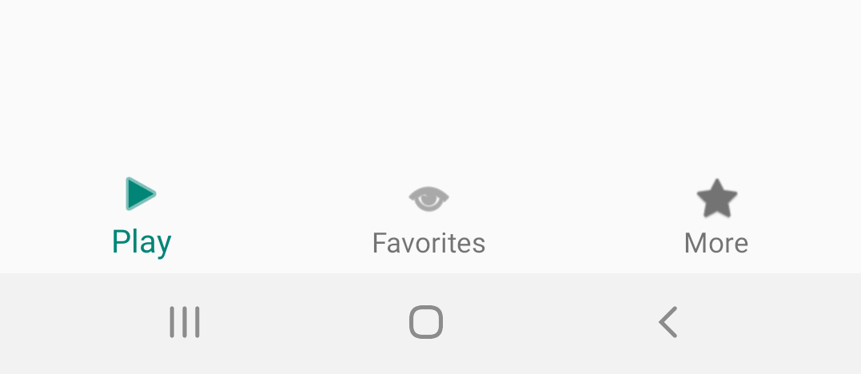
Create an empty Activity project. Name it HelloBottomNavigationView1.

Edit build.gradle (Module:app).

Add two dependencies to the dependencies.

implementation "androidx.navigation:navigation-fragment-ktx:2.0.0"
implementation "androidx.navigation:navigation-ui-ktx:2.0.0"

Create a new resource directory, app / res / menu. Create a new menu resource: menu_bottom_nav.xml inside that directory.

<?xml version="1.0" encoding="utf-8"?>
<menu xmlns:android="http://schemas.android.com/apk/res/android">
<item android:id="@+id/tab_abc" android:title="@string/play" android:icon="@android:drawable/ic_media_play"/>
<item android:id="@+id/tab_def" android:title="@string/favorites" android:icon="@android:drawable/ic_menu_view"/>
<item android:id="@+id/tab_ghi" android:title="@string/more" android:icon="@android:drawable/btn_star"/>
</menu>

This menu defines your bottom navigation view. The icon which has value like “@android:drawable/ic_media_play” is using the assets from Android framework. Of couse, you can use the custom one.

Edit app / res / values / styles.xml.

<resources>
<!-- Base application theme. -->
<style name="AppTheme" parent="Theme.AppCompat.Light.DarkActionBar">
<!-- Customize your theme here. -->
<item name="colorPrimary">@color/colorPrimary</item>
<item name="colorPrimaryDark">@color/colorPrimaryDark</item>
<item name="colorAccent">@color/colorAccent</item>
<item name="windowActionBar">false</item>
<item name="windowNoTitle">true</item>
</style>
<style name="ToolbarTheme" parent="Theme.AppCompat.Light.DarkActionBar">
<item name="colorPrimary">@color/colorPrimary</item>
<item name="colorControlNormal">@color/colorWhite</item>
<item name="android:textColorPrimary">@color/colorWhite</item>
</style>
</resources>

The ToolbarTheme will be used as a theme for the toolbar.

Edit app / res / values / strings.xml.

<resources>
<string name="app_name">HelloBottomNavigationView1</string>
<string name="play">Play</string>
<string name="favorites">Favorites</string>
<string name="more">More</string>
</resources>
Edit app / res / values / colors.xml.

<?xml version="1.0" encoding="utf-8"?>
<resources>
<color name="colorPrimary">#008577</color>
<color name="colorPrimaryDark">#00574B</color>
<color name="colorAccent">#D81B60</color>
<color name="colorWhite">#FFFFFF</color>
</resources>

You need three navigation files.

Create a new resource directory, app / res / navigation.

Create a new navigation file: app / res / navigation / tab_abc.xml.

<?xml version="1.0" encoding="utf-8"?>
<navigation xmlns:android="http://schemas.android.com/apk/res/android"
xmlns:app="http://schemas.android.com/apk/res-auto"
app:startDestination="@id/fragment_a"
android:id="@+id/tab_abc">
<fragment
android:id="@+id/fragment_a"
android:name="com.example.hellobottomnavigationview1.FragmentA"
android:label="Fragment A">
<action
android:id="@+id/action_a_to_b"
app:destination="@id/fragment_b" />
</fragment>
<fragment
android:id="@+id/fragment_b"
android:name="com.example.hellobottomnavigationview1.FragmentB"
android:label="Fragment B">
<action
android:id="@+id/action_b_to_c"
app:destination="@id/fragment_c" />
</fragment>
<fragment
android:id="@+id/fragment_c"
android:name="com.example.hellobottomnavigationview1.FragmentC"
android:label="Fragment C">
</fragment>
</navigation>

This is the navigation file that is used by first tab on Bottom Navigation View. Remember bottom navigation view has three tabs.

Create a new navigation file: app / res / navigation / tab_def.xml.

<?xml version="1.0" encoding="utf-8"?>
<navigation xmlns:android="http://schemas.android.com/apk/res/android"
xmlns:app="http://schemas.android.com/apk/res-auto"
app:startDestination="@id/fragment_d"
android:id="@+id/tab_def">
<fragment
android:id="@+id/fragment_d"
android:name="com.example.hellobottomnavigationview1.FragmentD"
android:label="Fragment D">
<action
android:id="@+id/action_d_to_e"
app:destination="@id/fragment_e" />
</fragment>
<fragment
android:id="@+id/fragment_e"
android:name="com.example.hellobottomnavigationview1.FragmentE"
android:label="Fragment E">
<action
android:id="@+id/action_e_to_f"
app:destination="@id/fragment_f" />
</fragment>
<fragment
android:id="@+id/fragment_f"
android:name="com.example.hellobottomnavigationview1.FragmentF"
android:label="Fragment F">
</fragment>
</navigation>

Create a new navigation file: app / res / navigation / tab_ghi.xml.

<?xml version="1.0" encoding="utf-8"?>
<navigation xmlns:android="http://schemas.android.com/apk/res/android"
xmlns:app="http://schemas.android.com/apk/res-auto"
app:startDestination="@id/fragment_g"
android:id="@+id/tab_ghi">
<fragment
android:id="@+id/fragment_g"
android:name="com.example.hellobottomnavigationview1.FragmentG"
android:label="Fragment G">
<action
android:id="@+id/action_g_to_h"
app:destination="@id/fragment_h" />
</fragment>
<fragment
android:id="@+id/fragment_h"
android:name="com.example.hellobottomnavigationview1.FragmentH"
android:label="Fragment H">
<action
android:id="@+id/action_h_to_i"
app:destination="@id/fragment_i" />
</fragment>
<fragment
android:id="@+id/fragment_i"
android:name="com.example.hellobottomnavigationview1.FragmentI"
android:label="Fragment I">
</fragment>
</navigation>

The id in navigation node must match the id of menu in menu_bottom_nav.xml. For example, the id in tab_ghi.xml file is tab_ghi. There must be menu item which has id tab_ghi in menu for Bottom Navigation View.

Edit app / res / layout / activity_main.xml.

<?xml version="1.0" encoding="utf-8"?>
<androidx.constraintlayout.widget.ConstraintLayout
xmlns:android="http://schemas.android.com/apk/res/android"
xmlns:tools="http://schemas.android.com/tools"
xmlns:app="http://schemas.android.com/apk/res-auto"
android:layout_width="match_parent"
android:layout_height="match_parent"
tools:context=".MainActivity">
<androidx.appcompat.widget.Toolbar
android:id="@+id/toolbar"
android:layout_width="match_parent"
android:layout_height="wrap_content"
android:background="?attr/colorPrimary"
app:layout_constraintEnd_toEndOf="parent"
app:layout_constraintStart_toStartOf="parent"
app:layout_constraintTop_toTopOf="parent"
app:theme="@style/ToolbarTheme" />
<FrameLayout
android:id="@+id/nav_host"
android:name="androidx.navigation.fragment.NavHostFragment"
android:layout_width="0dp"
android:layout_height="0dp"
app:layout_constraintBottom_toTopOf="@id/bottom_nav"
app:layout_constraintEnd_toEndOf="parent"
app:layout_constraintStart_toStartOf="parent"
app:layout_constraintTop_toBottomOf="@id/toolbar" />
<com.google.android.material.bottomnavigation.BottomNavigationView
android:id="@+id/bottom_nav"
android:layout_height="wrap_content"
android:layout_width="match_parent"
app:layout_constraintBottom_toBottomOf="parent"
app:layout_constraintEnd_toEndOf="parent"
app:layout_constraintStart_toStartOf="parent"
app:menu="@menu/menu_bottom_nav" />
</androidx.constraintlayout.widget.ConstraintLayout>

You have toolbar, framelayout on which the navigator with bottom navigation view will update its content, and bottom navigation view which is located on the bottom.

Create app / res / layout / fragment_a.xml layout file.

<?xml version="1.0" encoding="utf-8"?>
<androidx.constraintlayout.widget.ConstraintLayout xmlns:android="http://schemas.android.com/apk/res/android"
xmlns:app="http://schemas.android.com/apk/res-auto"
android:layout_width="match_parent"
android:layout_height="match_parent">
<TextView
android:text="Fragment A"
android:layout_width="wrap_content"
android:layout_height="wrap_content"
android:id="@+id/textViewFragmentA" app:layout_constraintTop_toTopOf="parent"
android:layout_marginBottom="8dp" app:layout_constraintBottom_toBottomOf="parent"
app:layout_constraintStart_toStartOf="parent" android:layout_marginStart="8dp"
app:layout_constraintEnd_toEndOf="parent" android:layout_marginEnd="8dp"/>
<Button
android:text="Button"
android:layout_width="wrap_content"
android:layout_height="wrap_content"
android:id="@+id/buttonFragmentA" android:layout_marginTop="8dp"
app:layout_constraintTop_toTopOf="parent" android:layout_marginBottom="8dp"
app:layout_constraintBottom_toTopOf="@+id/textViewFragmentA" app:layout_constraintEnd_toEndOf="parent"
android:layout_marginEnd="8dp" app:layout_constraintStart_toStartOf="parent"
android:layout_marginStart="8dp"/>
</androidx.constraintlayout.widget.ConstraintLayout>

Create app / res / layout / fragment_b.xml layout file.

<?xml version="1.0" encoding="utf-8"?>
<androidx.constraintlayout.widget.ConstraintLayout xmlns:android="http://schemas.android.com/apk/res/android"
xmlns:app="http://schemas.android.com/apk/res-auto"
android:layout_width="match_parent"
android:layout_height="match_parent">
<TextView
android:text="Fragment B"
android:layout_width="wrap_content"
android:layout_height="wrap_content"
android:id="@+id/textViewFragmentB"
app:layout_constraintTop_toTopOf="parent" android:layout_marginBottom="8dp"
app:layout_constraintBottom_toBottomOf="parent" app:layout_constraintEnd_toEndOf="parent"
android:layout_marginEnd="8dp" app:layout_constraintStart_toStartOf="parent"
android:layout_marginStart="8dp"/>
<Button
android:text="Button"
android:layout_width="wrap_content"
android:layout_height="wrap_content"
android:id="@+id/buttonFragmentB" android:layout_marginTop="8dp"
app:layout_constraintTop_toTopOf="parent" android:layout_marginBottom="8dp"
app:layout_constraintBottom_toTopOf="@+id/textViewFragmentB" app:layout_constraintEnd_toEndOf="parent"
android:layout_marginEnd="8dp" app:layout_constraintStart_toStartOf="parent"
android:layout_marginStart="8dp"/>
</androidx.constraintlayout.widget.ConstraintLayout>

Create app / res / layout / fragment_c.xml.

<?xml version="1.0" encoding="utf-8"?>
<androidx.constraintlayout.widget.ConstraintLayout xmlns:android="http://schemas.android.com/apk/res/android"
xmlns:app="http://schemas.android.com/apk/res-auto"
android:layout_width="match_parent"
android:layout_height="match_parent">
<TextView
android:text="Fragment C"
android:layout_width="wrap_content"
android:layout_height="wrap_content"
android:id="@+id/textViewFragmentC"
app:layout_constraintTop_toTopOf="parent" android:layout_marginBottom="8dp"
app:layout_constraintBottom_toBottomOf="parent" app:layout_constraintStart_toStartOf="parent"
android:layout_marginStart="8dp" app:layout_constraintEnd_toEndOf="parent" android:layout_marginEnd="8dp"/>
</androidx.constraintlayout.widget.ConstraintLayout>

Create fragment_d.xml, fragment_e.xml, and fragment_f.xml which mirror fragment_a.xml, fragment_b.xml, and fragment_c.xml.

Create fragment_g.xml, fragment_h.xml, and fragment_i.xml which mirror fragment_a.xml, fragment_b.xml, and fragment_c.xml.

Download NavigationExtensions.kt from https://github.com/googlesamples/android-architecture-components/blob/master/NavigationAdvancedSample/app/src/main/java/com/example/android/navigationadvancedsample/NavigationExtensions.kt to app / java / com.example.hellobottomnavigationview1 directory.

Edit app / java / com.example.hellobottomnavigationview1 / MainActivity.

package com.example.hellobottomnavigationview1
import android.os.Bundle
import androidx.appcompat.app.AppCompatActivity
import androidx.appcompat.widget.Toolbar
import androidx.lifecycle.LiveData
import androidx.lifecycle.Observer
import androidx.navigation.NavController
import androidx.navigation.ui.setupActionBarWithNavController
import androidx.navigation.ui.setupWithNavController
import com.google.android.material.bottomnavigation.BottomNavigationView
class MainActivity : AppCompatActivity() {
private var currentNavController: LiveData<NavController>? = null
override fun onCreate(savedInstanceState: Bundle?) {
super.onCreate(savedInstanceState)
setContentView(R.layout.activity_main)
if (savedInstanceState == null) {
setupBottomNavigationBar()
}
}
override fun onRestoreInstanceState(savedInstanceState: Bundle?) {
super.onRestoreInstanceState(savedInstanceState)
setupBottomNavigationBar()
}
private fun setupBottomNavigationBar() {
val bottomNavigationView = findViewById<BottomNavigationView>(R.id.bottom_nav)
val navGraphIds = listOf(R.navigation.tab_abc, R.navigation.tab_def, R.navigation.tab_ghi)
// Setup the bottom navigation view with a list of navigation graphs
val controller = bottomNavigationView.setupWithNavController(
navGraphIds = navGraphIds,
fragmentManager = supportFragmentManager,
containerId = R.id.nav_host,
intent = intent
)
controller.observe(this, Observer { navController ->
findViewById<Toolbar>(R.id.toolbar).setupWithNavController(navController)
})
currentNavController = controller
}
override fun onSupportNavigateUp(): Boolean {
return currentNavController?.value?.navigateUp() ?: false
}
override fun onBackPressed() {
if (currentNavController?.value?.popBackStack() != true) {
super.onBackPressed()
}
}
}

The core method is setupBottomNavigationBar. Inside this method you create a controller from NavigationExtensions.kt file.

Create FragmentA class.

package com.example.hellobottomnavigationview1
import android.os.Bundle
import android.view.LayoutInflater
import android.view.View
import android.view.ViewGroup
import android.widget.Button
import androidx.fragment.app.Fragment
import androidx.navigation.fragment.findNavController
class FragmentA : Fragment() {
private lateinit var button: Button
override fun onCreateView(inflater: LayoutInflater, container: ViewGroup?, savedInstanceState: Bundle?): View? {
val result = inflater.inflate(R.layout.fragment_a, container, false)
button = result.findViewById(R.id.buttonFragmentA)
return result
}
override fun onViewCreated(view: View, savedInstanceState: Bundle?) {
super.onViewCreated(view, savedInstanceState)
button.setOnClickListener {
findNavController().navigate(R.id.fragment_b)
}
}
}

Create also FragmentD and FragmentG which also mirror FragmentA.

Create FragmentB class.

package com.example.hellobottomnavigationview1
import android.os.Bundle
import android.view.LayoutInflater
import android.view.View
import android.view.ViewGroup
import android.widget.Button
import androidx.fragment.app.Fragment
import androidx.navigation.fragment.findNavController
class FragmentB : Fragment() {
private lateinit var button: Button
override fun onCreateView(inflater: LayoutInflater, container: ViewGroup?, savedInstanceState: Bundle?): View? {
val result = inflater.inflate(R.layout.fragment_b, container, false)
button = result.findViewById(R.id.buttonFragmentB)
return result
}
override fun onViewCreated(view: View, savedInstanceState: Bundle?) {
super.onViewCreated(view, savedInstanceState)
button.setOnClickListener {
findNavController().navigate(R.id.fragment_c)
}
}
}

Create also FragmentE and FragmentH which also mirror FragmentB.

Create FragmentC class.

package com.example.hellobottomnavigationview1
import android.os.Bundle
import android.view.LayoutInflater
import android.view.View
import android.view.ViewGroup
import androidx.fragment.app.Fragment
class FragmentC : Fragment() {
override fun onCreateView(inflater: LayoutInflater, container: ViewGroup?, savedInstanceState: Bundle?): View? {
val result = inflater.inflate(R.layout.fragment_c, container, false)
return result
}
}

Create also FragmentF and FragmentI which also mirror FragmentC.

Tab1

Fragment A → Fragment B → Fragment C

Tab 2

Fragment D → Fragment E → Fragment F

Tab 3

Fragment G → Fragment H → Fragment I

Run the application.

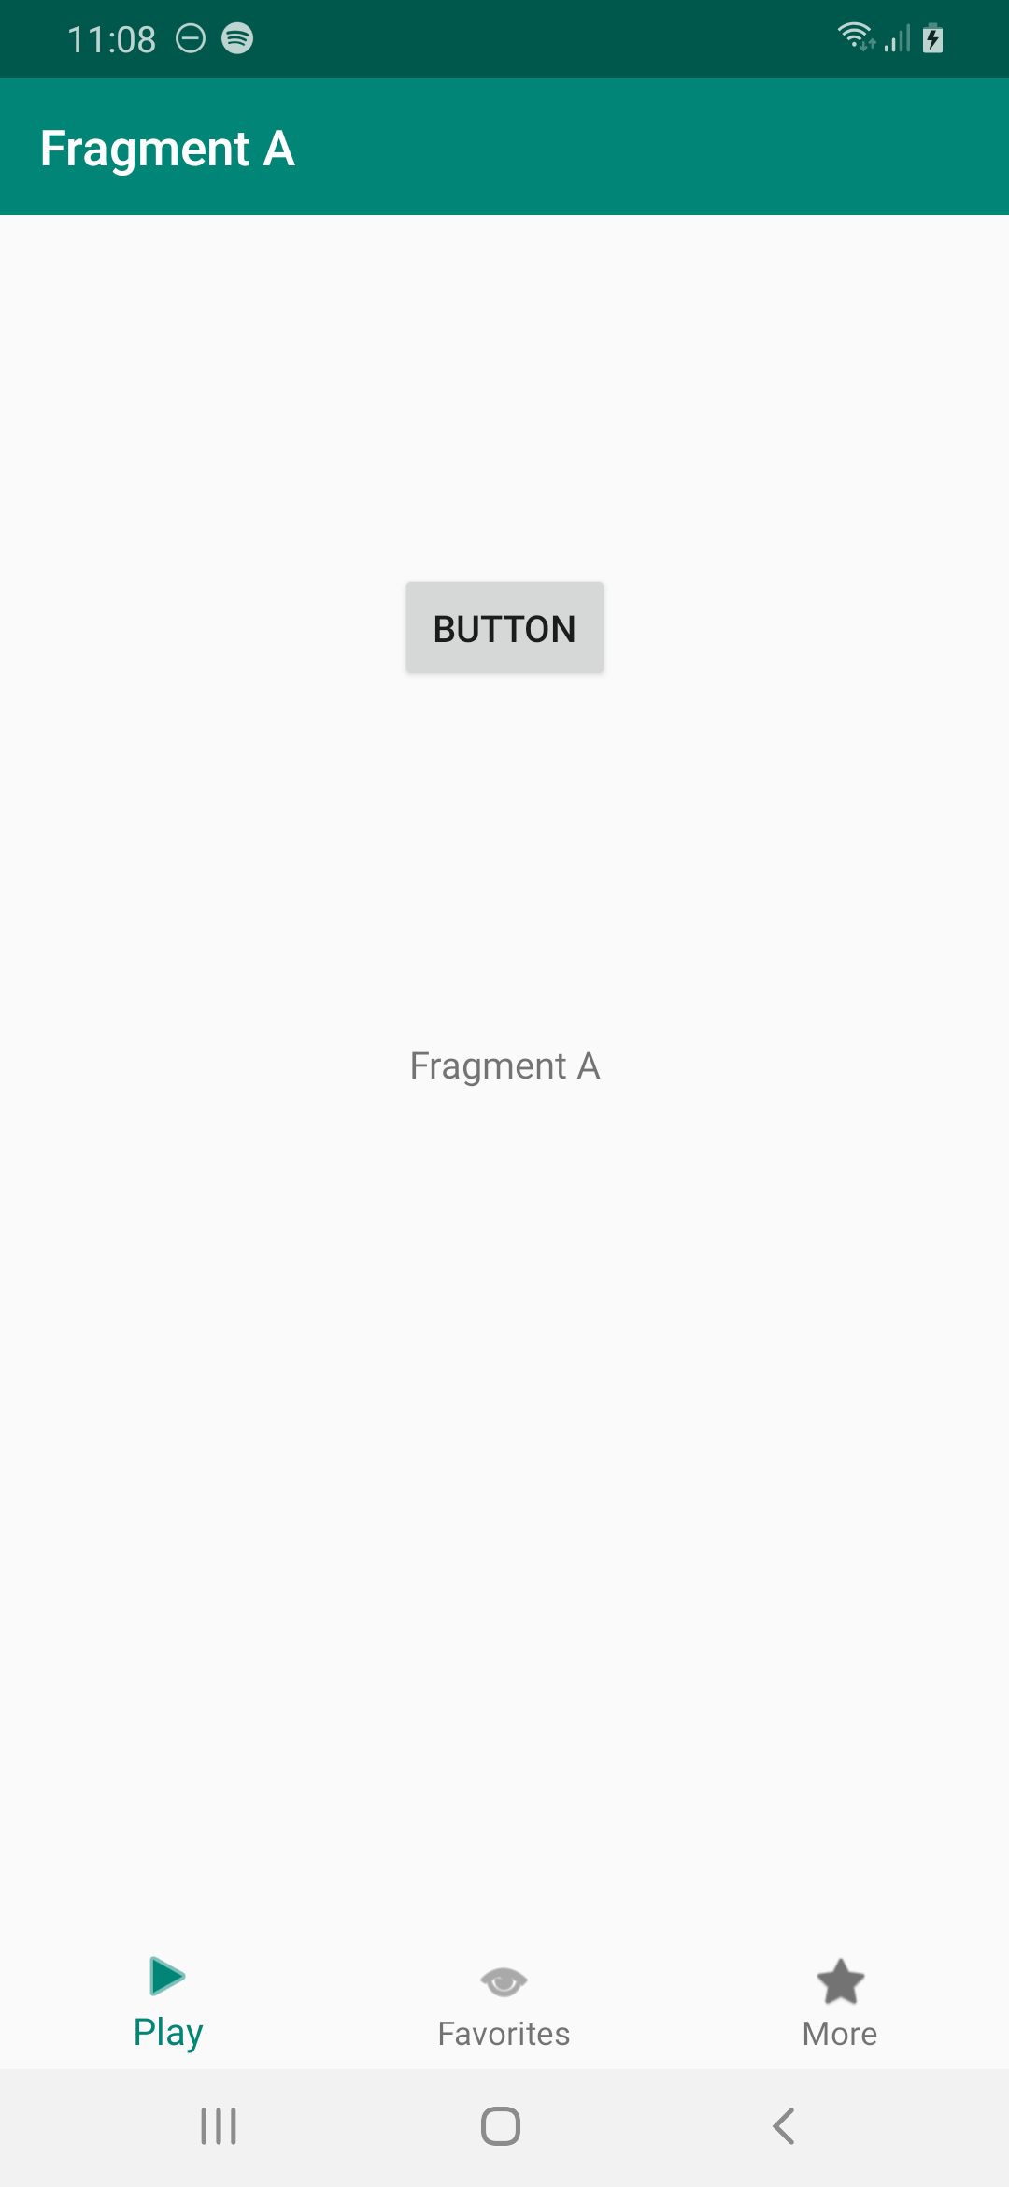

Click button. You will be in Fragment B in the first tab.

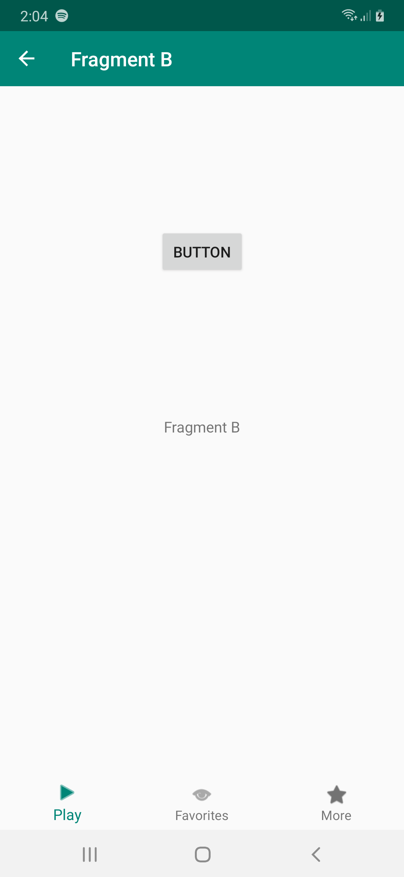

Click button again. You will be in Fragment C.

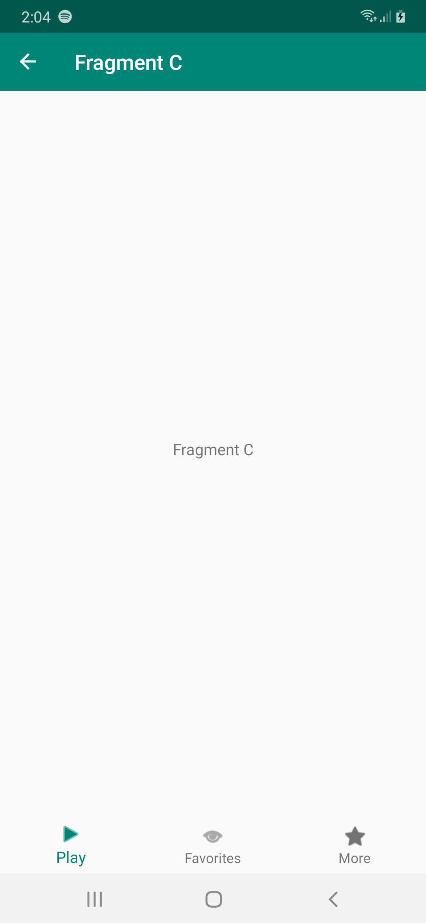

Click second tab. You will be in Fragment D.

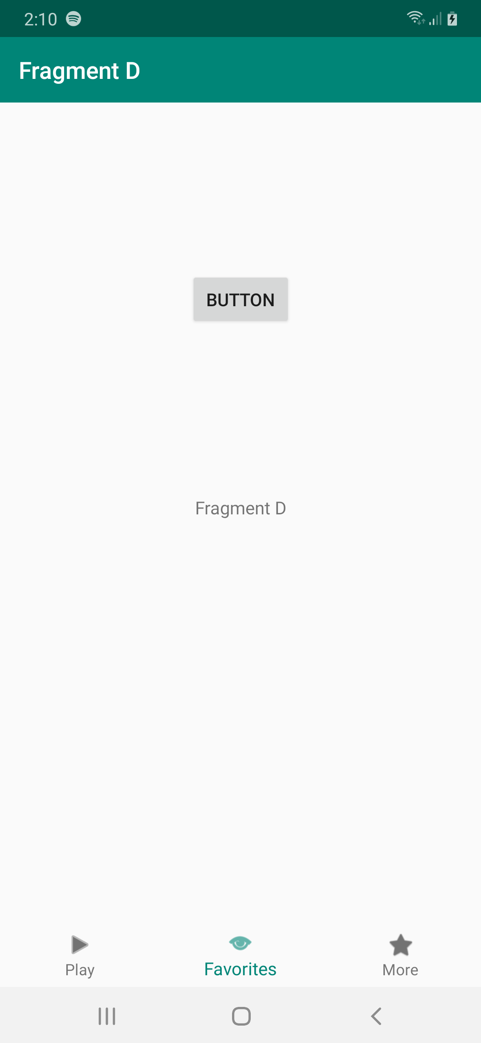

Each tab maintain its own navigation. If you click back the first tab, you will get Fragment C not Fragment A.

Optional Readings

https://developer.android.com/guide/navigation/navigation-ui

Exercises

1. Create bottom view like in Khan Academy app.

