Font

You can use custom fonts for the text view.

Create an empty Activity Android project. Name it HelloFont1.

Edit app / res / layout / activity_main.xml.

<?xml version="1.0" encoding="utf-8"?>
<androidx.constraintlayout.widget.ConstraintLayout
xmlns:android="http://schemas.android.com/apk/res/android"
xmlns:tools="http://schemas.android.com/tools"
xmlns:app="http://schemas.android.com/apk/res-auto"
android:layout_width="match_parent"
android:layout_height="match_parent"
tools:context=".MainActivity">
<TextView
android:id="@+id/textView"
android:layout_width="wrap_content"
android:layout_height="wrap_content"
android:text="Hello World!"
app:layout_constraintBottom_toBottomOf="parent"
app:layout_constraintLeft_toLeftOf="parent"
app:layout_constraintRight_toRightOf="parent"
app:layout_constraintTop_toTopOf="parent"/>
<TextView
android:text="TextView"
android:layout_width="wrap_content"
android:layout_height="wrap_content"
android:id="@+id/textView2"
app:layout_constraintTop_toBottomOf="@+id/textView" android:layout_marginBottom="8dp"
app:layout_constraintBottom_toBottomOf="parent" app:layout_constraintEnd_toEndOf="parent"
android:layout_marginEnd="8dp" app:layout_constraintStart_toStartOf="parent"
android:layout_marginStart="8dp"/>
</androidx.constraintlayout.widget.ConstraintLayout>

Create assets folder inside app / src / main.

Put font file (with ttf extension) inside assets folder. In my case, I got GreatVibes-Regular.ttf. You can download the font from https://www.1001fonts.com/great-vibes-font.html.

Edit app / java / com.example.hellofont1 / MainActivity.

package com.example.hellofont1
import android.graphics.Typeface
import androidx.appcompat.app.AppCompatActivity
import android.os.Bundle
import android.widget.TextView
class MainActivity : AppCompatActivity() {
override fun onCreate(savedInstanceState: Bundle?) {
super.onCreate(savedInstanceState)
setContentView(R.layout.activity_main)
val textView = findViewById<TextView>(R.id.textView)
val typeface = Typeface.createFromAsset(assets, "GreatVibes-Regular.ttf")
textView.typeface = typeface
}
}

You can get the font (they call it typeface) with Typeface.createFromAsset method.

val typeface = Typeface.createFromAsset(assets, "GreatVibes-Regular.ttf")

To change the font, you can set the typeface property of the text view.

textView.typeface = typeface

Then open activity_main.xml in design mode (not text mode).

Make sure the second text view on the layout is selected.

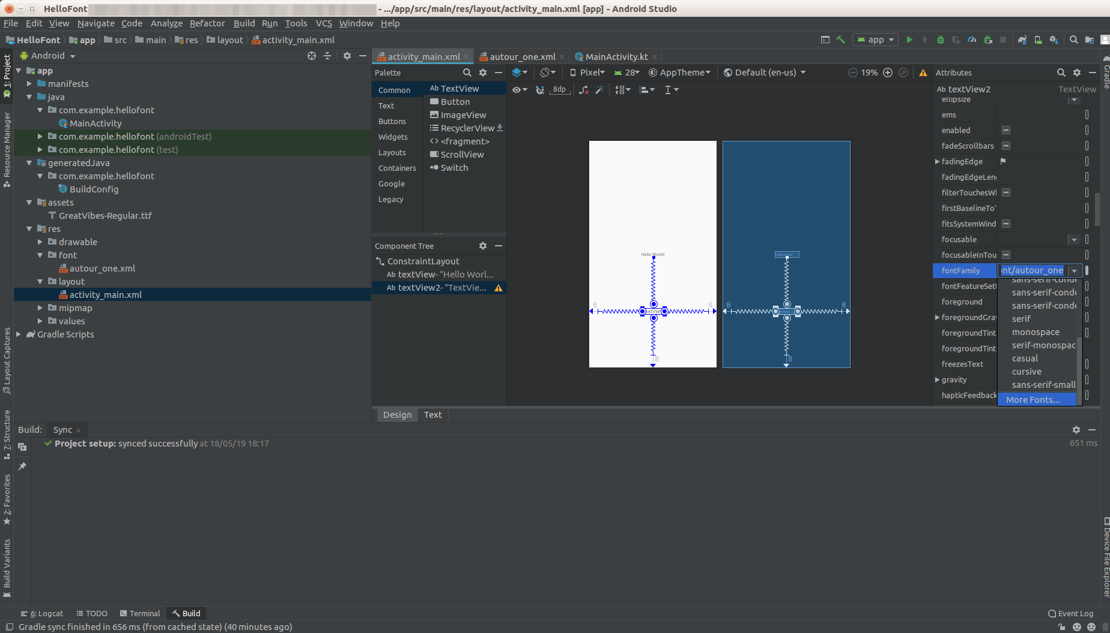
Then in the right panel, choose fontFamily attribute. Click “More Fonts...”

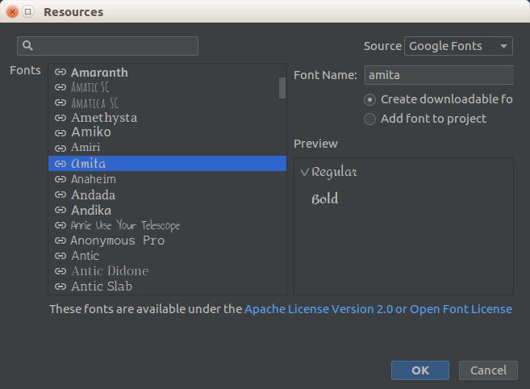
In the dialog, choose any font you like, and make sure “Create downloadable font” option is checked. Then click Ok.

The second text view will use the font you chose. If you open activity_main.xml, you will notice the second text view has additional attribute, whichh is android:fontFamily.

<TextView
android:text="TextView"
android:layout_width="wrap_content"
android:layout_height="wrap_content"
android:id="@+id/textView2"
app:layout_constraintTop_toBottomOf="@+id/textView" android:layout_marginBottom="8dp"
app:layout_constraintBottom_toBottomOf="parent" app:layout_constraintEnd_toEndOf="parent"
android:layout_marginEnd="8dp" app:layout_constraintStart_toStartOf="parent"
android:layout_marginStart="8dp" android:fontFamily="@font/amita"/>

Run the application and your application will have two text views, each with different font.

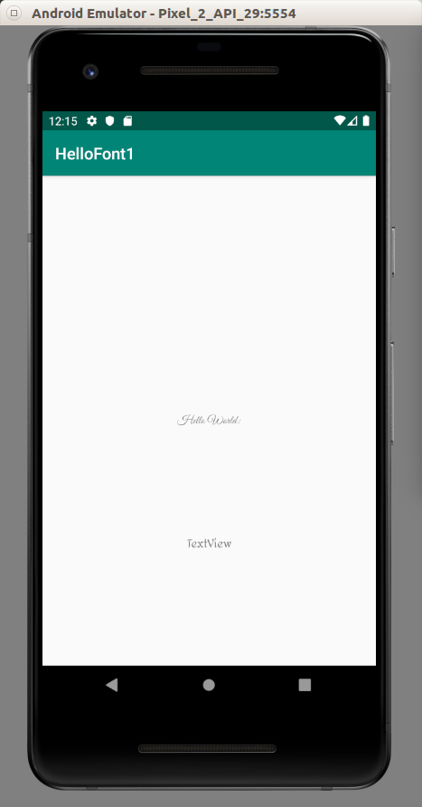

Optional Readings

https://developer.android.com/guide/topics/ui/look-and-feel/downloadable-fonts

https://developer.android.com/guide/topics/ui/look-and-feel/fonts-in-xml

https://developer.android.com/reference/kotlin/android/provider/FontRequest

https://developer.android.com/reference/kotlin/android/provider/FontsContract

Exercises

1. Create a downloadable fonts programmatically using FontRequest and FontsCotnract.

