WebView

WebView is a widget to display html file.

Create an empty Activity Android project. Name it HelloWebview1.

Edit app / manifests / AndroidManifest.xml. Add this line inside manifest node.

<uses-permission android:name="android.permission.INTERNET" />

If your Android application needs to access internet, you need to add the previous line.

Create a folder inside app / src / main and name it assets. Create a folder inside app / src / main / assets and name it html.

Create index.html inside this html folder.

<html>
<head><link rel="stylesheet" type="text/css" href="style.css">
</head>
<body>
<p>This is p node <strong>with strong node</strong>
</body>
</html>

Create style.css inside this html folder.

strong {
color: #faaf00;
}

Edit app / res / layout / activity_main.xml resource file.

<?xml version="1.0" encoding="utf-8"?>
<androidx.constraintlayout.widget.ConstraintLayout
xmlns:android="http://schemas.android.com/apk/res/android"
xmlns:tools="http://schemas.android.com/tools"
xmlns:app="http://schemas.android.com/apk/res-auto"
android:layout_width="match_parent"
android:layout_height="match_parent"
tools:context=".MainActivity">
<WebView
android:id="@+id/webViewInternet"
android:layout_width="match_parent"
android:layout_height="0dp"
app:layout_constraintBottom_toTopOf="@+id/guidelineHalf"
app:layout_constraintLeft_toLeftOf="parent"
app:layout_constraintRight_toRightOf="parent"
app:layout_constraintTop_toTopOf="parent">
</WebView>
<androidx.constraintlayout.widget.Guideline
android:orientation="horizontal"
android:layout_width="wrap_content"
android:layout_height="1dp"
app:layout_constraintGuide_percent="0.5"
android:id="@+id/guidelineHalf"/>
<WebView
android:id="@+id/webViewLocal1"
android:layout_width="match_parent"
android:layout_height="0dp"
app:layout_constraintTop_toBottomOf="@+id/guidelineHalf"
app:layout_constraintLeft_toLeftOf="parent"
app:layout_constraintRight_toRightOf="parent"
app:layout_constraintBottom_toTopOf="@+id/guideline3rdQuarter">
</WebView>
<androidx.constraintlayout.widget.Guideline
android:orientation="horizontal"
android:layout_width="wrap_content"
android:layout_height="1dp"
app:layout_constraintGuide_percent="0.75"
android:id="@+id/guideline3rdQuarter"/>
<WebView
android:id="@+id/webViewLocal2"
android:layout_width="match_parent"
android:layout_height="0dp"
app:layout_constraintTop_toBottomOf="@+id/guideline3rdQuarter"
app:layout_constraintLeft_toLeftOf="parent"
app:layout_constraintRight_toRightOf="parent"
app:layout_constraintBottom_toBottomOf="parent">
</WebView>
</androidx.constraintlayout.widget.ConstraintLayout>

Basically you have three webviews in this layout file.

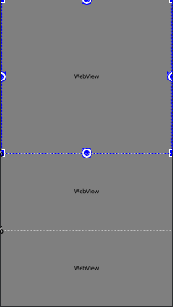

Edit app / java / com.example.hellowebview1 / MainActivity.

package com.example.hellowebview1
import android.os.Bundle
import android.webkit.WebView
import androidx.appcompat.app.AppCompatActivity
class MainActivity : AppCompatActivity() {
override fun onCreate(savedInstanceState: Bundle?) {
super.onCreate(savedInstanceState)
setContentView(R.layout.activity_main)
val webViewInternet : WebView = findViewById(R.id.webViewInternet)
webViewInternet.loadUrl("https://news.ycombinator.com")
val webViewLocal1 : WebView = findViewById(R.id.webViewLocal1)
val cssString = assets.open("html/style.css").bufferedReader().readText()
webViewLocal1.loadDataWithBaseURL(null, "<html>" +
"<head>" +
"<style>" +
cssString +
"</style>" +
"</head>" +
"<body>" +
"<p>This is p node <strong>with strong node</strong>" +
"</body>" +
"</html>",
"text/html", "UTF-8",null)
val webViewLocal2 : WebView = findViewById(R.id.webViewLocal2)
webViewLocal2.loadUrl("file:///android_asset/html/index.html")
}
}

To load url from internet, you can use loadUrl method as in this line:

webViewInternet.loadUrl("https://news.ycombinator.com")

To load html data as in string, you can use loadData method as in this line:

webViewLocal1.loadData("<html>" +
"<head>" +
"<style>" +
cssString +
"</style>" +
"</head>" +
"<body>" +
"<p>This is p node <strong>with strong node</strong>" +
"</body>" +
"</html>",
"text/html; charset=UTF-8",
null)

The cssString is from css file inside html folder. You can get the content of css file with assets as in this line:

val cssString = assets.open("html/style.css").bufferedReader().readText()

You can also load local html file with loadUrl method as in this line.

webViewLocal2.loadUrl("file:///android_asset/html/index.html")

The “file:///android_asset” refers to assets directory.

Run the application and you will see this screen.

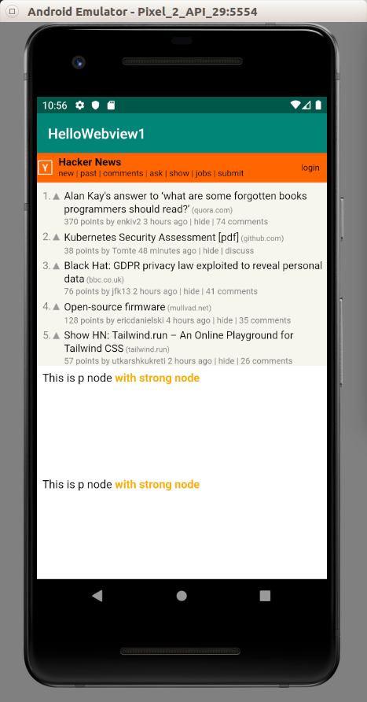

Optional Readings

https://developer.android.com/guide/webapps

https://developer.android.com/reference/androidx/webkit/package-summary?hl=en

Exercises

1. Create a webview with javascript code.

