Facebook

We can put Facebook authentication on our Android application.

Go to https://developers.facebook.com/docs/facebook-login/android.

But we need to have a Facebook account and Facebook developer account first.

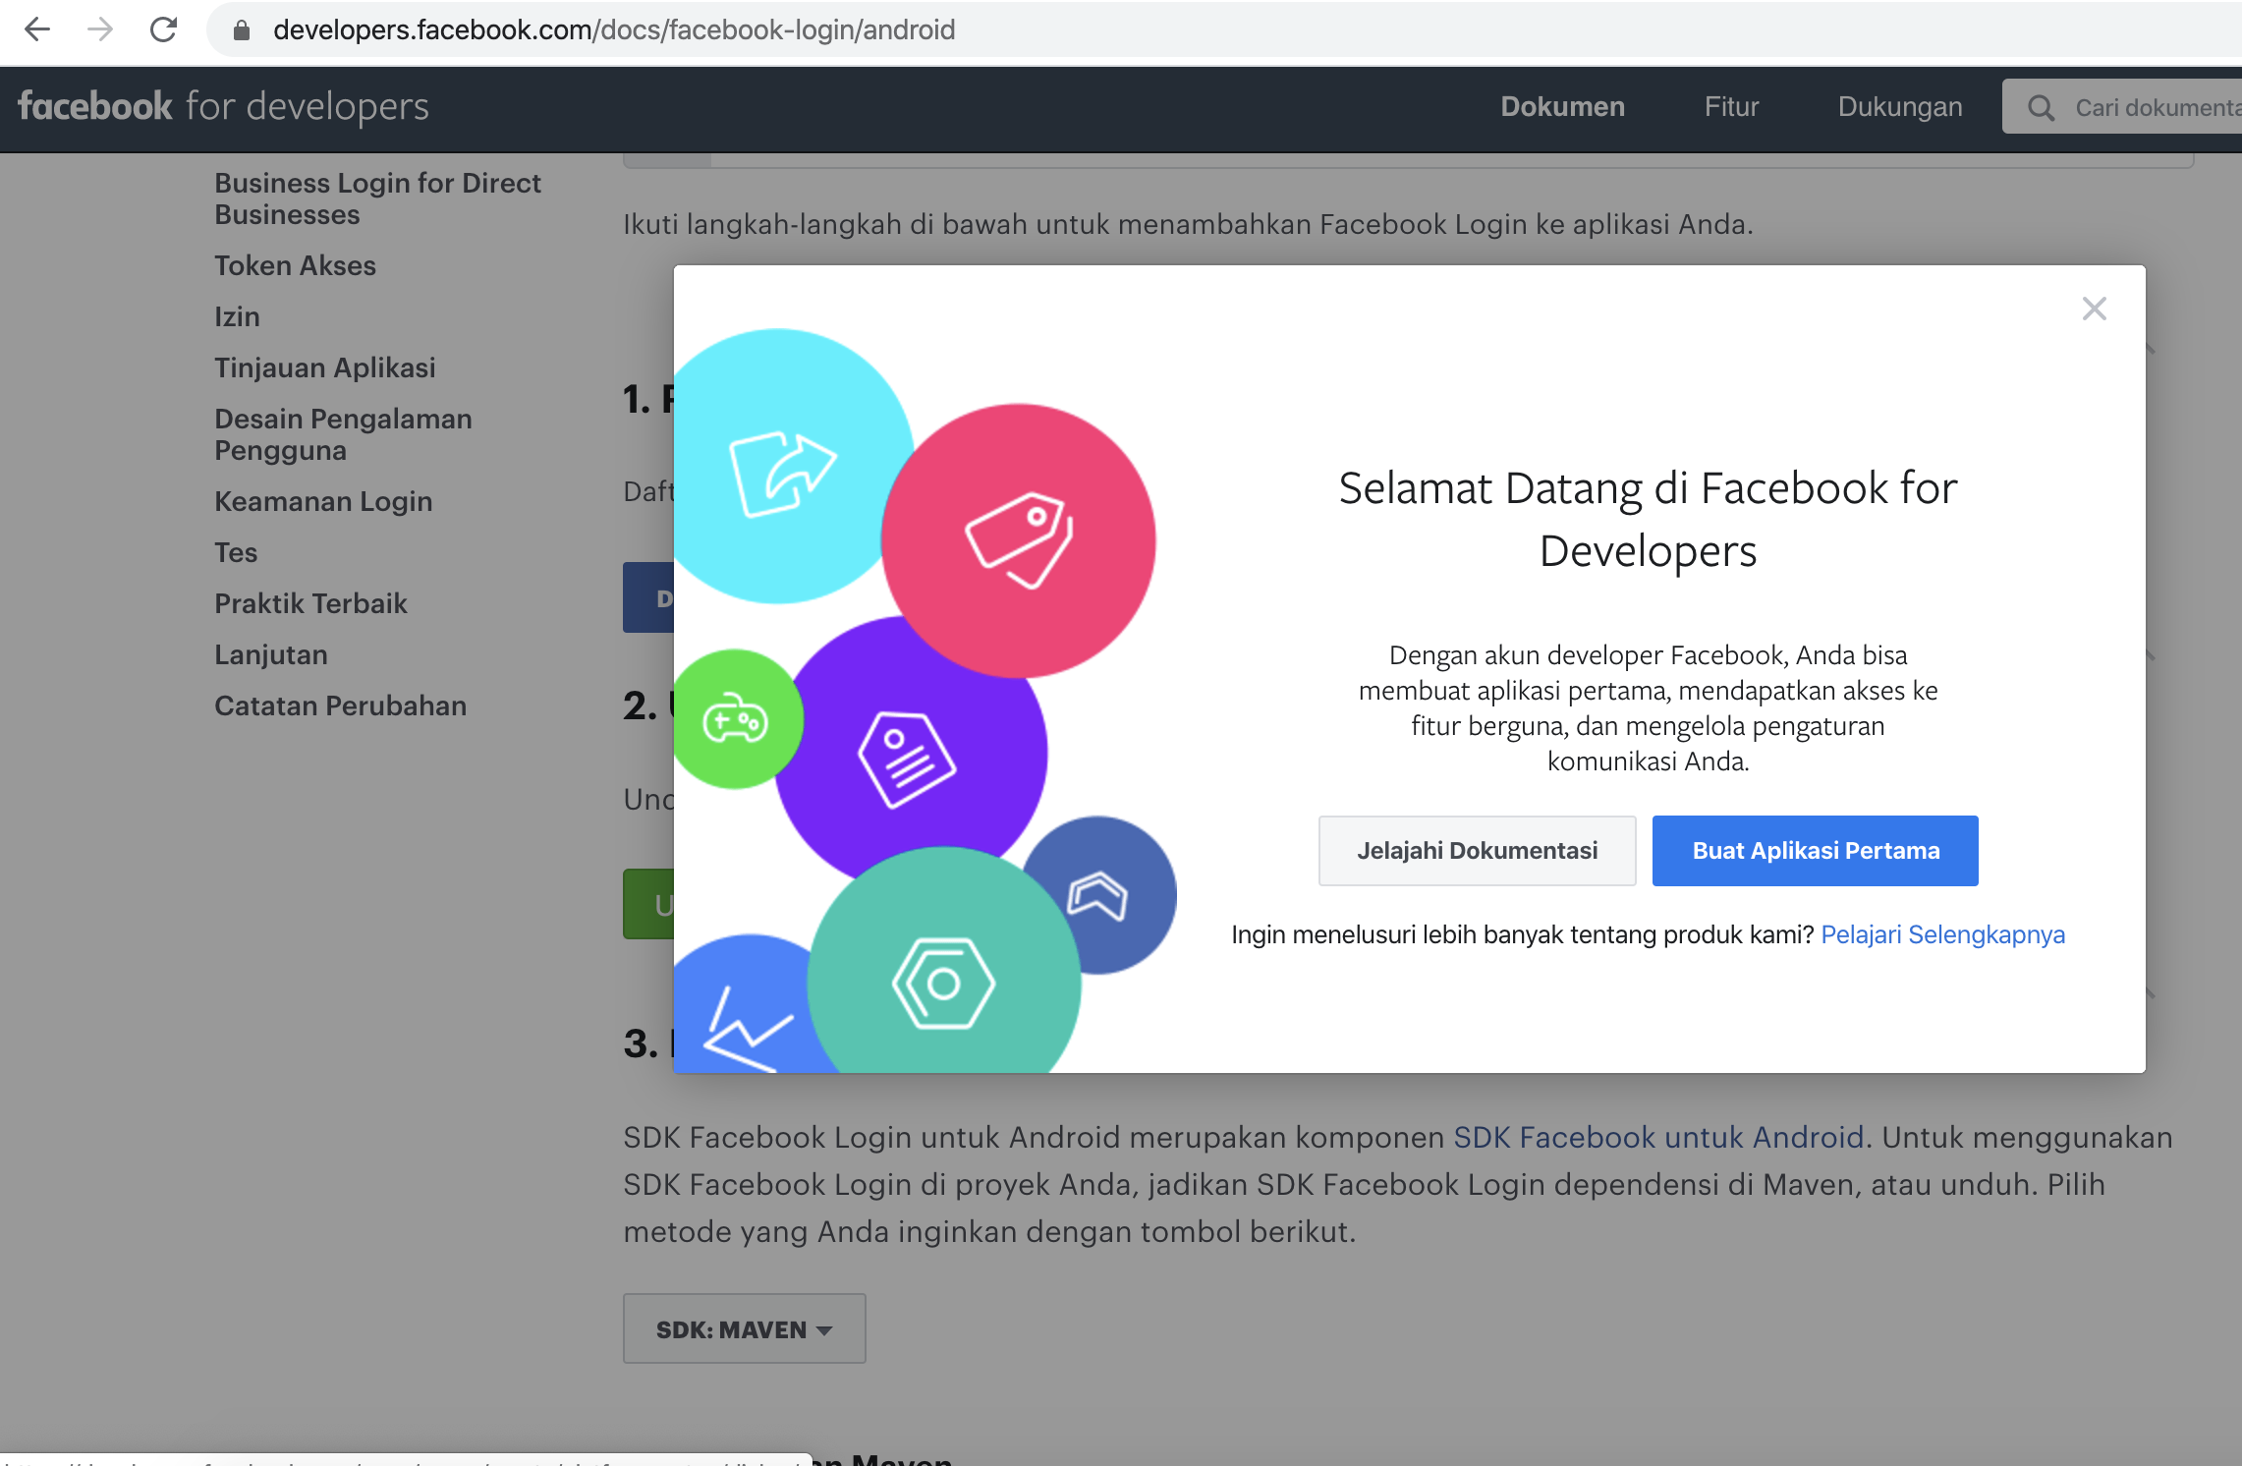
Then we need to create our application.

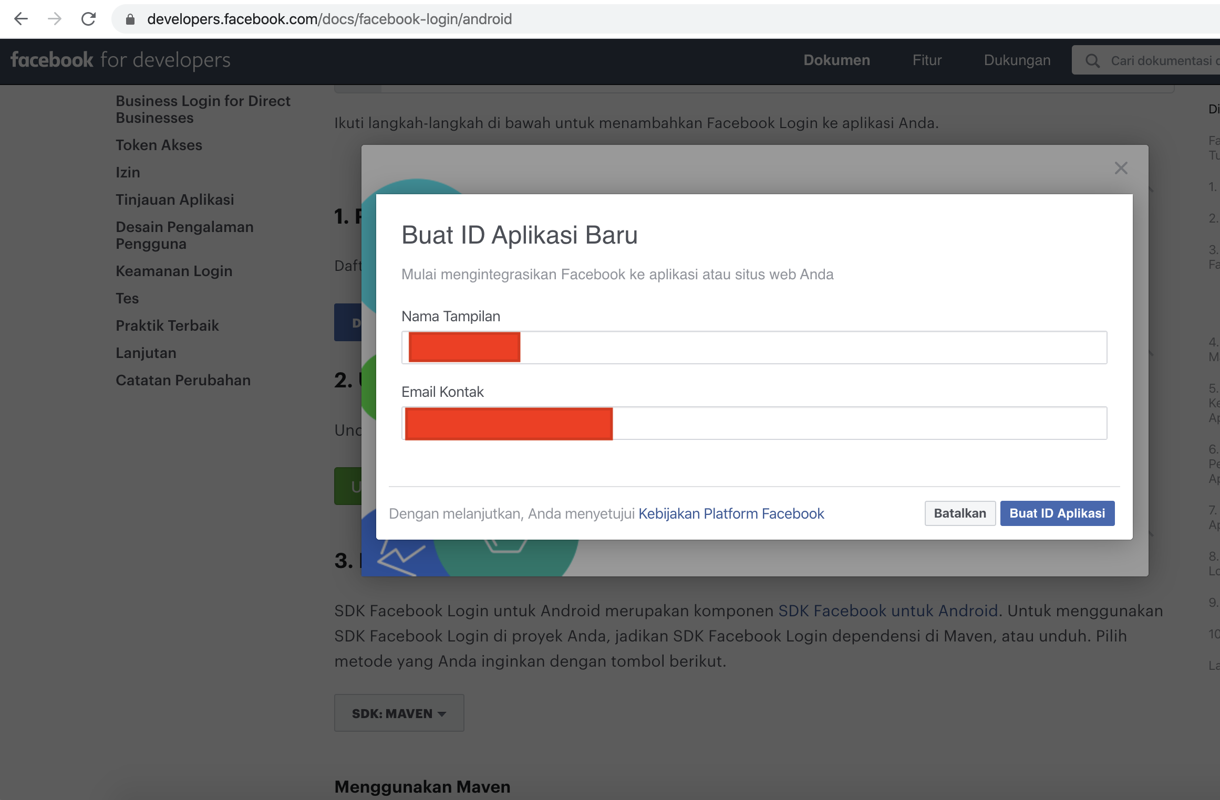
Then we choose our application in the Facebook Android authentication page.

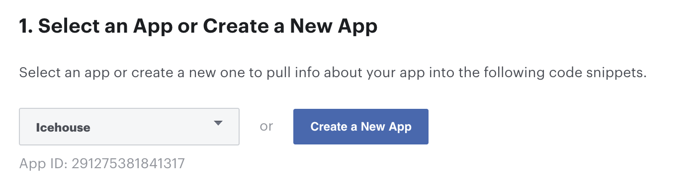

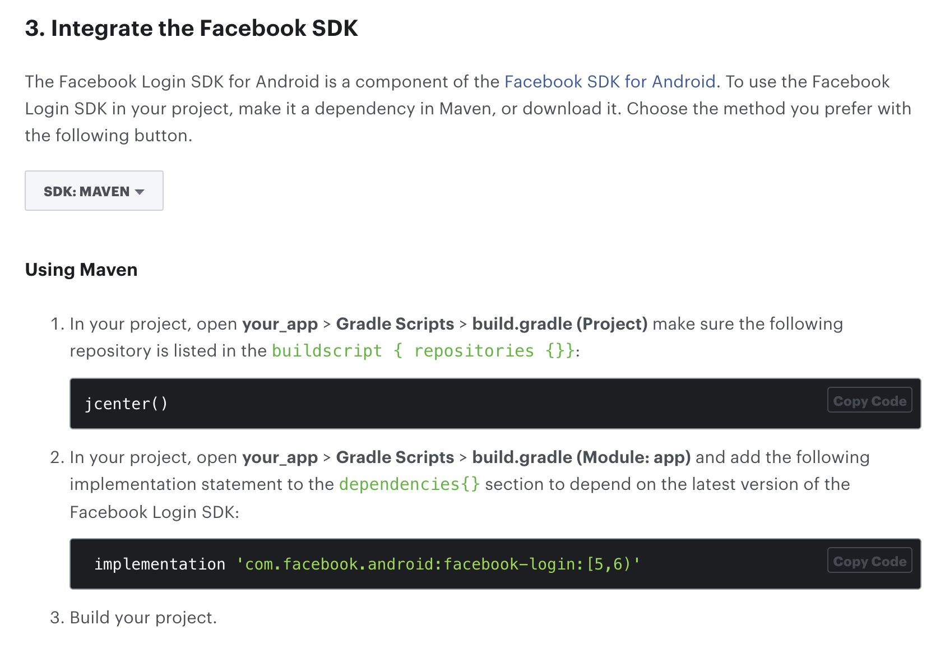

Create a new empty Activity project and name it HelloFacebook1.

Add dependency in our build.gradle (Module: app).

implementation 'com.facebook.android:facebook-login:[5,6)'

Then we need to edit resources and manifests file.

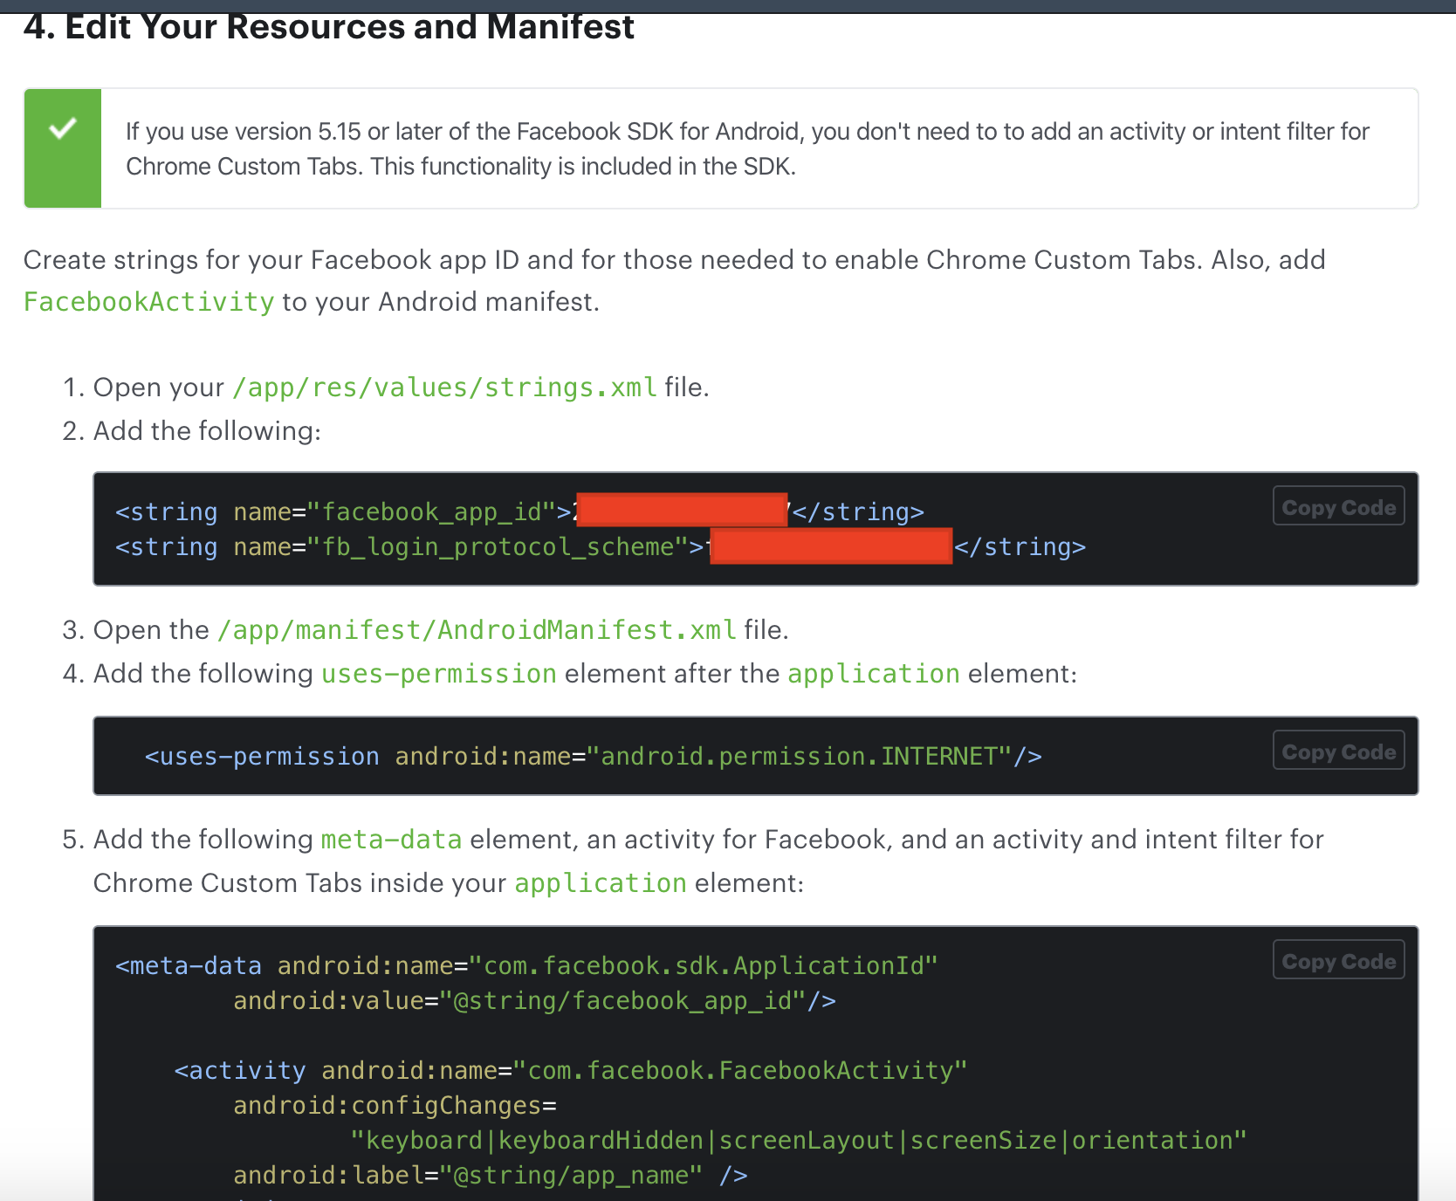

Then we need to associate our package name to our Facebook application.

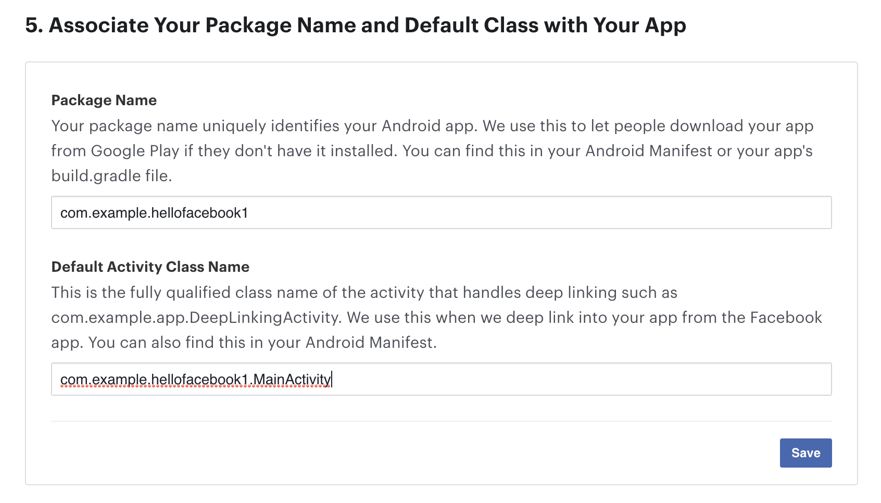
Then we need to add a key hash to this field.

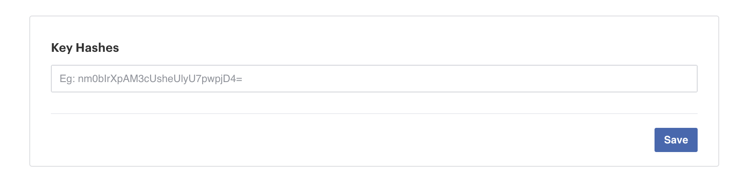
To get the key hash, we can run this command in our computer running Android studio.

$ keytool -exportcert -alias androiddebugkey -keystore ~/.android/debug.keystore | openssl sha1 -binary | openssl base64

Let’s go back to our application.

Edit app / res / layout / activity_main.xml.

<?xml version="1.0" encoding="utf-8"?>
<LinearLayout
xmlns:android="http://schemas.android.com/apk/res/android"
xmlns:app="http://schemas.android.com/apk/res-auto"
xmlns:tools="http://schemas.android.com/tools"
android:layout_width="match_parent"
android:layout_height="match_parent"
tools:context=".MainActivity"
android:orientation="vertical"
app:layout_constraintBottom_toBottomOf="parent"
app:layout_constraintTop_toTopOf="parent"
app:layout_constraintStart_toStartOf="parent"
app:layout_constraintEnd_toEndOf="parent">
<TextView
android:id="@+id/textView"
android:layout_width="match_parent"
android:layout_height="wrap_content"
android:layout_marginTop="20dp"
android:layout_marginBottom="40dp"
android:textAlignment="center"
android:text="Email" />
<com.facebook.login.widget.LoginButton
android:id="@+id/button"
android:layout_width="match_parent"
android:layout_marginStart="40dp"
android:layout_marginEnd="40dp"
android:layout_height="wrap_content" />
</LinearLayout>
Notice, the button is Facebook’s LoginButton not normal button.

Edit app / java / com.example.hellofacebook1 / MainActivity.

package com.example.hellofacebook1

import android.content.Intent
import androidx.appcompat.app.AppCompatActivity
import android.os.Bundle
import android.widget.TextView
import com.facebook.CallbackManager
import com.facebook.login.LoginManager
import com.facebook.login.widget.LoginButton

const val EMAIL = "email"

class MainActivity : AppCompatActivity() {

private lateinit var callbackManager: CallbackManager
private lateinit var facebookCallback: MyFacebookCallback

override fun onCreate(savedInstanceState: Bundle?) {
super.onCreate(savedInstanceState)
setContentView(R.layout.activity_main)

val loginButton = findViewById<LoginButton>(R.id.button)
loginButton.setPermissions(listOf(EMAIL))
val textView = findViewById<TextView>(R.id.textView)
callbackManager = CallbackManager.Factory.create()
facebookCallback = MyFacebookCallback(textView)
LoginManager.getInstance().registerCallback(callbackManager, facebookCallback)
}

override fun onActivityResult(requestCode: Int, resultCode: Int, data: Intent?) {
super.onActivityResult(requestCode, resultCode, data)
callbackManager.onActivityResult(requestCode, resultCode, data)
}
}
We create a variable for CallbackManager and MyFacebookCallback.

MyFacebookCallback is defined in another file which we will discuss shortly.

Then we set the permission for the login button.

val loginButton = findViewById<LoginButton>(R.id.button)
loginButton.setPermissions(listOf(EMAIL))

We setup the CallbackManager.

callbackManager = CallbackManager.Factory.create()

We setup MyFacebookCallback instance which accepts the textview instance.

Then we register the callback to our login process.

LoginManager.getInstance().registerCallback(callbackManager, facebookCallback)

Override onActivityResult method.

override fun onActivityResult(requestCode: Int, resultCode: Int, data: Intent?) {
super.onActivityResult(requestCode, resultCode, data)
callbackManager.onActivityResult(requestCode, resultCode, data)
}
Then we have to define MyFacebookCallback in app / java / com.example.hellofacebook1.

package com.example.hellofacebook1

import android.os.Bundle
import android.widget.TextView
import com.facebook.FacebookCallback
import com.facebook.FacebookException
import com.facebook.GraphRequest
import com.facebook.GraphResponse
import com.facebook.login.LoginResult
import org.json.JSONObject

class MyFacebookCallback(private val textView: TextView) : FacebookCallback<LoginResult> {

override fun onSuccess(result: LoginResult?) {
result?.let {
val accessToken = result.accessToken
val graphRequest = GraphRequest.newMeRequest(accessToken) { jsonObject: JSONObject, graphResponse: GraphResponse ->
textView.text = jsonObject.getString("email")
}
val parameters = Bundle()
parameters.putString("fields", "id,name,email")
graphRequest.parameters = parameters
graphRequest.executeAsync()
}
}

override fun onCancel() {
}

override fun onError(error: FacebookException?) {
}
}
In this example, we setup onSuccess callback only.

We get the access token.

val accessToken = result.accessToken

We create a graph request. In this case, we want to set the text view with the email of this login.

val graphRequest = GraphRequest.newMeRequest(accessToken) { jsonObject: JSONObject, graphResponse: GraphResponse ->
textView.text = jsonObject.getString("email")
}

Then we execute the graph request.

val parameters = Bundle()
parameters.putString("fields", "id,name,email")
graphRequest.parameters = parameters
graphRequest.executeAsync()

If we ran the application, we would get this screen.

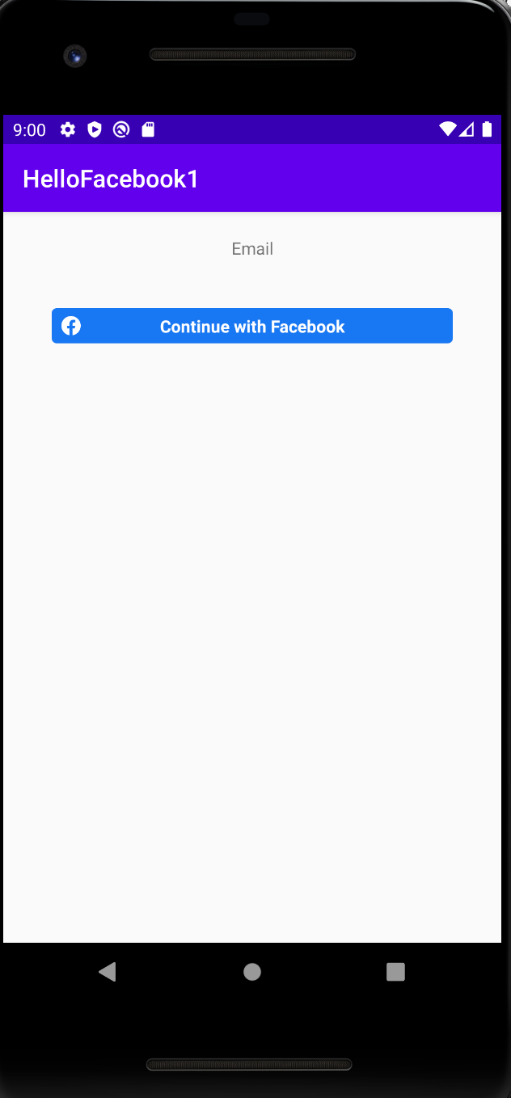

If we clicked Facebook login button, we would get this screen.

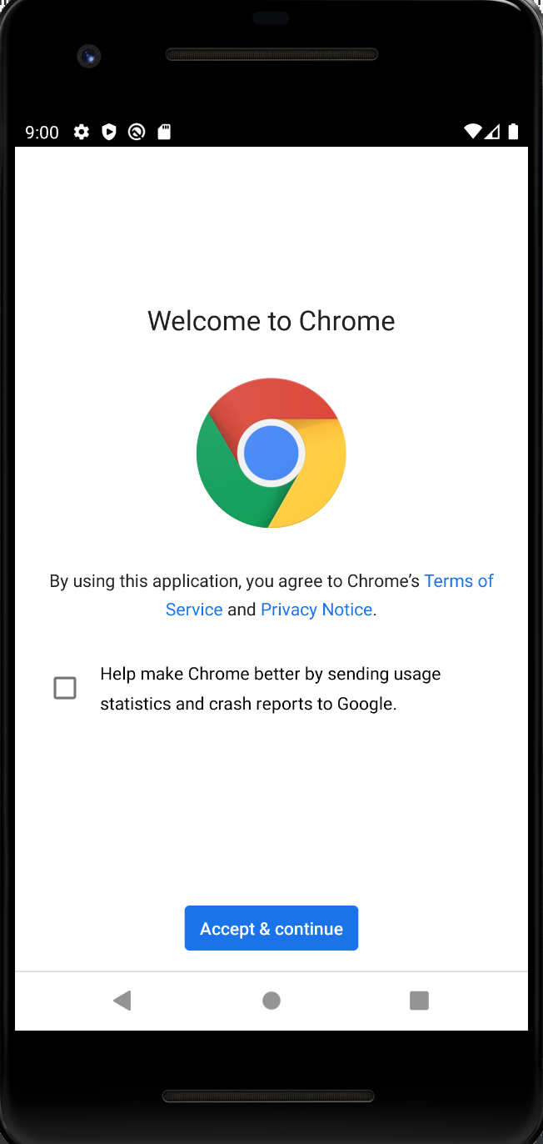

We login in Facebook through Chrome browser. Then we arrive in Facebook login screen.

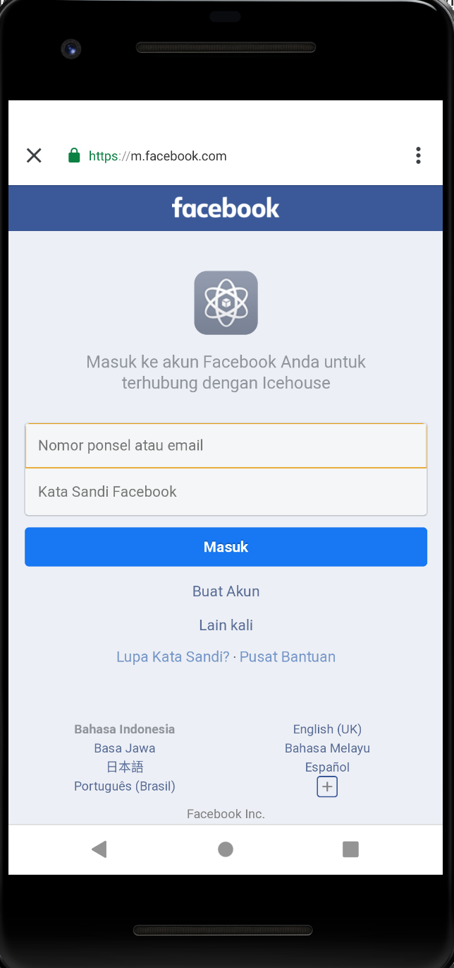

After logging in, we would get our email in the screen.

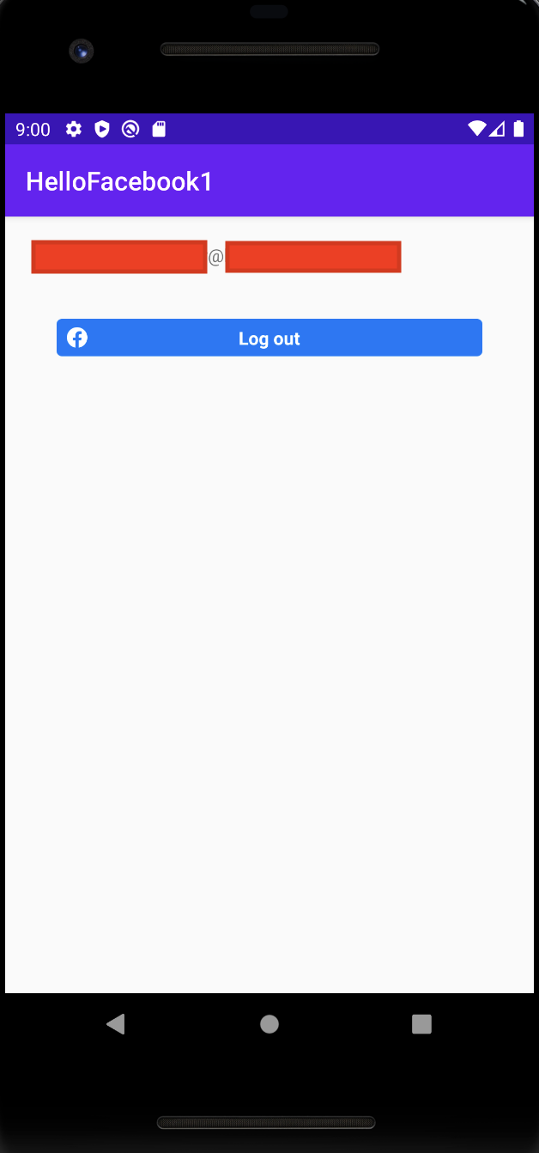

If we want to go further, we can pass the access token to the server on which we could confirm it.

To learn more, refer to this documentation.

https://developers.facebook.com/docs/facebook-login/manually-build-a-login-flow

https://developers.facebook.com/docs/facebook-login/web

Optional Readings

https://developers.facebook.com/docs/android/

https://developer.android.com/training/id-auth/authenticate

Exercises

1. Create a project on which you upload Facebook token to your server. In the server, you confirm the token legits or not. Then you make a request based on this token.

