Animation

Animation is moving and scaling views in a period of time.

UIView.animate Method

Create a new single-view application.

Add this code:

let textField = UITextField(frame: CGRect(x: -100, y: 100, width: 200, height: 50))
textField.layer.backgroundColor = UIColor.gray.cgColor
self.view.addSubview(textField)

UIView.animate(withDuration: 0.8, delay: 0.3, options: [.curveEaseIn],
animations: {
textField.center.x = self.view.bounds.midX
},
completion: nil
)

You put the text field in the x position of -100 (off the screen). Then you move the text field to the center of the screen in animations callback in UIView.animate method.

Run it and you would get this animation:

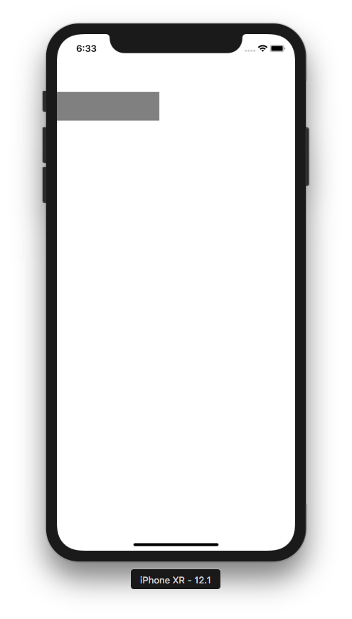

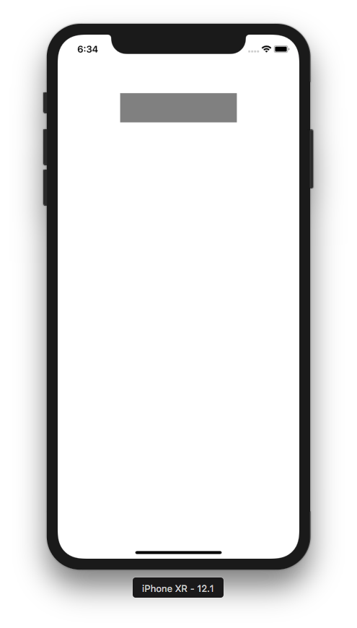

You can animate other property of the view, like alphaness.

Add this code:

let button = UIButton(frame: CGRect(x: 0, y: 200, width: 200, height: 50))
button.setTitle("Button", for: .normal)
button.backgroundColor = .green
button.center.x = self.view.bounds.midX
button.alpha = 0.0
self.view.addSubview(button)

UIView.animate(withDuration: 0.8, delay: 0.3, options: [],
animations: {
button.alpha = 1.0
},
completion: nil
)

Here, you animate the alphaness of the button, from “button.alpha = 0.0” to “button.alpha = 1.0”. Run it and you will get this animation.

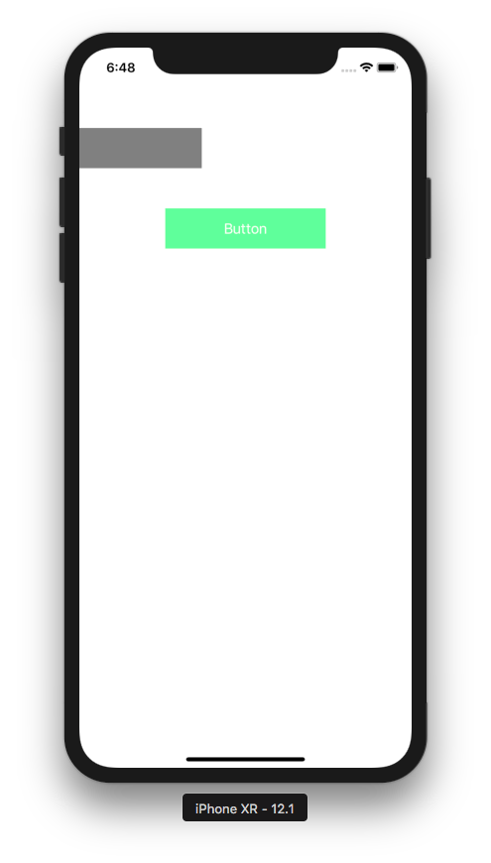

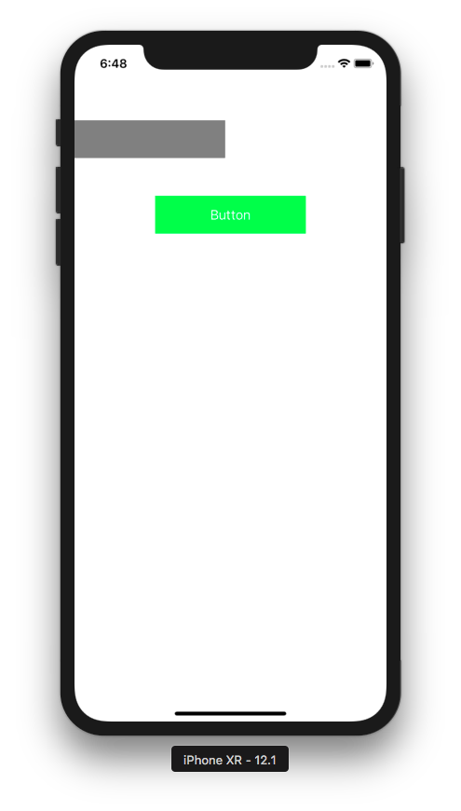

You can animate more than one property.

Add this code:

let imageView = UIImageView(frame: CGRect(x: 0, y: 350, width: 100, height: 100))
imageView.image = UIImage(named: "football")
imageView.center.x = self.view.bounds.midX
imageView.alpha = 0.0
self.view.addSubview(imageView)

UIView.animate(withDuration: 0.8,
delay: 0.3,
usingSpringWithDamping: 0.3,
initialSpringVelocity: 0.9,
options: [],
animations: {
imageView.alpha = 1.0
imageView.center.y -= 50
},
completion: nil
)

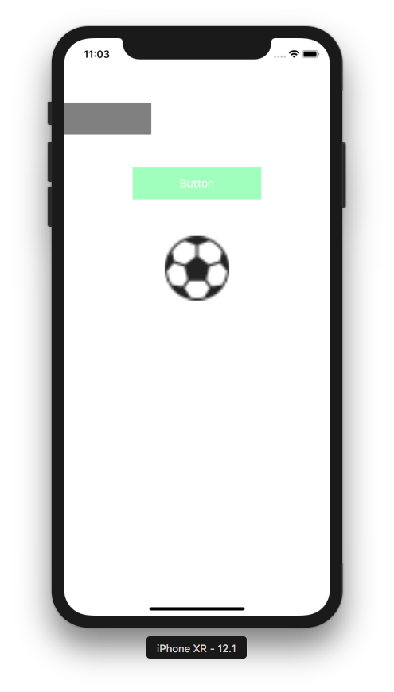

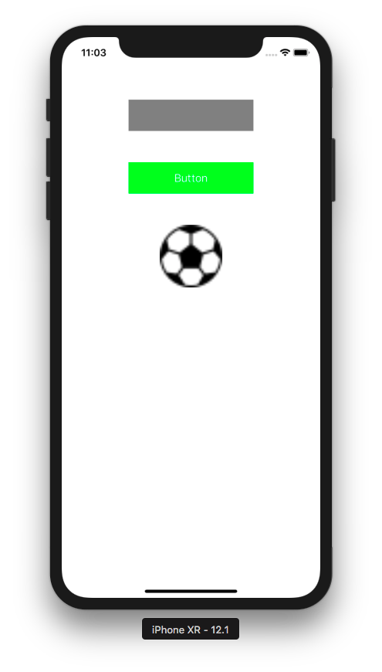

You can animate the appearance of the view from nothing to existence. It’s different from changing alphaness. You can use some animation style like curling (turning a page on the book).

Add an image view and make it a property of the class.

class ViewController: UIViewController {

var swordView: UIImageView!

Add this code inside viewDidLoad method.

swordView = UIImageView(frame: CGRect(x: 0, y: 450, width: 100, height: 100))
swordView.image = UIImage(named: "swords")
swordView.center.x = self.view.bounds.midX
swordView.isHidden = true
self.view.addSubview(swordView)

We hide the image view first with this statement:

swordView.isHidden = true

To animate the appearance of the view, you must put the animation code not inside viewDidLoad method, but viewDidAppear method.

override func viewDidAppear(_ animated: Bool) {
super.viewDidAppear(animated)

UIView.transition(with: self.swordView,
duration: 2.5,
options: [.transitionCurlDown],
animations: {
self.swordView.isHidden = false
},
completion: nil
)
}

Run it and you will get this animation.

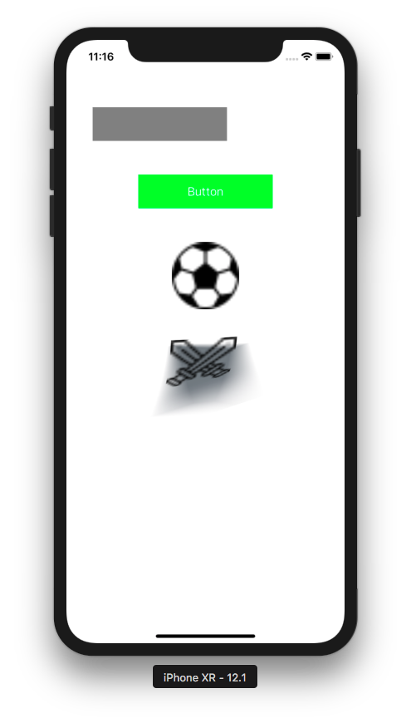

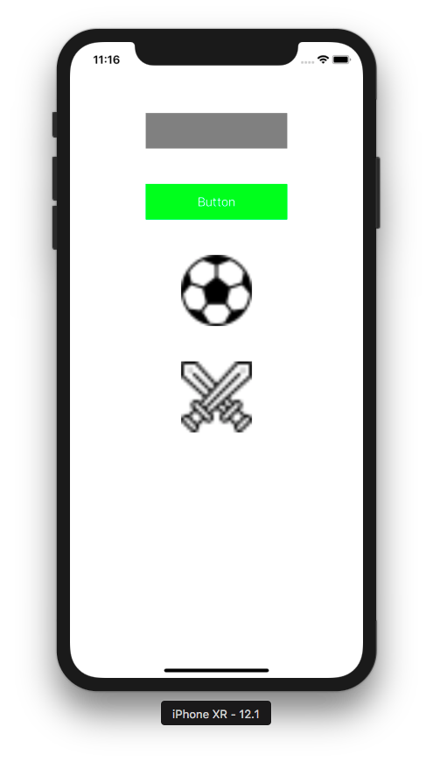

Keyframe

You can also add keyframes when using animation. Keyframe is like a point time in animation. To understand the keyframe, let’s see it in action:

let view1 = UIView(frame: CGRect(x: 0, y: 650, width: 100, height: 100))
view1.backgroundColor = .red
self.view.addSubview(view1)

UIView.animateKeyframes(withDuration: 2, delay: 0.0, animations: {

UIView.addKeyframe(withRelativeStartTime: 0.0, relativeDuration: 0.2, animations: {
view1.center.x += 100
view1.center.y += 10
})

UIView.addKeyframe(withRelativeStartTime: 0.2, relativeDuration: 0.5, animations: {
view1.transform = CGAffineTransform(rotationAngle: -.pi / 8)
})

UIView.addKeyframe(withRelativeStartTime: 0.7, relativeDuration: 0.3, animations: {
view1.center.x += 350
view1.center.y -= 50
})

}, completion: nil)

You add animation inside UIView.addKeyframe method. WithRelativeStartTime parameter means the start time. 0.0 value means the very beginning. 1.0 value means the very end. RelativeDuration parameter means how long this keyframe lasts. 0.3 value means 30% of the whole animation duration.

This UIView.addKeyframe method must be wrapped inside UIView.animateKeyframes which accepts withDuration parameter. This is how long the entire animation lasts.

Run it and you will get this animation.

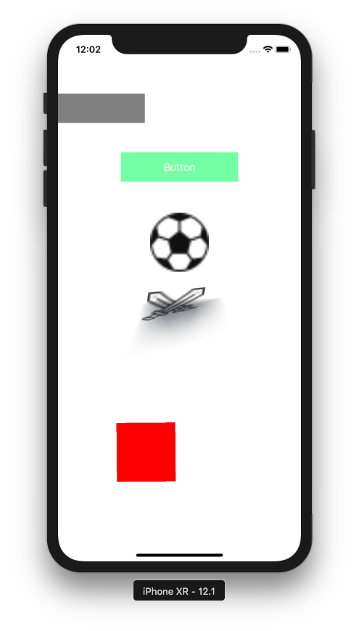

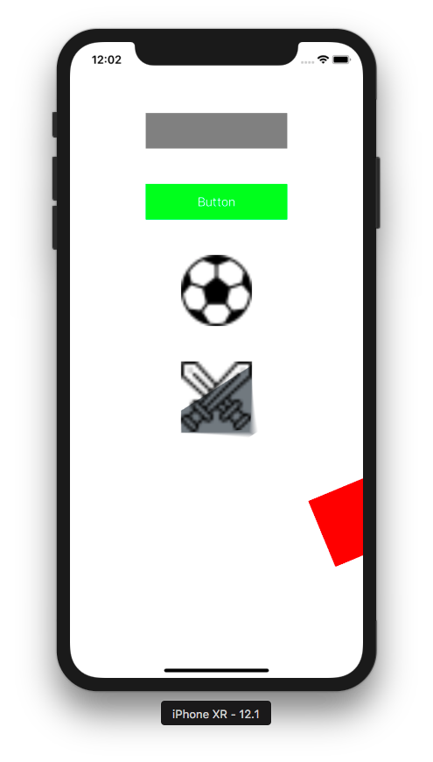

Animating Constraints

When animating constraints, you can change the constant value of the constraint or activate/disactivate certain constraints, but there are some things that you need to set.

Create a new single-view application.

Let’s create views with their constraint. Add this code:

class ViewController: UIViewController {

var view1Constraint1 : NSLayoutConstraint!
var view1Constraint2 : NSLayoutConstraint!
var view1Constraint3 : NSLayoutConstraint!
var view1Constraint4 : NSLayoutConstraint!
var view2Constraint1 : NSLayoutConstraint!
var view2Constraint2 : NSLayoutConstraint!
var view2Constraint3 : NSLayoutConstraint!
var view2Constraint4 : NSLayoutConstraint!

var view2 : UIView!

override func viewDidLoad() {
super.viewDidLoad()
// Do any additional setup after loading the view, typically from a nib.

let view1 = UIView()
view1.translatesAutoresizingMaskIntoConstraints = false
view1.backgroundColor = .red
self.view.addSubview(view1)
view1Constraint1 = view1.widthAnchor.constraint(equalToConstant: 100)
view1Constraint2 = view1.heightAnchor.constraint(equalToConstant: 100)
view1Constraint3 = view1.topAnchor.constraint(equalTo: self.view.topAnchor, constant: 100)
view1Constraint4 = view1.centerXAnchor.constraint(equalTo: self.view.centerXAnchor)
NSLayoutConstraint.activate([view1Constraint1, view1Constraint2, view1Constraint3, view1Constraint4])

view2 = UIView()
view2.translatesAutoresizingMaskIntoConstraints = false
view2.backgroundColor = .blue
self.view.addSubview(view2)
view2Constraint1 = view2.widthAnchor.constraint(equalTo: view1.widthAnchor)
view2Constraint2 = view2.heightAnchor.constraint(equalTo: view1.heightAnchor)
view2Constraint3 = view2.topAnchor.constraint(equalTo: view1.bottomAnchor, constant: 100)
view2Constraint4 = view2.centerXAnchor.constraint(equalTo: self.view.centerXAnchor)
NSLayoutConstraint.activate([view2Constraint1, view2Constraint2, view2Constraint3, view2Constraint4])

let button = UIButton()
button.translatesAutoresizingMaskIntoConstraints = false
button.setTitle("Button", for: .normal)
button.setTitleColor(.blue, for: .normal)
self.view.addSubview(button)
let buttonConstraint1 = button.topAnchor.constraint(equalTo: self.view.topAnchor, constant: 50)
let buttonConstraint2 = button.centerXAnchor.constraint(equalTo: self.view.centerXAnchor)
NSLayoutConstraint.activate([buttonConstraint1, buttonConstraint2])
button.addTarget(self, action: #selector(buttonTapped(_:)), for: .touchUpInside)

self.view2.layoutIfNeeded()
}

Then add buttonTapped method.

@objc func buttonTapped(_ sender: UIButton) {
self.view2Constraint3.constant = 400
UIView.animate(withDuration: 5.8, delay: 0.0, options: [.curveEaseIn],
animations: {
self.view.layoutIfNeeded()
},
completion: nil
)
}

The key point is you change the constraint before calling UIView.animate method. Inside the buttonTapped method (specifically inside animations callback), you call layoutIfNeeded method.

self.view.layoutIfNeeded()

Run it and you will get this screen.

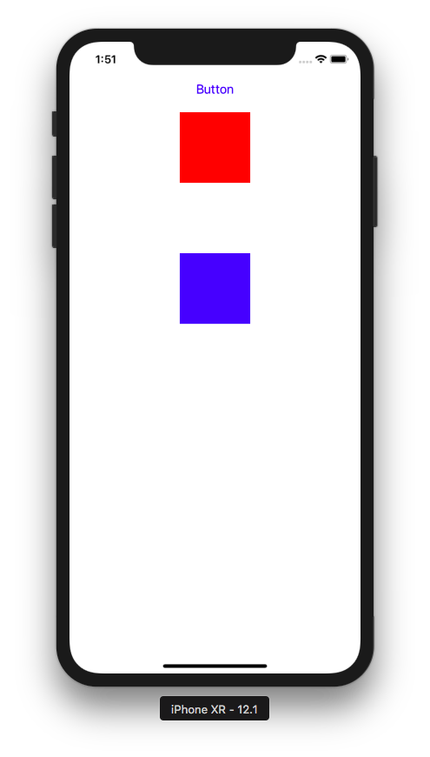

Click the button. The the blue view will move down.

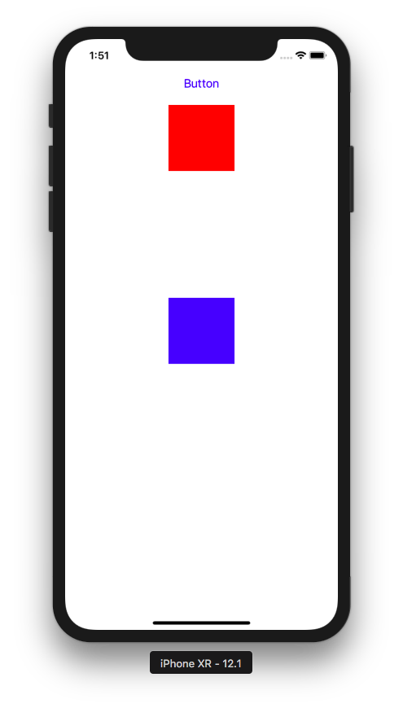

Animation Presenting View Controller

You can also animate the presenting view controller process.

Create a new single-view application.

Add this code inside viewDidLoad method.

super.viewDidLoad()
// Do any additional setup after loading the view, typically from a nib.
let buttonView = UIView()
buttonView.translatesAutoresizingMaskIntoConstraints = false
buttonView.backgroundColor = .green
self.view.addSubview(buttonView)

NSLayoutConstraint.activate([
buttonView.widthAnchor.constraint(equalToConstant: 100),
buttonView.heightAnchor.constraint(equalToConstant: 100),
buttonView.centerXAnchor.constraint(equalTo: self.view.centerXAnchor),
buttonView.centerYAnchor.constraint(equalTo: self.view.centerYAnchor)
])

let t1 = UITapGestureRecognizer(target: self, action: #selector(singleTap))
buttonView.addGestureRecognizer(t1)

Add singleTap method.

@objc func singleTap(_ t: UITapGestureRecognizer) {
guard t.view != nil else { return }

let presentedViewController = PresentedViewController()
presentedViewController.transitioningDelegate = self
present(presentedViewController, animated: true, completion: nil)
}

Add a new file, PresentedViewController.swift. Make it subclass of ViewController. This is the code.

class PresentedViewController: UIViewController {

override func viewDidLoad() {
super.viewDidLoad()

// Do any additional setup after loading the view.
self.view.backgroundColor = .green
let label = UILabel()
label.text = "Presented View Controller"
label.numberOfLines = 2
label.font = UIFont(name: "Arial", size: 46)!
label.translatesAutoresizingMaskIntoConstraints = false
self.view.addSubview(label)
NSLayoutConstraint.activate([
label.topAnchor.constraint(equalTo: self.view.topAnchor, constant: 300),
label.widthAnchor.constraint(equalTo: self.view.widthAnchor, constant: 0.8),
label.centerXAnchor.constraint(equalTo: self.view.centerXAnchor)
])

let button = UIButton()
button.setTitle("Dismiss", for: .normal)
button.titleLabel!.font = UIFont(name: "Arial", size: 23)!
button.translatesAutoresizingMaskIntoConstraints = false
self.view.addSubview(button)
NSLayoutConstraint.activate([
button.topAnchor.constraint(equalTo: self.view.topAnchor, constant: 100),
button.centerXAnchor.constraint(equalTo: self.view.centerXAnchor)
])
button.addTarget(self, action: #selector(buttonTapped(_:)), for: .touchUpInside)

}

@objc func buttonTapped(_ sender: UIButton) {
self.presentingViewController?.dismiss(animated: true, completion: nil)
}

}

Run it and you will get a green view on which you can click, then the presented view controller will appear. You can click “Dismiss” button on the presented view controller to dismiss it.

To animate the presenting presented view controller, make ViewController subclass of UIViewControllerTransitioningDelegate.

Then you need to implement two methods for presenting and dismissing view controller.

func animationController(forPresented presented: UIViewController, presenting: UIViewController, source: UIViewController) -> UIViewControllerAnimatedTransitioning? {
return PresentingAnimator()
}

func animationController(forDismissed dismissed: UIViewController) -> UIViewControllerAnimatedTransitioning? {
return DismissingAnimator()
}

You also need to implement two animator objects. The first one will be used when presenting view controller. The second one will be used when dismissing view controller.

Let’s create PresentingAnimator class. Add new file: PresentingAnimator.swift. This is the code.

class PresentingAnimator: NSObject, UIViewControllerAnimatedTransitioning {

func transitionDuration(using transitionContext: UIViewControllerContextTransitioning?) -> TimeInterval {
return 2.0
}

func animateTransition(using transitionContext: UIViewControllerContextTransitioning) {
let containerView = transitionContext.containerView
let presentedView = transitionContext.view(forKey: .to)!
let presentingView = transitionContext.view(forKey: .from)!

let originFrame = CGRect(x: presentingView.frame.midX - 50,
y: presentingView.frame.midY - 50,
width: 100,
height: 100)

let xScaleFactor = originFrame.width / presentedView.frame.width
let yScaleFactor = originFrame.height / presentedView.frame.height

presentedView.transform = CGAffineTransform(scaleX: xScaleFactor, y: yScaleFactor)

containerView.addSubview(presentedView)

UIView.animate(withDuration: 2.0,
delay: 0.0,
usingSpringWithDamping: 1,
initialSpringVelocity: 0.0,
animations: {
presentedView.transform = CGAffineTransform.identity
}, completion: { _ in
transitionContext.completeTransition(true)
})
}

}

This method determines how long the animation lasts.

func transitionDuration(using transitionContext: UIViewControllerContextTransitioning?) -> TimeInterval {
return 2.0
}

Inside animateTransition method, you can get the containerView, presenting view controller, presented view controller.

let containerView = transitionContext.containerView
let presentedView = transitionContext.view(forKey: .to)!
let presentingView = transitionContext.view(forKey: .from)!

You can get the frame of the view on the view controller with this way.

let originFrame = CGRect(x: presentingView.frame.midX - 50,
y: presentingView.frame.midY - 50,
width: 100,
height: 100)

You can get the scale between the view and the presented view with this way.

let xScaleFactor = originFrame.width / presentedView.frame.width
let yScaleFactor = originFrame.height / presentedView.frame.height

You make the presented view as small as the button view.

presentedView.transform = CGAffineTransform(scaleX: xScaleFactor, y: yScaleFactor)

You bring the presented view inside the container view.

containerView.addSubview(presentedView)

Then you animate the enlargement of the presented view.

UIView.animate(withDuration: 2.0,
delay: 0.0,
usingSpringWithDamping: 1,
initialSpringVelocity: 0.0,
animations: {
presentedView.transform = CGAffineTransform.identity
}, completion: { _ in
transitionContext.completeTransition(true)
})

You need to confirm the transition is over with this way:

transitionContext.completeTransition(true)

For the dismissing animation, this is the code for DismissingAnimator.swift file.

import UIKit

class DismissingAnimator: NSObject, UIViewControllerAnimatedTransitioning {

func transitionDuration(using transitionContext: UIViewControllerContextTransitioning?) -> TimeInterval {
return 2.0
}

func animateTransition(using transitionContext: UIViewControllerContextTransitioning) {
let containerView = transitionContext.containerView
let toView = transitionContext.view(forKey: .to)!
let presentedView = transitionContext.view(forKey: .from)!

let originFrame = CGRect(x: toView.frame.midX - 50,
y: toView.frame.midY - 50,
width: 100,
height: 100)

let xScaleFactor = originFrame.width / toView.frame.width
let yScaleFactor = originFrame.height / toView.frame.height

let scaleTransform = CGAffineTransform(scaleX: xScaleFactor, y: yScaleFactor)

containerView.addSubview(toView)
containerView.bringSubviewToFront(presentedView)

UIView.animate(withDuration: 2.0,
delay: 0.0,
usingSpringWithDamping: 1,
initialSpringVelocity: 0.0,
animations: {
presentedView.transform = scaleTransform
}, completion: { _ in
transitionContext.completeTransition(true)
})
}

}

It’s similar to PresentingAnimator counterpart. You shrink the presented view controller with this way.

presentedView.transform = scaleTransform

Don’t forget to bring the presented view to the front.

containerView.bringSubviewToFront(presentedView)

Run it and you will get this screen.

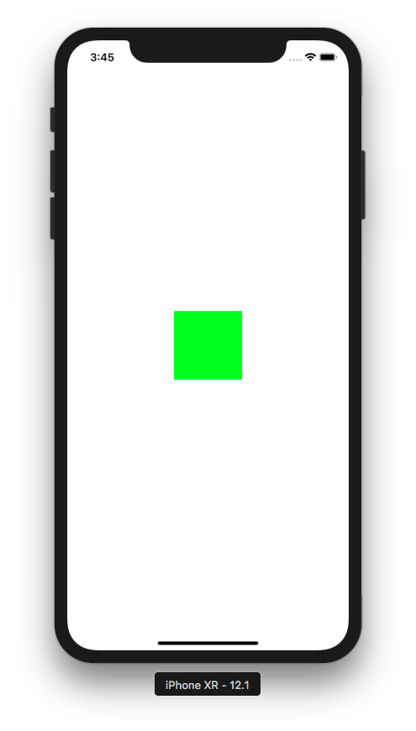

Tap the green view and you will get this animation.

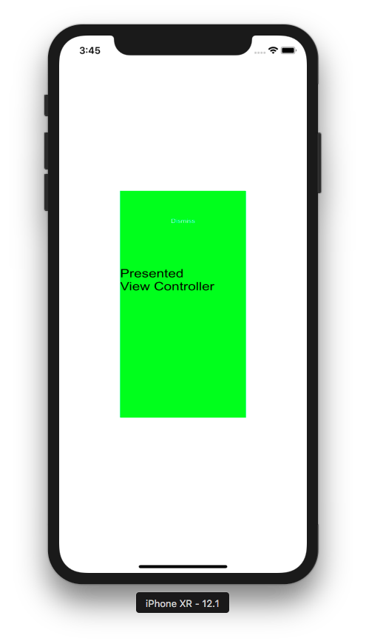

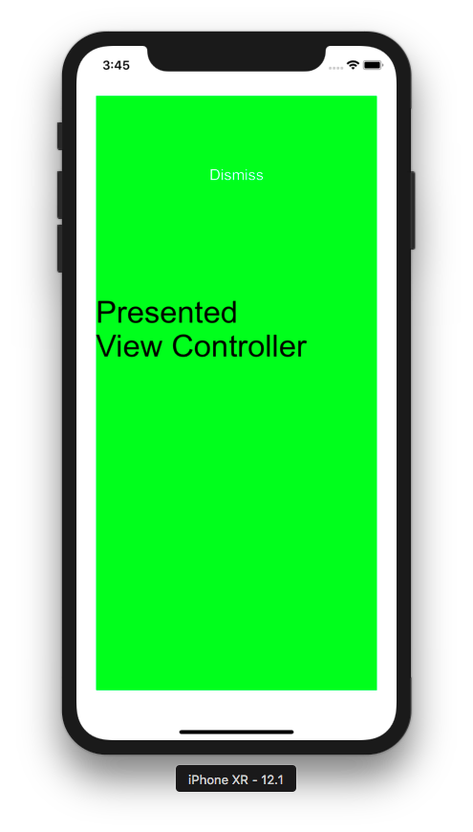

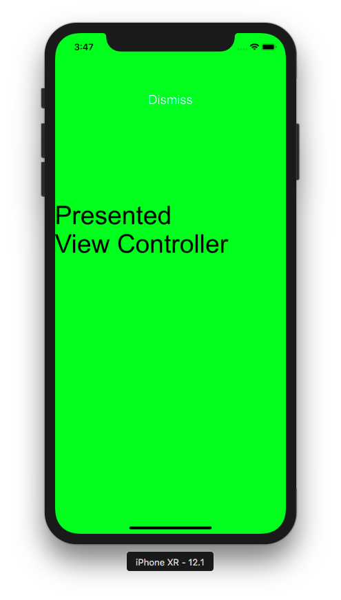

If you click “Dismiss” button, it will be shrunk.

Optional Reading

https://developer.apple.com/documentation/uikit/uiviewpropertyanimator
https://developer.apple.com/documentation/uikit/uiviewcontrolleranimatedtransitioning

Exercise

1. Recreate all previous examples but not with UIView.animate method. Use UIViewPropertyAnimator object.

