WebSocket

iOS 13 provides a way to connect to a websocket server with webSocketTask method.

App Transport Security Settings

We need to change the configuration of app everytime when we play with localhost instead of server with domain and HTTPS.

Edit info.plist. Add “App Transport Security Settings” key from “Information Property List” key. Then add “Allows Local Networking” key inside “App Transport Security Settings” key. The value of “Allows Local Networking” key is “YES”.

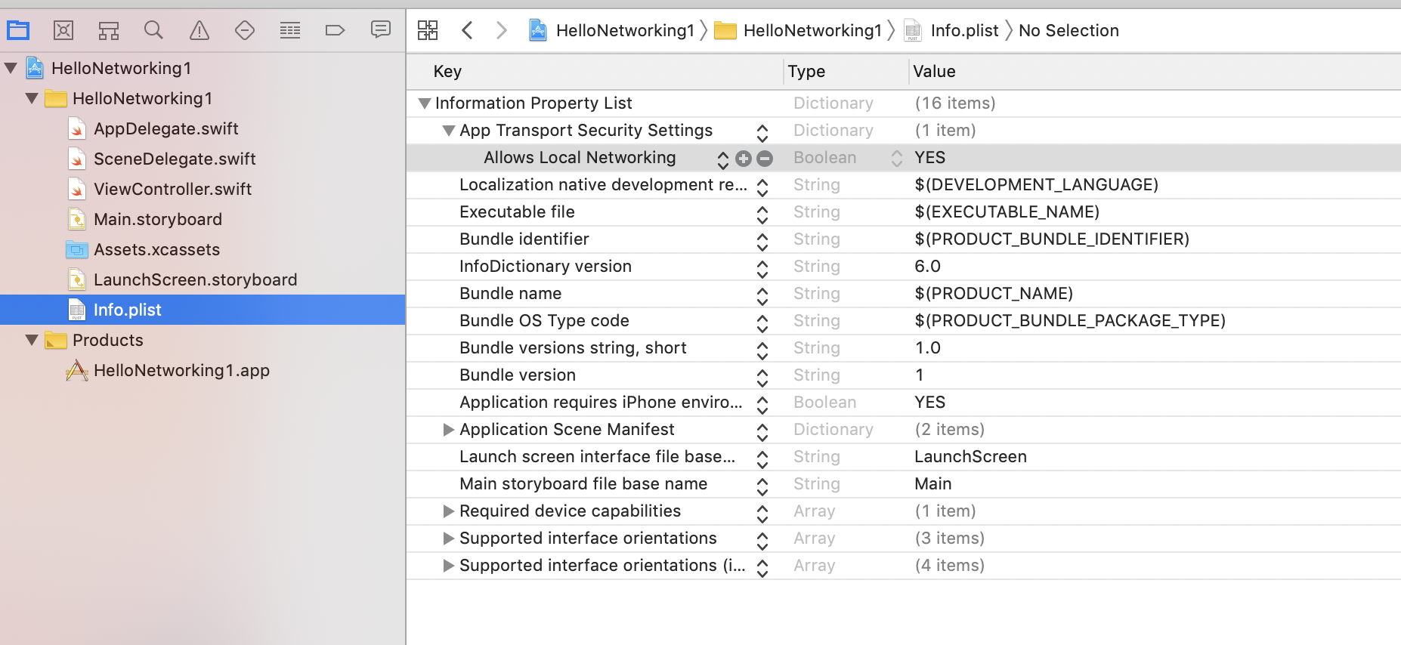
webSocketTask

Create a new application. Name it HelloWebSocket1.

Edit ViewController.swift.

Execute a method named “interact” in viewDidLoad method.

override func viewDidLoad() {
super.viewDidLoad()
// Do any additional setup after loading the view.

interact()
}

Create a method named “interact” inside ViewController class.

// https://appspector.com/blog/websockets-in-ios-using-urlsessionwebsockettask
// Code for backend is in Common/WebSocket/code/HelloWebSocket1
func interact() {
let url = URL(string: "ws://localhost:8765")!
let webSocketSession = URLSession.shared.webSocketTask(with: url)

let message = URLSessionWebSocketTask.Message.string("Hello World")
webSocketSession.send(message) { error in
print("Send message with WebSocket")
}

webSocketSession.receive { result in
switch result {
case .failure(let error):
print("Got error in receiving message: \(error)")
case .success(let message):
switch message {
case .string(let text):
print("Got message: \(text)")
case .data(let data):
print("Got data: \(data)")
@unknown default:
print("Fatal error. Got message which is not a string, not a binary.")
}
}
}

webSocketSession.resume()
sleep(1)
webSocketSession.cancel(with: .goingAway, reason: "Enough is enough".data(using: .utf8)!)
}

Create a websocket session.

let url = URL(string: "ws://localhost:8765")!
let webSocketSession = URLSession.shared.webSocketTask(with: url)

To send a message to a websocket server, we use “send” method. The message must be in Message object.

let message = URLSessionWebSocketTask.Message.string("Hello World")
webSocketSession.send(message) { error in
print("Send message with WebSocket")
}

To receive a message from a websocket server, we use “receive” method.

webSocketSession.receive { result in
switch result {
case .failure(let error):
print("Got error in receiving message: \(error)")
case .success(let message):
switch message {
case .string(let text):
print("Got message: \(text)")
case .data(let data):
print("Got data: \(data)")
@unknown default:
print("Fatal error. Got message which is not a string, not a binary.")
}
}
}

We can check whether the message is a success or a failure one. If it is a success case, we can filter whether the result is a string type or a data type.

Don’t forget to start this web socket session.

webSocketSession.resume()

To close the web socket session, we can execute its “cancel” method.

webSocketSession.cancel(with: .goingAway, reason: "Enough is enough".data(using: .utf8)!)

We need to run the server first in Common/WebSocket/code/HelloWebSocket1.

(virtual-environment) $ cd Common/WebSocket/code/HelloWebSocket1
(virtual-environment) $ python hello_websocket.py

If we ran the application, we would get this output.

Send message with WebSocket
Got message: Hello WorldHello World

The server would get this output.

Hello World

Exercise

