**Daily NBA**

Group member：

孟铃翔 2017040334

车子杰 2017040314

史新玮 2017060246

1. Project Description

The name of our app is Daily-NBA, so it’s easy to tell that this app is about NBA.

As we all know that basketball is one of the most popular sports around the world. And if you watch basketball a lot, you will definitely know and watch the NBA games. As a result, there is no doubt that the app is useful for many basketball fans in our daily lives. And the members of our group also watch the NBA in our daily lives, which inspires us to devote ourselves to developing the app. Because of the fact that we are NBA fans, we tried to make the statistics and details of the games, players and teams as comprehensive as possible. In other words, this app is also developed for ourselves for daily use.

The app consists of the basic functions of a usual app about NBA. You can check the results of the games which are happening or have already happened with the detailed statistics of the players and teams. It’s also available to view news. And for the detailed use of the app, you can see further in the document.

1. 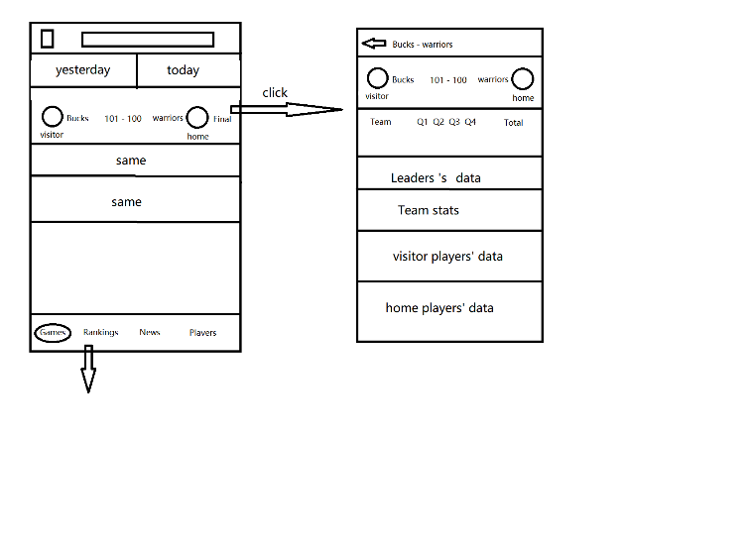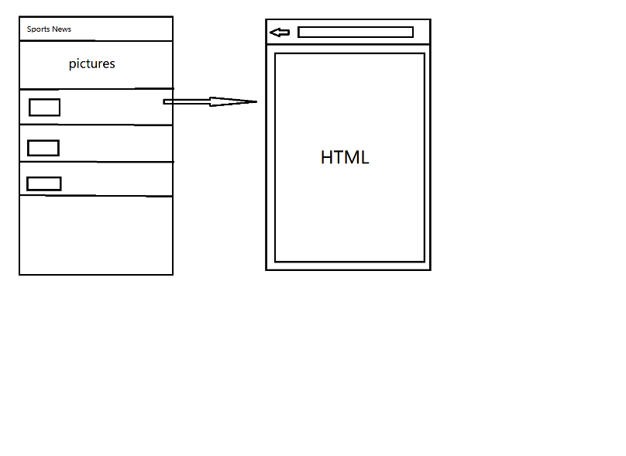Project Design

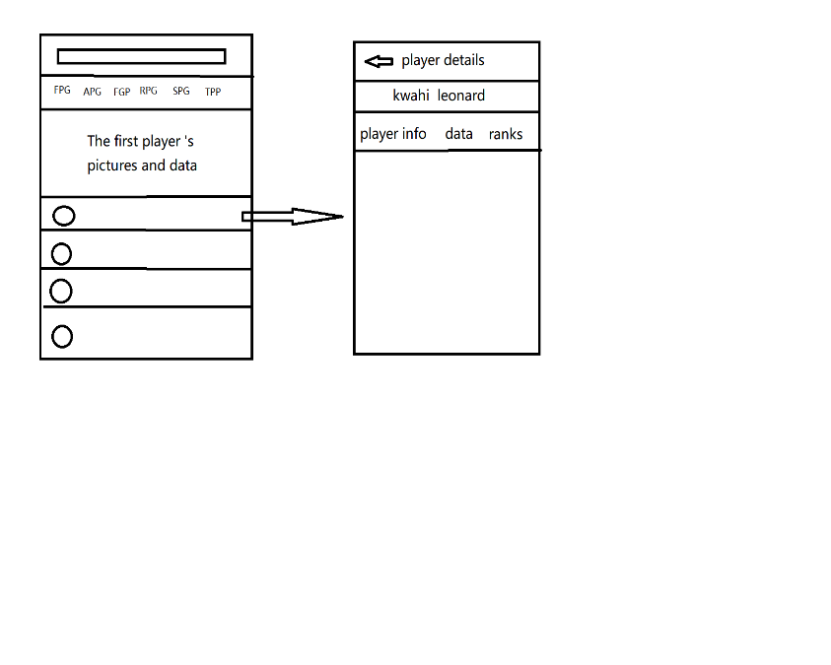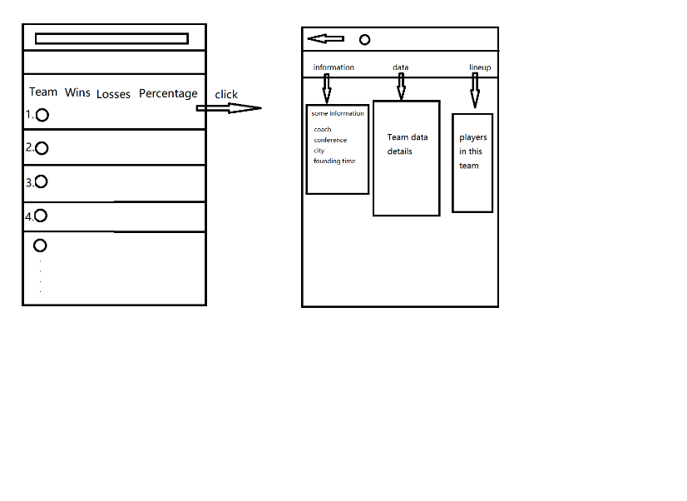

As basketball fans, in our daily life, we always need to check the result of the games we are interested in and the detailed statistics of the players. So it crossed our mind that we can develop an app for ourselves and show the components in our own favorite way. It is very useful for a lot of students in university.

As is said before, our project is divided into four parts: games, rankings, web and players. Each part was joined by the “Material-Bottom-Tab-Navigation” component. Roughly every screen contains a basic home page and another page of details. You can click and see the details. Each of the four pages we have mentioned above features a search bar, which is designed for users to search information they need.

Though the functions may seem simple, but it took us a lot of time to search relative information. For example, we used the react-navigation to construct our whole app. And each page contains several layers of pages with the navigators nested in other navigators. We need to find out how to use those navigators correctly and pass arguments into a sub-navigator. We also looked for ways to make our whole layout to be as good-looking as possible, including some special colors, some useful third-class components like react-native-elements. Another thing we have to search is the API we need to use in the app. Fortunately we found the API of NBA on GitHub. And the addresses we used are all stored in the JavaScript file in the folder assets/address.js. In addition to the whole layout, we also searched the algorithms to judge the input in the search bars. For example, how to predicate if the date input is correct or if the player name the users entered really exists. So we actually did a lot of job to improve our app.

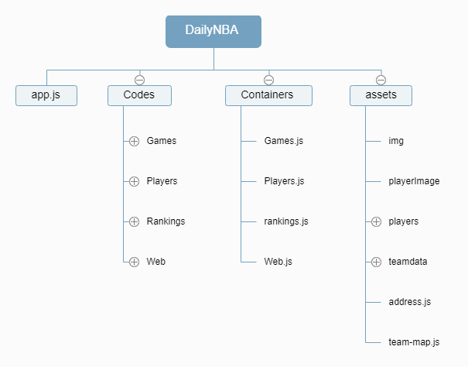

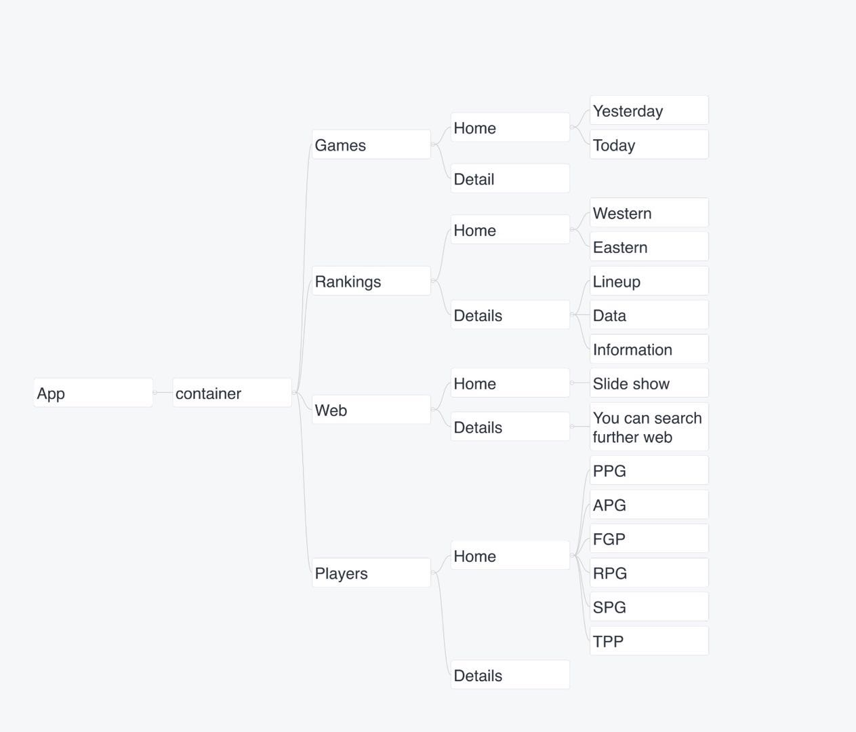

1. Application Instruction

The navigation of our app consists of four parts. One is about game information from the NBA, which is also the home page of the app. The other three are players, team-rankings and News.

In games page, you can see the information of yesterday’s and today’s games. If you touch one particular game you are interested in, there will be more details about the game. What’s more, if you want to know previous games, you can get their details in the search box or date-picker at the top of the home page. As for the rankings screen, you can see the eastern ranking and western rankings. If you are interested in a specific team, you can touch the team’s name. Or you can find your favorite team by entering the name or location of the team in the search bar. You’ll see almost all the statistics about your team in this season. Through another button on the navigation bar, you can see some best players in the season. You can see all kinds of NBA stats leaders there. Like other screens, you can get more details by touching the players’ name or searching their names in the search box. In the end, we also have a sports news page, which contains a lot of current live sports news. You can pull it down to get a refresh. When you click a news item, you can see the details. What’s more, there is a search box at the top of the page. You can get to the corresponding website by typing in the url.

1. Developing Notes

In the process of our development, there are two difficult parts which caused a lot of trouble to us. The first part is how to pass parameters in the navigations. In our app, we use navigators many times and we even used nested navigators, which means we have to pass the parameters into sub-components a lot of times. But the navigators’ parameters are associated with many other small tricks. So we surf the Internet for help. After reading many other project source code, we finally solve this problem by using the object consisting of Screen-props. And the second part is the object. Because our data is required from the API, so the object have multiple levels. And when we use the object, there are always some mistakes of “undefined”. We asked other developers of React-Native for advice on the Internet. And finally we found a solution using ‘&&’ operator to solve this problem.

1. Testing

The functions our app have are all available. There are three search bars in our app. The first bar is to search one day’s games. If there are no games, the screen will display ‘No games on current date’. If you search the future day, and there are no game details, so the screen will display the “The game hasn’t started yet”. It also has the function to judge if the date input is legal. It will alert “Wrong date!” if you have mistakenly input a wrong date. The second bar is to search the team detail. If you input a wrong name, it will pop up an alert ‘the wrong team name’. The third search bar is to search player name. If you input a wrong name, it will alert ‘wrong player name’.

1. Issues

Though we’ve spent a lot of time developing our own app, there are still some bugs existing. For example:

* In the news part, there is something wrong with the size of html, but we did not find a possible solution. And you can not see some news’ details because of the API.
* In the search bar of the news details, users have to add [https://](NULL) to be the prefix of the url.
* Our usage of the layout is not compatible with all kinds of Android devices. In some devices there will be something with the size of the pages and texts.
* Some of our pages can be refreshed using the pull-to-refresh method, but we end up realizing the function in only one page.

1. Extra Credits

Apart from the basic functions, we used some small tricks that we assume worth some extra credits.

* In the navigation component, we used create-material-bottom-tab-navigator to realize different performance of switching tabs.
* Optimized the memory use by using react-native-screens.
* Search bars of app can judge numerous normal mistakes, which makes our app stronger in daily use.
* If there are no data of games on some dates, or before the game starts, we will show notifications on the screens to users.

1. Conclusion and future improvement

Looking back on the app, we have realized a lot of functions to make this project as comprehensive as possible. We can show the statistics from almost every angle, and the data can be synchronized thanks to the API we used. Apart from the function, we made a combination of colors successfully in our opinion.

But there are still some enhancements to be made. At first, we need to make our app adaptable to all kinds of Android devices, which can be made if we use dimensions of the device to regulate the sizes of the components. Second, if possible, we are about to find another API to show some NBA news. There are too many problems in the current API.