**Algorithms**

Homework 3: 2023-12753 EunSu Yeo

1. Environment & Setting

|  |  |
| --- | --- |
| **Environment** | **Setting** |
| OS | Window 11 |
| Code Editor | Visual Studio Code (Linux VM) |
| Language | Python |
| Version | 3.11.5 |

1. Program description

This assignment presents two methods to solve the N-Queens problem on a board containing holes. Queens cannot be placed on blocked cells, and blocked cells also obstruct attack paths.

I made the two functions as the below explanation.

**solve_iterative_nqueens**: Iterative backtracking using an explicit stack.

**solve_recursive_nqueens**: Classical recursive backtracking.

Each function is implemented with 6 steps.

**Shared steps**:

**① Hole Board Initialization**: Create a 2D boolean array hole_board and mark blocked cells as True. The initial empty cells are marked as False.

**② Column-to-Holes Mapping**: Build column_to_holes, a dictionary mapping each column to the list of blocked rows. This is used to generate the segments.

**③ Segment Construction**: Split each column’s rows into contiguous segments without holes, storing tuples (col, row_start, row_end) in segments.

**④ Hole-Blocking Helpers**: Functions to check if any hole lies strictly between two cells on the same row, column, or diagonal.

**⑥ Backtracking**: Place one queen per segment, ensuring no two queens attack each other unless a blocking hole lies between them. This step works differently in 2 functions.

A more detailed explanation of step 6 is like below.

**a) solve_iterative_nqueens**

# Stack Frame: [segment_index, placed_queens_count, part, next_row_to_try]

stack: List[List[int]] = [[0, 0, 0, 0]]

while stack:

frame = stack[-1]

segment_index, placed_count, part, next_row = frame

# All queens placed: count a solution

if placed_count == n:

solution_count += 1

# Exit the current stack

stack.pop()

continue

# Out of segments or not enough segments left: break

# Do not go deeper, some kind of pruning added for performance

if segment_index == total_segments or total_segments - segment_index < n - placed_count:

stack.pop()

continue

# Part 1: skip current segment

if part == 0:

# change to Part 2

frame[2] = 1

stack.append([segment_index + 1, placed_count, 0, 0])

continue

# Part 2-1: initialize row scanning for placement

if part == 1:

col, row_start, row_end = segments[segment_index]

# Set the next row to try search for queen placement to row_start

frame[3] = row_start

# change part not to go back to Part 1 or 2-1

frame[2] = 2

# Part 2-2: scan rows in the segment to place queen

col, row_start, row_end = segments[segment_index]

placed = False

while frame[3] <= row_end:

# Get the current row to try

row = frame[3]

# Increse the row to try for the next iteration

frame[3] += 1

# Check if the current position is blocked by a hole

if hole_board[row][col]:

continue

# Check if the current position is safe to place a queen

safe = True

for i in range(placed_count):

qr, qc = queen_rows[i], queen_cols[i]

# Check if the current position is blocked by a hole or attaked by another queen

if qr == row and not is_hole_between_in_row(row, qc, col):

safe = False

break

if qc == col and not is_hole_between_in_col(col, qr, row):

safe = False

break

if abs(qr - row) == abs(qc - col) and not is_hole_between_in_diag(qr, qc, row, col):

safe = False

break

if not safe:

continue

# Place the queen at (r, col)

queen_rows[placed_count] = row

queen_cols[placed_count] = col

# Update the stack frame to reflect the placement

stack.append([segment_index + 1, placed_count + 1, 0, 0])

placed = True

break

# If no queen was placed in the current segment, pop the stack

if not placed:

stack.pop()

The iteration with backtracking looks like the code above. This consists of 3 steps.

# Check if the current position is safe to place a queen

safe = True

for i in range(placed_count):

qr, qc = queen_rows[i], queen_cols[i]

# Check if the current position is blocked by a hole or attaked by another queen

if qr == row and not is_hole_between_in_row(row, qc, col):

safe = False

break

if qc == col and not is_hole_between_in_col(col, qr, row):

safe = False

break

if abs(qr - row) == abs(qc - col) and not

is_hole_between_in_diag(qr, qc, row, col):

safe = False

break

if not safe:

continue

# Place the queen at (r, col)

queen_rows[placed_count] = row

queen_cols[placed_count] = col

# Update the stack frame to reflect the placement

stack.append([segment_index + 1, placed_count + 1, 0, 0])

placed = True

break

# If no queen was placed in the current segment, pop the stack

if not placed:

stack.pop()

**① Solution Counting**: Increment solution count when placed_count == n

**② Pruning**: Immediately backtrack if the remaining segments cannot accommodate the remaining queens.

**③ Brach with placing Queen**: This step can be finished in 2 parts. Because we can put more than 1 queen in the row where there is a hole, there might be a row that has no queen. To find all possible situations we can think of 2 possible situations of each segment.

**Part 1**: Skip the current segment. (which means this segment is empty)

**Part 2**: Initialize row scanning within the current segment. Attempt queen placement row by row. (place the queen in this segment)

With this process we can find all possible cases.

**b) solve_recursive_nqueens**

# Backtracking function

def backtrack(seg_idx: int, placed: int):

"""

Recursive backtracking function to place queens.

Args:

seg_idx (int): Segment index to consider for placement.

placed (int): Number of queens already placed.

"""

nonlocal solution_count

# All queens placed: count a solution

if placed == n:

solution_count += 1

return

# Out of segments or not enough segments left: break

# Do not go deeper, some kind of pruning added for performance

if seg_idx == total_segments or total_segments - seg_idx < n - placed:

return

# Part 1: Skip segment

backtrack(seg_idx + 1, placed)

# Part 2: Try placing queen in segment

col, row_start, row_end = segments[seg_idx]

for row in range(row_start, row_end + 1):

# Check if the current position is blocked by a hole

if hole_board[row][col]:

continue

safe = True

for i in range(placed):

# Check if the current position is blocked by a hole or attacked by another queen

qr, qc = queen_rows[i], queen_cols[i]

if qr == row and not is_hole_between_in_row(row, qc, col):

safe = False

break

if qc == col and not is_hole_between_in_col(col, qr, row):

safe = False

break

if abs(qr - row) == abs(qc - col) and not

is_hole_between_in_diag(qr, qc, row, col):

safe = False

break

if not safe:

continue

# Place the queen at (row, col)

queen_rows[placed] = row

queen_cols[placed] = col

backtrack(seg_idx + 1, placed + 1)

This recursive function with backtracking looks like the code above.

This also consists of 3 steps.

**① Solution Counting**: Increment solution count when placed == n

**② Pruning**: Immediately stop if the remaining segments cannot accommodate the remaining queens.

**③ Brach with placing Queen**: This step can be finished in 2 parts. Because we can put more than 1 queen in the row where there is a hole, there might be a row that has no queen. To find all possible situations we can think of 2 possible situations of each segment.

**Part 1**: Skip the current segment. (which means this segment is empty) This is simply implemented by calling backtrack(seg_idx + 1, placed).

**Part 2**: Initialize row scanning within the current segment. Attempt queen placement row by row. (place the queen in this segment) if placed call the next process.

With this process we can find all possible cases.

As the explanation of the 2 functions, I optimized both functions for maximum speed in the following way.

**Segment-based Placement**: By splitting each column into hole-free segments, we avoid iterating over all cells in blocks and only attempt placements in valid intervals.

**Early Pruning**: Before descending into deeper recursion or stack frames, we check if the number of remaining segments is sufficient for the remaining queens, cutting off unproductive branches.

**Unified Hole Test**: We consolidated row, column, and diagonal hole checks into a single helper (is_hole_between), minimizing duplicate code and inlining overhead.

1. Result Analysis

To compare the running time of two functions, I ran the code with different n and different number of holes. The running time of each functions looks like the below.

① Iterative nqueens

The unit of the running time is milli second.

|  |  |  |  |  |  |  |
| --- | --- | --- | --- | --- | --- | --- |
| n  hole | 5 | 6 | 7 | 8 | 9 | 10 |
| 1 | 0.215381 | 0.611286 | 2.720083 | 13.818505 | 70.000980 | 402.379844 |
| 2 | 0.354235 | 1.142960 | 7.071381 | 34.769333 | 194.428268 | 1253.863809 |
| 3 | 0.249805 | 1.059964 | 6.943373 | 79.996963 | 479.538017 | 3554.985622 |

② Recursive nqueens

|  |  |  |  |  |  |  |
| --- | --- | --- | --- | --- | --- | --- |
| n  hole | 5 | 6 | 7 | 8 | 9 | 10 |
| 1 | 0.126734 | 0.484077 | 2.301283 | 11.965761 | 58.088262 | 355.790514 |
| 2 | 0.285872 | 0.991806 | 5.853652 | 29.031568 | 168.348853 | 1120.658214 |
| 3 | 0.141657 | 0.784948 | 5.602550 | 71.945306 | 407.898721 | 3173.842826 |

③ Number of outputs for each case I put.

|  |  |  |  |  |  |  |
| --- | --- | --- | --- | --- | --- | --- |
| n  hole | 5 | 6 | 7 | 8 | 9 | 10 |
| 1 | 10 | 32 | 110 | 371 | 1386 | 5151 |
| 2 | 9 | 50 | 294 | 1561 | 8115 | 37235 |
| 3 | 16 | 111 | 275 | 3774 | 25678 | 217844 |

Now let’s analysis the results.

① Different n with 1 hole

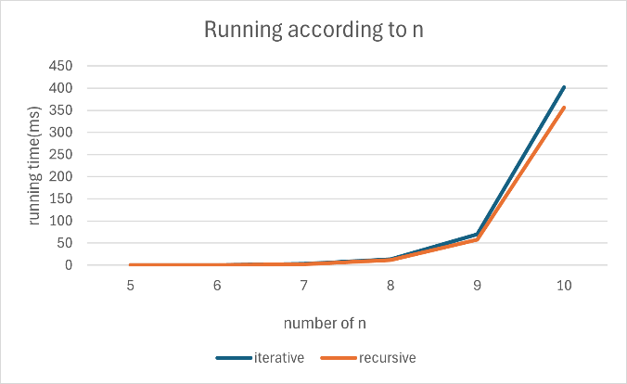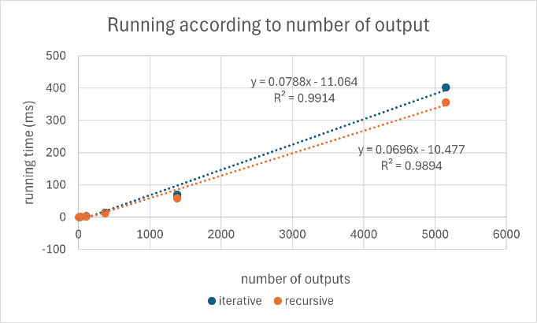

② Different n with 2 holes

텍스트, 스크린샷, 그래프, 라인이(가) 표시된 사진

AI가 생성한 콘텐츠는 부정확할 수 있습니다.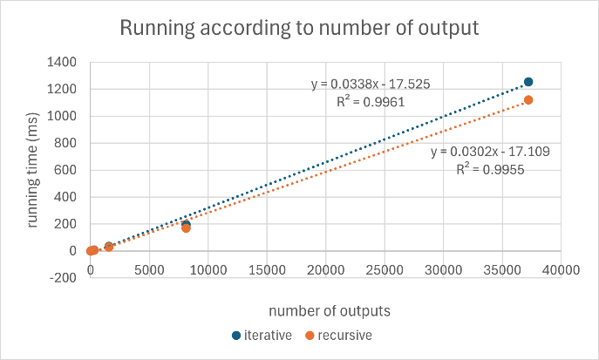

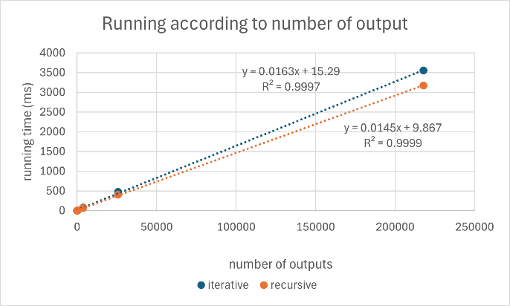텍스트, 스크린샷, 그래프, 라인이(가) 표시된 사진

AI가 생성한 콘텐츠는 부정확할 수 있습니다.③ Different n with 3 holes

With the results above, we can see that the running time of functions are linear to the total number of outputs. Also, the recursive version is slightly faster than the iterative version.

This difference may be from the structure of stack frame management. In the iterative version we track the state by using ‘part’ flag, also including segment_index, placed_count, next_row, adding extra condition checks. But the recursive version does not have those extra condition checks.

Also, the difference may be from the local-variable access cost. In the iterative version, the function frequently performs nested list indexing (stack[-1], then frame[...]). But in the recursive version, accesses go directly on the call stack, which is much faster than Python’s sequence indexing.

Due to these reasons recursive version of backtracking nqueen problems may work faster than the iterative version.