|  |  |
| --- | --- |
| **Assignment Case** |  |
| COMP7116 | COMP7116001 | COMP7116016 | MATH6168  Computer Vision |
| **Computer Science** | **Example Case** |
| ***Valid on*** *-* | **Revision 00** |

## Soal

*Case*

**Snacks**

It’s 7 o’clock in the night, and all of your friends came to your house. Your good friend **Wilbert**, wants to have his **favourite** **snack** on your house, but he **forgot** **what kind of snacks that he likes**, but **he still got the picture that he taken on his cellphone of his favourite snacks**. To find his favourite snacks, you are **required** **to match the picture that Wilbert has taken with the ones that available** on online. You as his best friend want to help Wilbert. So please **create a program** to help him know which **snacks** is his favorite. The program will use a **feature matching** to compare between the picture of the **favorite snacks** and **all photos of snacks available on the online shop**. After the program finished comparing all the snacks photos, the program also needs to **show the best match** **between all comparisons.**

* **Dataset Description**

The dataset consists of:

* + **Target Snacks Image**

Picture of the target snacks to be found. It is located on **target** **directory**.

* + **Snacks Images**

Pictures of all the snacks in the online shop. It is located on **assets** **directory**.

* **Dataset Preprocessing**

Before being processed, all images (including target image) must be **converted to grayscale** and **preprocessed using Median Blur** with the following specifications:

* + **ksize**: **3**
* **Feature Detection**

After being processed, the program will detect the feature for all pictures using **SIFT algorithm**.

* **Feature Matching**

The target mascot image will be matched with all the mascot images using **FLANN algorithm**. All matching results will be compared based on **Iowe’s theory** and the best result will be shown. The result must be shown in **full RGB colors** as shown in figure 1.

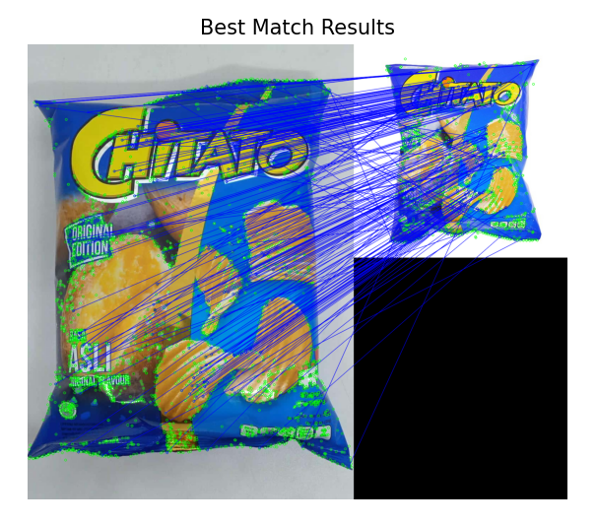

Figure 1. Best Match Result

References:

Target:

1. <https://kliktobuy.com/wp-content/uploads/2018/01/8353-2.jpg>

Testcases:

1. <https://images.tokopedia.net/img/cache/100-square/VqbcmM/2021/9/24/26b4bb43-6bbe-4100-aa4f-03761d2ea761.jpg.webp?ect=4g>
2. <https://arti-assets.sgp1.digitaloceanspaces.com/megaswalayan/products/454dfb94-f1e1-4d7c-81aa-8293961ba7b7.jpg>
3. <https://arti-assets.sgp1.digitaloceanspaces.com/megaswalayan/products/85e9367e-739f-4850-ac2b-ab9a9507b75e.jpg>
4. <https://arti-assets.sgp1.digitaloceanspaces.com/dutalia/products/a1c3877f-0f9f-4b1f-ac61-91e130145725.jpg>
5. <https://arti-assets.sgp1.digitaloceanspaces.com/megaswalayan/products/5267f1ba-6c0e-4b66-8a3d-1ad44ea4ffcd.jpg>
6. <https://arti-assets.sgp1.digitaloceanspaces.com/megaswalayan/products/0e639575-08ba-4f0c-b013-902a9f7cb853.jpg>