**Number 1. Describe**

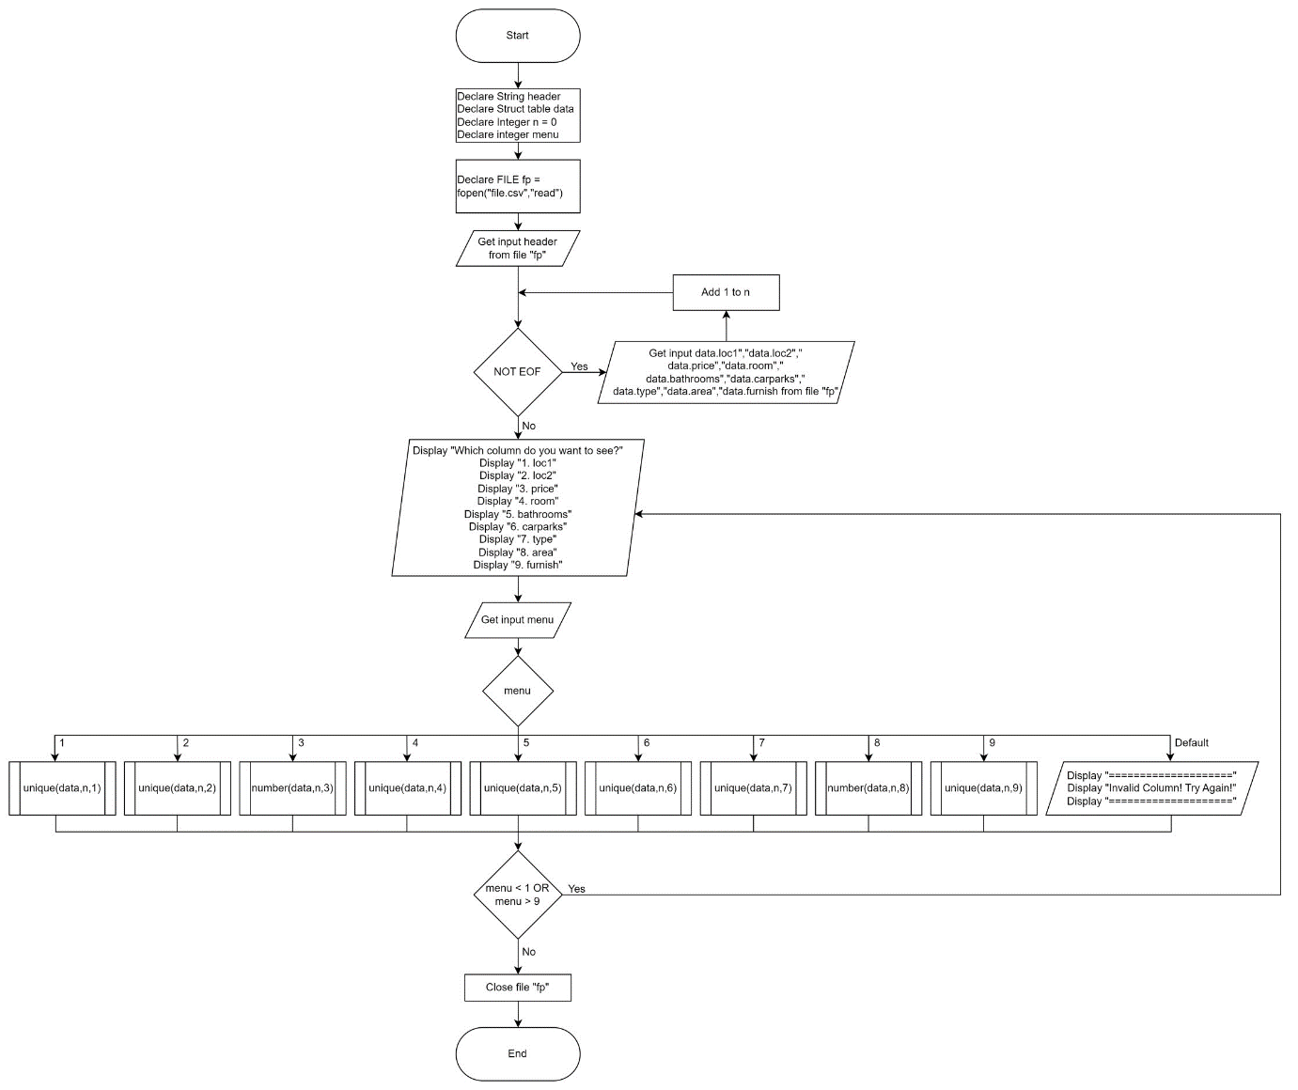

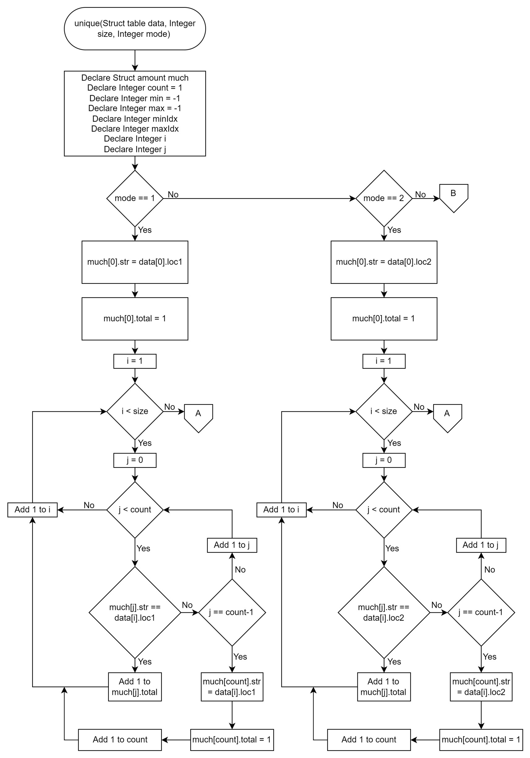

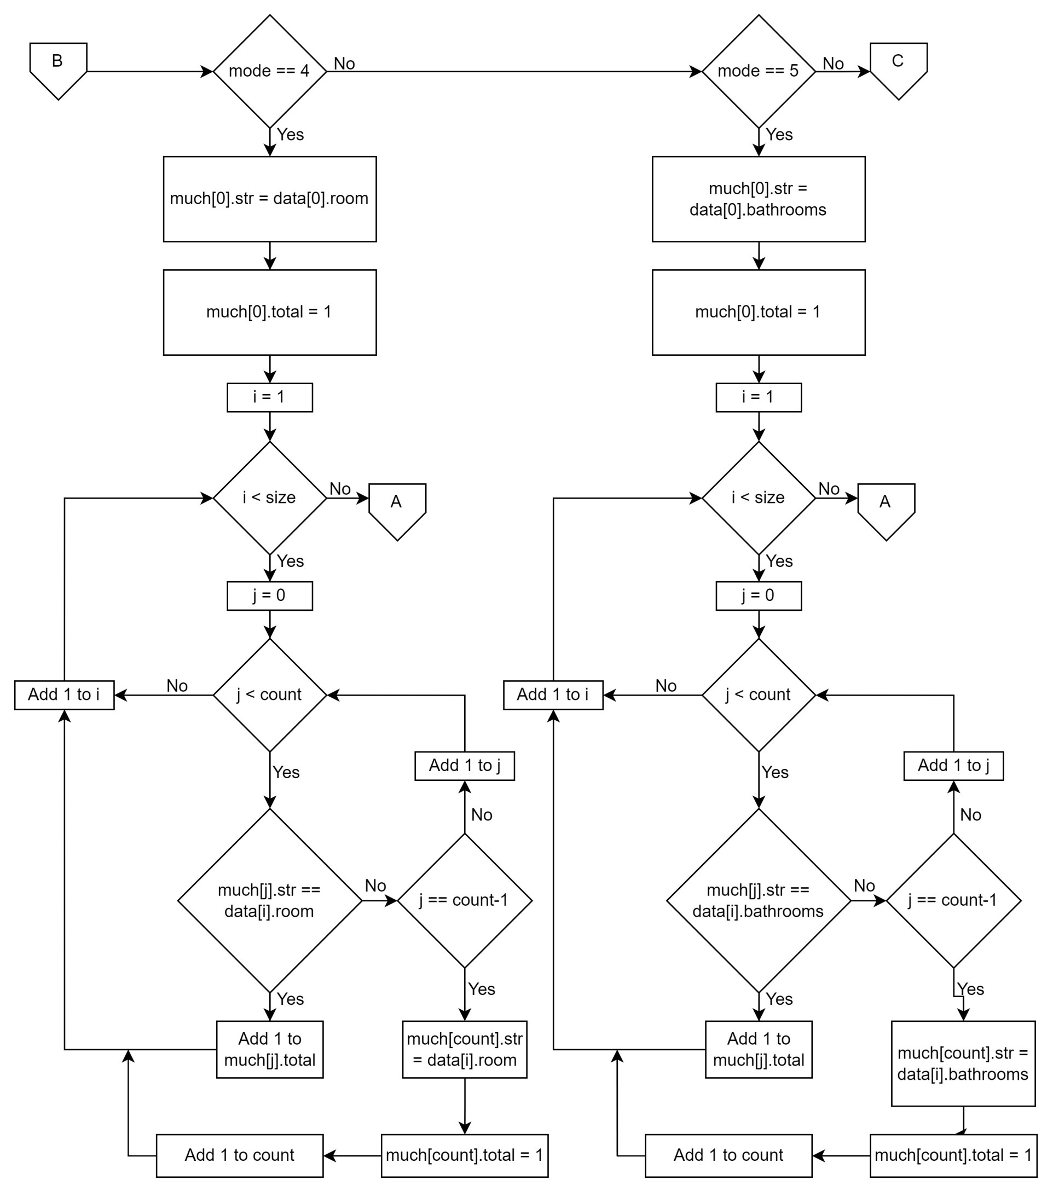

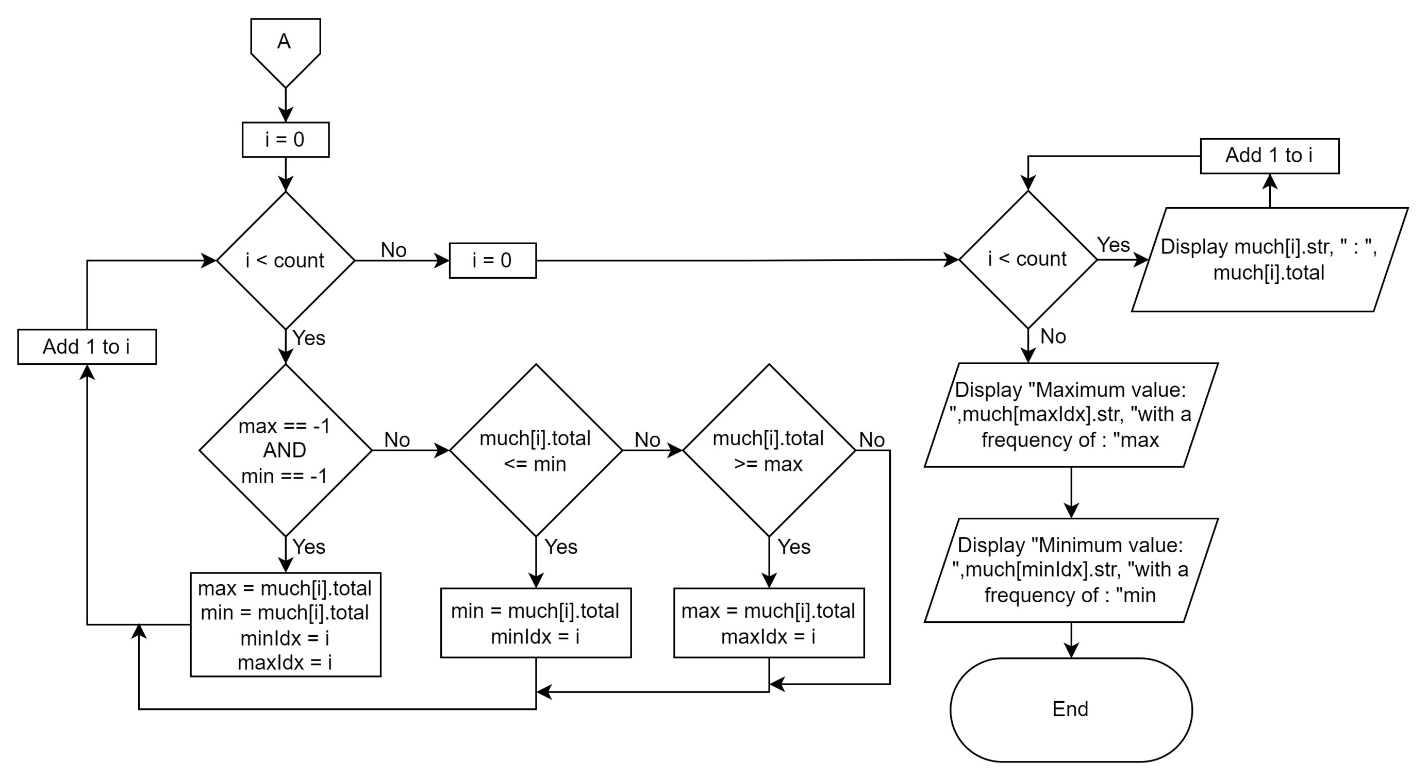

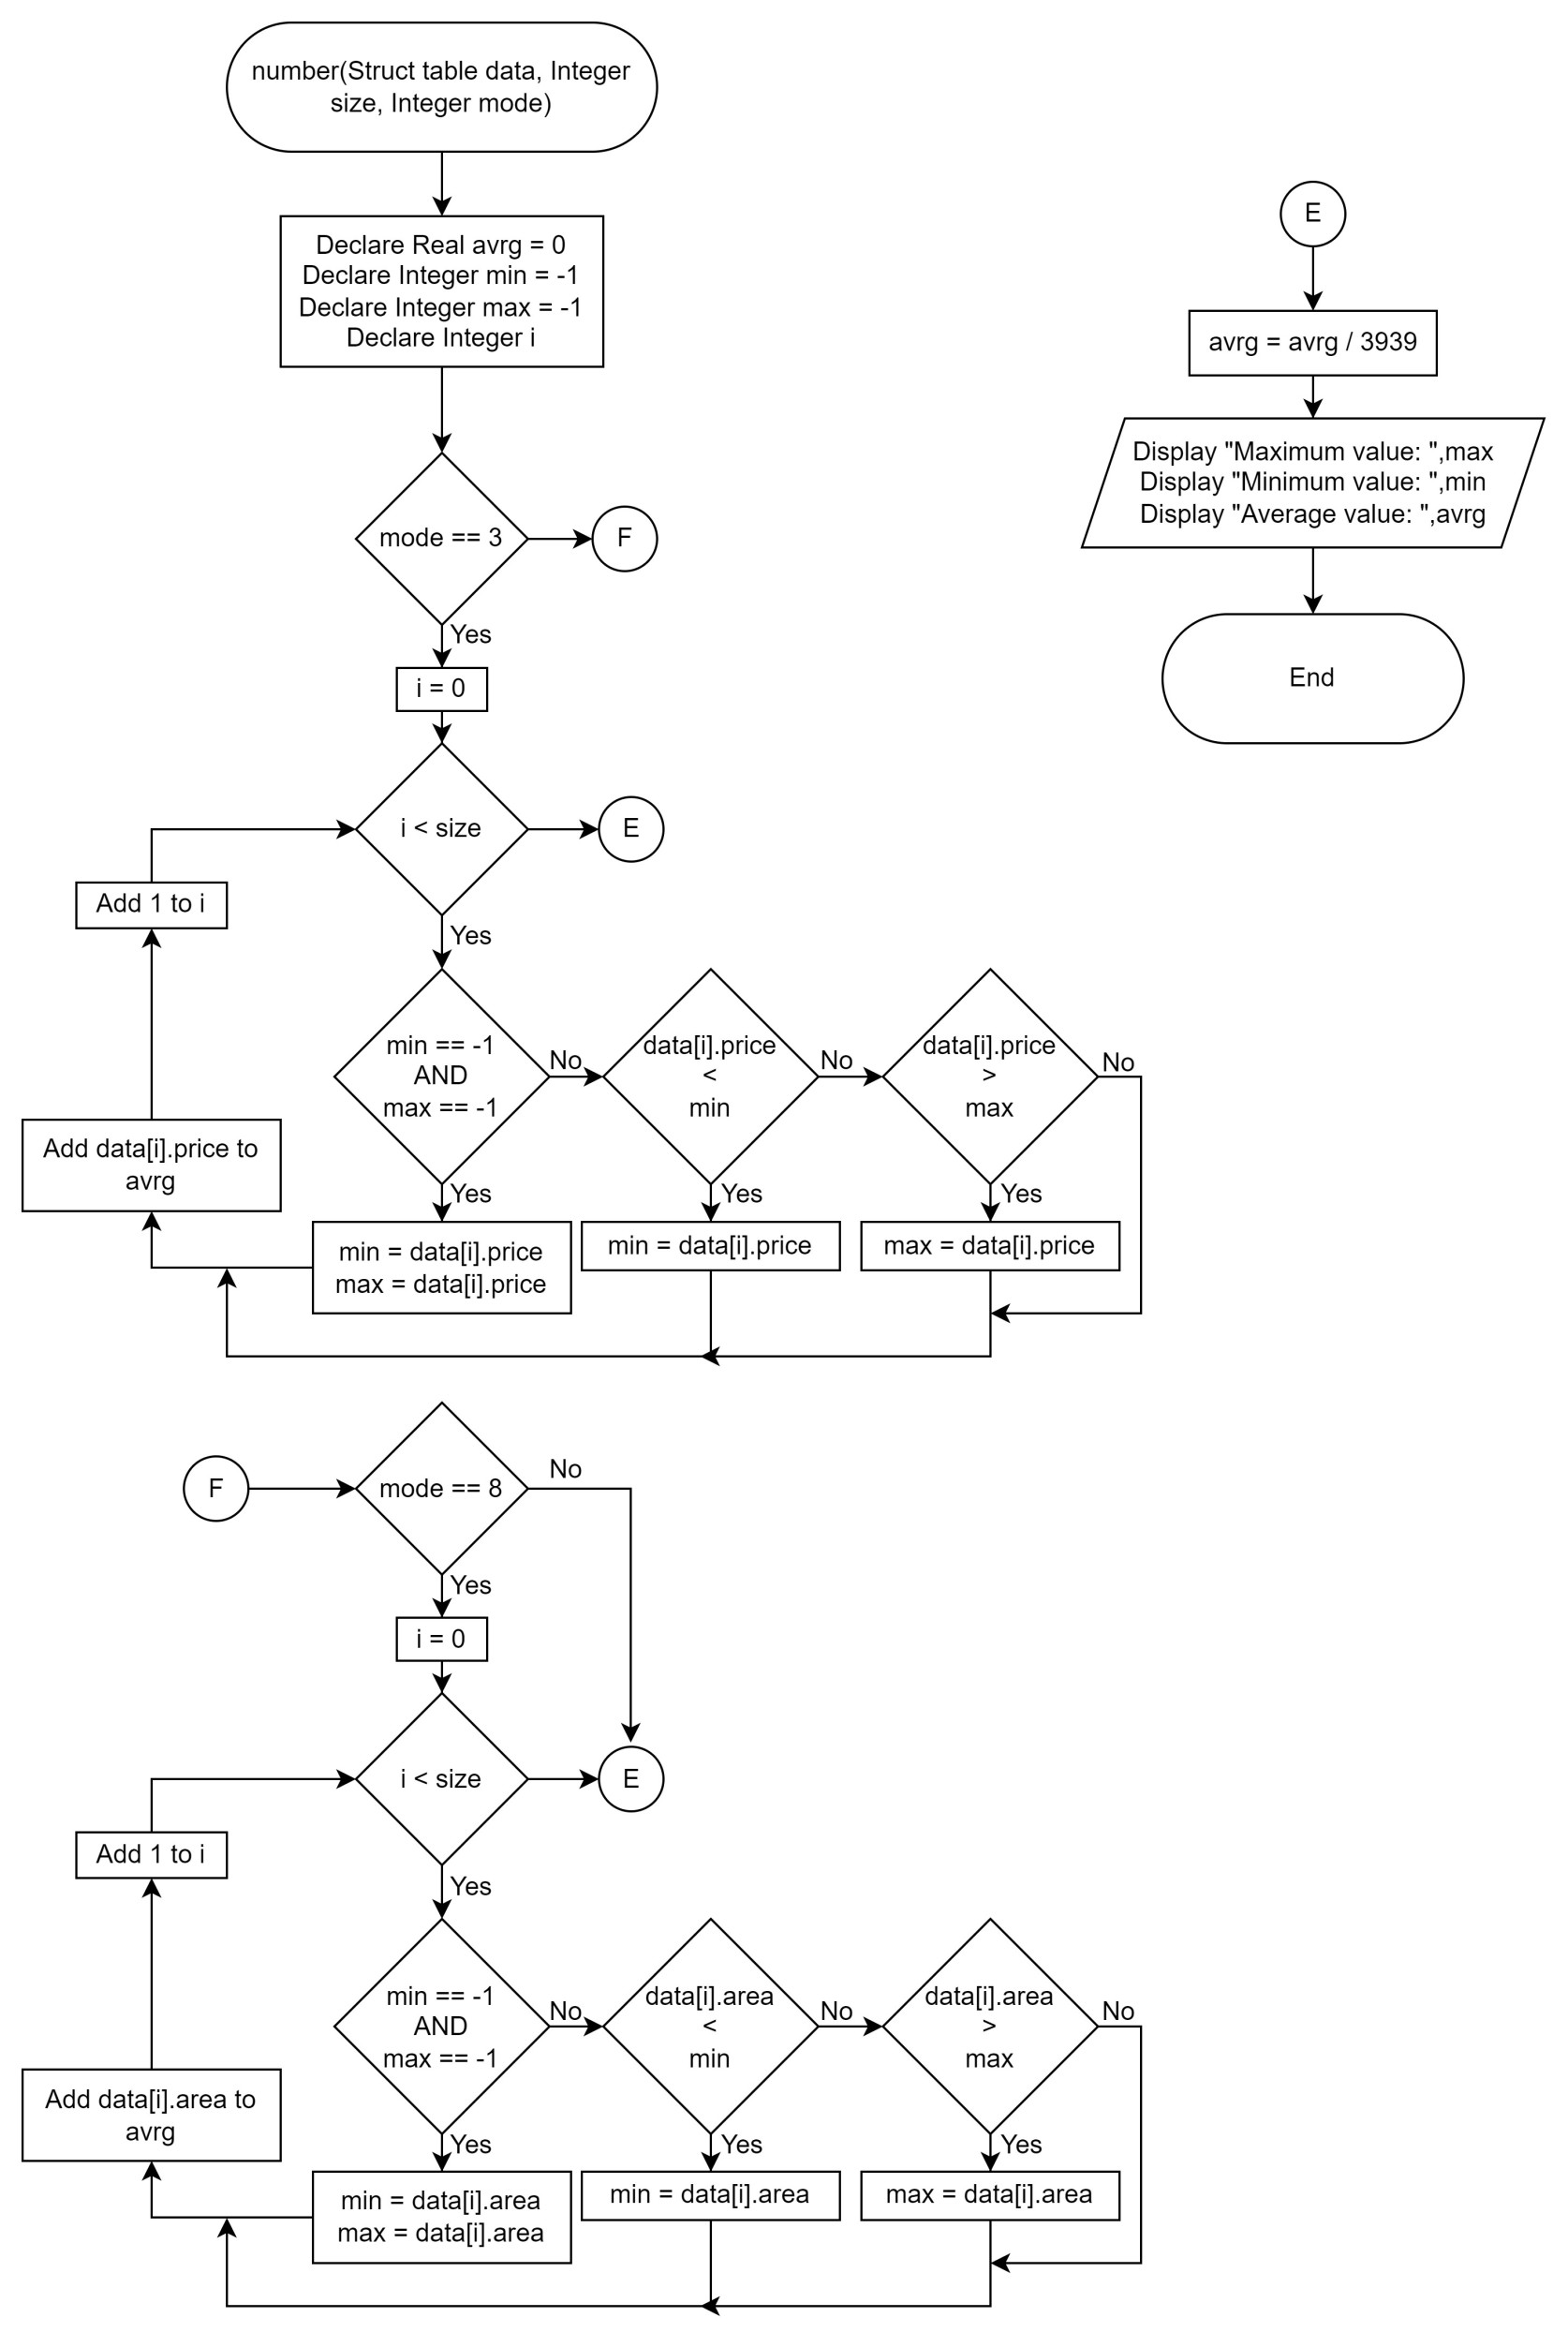

**Number 2. Search**

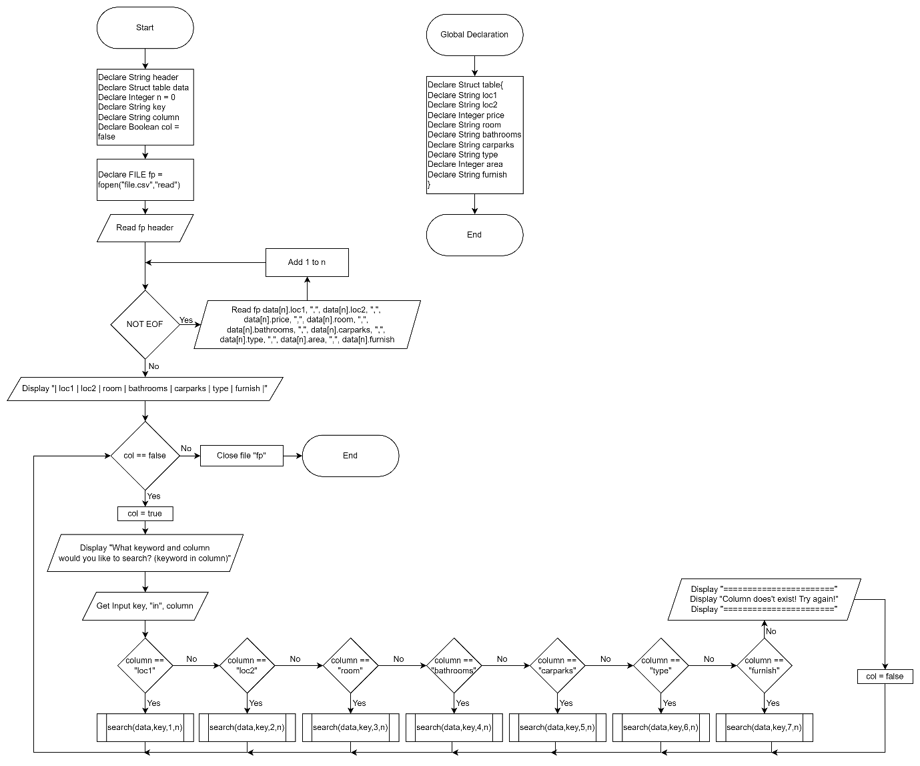

**Number 3. Sorting**

