
QuecPython Electricity Meter Solution Design Guide
LTE Standard/LPWA Module Series
Version: 1.0.0
Date: 2023-03-24
Status: Preliminary

At Quectel, our aim is to provide timely and comprehensive services to our customers. If you require any assistance, please contact our headquarters:

Quectel Wireless Solutions Co., Ltd.
Building 5, Shanghai Business Park Phase III (Area B), No.1016 Tianlin Road, Minhang District, Shanghai 200233, China
Tel: +86 21 5108 6236
Email: info@quectel.com

Or our local offices. For more information, please visit:
http://www.quectel.com/support/sales.htm.

For technical support, or to report documentation errors, please visit:
http://www.quectel.com/support/technical.htm.
Or email us at: support@quectel.com.

Legal Notices
We offer information as a service to you. The provided information is based on your requirements and we make every effort to ensure its quality. You agree that you are responsible for using independent analysis and evaluation in designing intended products, and we provide reference designs for illustrative purposes only. Before using any hardware, software or service guided by this document, please read this notice carefully. Even though we employ commercially reasonable efforts to provide the best possible experience, you hereby acknowledge and agree that this document and related services hereunder are provided to you on an “as available” basis. We may revise or restate this document from time to time at our sole discretion without any prior notice to you.

Use and Disclosure Restrictions
License Agreements
Documents and information provided by us shall be kept confidential, unless specific permission is granted. They shall not be accessed or used for any purpose except as expressly provided herein.

Copyright
Our and third-party products hereunder may contain copyrighted material. Such copyrighted material shall not be copied, reproduced, distributed, merged, published, translated, or modified without prior written consent. We and the third party have exclusive rights over copyrighted material. No license shall be granted or conveyed under any patents, copyrights, trademarks, or service mark rights. To avoid ambiguities, purchasing in any form cannot be deemed as granting a license other than the normal non-exclusive, royalty-free license to use the material. We reserve the right to take legal action for noncompliance with abovementioned requirements, unauthorized use, or other illegal or malicious use of the material.
Trademarks
Except as otherwise set forth herein, nothing in this document shall be construed as conferring any rights to use any trademark, trade name or name, abbreviation, or counterfeit product thereof owned by Quectel or any third party in advertising, publicity, or other aspects.

Third-Party Rights
This document may refer to hardware, software and/or documentation owned by one or more third parties (“third-party materials”). Use of such third-party materials shall be governed by all restrictions and obligations applicable thereto.

We make no warranty or representation, either express or implied, regarding the third-party materials, including but not limited to any implied or statutory, warranties of merchantability or fitness for a particular purpose, quiet enjoyment, system integration, information accuracy, and non-infringement of any third-party intellectual property rights with regard to the licensed technology or use thereof. Nothing herein constitutes a representation or warranty by us to either develop, enhance, modify, distribute, market, sell, offer for sale, or otherwise maintain production of any our products or any other hardware, software, device, tool, information, or product. We moreover disclaim any and all warranties arising from the course of dealing or usage of trade.

Privacy Policy
To implement module functionality, certain device data are uploaded to Quectel’s or third-party’s servers, including carriers, chipset suppliers or customer-designated servers. Quectel, strictly abiding by the relevant laws and regulations, shall retain, use, disclose or otherwise process relevant data for the purpose of performing the service only or as permitted by applicable laws. Before data interaction with third parties, please be informed of their privacy and data security policy.

Disclaimer
- We acknowledge no liability for any injury or damage arising from the reliance upon the information.
- We shall bear no liability resulting from any inaccuracies or omissions, or from the use of the information contained herein.
- While we have made every effort to ensure that the functions and features under development are free from errors, it is possible that they could contain errors, inaccuracies, and omissions. Unless otherwise provided by valid agreement, we make no warranties of any kind, either implied or express, and exclude all liability for any loss or damage suffered in connection with the use of features and functions under development, to the maximum extent permitted by law, regardless of whether such loss or damage may have been foreseeable.
- We are not responsible for the accessibility, safety, accuracy, availability, legality, or completeness of information, advertising, commercial offers, products, services, and materials on third-party websites and third-party resources.
Copyright © Quectel Wireless Solutions Co., Ltd. 2023. All rights reserved.

About the Document

Revision History
Version | Date | Author | Description
- | 2023-03-24 | Pawn ZHOU | Creation of the document
1.0.0 | 2023-03-24 | Pawn ZHOU | Preliminary

Contents
About the Document 3
Contents 4
Table Index 5
Figure Index 6
1 Introduction 7
1.1. Applicable Modules 7
2 System Framework 8
2.1. Hardware Framework 8
2.2. Software Framework 8
3 Key Components 10
3.1. EventMesh 11
3.2. RFC1662ProtocolResolver 12
3.3. ConfigStoreManager 15
3.4. NetStateManager 16
3.5. TcpModeManager 17
3.6. MainUartManager 18
3.7. DeviceInfoManager 20
3.8. FtpOtaManager 21
4 System Initialization Process 23
5 Business Process 25
6 Example 26
7 Appendix References 29

Table Index
Table 1: Applicable Modules 7
Table 2: Terms and Abbreviations 29

Figure Index
Figure 1: Hardware Framework 10
Figure 2: Software Framework 11
Figure 3: UML Class Diagram of Project Software Code 12
Figure 4: EventMesh Middleware Flow Diagram 13
Figure 5: Electricity Meter System Initialization Flowchart 25
Figure 6: Business Flowchart 27

- Introduction

This document describes the design framework of the electricity meter in QuecPython solution, including software and hardware framework, key component features, system initialization process, business process and feature examples, so that you can quickly know about the overall framework and features of the electricity meter in QuecPython solution.

  - Applicable Modules

Table 1: Applicable Modules
Module Family | Module
LTE Standard | EC21-AUX
LTE Standard | EC200U Series
LTE Standard | EC600U Series
LTE Standard | EG915U Series
LTE Standard | EC200A Series
NB-IoT | BC25 Series
LPWA | BG95 Series
LPWA | BG77

- System Framework

  - Hardware Framework

The hardware system framework is as follows:
- The module supports some hardware interfaces, such as SIM card, GPIO and UART.
- The module communicates with MCU through the UART.
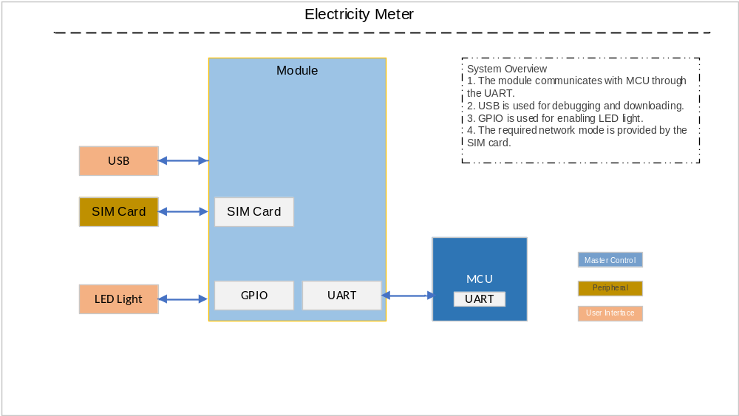Figure 1: Hardware Framework

  - Software Framework

The hardware system framework is as follows:
- The application layer is used for processing core business of the meter and parsing uplink and downlink data.
- EventMesh, the event processor, implements the triggering and execution of business features through event subscription and publication.
- After receiving external events or data, the module calls the event or data processor registered by upper-layer through EventMesh to process the event or data.
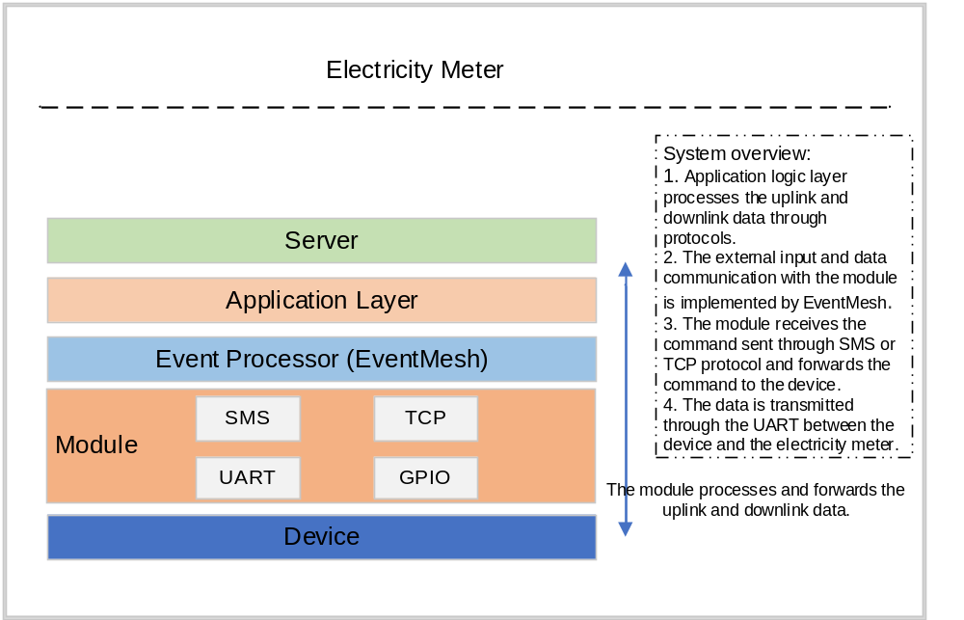
Figure 2: Software Framework

- Key Components

The following is a UML class diagram, which describes the dependency and inheritance relationships among the component objects in the project software code. In the figure, the electricity meter is the top-level object and is associated with the dependent component objects. It is shown as follows:
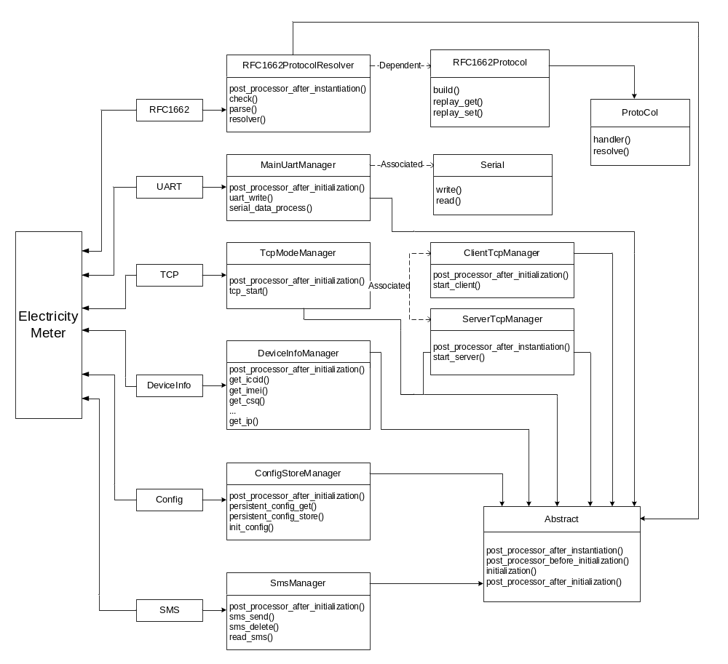Figure 3: UML Class Diagram of Project Software Code

  - EventMesh

- Feature description
EventMesh is a dynamic infrastructure middleware. In the event-driven architecture, an event refers to a change, operation or observation in the system. Then a notification is generated and used in the various processor functions that respond to the event.

- Principle
The flow principle of middleware EventMesh is shown as follows. Please consult Quectel Technical Support for details.
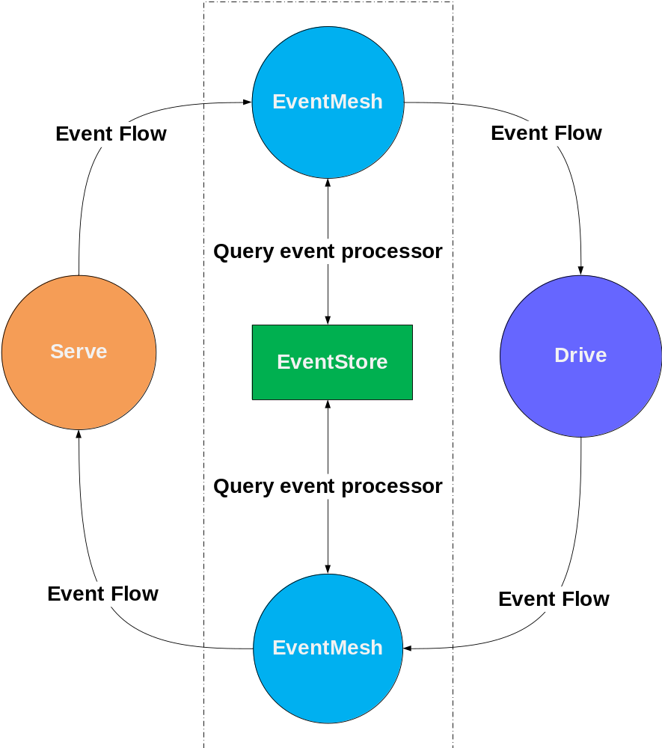
Figure 4: EventMesh Middleware Flow Diagram
NOTE
The upper-level business feature and the actual execution function communicate through EventMesh, and all events in the system come from EventStore (event pool). Please note that EventStore in the EventMesh framework is used for storing user registration events. EventStore is not reflected in the external interface of the code, so EventStore in the above figure is only used for showing the basic implementation principle of EventMesh.

- Subscribe to an event
import EventMesh

def test(event, msg):
return msg

# Function for subscribing to an event
EventMesh.subscribe("test_event", test)

- Publish an event
import EventMesh

def test(event, msg):
return msg

# Function for subscribing to an event
EventMesh.subscribe("test_event", test)

# Publish an event
EventMesh.publish("test_event", "OK")

  - RFC1662ProtocolResolver

- Feature description
RFC1662ProtocolResolver is used for parsing the RFC1662 protocol data transmitted in the business and unpack and package the data.

- Principle
- Instantiate RFC1662ProtocolResolver. It is shown as follows.
rfc1662_protocol_resolver = RFC1662ProtocolResolver()
rfc1662_protocol_resolver.add_support_protocol(ModuleToELEMeterProtocol()) \
.add_support_protocol(ELEMeterToModuleProtocol()) \
.add_support_protocol(EventReporterProtocol()) \

Add the protocol command event to the List array. It is shown as follows.
def add_support_protocol(self, prot):
self.support_col_list.append(prot)
return self

- When the RFC1662 protocol parsing class function is initialized, the added protocol command event MODE and the corresponding handler function are registered in the EventMesh. Having received the MODE command, the device publishes the registered protocol command event through EventMesh.
def post_processor_after_instantiation(self):
for prot in self.support_col_list:
EventMesh.subscribe(prot.MODE, prot.handler)
for proc in self.support_cmd_list:
EventMesh.subscribe(proc.MODE, proc.handler)
EventMesh.subscribe("RFC1662-PROTOCOL-EXECUTE", self.execute)

The example of MODE command function is as follows:
class ELEMeterToModuleProtocol(ProtoCol):
"""electricity meter to module"""
MODE = 0x2300

def handler(self, topic, msg: RFC1662Protocol):
print("ELEMeterToModuleProtocol {} {}".format(hex(topic), msg))
if msg.info().param_id() in [CONSEM_COMMON_RFC1662_PARAM_ID.LQI]:
EventMesh.publish(msg.info().param_id(), msg)
else:
EventMesh.publish(msg.info().request_id(), msg)

- Check the format of the matched protocol frame after the data sent by the electricity meter to the module is received.

The fixed format of RFC1662 protocol frame is as follows:
class RFC1662ProtocolResolver(Abstract):
HEADER = 0x7e
ADDRESS = 0xFF
CONTROL = 0x03

Check whether the protocol frame meets the format:
def check(self, data):
return data[0] == self.HEADER and data[1] == self.ADDRESS and data[2] == self.CONTROL

- Check whether the data can be parsed and then the parsing status and the parsed end are returned
def parse(self, data):
# HEADER/1b ADDRESS/1b CONTROL/1b RFC_PROTO/2b INFO_LEN/2b
_i = 0
if len(data) < 7:
# The data length is less than 7 bytes and does not meet the requirement of fixed frame header.
return False, _i
if data[0] == self.HEADER and data[1] == self.ADDRESS and data[2] == self.CONTROL:
# Skip the protocol directly and 2 bytes is occupied.
_i += 7
info_len = struct.unpack(">H", data[5:7])[0]
# The size of packet is equal to 7 bytes + length + (fcs/2b + 0x7e)
_i = _i + info_len + 3
# The size of the packet data is smaller than that of the entire packet data and the packet is incomplete.
if len(data) < _i:
return False, 0
else:
return True, _i
else:
return False, _i

- Data is parsed by the build function in RFC1662Protocol class method. Build function reads data sequentially by using struct method according to the protocol frame format, and save the parsed data in RFC1662Protocol class attribute respectively. After the data is parsed, RFC1662Protocol class is returned to the function caller as an object.

Call build function:
@classmethod
def resolver(cls, data):
rfs: RFC1662Protocol = RFC1662Protocol.build(data)
rfs.print()
EventMesh.publish(rfs.protocol(), rfs)
return None

Method of parsing data:
@classmethod
def build(cls, data):
rfc_proto = RFC1662Protocol()
if data[0] == cls.HEADER and data[1] == cls.ADDRESS and data[2] == cls.CONTROL:
# Read the protocol and read two bytes starting from the third byte.
rfc_proto.increment(3)
rfc_proto.set_protocol(struct.unpack_from("<H", data[rfc_proto.position():rfc_proto.position() + 2])[0])
rfc_proto.increment(2)

# Continue to read the length in info area
info_len = struct.unpack(">H", data[rfc_proto.position():rfc_proto.position() + 2])[0]
rfc_proto.set_info_len(info_len)
rfc_proto.increment(2)

# Continue to read the commands in info area
info_cmd = struct.unpack("B", data[rfc_proto.position():rfc_proto.position() + 1])[0]
rfc_proto.set_info_cmd(info_cmd)
rfc_proto.increment(1)

RFS object is returned to the function caller which calls build function. After the data is parsed, all data information is included in RFS object and the event will be published through EventMesh to find the corresponding handler function to execute the command.
//The command is registered when the class function is initialized. For details, see the description in step 2.
EventMesh.publish(rfs.protocol(), rfs) = EventMesh.publish(MODE command function, rfs)

  - ConfigStoreManager

- Function description
This component is used for storing device parameters persistently and providing methods for reading and writing file data.

- Principle
- When the class method is initialized, it automatically checks whether the profile exists. If the profile does not exist, a JSON file is created automatically. After the file is created successfully, the default parameter is written to the profile automatically. If the profile exists, it automatically checks whether there are parameters added to the default parameters and updates the profile if there is any new parameter.

- The class method registers two events through EventMesh, reading file and updating file.
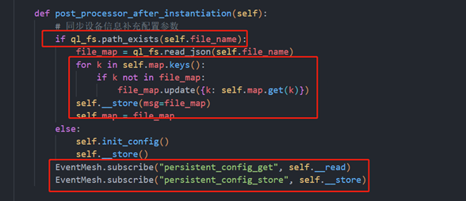
Check whether the profile exists.
Check whether there are parameters added to the default parameters and update the profile if there is any new parameter.
Register two events: reading file and updating file.
Synchronize the device information and supplement the configuration parameters.

  - NetStateManager

- Feature description
This component is used for module network initialization and network state management.

- Principle
When the class method is initialized, it waits for the device to complete the network registration, registers the network change callback function, and determines the device's network registration status based on the return value of CheckNet API. After the network is registered, TCP connection is enabled through event publication. If the network registration fails, the device will try to register the network again. For details about CheckNet API, you can refer to https://python.quectel.com/wiki.
def wait_net_connect(self, timeout):
"""Wait for network registration"""

apn_info_list = EventMesh.publish("persistent_config_get","apn")
self.log.info("apn:{},user:{},password:{}".format(apn_info_list[0], apn_info_list[1], apn_info_list[2]))
ret = self.__net.setApn(1,0,apn_info_list[0],apn_info_list[1],apn_info_list[2],0,0)
if ret == -1:
self.log.info("set apn failed.")
else:
self.log.info("set apn success.")
self.log.info("wait net connect")
EventMesh.publish("net_led", [600, 600, 0, 0])
self.check_net.poweron_print_once()
stagecode, subcode = self.check_net.wait_network_connected(timeout)
if stagecode == 3:
if subcode == 1:
# Successful network registration/Successful dial-up
self.log.info("network register success")
self.log.info("datacall connect success.")
EventMesh.publish('get_sim_iccid')
EventMesh.publish('get_csq')
EventMesh.publish('get_ip')
EventMesh.publish('tcp_start')
EventMesh.publish("net_led", [75, 3000, 0, 1])
else:
# Network registration failed and dial up manually.
self.log.info("check net connect:network register success")
self.log.info("check net connect:data call failed.")
self.net_data_call()

  - TcpModeManager

- Feature description
This component is used for managing two TCP connection modes (client and server) supported by the device, and enables TCP connection according to the corresponding mode after the successful registration.

- Principle
- The class method enables TCP event through EventMesh registration. After the network is registered successfully, the class method enables TCP connection through publishing the TCP event.
def post_processor_after_initialization(self):
EventMesh.subscribe("tcp_start", self.tcp_start)
self.__tcp_mode = EventMesh.publish("persistent_config_get", "svr")

- TCP start method will enable the client or server according to the TCP mode of the profile.
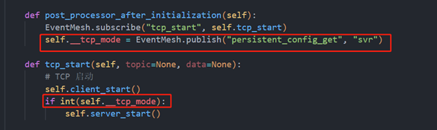
Read TCP mode of the profile.
Enable the client or server according to the TCP mode.

  - MainUartManager

- Function description
This component is used for initializing the UART of the device, sending, receiving and processing serial port message data.

- Principle
- The module and the electricity meter communicate through the UART over RFC1662 protocol, so the UART object needs to be equipped with a protocol parser for data parsing.

main_uart_manager = MainUartManager()
main_uart_manager.add_resolver(at_cmd_resolver)\
.add_resolver(rfc1662_protocol_resolver)

def add_resolver(self, rsl):
self.resolver_list.append(rsl)
return self

- When the class function is initialized, it creates a UART object, through which it can read and write the UART and enable the UART the feature of writing data to the UART.
def post_processor_after_instantiation(self):
for rsl in self.resolver_list:
rsl.post_processor_after_instantiation()
self.uart = Serial(self.no, self.bate, self.data_bits, self.parity, self.stop_bits, self.flow_control)
EventMesh.subscribe("uart_write", self.write)

- Start a task of monitoring UART data. When the data sent by the meter is received by the UART, the parser is matched automatically to determine whether the data can be parsed. If the data can be parsed, the data is returned through the parser. When the returned data is received, the parsed result of the data is packaged and returned to the electricity meter according to the protocol.
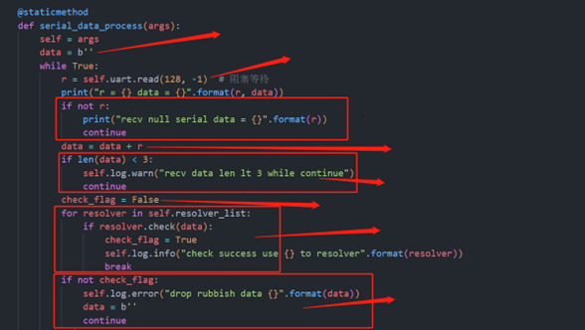
Initial data and half a packet of the data may be saved.
Blocked and wait for the UART to callback data.
No data and continue to parse data.
Check whether the last data is received completely. If it is not complete, add the second data to the first data. Check whether data length is longer than 3 bytes and data is saved in the last step.
Check the flag.
Traverse all supported parser. Continue to parse data after parser is matched.
If no parser is matched, the data is invalid.

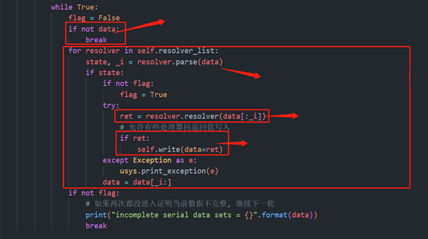
Check whether there is data. End the operation and continue to wait for the data to be parsed if there is no data.
Traverse all supported parser. Check whether the data can be parsed and the parsing status and the parsed end are returned
Process and parse data
If there is the returned value, it is returned by the UART.

  - DeviceInfoManager

- Feature description
This component is used for obtaining some basic information of the device, such as the IMEI of the device, ICCID of the SIM card.

- Principle
- When the class function is initialized, the function for obtaining device information is registered as an event through EventMesh, and you can use the class function directly by publishing the event.
def post_processor_after_instantiation(self):
# Register events
EventMesh.subscribe("get_sim_iccid", self.get_iccid)
EventMesh.subscribe("get_device_imei", self.get_imei)
EventMesh.subscribe("get_fw_version", self.get_device_fw_version)
EventMesh.subscribe("get_csq", self.get_csq)
EventMesh.subscribe("get_ip", self.get_ip)

- Call the SIM API to obtain the ICCID of the current SIM card.
def get_iccid(self, event=None, msg=None):
"""Query ICCID"""
if self.__iccid == "":
msg = sim.getIccid()
if msg != -1:
self.__iccid = msg
self.log.info("ccid:{}".format(self.__iccid))
else:
self.log.warn("get sim iccid fail, please check sim")
return self.__iccid

- For more information about device information API, you can refer to https://python.quectel.com/wiki.

  - FtpOtaManager

- Feature description
This component is used for updating the application code through FTP remotely.

- Principle
- Address information, user name and password of server are required for remote upgrade of FTP.
- When the class method is initialized, FTP remote upgrade detection event is registered through EventMesh. And the method is called by publishing the event.
def post_processor_before_initialization(self):
EventMesh.subscribe("ftp_upgrade", self.download)

- Establish a connection with the FTP server. After the connection is established successfully, you can log in to the FTP server to obtain the upgrade package path.
def download(self, topic, msg):
from ftplib import FTP
self.ftp = FTP()
connect_res = self.ftp.connect(host=self.host, port=self.port)
print("ftp.connect(): %s" % connect_res)
login_res = self.ftp.login(user=self.user, passwd=self.passwd)
print("ftp.login(): %s" % login_res)
fp = open(self.parent_dir + self.file_name, "wb")
server_path = self.ftp.pwd()

- Download the upgrade package to the module. After the download is completed, the upgrade package needs to be decompressed. Set the upgrade flag after the decompression, and the upgrade is completed after the device is rebooted.
def download(self, topic, msg):
from ftplib import FTP
self.ftp = FTP()
connect_res = self.ftp.connect(host=self.host, port=self.port)
print("ftp.connect(): %s" % connect_res)
login_res = self.ftp.login(user=self.user, passwd=self.passwd)
print("ftp.login(): %s" % login_res)
fp = open(self.parent_dir + self.file_name, "wb")
server_path = self.ftp.pwd()
res = self.ftp.retrbinary("RETR " + server_path + "/" + self.file_name, fp.write)
msg = "Download %s to device %s."
if res.startswith('226 Transfer complete'):
print(msg % (self.file_name, "success"))
app_fota_download.app_fota_pkg_mount.mount_disk()
fd = FileDecode(self.parent_dir + self.file_name, parent_dir=app_fota_download.get_updater_dir())
fd.unzip()
stat = fd.unpack()
if stat:
fd.update_stat()
fd.set_flag()
# Upgrade is completed after the device is rebooted.
print("success")
else:
print("failed")
pass
else:
print(msg % (self.file_name, "falied"))
fp.close()

- System Initialization Process

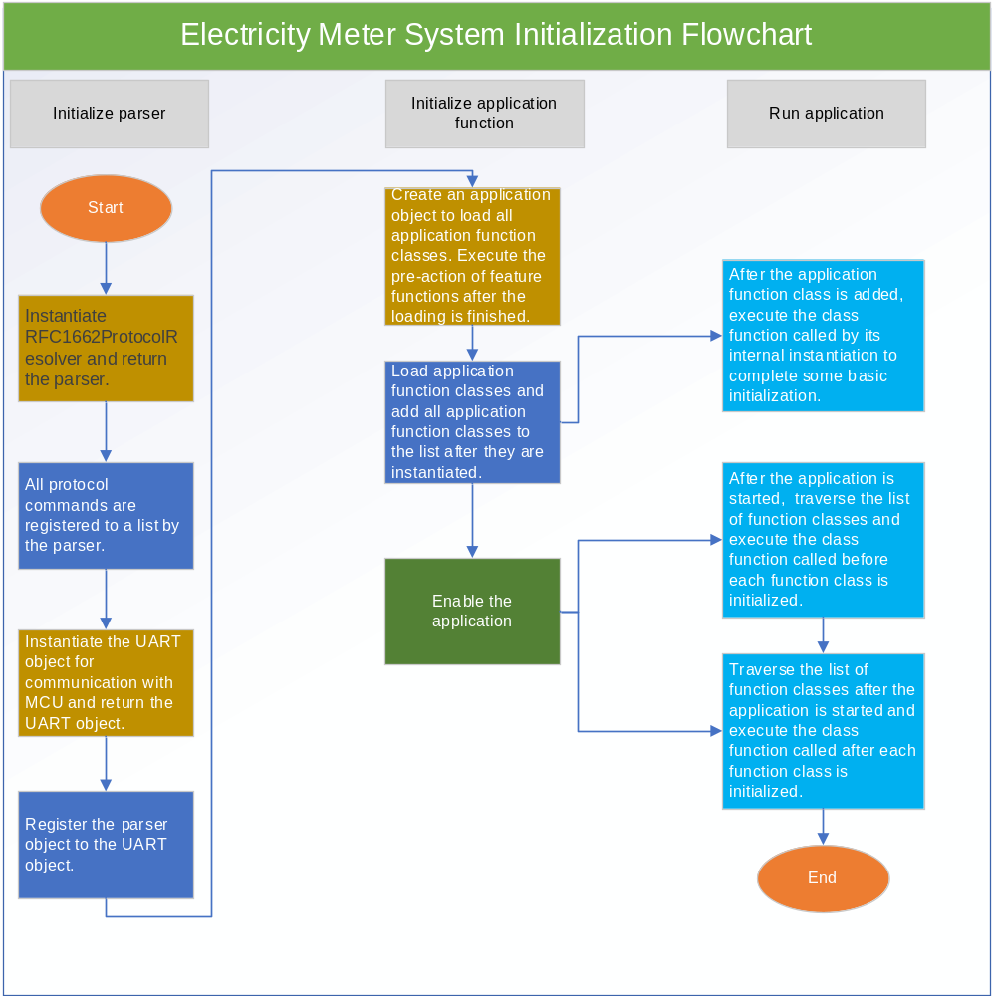Figure 5: Electricity Meter System Initialization Flowchart

Description of system initialization process:
- Create RFC1662ProtocolResolver object, and register all the class methods of the parser that need to be used to the parser object. The class methods here represent the implementation of the command function defined by the developer.
- Create a UART object for communicating with the meter. As the UART monitors the data sent by the meter, the parser needs to be registered to the UART object. When the data is received, the parser object can be used for parsing data and returning the result.
- There must be event registration or function processing to be completed before and after initialization and instantiation in all class methods. Therefore, when each class method is loaded and enabled, the developer executes the action before and after the initialization of the class method through an App class.

- Business Process

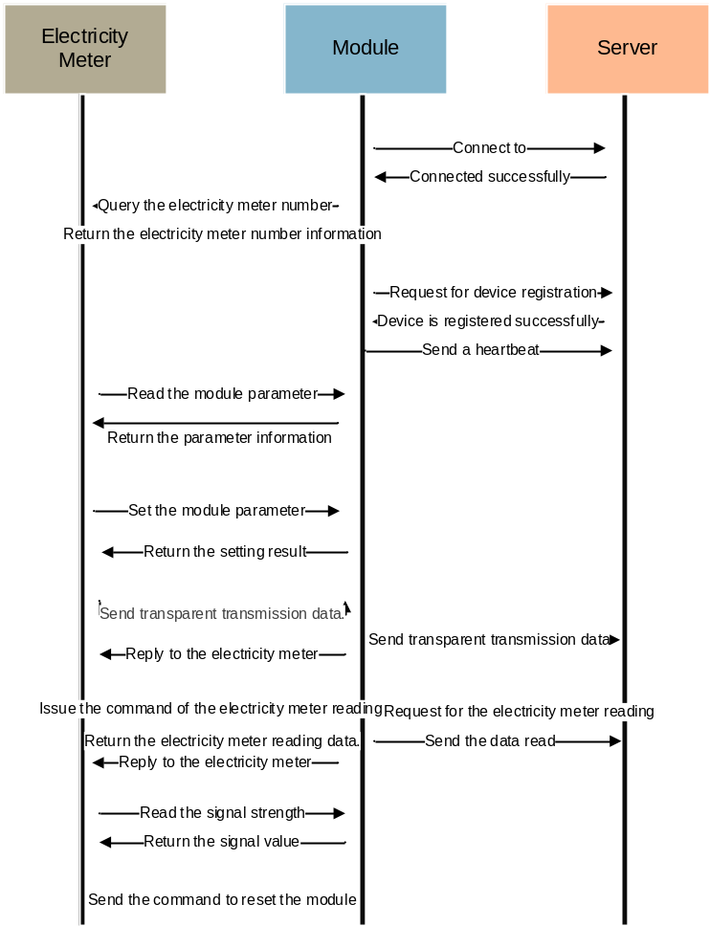
Figure 6: Business Flowchart

- Example

This chapter introduces how to perform secondary development based on the project code, such as adding new functions and modifying code function logic. You can refer to the examples below to get started quickly and get familiar with the code flow.

Before adjusting the code, you need to know how the features in the current code run. The feature functions implemented in the entire project are all event-driven through EventMesh, that is, after a feature function is implemented, define an event name for the function. For example, when a device IMEI is queried, and the event name and the corresponding event function is mapped in the form of key-value pairs (such as "Get_Imei": Function), it is called the subscription event (that is, creating a mapping relationship). The subscription event is saved by EventMesh. When you need to query the device IMEI, you can get the returned result only through publishing Get_Imei event. Therefore, each feature can be developed and debugged independently to achieve the decoupling effect.

Description of secondary development is as follows:

- The feature class function needs to be implemented before a feature class function is added. It is shown as follows:
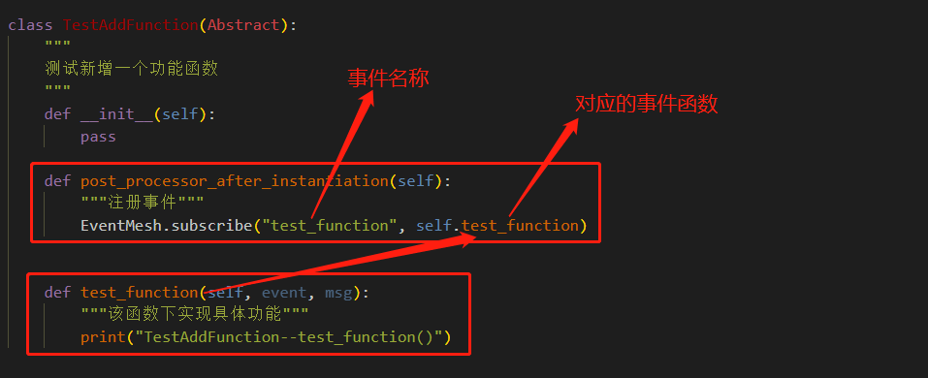
Event name
Corresponding event function
Added feature function is tested
Registration event
Specific feature is implemented in the function.

As shown in the figure above, it creates a function class method which inherits a common base class Abstract first. The base class is used for maintaining consistency in feature implementation. Then post_processor_after_instantiation() function of public base class Abstract is reimplemented. After the newly added feature class function is implemented, the added function needs to be registered and enabled in the App class. The initialization method of feature class inherited from the Abstract class is called and executed by App class, that is post_processor_after_instantiation() function. Therefore, the method called in the method needs to be subscribed to EventMesh.

Abstract base class:
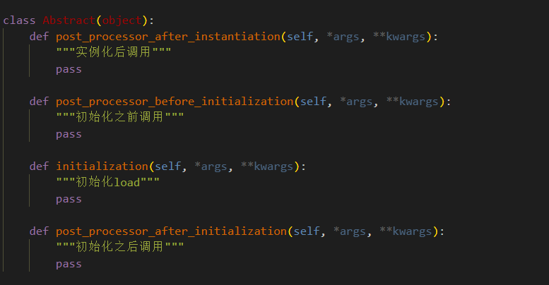
Call the method after instantiation
Call the method before initialization
Initialize load
Call the method after initialization

App class:
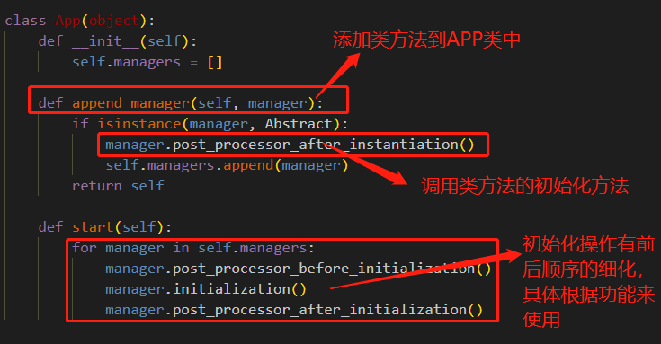
Add the class method to the App class.
Call the initialization method of class method.
These initialization operations are defined by the framework and you cannot or do not need to change the sequence and the content of the operations.

- Add the new class method to the entry function main.py:
- Import the added class method. usr.msg indicates mgr.py file in usr partition and the added class method is written in mgr.py file.
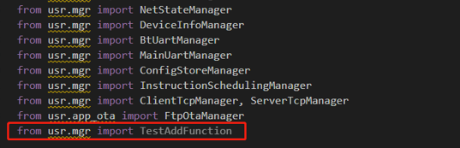

- Add the class method to the App class:
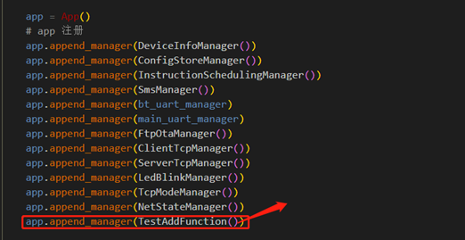
Note: Class method with () which is initialized indicates the class method is added to APP class.

- Use the added class method:
class PlayTestFuntion():
"""
Use the added class method
"""

def execute_test_function(self):
# Find the corresponding method by publishing the event to execute the event function.
EventMesh.publish("test_function")

Find the subscribed event by publishing the event and execute the corresponding event function.

- Appendix References

Table 2: Terms and Abbreviations
Abbreviation | Description
API | Application Programming Interface
App | Application
FTP | File Transfer Protocol
GPIO | General Purpose Input/Output Port
ICCID | Integrate Circuit Card Identity
IMEI | International Mobile Equipment Identity
LED | Light Emitting Diode
MCU | Microcontroller Unit
RFC | Request For Comments
SIM | Subscriber Identity Module
SMS | Short Message Service
TCP | Transmission Control Protocol
UART | Universal Asynchronous Receiver/Transmitter
UML | Unified Modeling Language
USB | Universal Serial Bus

