Traffic Surveillance Dataset (TSD)
  - Class Definition

Class Definition
cat_id | category | train_id | id | name | description | example
0 | void | 255 | 0 | unidentified | unclear or corrupted | 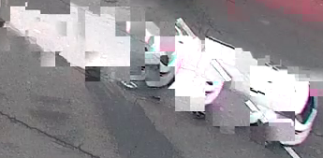
0 | void | 255 | 1 | others | Any vehicles that are clearly visible but not included in this list | 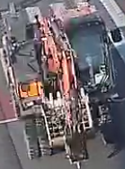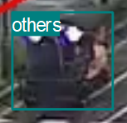  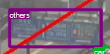
1 | pedestrian | 0 | 2 | pedestrian |  | 
2 | micromobility | 1 | 3 | micromobility | cycles  (bike, motorbike) | 
 |  |  |  |  | scooter
3 | vehicle | 2 | 4 | car | sedan  (2-4 seats) | 
 |  |  |  |  | SUV  (6 seats) | 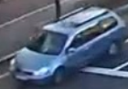
 |  |  |  |  | van  (7-10 seats) | 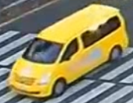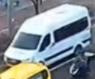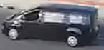
3 | vehicle | 3 | 5 | bus | mini bus  (30 seats) | 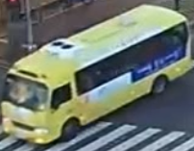
 |  |  |  |  | bus  (50 seats) | 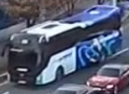
3 | vehicle | 4 | 6 | small truck  (same size as an SUV or van) | pickup | 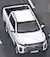
 |  |  |  |  | small truck | 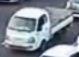
 |  |  |  |  | small box truck | 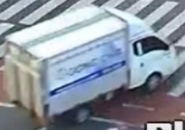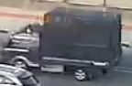
3 | vehicle | 5 | 7 | truck | large box truck | 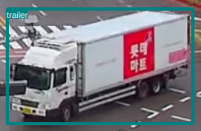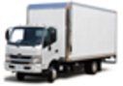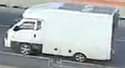
 |  |  |  |  | trailer truck | 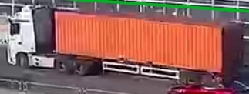
 |  |  |  |  | flatbed truck | 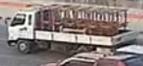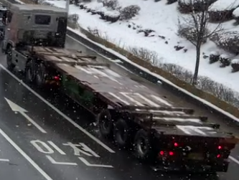
 |  |  |  |  | dump truck | 
 |  |  |  |  | tanker truck | 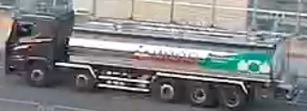
 |  |  |  |  | concrete truck | 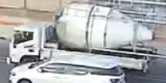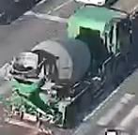
 |  |  |  |  | garbage truck | 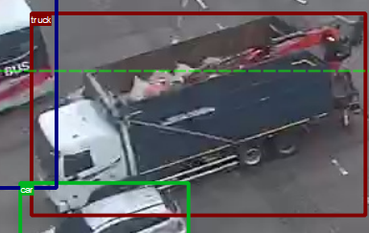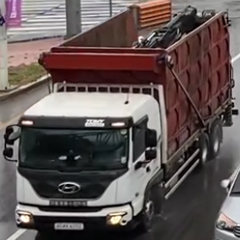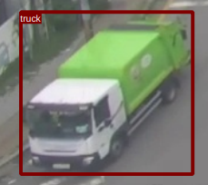
 |  |  |  |  | crane truck | 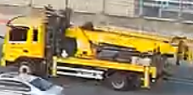
 |  |  |  |  | tow truck | 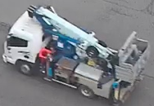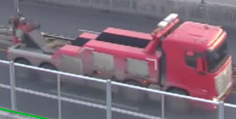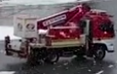
 |  |  |  |  | fire truck | 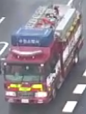
 |  |  |  |  | car transporter | 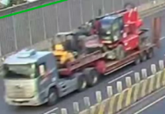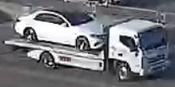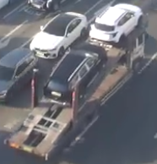

Labelling Policy
# | Policy | Example
1 | Draw bounding boxes tightly around the objects of interest. This helps the model accurately learn the object’s shape and location. Avoid unnecessary background or empty space within the bounding box. | 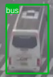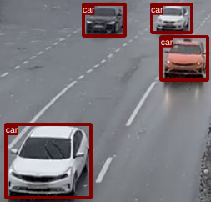
2 | Label occluded objects as if they are fully visible. We see better detections when we label occluded objects as if they are fully visible. This will help the model to learn that the car is still there, even though it is not fully visible. | 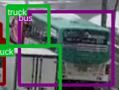
3 | A vehicle is considered within the ROI if the center point of its bounding box lies inside the ROI. | 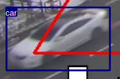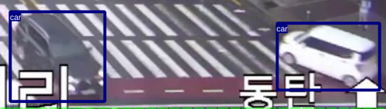
4 | Objects being transported by trucks must be labeled separately. | 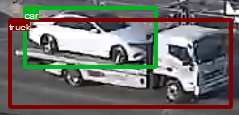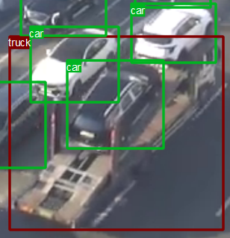
5 | Traffic signs covering vehicles must be labeled as others. | 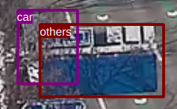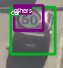
6 | Objects moving by pedestrian must be labeled as others. | 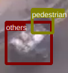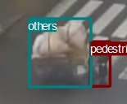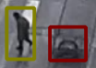

Questions
- What is the difference between a “pickup truck” and a “small truck”?
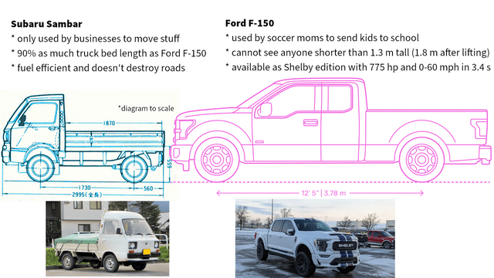

- Should we also label objects outside of ROI?
  - Don’t label modify training pipeline: https://github.com/ultralytics/ultralytics/issues/16440

References
- Types of trucks:
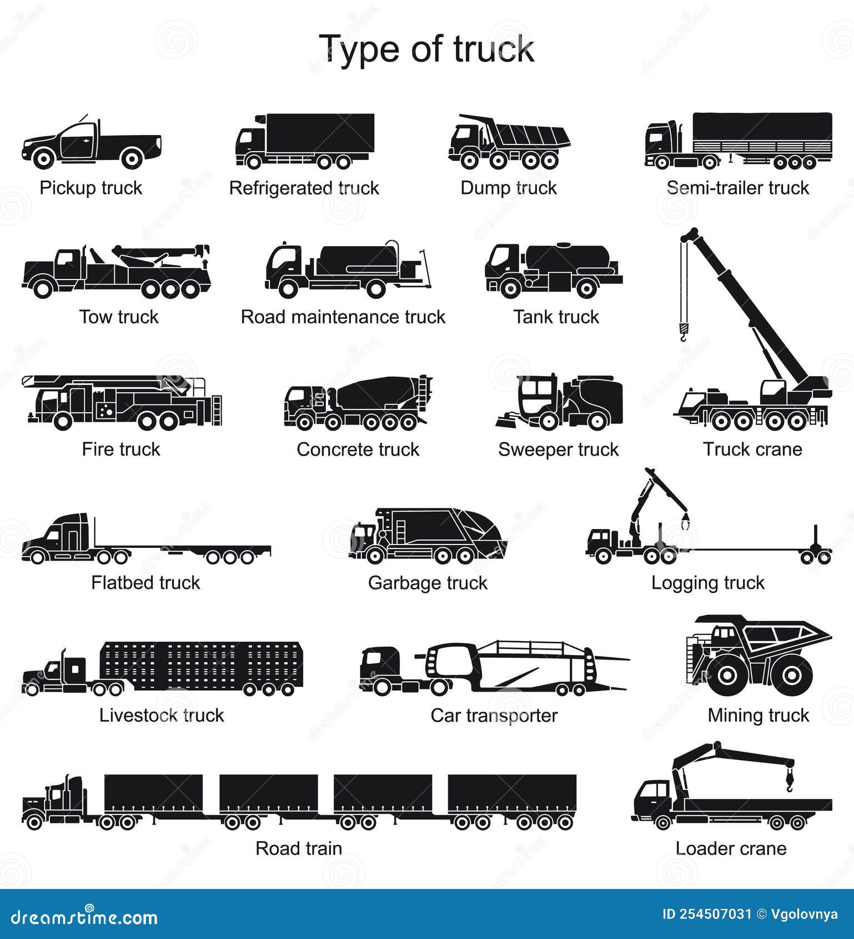

- Vehicle classification based on weights and sizes:
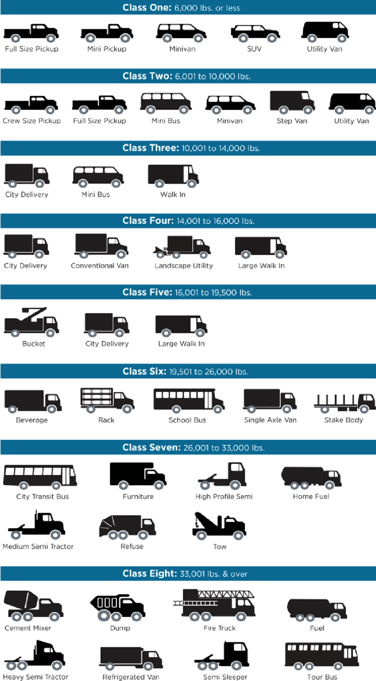
- Links:
  - https://www.esri.com/arcgis-blog/products/arcgis-pro/geoai/tips-for-labeling-images-for-object-detection-models/
  - https://github.com/waymo-research/waymo-open-dataset/blob/master/docs/labeling_specifications.md

