Alberto Martinez

CST407 – Threads

Lab 02

# Activity 1: Finding Hotspots

## Questions

1. What function in gzip.exe takes the most time?
   1. ‘deflate’ took 37.06% of the total run time of gzip.
2. Which function in gzip.exe has the highest CPI?
   1. ‘bi_reverse’ has the highest CPI of 2.5000
3. Which line of source in gzip.exe has the most clock tick samples?
   1. Line 685 in ‘deflate’ has 107 clock tick samples.
4. Is gzip.exe multithreaded?
   1. Nope

# Activity 2: Sampling Over Time

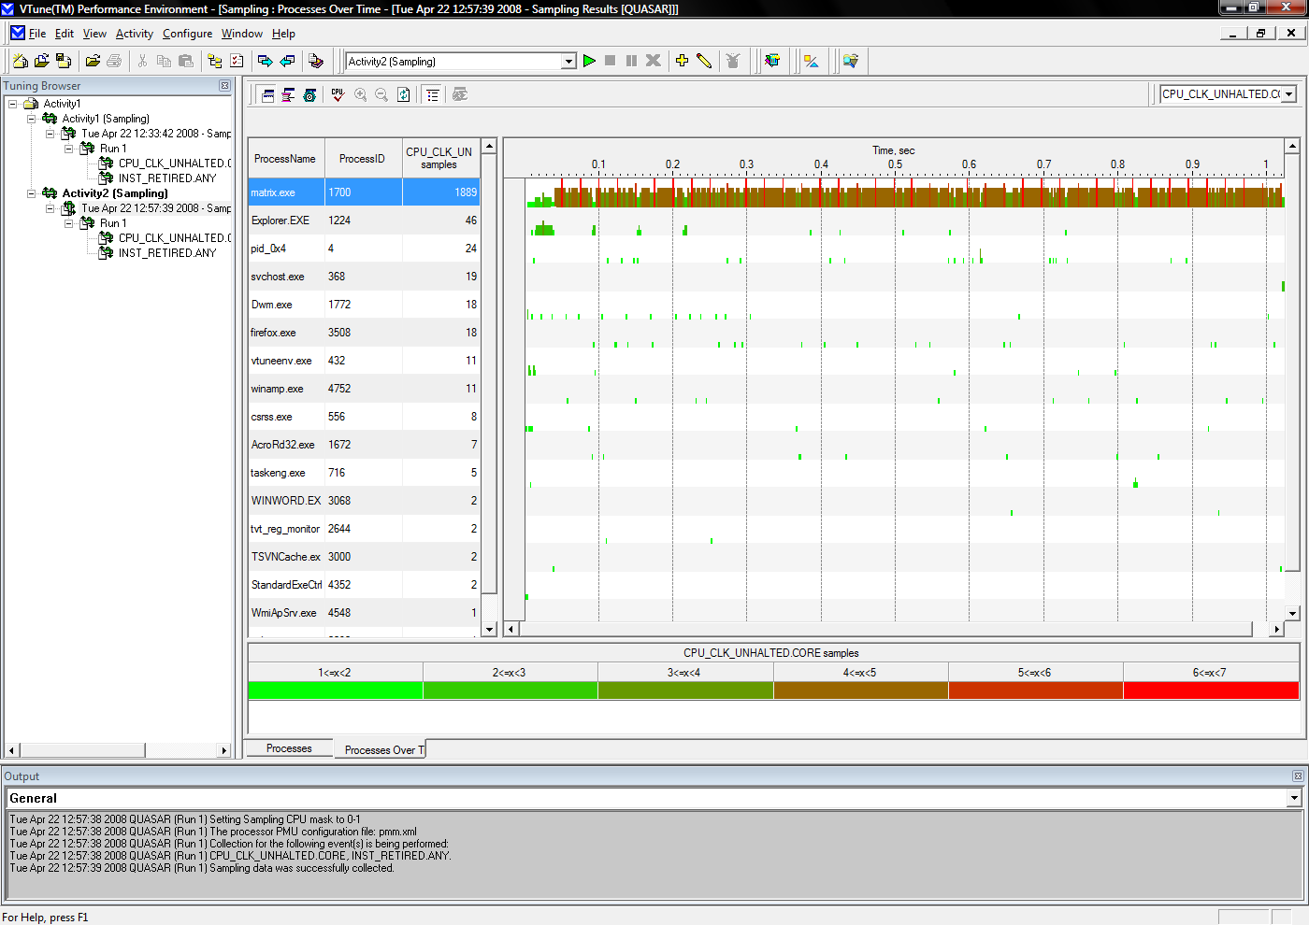

12. You can now see when each of the different Process, Thread, and Module views.

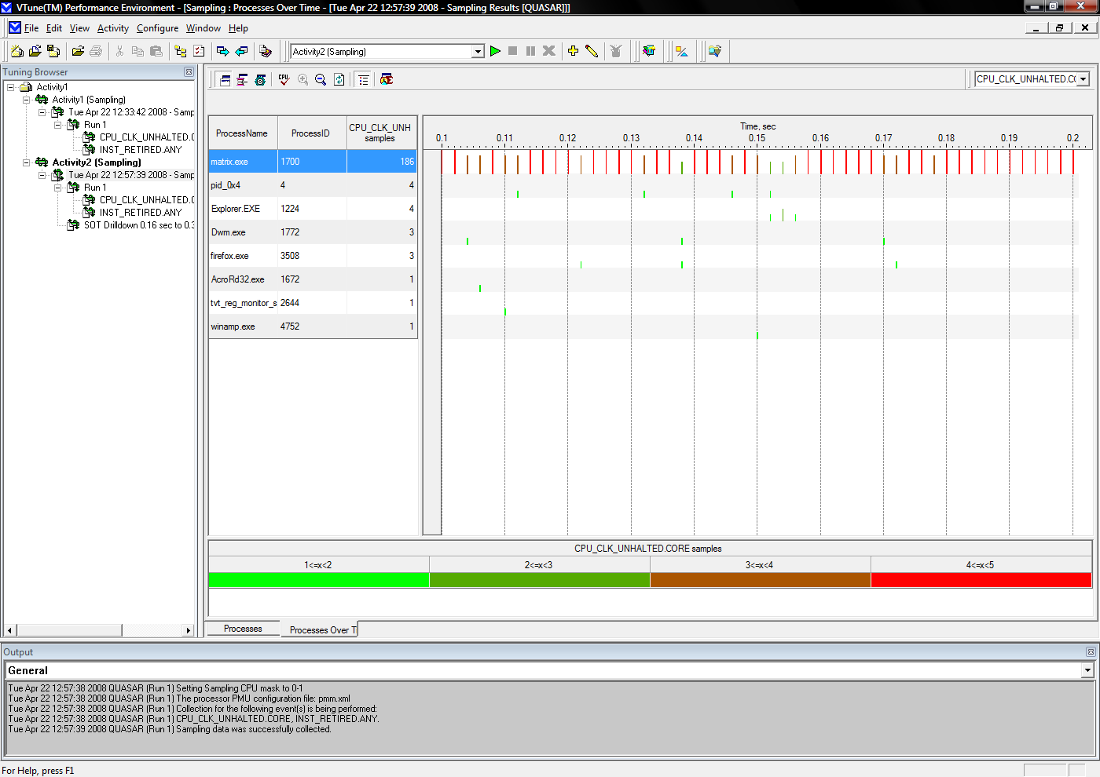

13. To zoon in on a particular time region, select the time region by clicking and draggin over it. Then click the Zoon In button, shown at left.

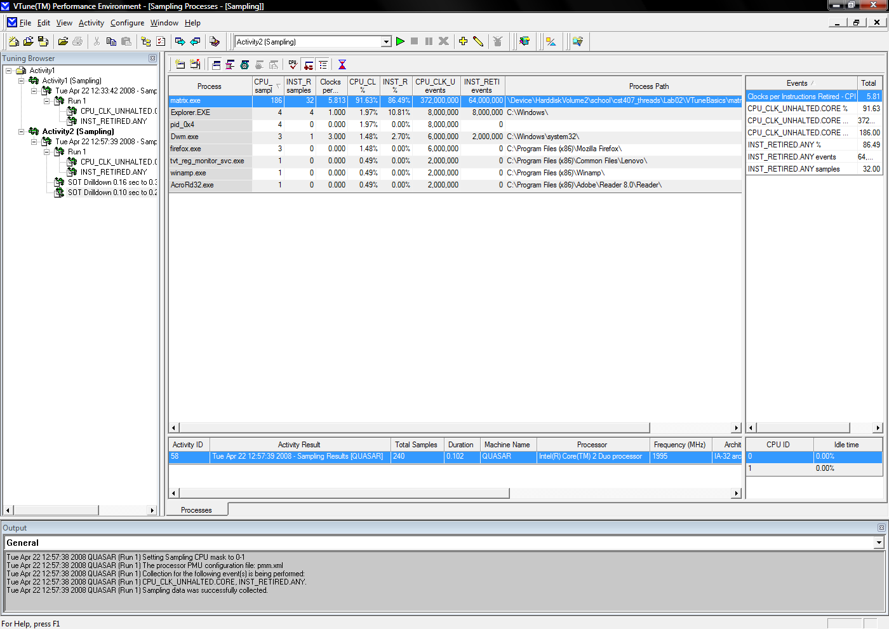

14. To see the regular sampling view for that time region, click the Regular Sampling View Button, show at left. You will now be able to drill down into your code for that time region.

# Activity 3: Using Call Graph

## Question

1. What function has the most time spent in it and what functions are calling it?
   1. gzip spends the most time in ‘zip’ which is called only by ‘treat_file’. Total time spent in ‘zip’ is 2,239,695mcs.

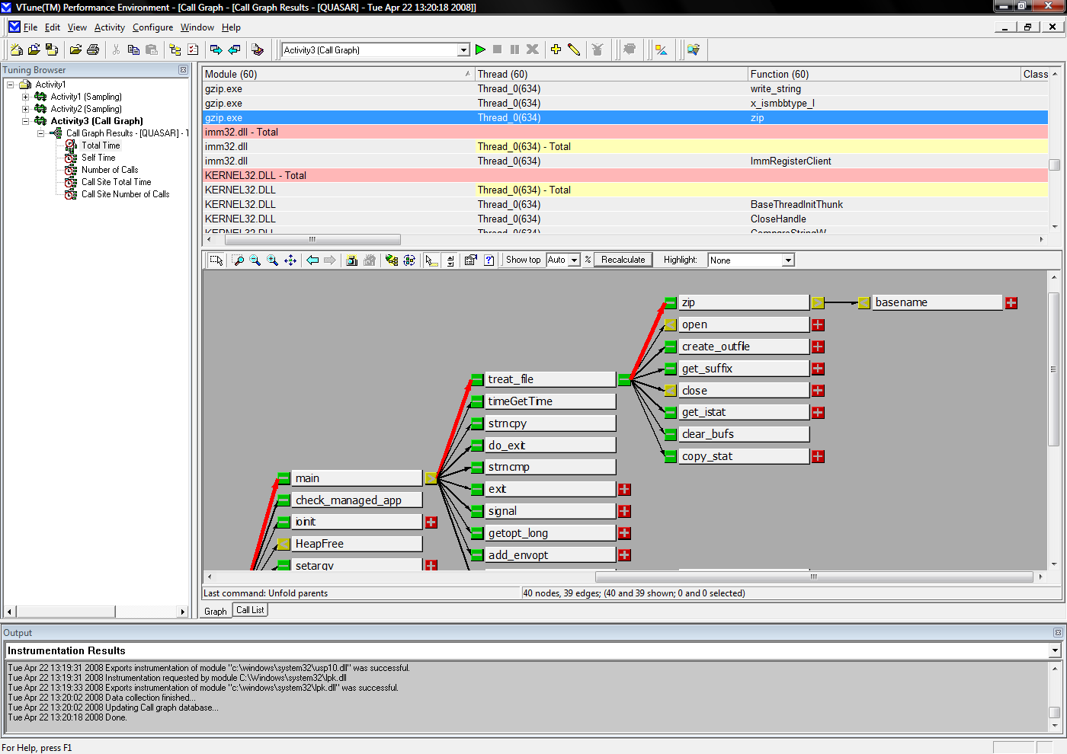

# Conclusion

VTune is neat. There were some quirks in figuring out how to use or navigate to some areas, but once a familiarity is found the usefulness is realized. It will be interesting to run these activities on a program that I write.