Alberto Martinez
CST229 – Grammars
Submitted to: Metzler
October 22, 2005

Chap. 5: Problems 2, 3, 5, 6, 9, 17

- Build an FA that accepts only the language of all words with b as the second letter. Show both the picture and the transition table for this machine and find a regular expression for the language.

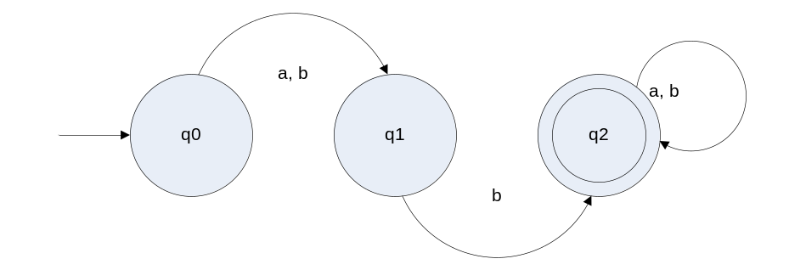

 | a | b
q0 | q1 | q1
q1 |  | q2
q2 | q2 | q2

( a + b ) b ( a + b )*

- Build an FA that accepts only the words baa, ab, and abb and no other strings longer or shorter.

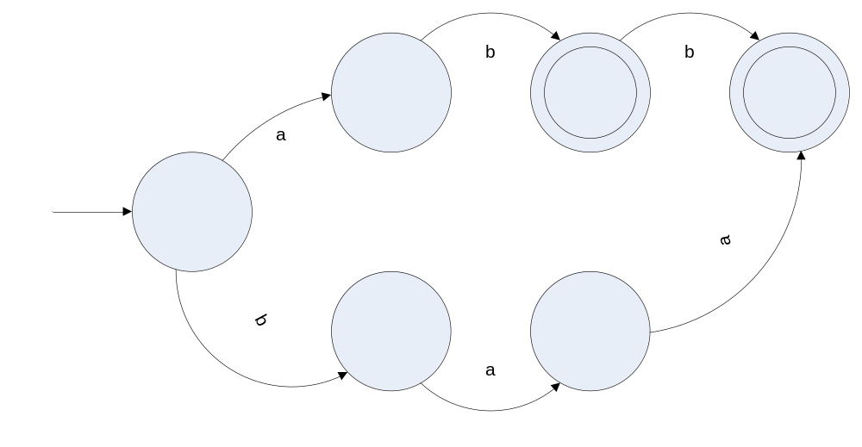

- -
  - Build an FA that accepts only those words that have more than four letters.
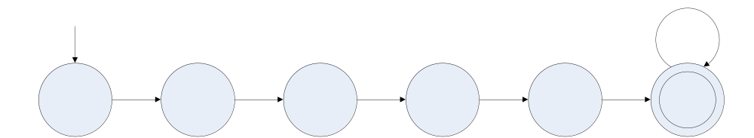

  - Build an FA that accepts only those words that have fewer than four letters.
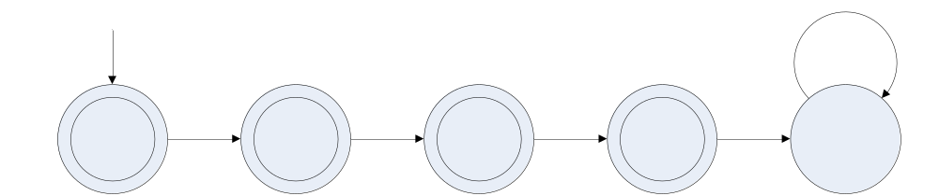

  - Build an FA that accepts only those words with exactly four letters.
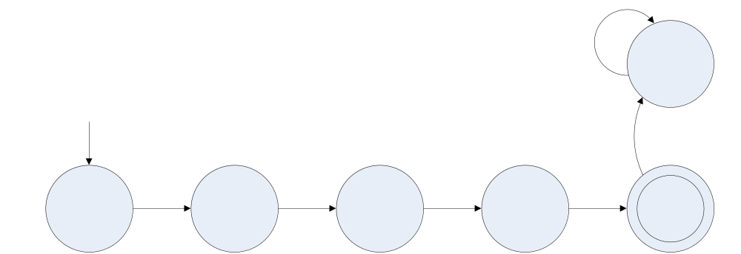

- Build an FA that accepts only those words that do no end with ba.
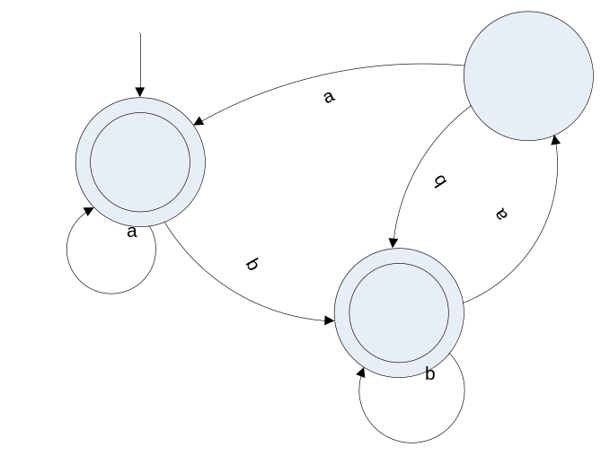

- -
  - Recall from chapter 4 the languages of all words over the alphabet { a b } that have both the letter a and the letter b in them, but not necessarily in that order. Build an FA that accepts this language.
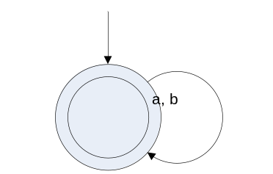

  - Build an FA that accepts the language of all words with only a’s or only b’s in them. Give a regular expression for this language.
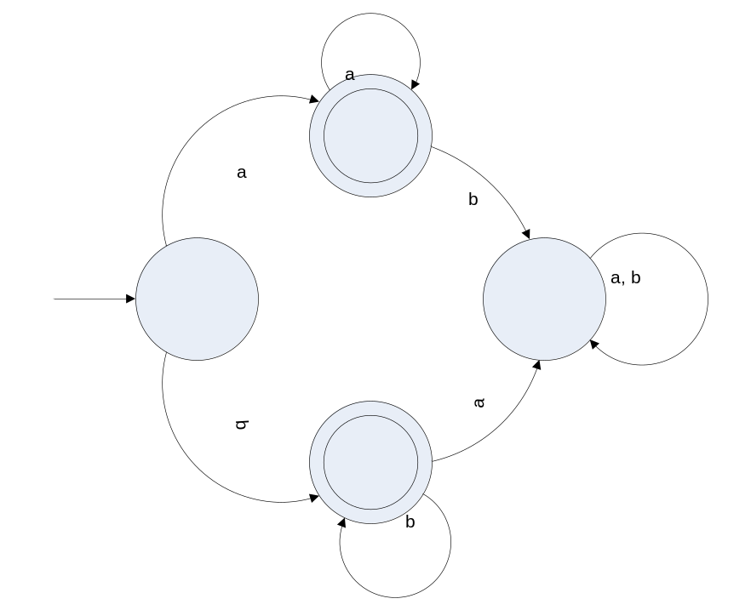
( a* + b* )

- Describe in English the languages accepted by the following FAs:
  - –
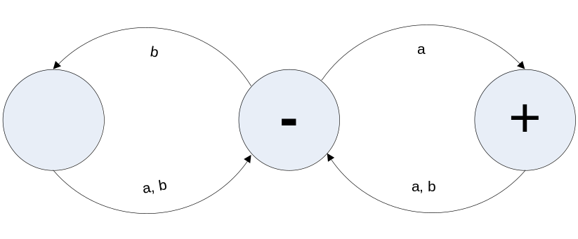
All words must end with an ‘a’.

  - –
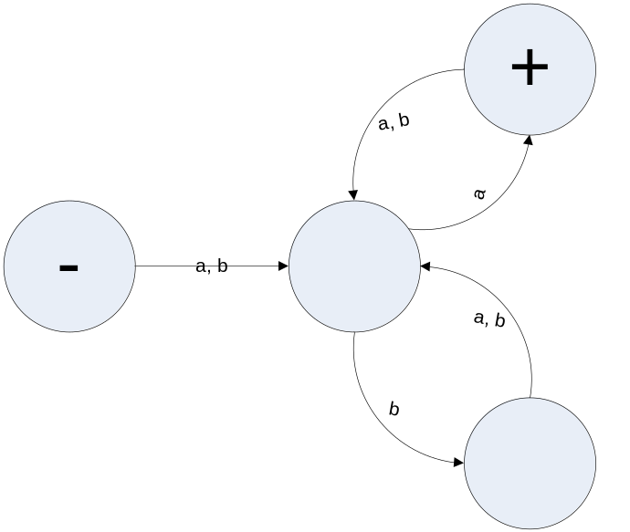
All words must end with an ‘a’.

  - -
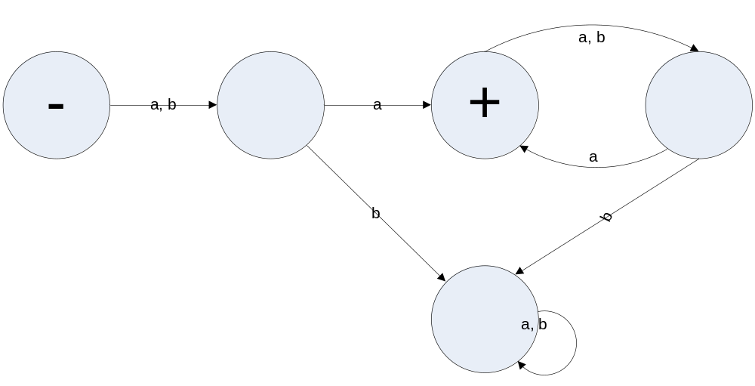
All words with even indexes of ‘a’.

  - Write regular expressions for the languages accepted by these three machines.

Third machine = ( a + b ) a ( ba )*

