Alberto Martinez
CST 229 – Grammars
Submitted to: Donald Metzler
November 29, 2005
Chapter 14

In Problems 1 and 2, convert the following FAs into equivalent PDAs.
- -
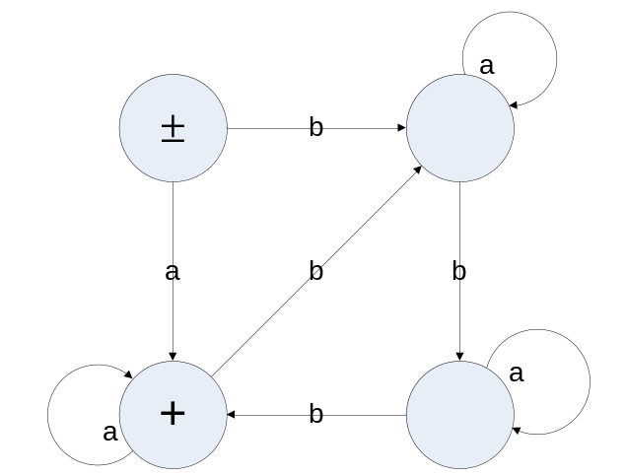

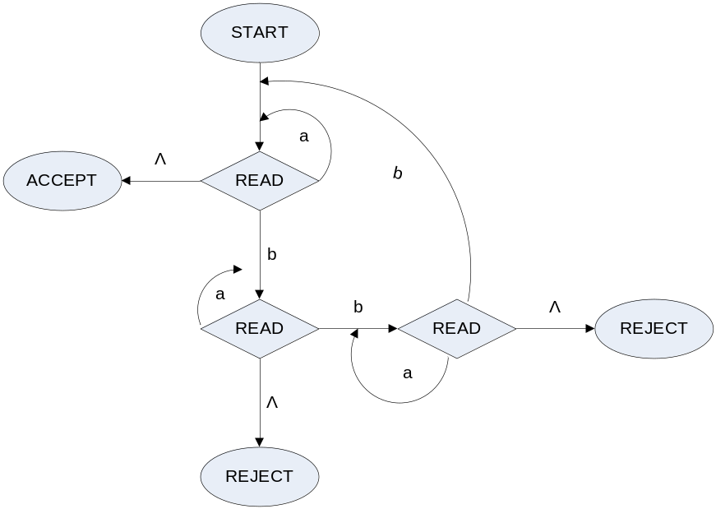

For Problems 3 and 4, consider the deterministic PDA:
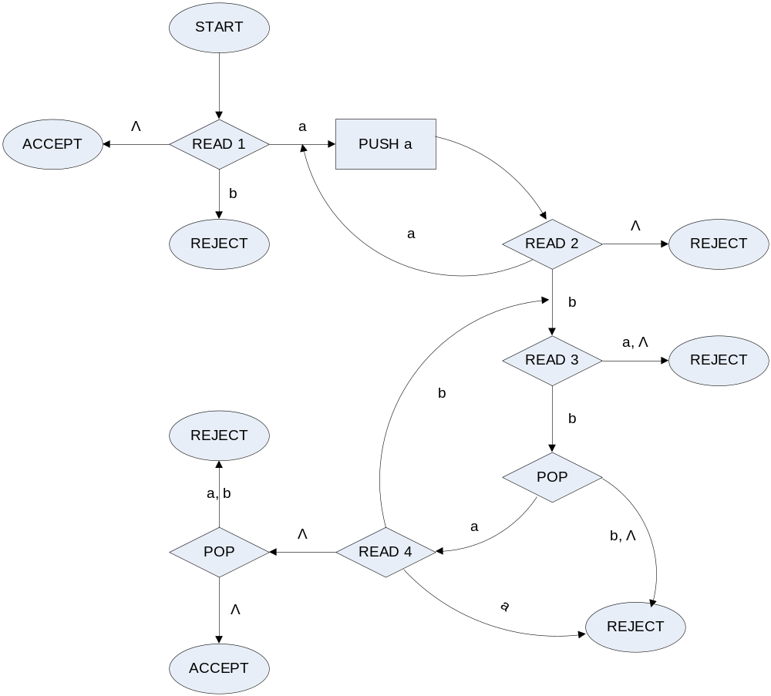

- Using a trace table like those in this chapter, show what happens to the INPUT TAPE and STACK as each of the following words proceeds through the machine:
  - abb
State | Stack | Tape
START | Λ | abbΛ
READ₁ | Λ | abbΛ
PUSH_{a} | aΛ | abbΛ
READ₂ | aΛ | abbΛ
READ₃ | aΛ | abbΛ
POP | Λ | abbΛ
READ₄ | Λ | abbΛ Λ
POP | Λ | abbΛ Λ
ACCEPT | Λ | abbΛ Λ

  - abab
State | Stack | Tape
START | Λ | ababΛ
READ₁ | Λ | ababΛ
PUSH_{a} | aΛ | ababΛ
READ₂ | aΛ | ababΛ
READ₃ | aΛ | ababΛ
REJECT | aΛ | ababΛ

  - aabb
State | Stack | Tape
START | Λ | aabbΛ
READ₁ | Λ | aabbΛ
PUSH_{a} | aΛ | aabbΛ
READ₂ | aΛ | aabbΛ
PUSH_{a} | aaΛ | aabbΛ
READ₂ | aaΛ | aabbΛ
READ₃ | aaΛ | aabbΛ
POP | aΛ | aabbΛ
READ₄ | aΛ | aabbΛΛ
POP | Λ | aabbΛΛ
REJECT | Λ | aabbΛΛ

  - aabbbb
State | Stack | Tape
START | Λ | aabbbbΛ
READ₁ | Λ | aabbbbΛ
PUSH_{a} | aΛ | aabbbbΛ
READ₂ | aΛ | aabbbbΛ
PUSH_{a} | aaΛ | aabbbbΛ
READ₂ | aaΛ | aabbbbΛ
READ₃ | aaΛ | aabbbbΛ
POP | aΛ | aabbbbΛ
READ₄ | aΛ | aabbbbΛ
READ₃ | aΛ | aabbbbΛ
POP | Λ | aabbbbΛ
READ₄ | Λ | aabbbbΛ
POP | Λ | aabbbbΛ
REJECT | Λ | aabbbbΛ

- –
  - Show that the language a^{n}b^{m}a^{m}b^{n} is context-free.
S → aSb | aXb
X → bXa | ba

- Build a deterministic PDA to accept the language {a^{n}b^{n + 1}}. (As always, when unspecified, the condition on n is assumed to be n = 1, 2, 3, …)
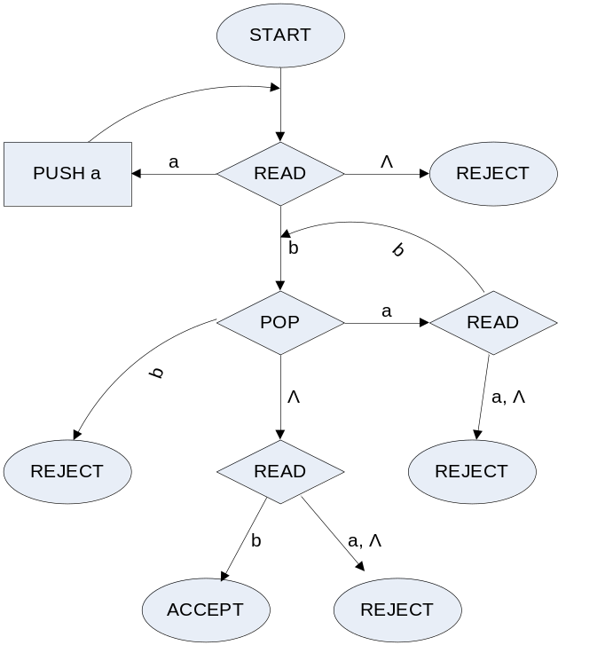

- Let the input alphabet be Σ = {a b c} and L be the language of all words in which all the a’s come before the b’s and there are the same number of a’s as b’s and arbitrarily many c’s that can be in front, behind, or among the a’s and b’s. Some words in L are abc, caabcb, ccacaabcccbccbc.
  - Write out all the words in this language with six or fewer letters
cccccc, abcccc, acbccc, accbcc, acccbc, accccb
aabbcc, aacbbc, aaccbb, acacbb, aacbcb, caabbc, cacabb

  - Show that the language L is not regular.
Because it is formed using a^{n}b^{n}
  - Find a PDA (deterministic) that accepts L.
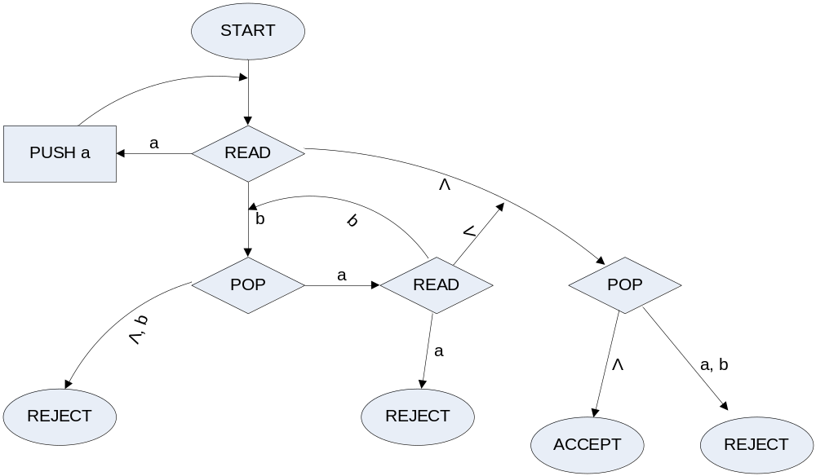
(ignore all instances of c)

  - Find a CFG that generates L.
S → c | aSb | caSb | aSbc

