Artificial Intelligence
Distributed Artificially Intelligent Immune System



Author: Alberto Martinez
Submitted to: Professor James Long
CST 415: Networks
Oregon Institute of Technology
June 14, 2006
Contents
Abstract 3
Introduction 1
Contextual Information 2
Basic Principles of Immunity 3
Synopsis 3
Inherent Immunity 3
Layers of Protection 3
Adaptive Immunity 4
Network Attack Recognition 4
Synopsis 4
Intrusion Detection 5
Virus Scanning Methods 5
Overview 6
Network Quarantine 6
Conclusion 7
References 10

Abstract
This research presents a new method for securing a private network. The ideas discussed throughout the research show some promise for implementation on individual PCs. If matured, a system such as the one proposed in this document would push the virus scanning industry towards a more intelligent and light weight solution to contracted internet ailments. It would also allow for a more care-free administration of a private network as only minimal effort is required to teach the system to differentiate between safe and harmful network traffic and data.

The system to be detailed is a mixture of ideas and technologies. The Distributed Artificial Intelligence is really a mixture of Distributed artificial intelligence, multi-agent systems and collective intelligence. The system is distributed because of the immune system itself. Resources related to the immune system are shared amongst all involved hosts. But the traits lead off into a description of a Multi-agent system because each host machine has the ability to fight off incoming attacks. Finally, it has aspects of a collective intelligence because of the database and the constant sharing of data between internal machines for the common good of the network.

Similar systems have been proposed and some taken to implementation, however the scope proposed here is one that I have not discovered yet in my research. A fully functional distributed artificially intelligent immune system is a one that implies full immunity from network based attacks as well as supporting autoimmunity for localized host infections provided time enough to obtain the antigens required for self-preservation.

Introduction
For billions of years, organisms have been capable of fighting off microscopic enemies such as virus, fungi, and bacteria. The immune system inside of every organism provides the means to fight off these microscopic, invisible killers. This system is billions of years proven against biological influences that would otherwise eliminate some or all species on the planet.

With the increasing availability of cheap, fast computers, building an infrastructure with 100+ computers is fairly easy. For anyone doing this it must be considered that with 100+ computers could also come 100+ users putting the new and well-established cluster of computers at risk. Not to mention the billions of users to worry about who are on the internet and can see your new infrastructure busily sending and receiving transactions of all types. A single computer, infected with a Trojan or virus could bring the cluster crashing down. Or possibly worse, customers involved with the transactions occurring between, to or from this cluster have their information infiltrated from an unseen intruder.

In comes the plethora of software solutions: virus scanners, firewalls, ad-blockers, spam filters, etc. All high-priced no-guarantee “solutions” to the risks a business or individual is probably exposed to. This is the fundamental motivation for the development and implementation of a Distributed Artificially Intelligent Immune System (DAIIS). The precedents possible with such a system would bring up the draw-bridge on malicious software and intruders infiltrating anonymous entities exposed to the internet.

Contextual Information
A Distributed Artificial Intelligent Immune System (DAIS) is an interdisciplinary project with several areas of research that need to be explored to understand how to possibly implement such a system. Research areas include but are not inherently limited to:
- Basic Principles of Immunity
- Network Attack Recognition
- Virus Scan Methods

Each topic of research will be summarized describing the application and association to the desired implementation. After the topics have been discussed the report will conclude providing a generalization of the research gathered. Included below is a network diagram showing a very simple environment for the DAIIS.
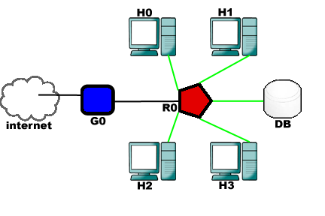
4 host machines (H0, H1, H2, H3), 1 border gateway device (G0), one database server for the DAIIS (DB), and one internal router (R0).

Figure 1: Network Model

The figure above presents a simple DAIIS setup. Notice the only portion of the network that is left monolithic is the database. Where to place the database should come under some consideration as network traffic combined with database queries can hinder the overall performance of the system. There is such an implementation that distributes the database amongst host machines. The overhead in such a decision is development time as there are obvious synchronizing issues with such a system. For simplicity’s sake, I have kept the database as a separate entity.

Basic Principles of Immunity

Synopsis
Understanding the basics of an immune system in nature will provide the vision necessary to piece together the equivalent automated process. While it would be beneficial to know all there is to know about a biological immune system, it is unnecessary as the desired system will not be biological. Capturing the basics of biological immunity mechanisms should provide adequate knowledge for an implementation strategy.

Inherent Immunity
A fundamental mechanism required for a successful biological and artificial immune system is the recognition of antigens. An antigen is anything that stimulates immune response. A DAIIS would observe incoming and outgoing network packets searching for the ones matching criteria in gathered antigen data. When encountered, the appropriate immune response would be executed. In a biological system, the most important recognition type is the ability to distinguish from self and non-self cells. This mechanism successfully identifies foreign substances and coincides with the goal at hand. Since the objective is to eliminate malicious packet traffic it would be safe to assume that a packet not targeted to any machine inside the network be eliminated, assuming the border device is also a part of the DAIIS network and the internal network is large enough that questionable destination packets can still come in through the border.

Layers of Protection
The first line of defense for any immune system is the physical barriers such as the skin, urine, tears, mucosal membrane, etc. These barriers prevent pathogens from entering the system altogether. For a network, this would be identified as the border gateway devices and protocols that allow external communication to the internet or other networks. DAIIS would be capable of monitoring Borders at a cost; this can only be accomplished if the border device has DAIIS onboard with access to the database. This is required unless it is desirable to separate the system up into two DAIIS systems, one for border and one for internal hosts. Having the border a part of the DAIIS setup would simulate a behavior closer to that of a biological immune system. Such that if an intercepted pathogen internal to the network was successfully destroyed, the antigen would propagate to the borders establishing a perimeter lockout of that particular type of malicious packets until they are deemed safe again.
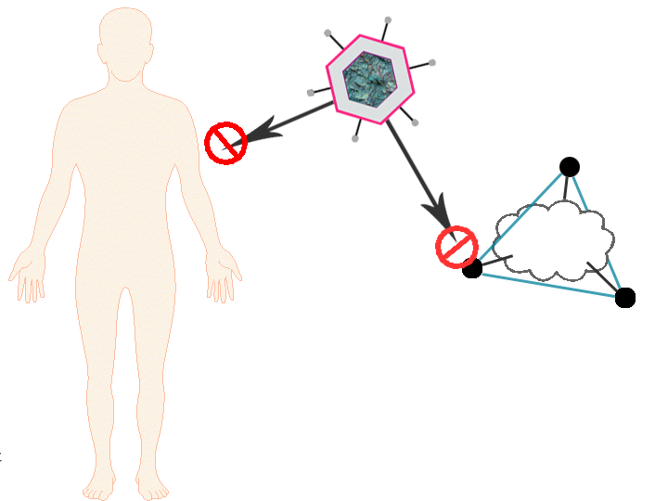
(left) Humans and other organisms have skin to protect them from many biological threats. (right)A network is also protected isolating external traffic through few points of exposure called border gateways.

Figure 2: Born with Some Protection

Adaptive Immunity
The adaptive immune system is complex, with an emergent property being the responsive protection against invading pathogens. Some of this complexity arises from the fact that there is no one entity governing the systems function. The key component of this system is mechanism equivalent to white blood cells. White blood cells identify and eliminate invading pathogens. The adaptability arises from the cell’s ability to display an eliminated invader’s antigen. Once displayed, other white blood cells respond by multiplying and producing antibodies which lock onto foreign antigens making it easier for other immune cells to destroy them. Finally, the antigen is adopted by the immune system by storing the antigen in memory cells which prepares the entire system for the next arrival of an equivalent pathogen associated with the stored antigen.

It is interesting to observe that the process of recognition, identification and post processing involve several mechanisms such as the pattern recognition, learning, communication, adaptation, self-organization, memory and distributed control by which the body attains immunity (Dasgupta, 1999).

Network Attack Recognition

Synopsis
Since we now have a well-established basis for what the DAIIS will do we can now explore the various techniques to recognize more pathogens other than ones identified as non-self. The detection here splits into a few different types. Intrusion detection will capture unwanted manipulations to the host machines in the network. Attack detection will prevent network attacks such as DDoS and Syn floods. There are more types of attacks to identify and address, however these are the most common attacks. This is a big stepping stone for a project such as this. Still, there is no efficient and accurate way of detecting a full spectrum of network attacks. Instead the system will be limited to detecting attacks that it has been provided details on for pattern recognition.

Intrusion Detection
Unwanted manipulations to internal systems must be captured before the malicious packet is allowed to be transmitted on the internal network. This must be done because once the malicious packet reaches any host computer, the attack is a success. Therefore, the intrusion detection must be established on the border gateways and internal host machines. The necessity for requiring internal detection is a valid precaution taken due to the ease of attacks occurring internally.

There are two main types of intrusion detection. Misuse detection, also known as a signature-based intrusion detection system, identifies hostile network activity by recognizing patterns of malicious traffic or data. This means that if an attack is seen every hour, then the detection system will be able to identify the attack by the time signature it has been leaving behind. The other type is anomaly-based intrusion detection which recognizes traffic or data that is abnormal compared to traffic and data history. This means that given a history of viewing only e-mail and the occasional road report, if some other web-site were visited, then the detection would recognize the questionable traffic as abnormal. Over time the system would become better at recognizing safe and abnormal traffic.

Misuse detection is a pre-programmed solution for detecting malicious packets. Attack types and techniques are known beforehand and provided to the system. Anomaly detection practices self-learning to reduce the need for a human administrator while successfully distinguishing between safe and hazardous packets. The key concept in this section is pattern recognition. Once malicious packets are encountered they must be recorded and learned by the DAIIS for immediate propagation to the rest of the machines in the network as well as antigen creation and history in the database.

Virus Scanning Methods

Overview
Scanning for viruses is always an uncomfortable experience. The anticipation of whether or not the computer being scanned will be infected can be very stressful. Unfortunately, there is still no end-all solution to the virus problem. It remains that all virus scanners require downloading up to date virus definitions in order to recognize the latest and greatest menaces.

Computer viruses are the first and only form of artificial life to have had a measurable impact on society. Provided the theories discussed above hold true and combined with a similar pattern recognizer made especially for DAIIS to learn what makes a virus the solution could be there. There is however a different approach that can be taken utilizing features in the DAIIS to possibly prevent some viruses from spreading once internal infection has occurred.

Network Quarantine
At this point, we have been going through separate yet very much inclusive portions of what would make a DAIIS. So now there is an emergent behavior that should be explored. When covering the biological immune system and how it directly relates to system in question, remember the primary method of recognizing pathogens. This concept has been expanded a bit to include viruses as pathogens. Given the two fundamental identifiers of self and not-self, one could easily use this network schema and associated software to quarantine regions of the internal network. In the biological case this would be an autoimmune condition where an organism fails to recognize self. In this case what is really happening is an internal portion of the network has been found to have a virus and has therefore been made an antigen. Once the antigen is shared with the entire network, the infected host machine is successfully secluded from the network entirely, even the border gateway devices. Packets are still exchanged on the physical layer but they are dumped by all the machines ignoring the infected host.

Curing Network Injuries
One of the benefits a computer engineered immune system has over a biological immune system is the tight grasp on time. Already, the proposed DAIIS has the capabilities to quarantine entire regions of a network, produce antigens for future attacks and learn more about traffic as traffic comes in. The concern that should remain is that in order to learn from an attack, the system must be attacked. This is counter-intuitive to the primary goal of the system which is to prevent all attacks. What good are antigens if the entire network went down after a single attack?

Enter this addition to the DAIIS. The conditions that cause single or multiple hosts to recognize that they have been attacked are unexpected changes to the network or host system. The conditions that cause single or multiple hosts to recognize they have a virus are an antigen event on a local host and broadcasted to the network. The system is now setup to separate hosts from the network whenever they get into trouble. This is accomplished by throwing away packets that are received from infected hosts and no longer sending packets to infected hosts. This information is provided by the host upon infection or from a generated ARP sequence from the database server to remove the knowledge from uninfected hosts that the infected host still exists. Now, there remains the question “what happens to them?” The answer is a system restorer mechanism. Very similar to RAID setups on large-scale servers the restore system rolls back events that occurred on the now blocked host machine. Information on the downed machine is stored in the database. During restoration, the server accepts incoming packets on behalf of the downed machine so that when the restore is complete, no information is lost. This ability for computers to halt and execute these rescue sequences provides more stability and prevents the loss of data.

Conclusion
A DAIIS offers plenty of hurdles to overcome. The biggest hurdle is defining a solid solution for recognizing harmful network packets. In Fuzzy Network Profiling for Intrusion Detection, John and Julie Dickerson propose data mining techniques for each protocol. While there is overhead defining the data mining technique for each protocol that comes into the network, it may be the only solution that will produce satisfying results all the time. The technique proposed in their paper, tore apart the TCP header into useful pieces of data and stored each one in a database similar to what would be happening in the DAIIS. Beyond that the data mining techniques they use are geared towards their Fuzzy logic system and therefore would not be applicable to the DAIIS.

In closing, the research I did on this was really cloudy in some areas. However, the concepts derived from biological immune systems are quite amazing when applied to computer science. The model is there and we are just starting to use it. Smart connections everywhere like this would be quite convenient as far as keeping your computer clean. The rollback and other parts of the system are still flawed with a solution yet to be discovered. Nonetheless, AI is developing a lot faster than I thought it was and after this paper, I feel I need to get up to date.
Appendix A: Glossary

Agent – In computer science, a software agent is an abstraction, a logical model that describes software that acts for a user or other program in a relationship of agency. Such "action on behalf of" implies the authority to decide when (and if) action is appropriate. The idea is that agents are not strictly invoked for a task, but activate themselves (Wikipedia, 2006).

Antigen – A substance that induces an immune response, usually foreign (Wikipedia, 2006).

Artificial Intelligence (AI) – The ability of a computer or other machine to perform those activities that are normally thought to require intelligence (The American Heritage® Dictionary of the English Language, 2000).

Distributed Artificial Intelligence (DAI) – was a subfield of Artificial intelligence research dedicated to the development of distributed solutions for complex problems regarded as requiring intelligence. These days DAI has been largely supplanted by the field of Multi-Agent Systems (Wikipedia, 2006).

Immune System – The integrated body system of organs, tissues, cells, and cell products such as antibodies that differentiates self from non-self and neutralizes potentially pathogenic organisms or substances (The American Heritage® Dictionary of the English Language, 2000).

Multi-agent System (MAS) – In computer science, a multi-agent system is a system composed of several agents, collectively capable of reaching goals that are difficult to achieve by an individual agent or monolithic system (Wikipedia, 2006).

Pathogen – Any organism or substance, especially a microorganism, capable of causing disease, such as bacteria, viruses, protozoa or fungi. Microorganisms are not considered to be pathogenic until they have reached a population size that is large enough to cause disease (Wikipedia, 2006).

References

Dasgupta, D. (1999). Artificial Immune Systems and Their Applications. Germany: Springer-Verlag.

Dickerson, J. E., & Dickerson, J. A. (n.d.). Fuzzy Network Profiling for Intrusion Detection. Retrieved June 14, 2006, from http://home.eng.iastate.edu/~julied/publications/NAFIPSpaper2000.pdf

Sathyanath, S., & Sahim, F. (2002). ASIMAM - An Artificial Immune System Based Intelligent Multi Agent Model and its Application to a Mine Detection Problem. Retrieved June 13, 2006, from http://www.aber.ac.uk/~icawww/Proceedings/paper-28/icarisfinal-final.pdf

Houghton Mifflin. (2000, January 15). Editors of The American Heritage Dictionaries, The American Heritage® Dictionary of the English Language (4th ed., pp. 2076). Boston, MA:.

Marriam-Webster, (2006). Retrieved Jun. 13, 2005, from MERRIAM-WEBSTER ONLINE Web site: http://www.webster.com.

Fauci, M. A., Krause, M. R., Davis, M. D., Andrews, P. S., & Haas, M. V. (2003, September 25). The Immune System. Retrieved June 14, 2006, from http://www.niaid.nih.gov/final/immun/immun.htm

(2006). Wikipedia. Retrieved June 14, 2006, from http://wikipedia.org

